Reconstructing palaeoclimate from southern Poland using stalagmites from Niedźwiedzia Cave coupled with modern day environmental monitoring data

Niamh Monaghan

Department of Earth Sciences
University of Durham
September 2011

This Dissertation is submitted in partial fulfilment of the requirements for the degree of M.Sc.R in Geology.
Abstract

The aim of this thesis is to perform a palaeoclimate reconstruction for Niedźwiedzia Cave, southern Poland using stable isotopes, and to examine factors which may influence these results. Stable isotope analyses of three stalagmite samples from Niedźwiedzia Cave yielded a palaeoclimate record for the last 16,000 years for this region. Uranium series dating provided a chronology that was used to investigate oxygen and carbon stable isotope variations through the record, which reveal the effects of some notable palaeoclimate events such as the Younger Dryas Event, the Bølling-Allerød and Bond Events. The identification of shorter, non-cyclic events (e.g. the 8.2 ka event) was hampered by large errors in the uranium series dating due to the low uranium content of the stalagmites from the site.
Oxygen isotopes in meteoric precipitation (δ¹⁸Op) were examined to determine the main controls that affect isotope ratios such as the temperature and continental effects. An investigation was also carried out to determine whether a relationship is observed between precipitation results and dominant European circulation patterns, i.e. the North Atlantic Oscillation (NAO) and the Quasi-Biennial Oscillation (QBO). Understanding these controls has wider implications for interpreting the palaeoclimate record, as recognizing how they alter the isotopic signature of a speleothem at the time of deposition can then be used to calibrate the record. The investigation was carried out by examining anomaly data from a multitude of datasets, including drip-water data from Niedźwiedzia Cave and Global Network of Isotopes in Precipitation (GNIP) data from multiple sites in Germany and Poland. Identification of anomalous data was accomplished by using linear regression analysis of δ¹⁸Op data. Back trajectory analyses were then carried out for these data points to determine the air mass’s source zone, and to provide further information on the factors which may have affected the δ¹⁸Op, such as the potential magnitude of the rainout effect, temperature effect and the amount effect.

Contents
Abstract
1. Thesis Introduction 7
2. Identifying the controls on oxygen isotope ratios in meteoric precipitation in
Poland and Germany 9
2.1 Introduction 10
2.1.1 Processes which affect δ¹⁸Op 11
2.1.2 The North Atlantic Oscillation 15
2.2 Methods 17
2.2.1 Data sampling sites 17
2.2.2 Statistical analyses 21
2.2.3 Back trajectory analysis 22
2.3 Results and discussion 24
2.3.1 Niedźwiedzia Cave monitoring data 24
2.3.2 Niedźwiedzia Cave rain- & drip-water samples 28
2.3.3 δ¹⁸Op and δD GNIP and Górka data 34
2.3.4 Linear regression 39
2.3.5 Back trajectory analysis 43
2.3.6 Isotope data and the NAO and QBO 50
2.4 Conclusions 56
3. Palaeoclimate reconstruction in southern Poland, using low-uranium stalagmites
from Niedźwiedzia (Bear) cave, Poland 58
3.1 Introduction 58
3.1.1 Stable isotopes 60
3.1.2 Uranium series dating of speleothems 61
3.1.3 Trace element analysis 62
3.2 Study area, environmental setting and sample description 64
3.2.1 Niedźwiedzia cave 64
3.2.2 Speleothem samples 66
3.3 Methods 67
3.3.1 Microdrilling 67
3.3.2 Isotope analysis 67
3.3.3 Uranium series 68
3.3.4 Trace element analysis 70
3.4 Results and discussion 71
3.4.1 Chronology 71
3.4.2 Stable isotopes 74
3.4.3 Comparison with other proxy records and notable climate events 80
3.5 Conclusion 86
4. Thesis Conclusion 87
4.1 Further recommendations 88
Appendix 91
References 107

Table of Figures
Figure 2.1 | Processes which affect δ¹⁸O | 12
Figure 2.2 | GNIP stations, Gόrka event and Niedźwiedzia Cave locations | 13
Figure 2.3 | A:Positive & negative phases of the NAO, B: NAOI | 15
Figure 2.4 | Monitoring sites, Niedźwiedzia Cave | 17
Figure 2.5 | Monthly precipitation and rainfall data Nied08-02 | 24
Figure 2.6 | Monthly precipitation and rainfall data Nied08-04 | 25
Figure 2.7 | Monthly precipitation and rainfall data Nied08-05 | 26
Figure 2.8 | Monthly δ¹⁸Op with temperature for Niedźwiedzia Cave | 28
Figure 2.9 | Monthly δ¹⁸Op versus precipitation amount for Niedźwiedzia Cave | 29
Figure 2.10 | δ¹⁸O for Niedźwiedzia Cave drip-water samples | 31
Figure 2.11 | Local Meteoric Water Line for Niedźwiedzia Cave | 32
Figure 2.12 | δ¹⁸O for Górka event | 33
Figure 2.13 | Local Meteoric Water Line for Gόrka | 34
Figure 2.14 | Monthly Krakow δ18O 1978-2002 | 36
Figure 2.15 | LMWL for GNIP sites | 37
Figure 2.16 | δ¹⁸O vs. Air temperature for Krakow and Górka events | 39
Figure 2.17 | Monthly averaged Krakow δ¹⁸O vs. temp. & precip. data | 40
Figure 2.18 | GNIP precipitation and air temperature data 1978-2002 | 41
Figure 2.19 | Górka trajectories for the most anomalous data | 45
Figure 2.20 | Górka trajectories for the most "normal" or average data | 46
Figure 2.21 | Anomaly back trajectory data GNIP stations | 47
Figure 2.22 | Global oceans and seas relative δ¹⁸O values | 48
Figure 2.23 | Running correlation between δ¹⁸O and NAOI for Krakow | 52
Figure 2.24 | Spectral analysis Krakow data | 53
Figure 2.25 | Krakow correlation with NAO versus QBO | 54
Figure 2.26 | QBO monthly zonal wind versus pressure | 54
Figure 3.1 | Plan of Niedźwiedzia Cave, southern Poland | 63
Figure 3.2 | Location of speleothem samples within the Cave | 63
Figure 3.3 | Niedźwiedzia speleothem samples | 64
Figure 3.4 | Location of uranium series | 67
Figure 3.5 | Autosignal best spline fit chronology for Nied08-02 | 69
Figure 3.6 | Excel linear plot chronology for Nied08-04 | 70
Figure 3.7 | Excel linear plot chronology for Nied08-05 | 70
Figure 3.8 | Combined oxygen isotope results Niedźwiedzia samples | 73
Figure 3.9 | Combined carbon isotope results Niedźwiedzia samples | 73
Figure 3.10 | δ¹³C vs. δ¹⁸O for Niedźwiedzia speleothem samples | 74
Figure 3.11 | Stable isotope data for Niedźwiedzia displaying climate events | 75-76
Figure 3.12 | Map of the extent of the LGM in the Northern Hemisphere | 77
Figure 3.13 | GRIP, NGRIP, GISP2 oxygen isotope records | 78
Figure 3.14 | The GISP2 δ¹⁸O record | 79
Figure 3.15 | Trace elements vs. δ¹³C | 82

List of Tables
Table 2.1 | Górka event data | 19
Table 2.2 | Monthly precipitation data from Niedźwiedzia Cave | 28
Table 2.3 | Monthly drip-water isotope data Niedźwiedzia Cave | 30
Table 2.4 | LMWL for Niedźwiedzia Cave drip-water and rainwater samples | 32
Table 2.5 | Mean δ¹⁸0 and δD data for GNIP sites | 35
Table 2.6 | LMWL for GNIP sites | 37
Table 2.7 | Summary of linear regression results for GNIP sites | 38
Table 2.8 | Górka event data used for back trajectories | 42
Table 2.9 | Most anomalous δ¹⁸0 and δD data for GNIP sites | 42
Table 2.10 | List of most anomalously negative & positive NAOI values | 50
Table 2.11 | List of NAOI values 1975-2010 | 51
Table 3.1 | Uranium series sample locations | 67
Table 3.2 | Uranium series results | 68

Statement of Copyright
“The copyright of this thesis rests with the author. No quotation from it should be published without the prior written consent and information derived from it should be acknowledged.”

Acknowledgements
My sincerest thanks go to James and Lisa Baldini for their guidance throughout this project. My thanks also go to my internal and external examiner and the Earth Science researchers and staff at Durham University, also to Frank McDermott and Adelheid Fankhauser at UCD for their assistance in the uranium series dating, Krzysztof and the team of Polish researchers who assisted by collecting monthly precipitation samples and One North East for funding the MScR. Finally thanks to my family, friends, and Weatherford Petroleum Consultants AS, for their continued support throughout my MScR project.

Chapter 1: Thesis Introduction
The purpose of this thesis is to reconstruct palaeoclimate from southern Poland using stalagmites from Niedźwiedzia Cave, coupled with modern day environmental monitoring data.
Palaeoclimate reconstructions are vital in order to understand natural and anthropogenic climate variability in the past, and for current and future climate models. Reconstructions use a number of proxies such as tree rings, glacial ice cores, corals, ocean and lake sediment cores and speleothems. These data can be interpreted in the context of vegetation, hydrology, sea-level change, solar-forcing, atmospheric circulation changes, and anthropogenic effects (McDermott 2004, 2005, Richards 2003, Watanabe et al. 2010).
This study uses stable isotope data from three stalagmite samples (Nied08-02, Nied08-04 and Nied08-05, Figure 3.3) from Niedźwiedzia Cave, southern Poland (Figure 3.1) in order to create a palaeoclimate reconstruction.
Calcite stalagmites are formed by the slow degassing of CO₂ from calcite supersaturated drip-water. The oxygen and carbon stable isotope values of speleothem samples provide information on the temperature, meteoric precipitation, composition, and vegetation at the time of deposition, and may be used to determine the timing and duration of major O-isotope defined climate events (Winograd et al. 1992, Wang et al. 2001, McDermott 2004, Baldini 2010). Stalagmites and other forms of speleothem, such as flowstones or stalactites, are desirable as palaeoclimate proxies as they can be precisely dated using uranium series dating methods.
Uranium series dating was carried out in order to provide a chronology for the isotope results, allowing for any possible climate events to be observed within the Niedźwiedzia Cave record. The results of the stable isotope and uranium series analysis constructed a record for the cave site from approximately 16,000 to present (section 3.4).
Niedźwiedzia Cave has the potential to extend palaeoclimate reconstruction in Poland back to the post Last Glacial Maximum (LGM). This is important as Polish palaeoclimate proxy data does not typically extend further back than 1,500 AD (Majorowicz et al. 2004, Przybylak et al. 2005). A map by Ehlers and Gibbards (2004) examining the extent of the LGM in the Northern Hemisphere, reveals that southern Poland and indeed Niedźwiedzia Cave, was not covered by glaciers, as was the case for much of continental Europe during the LGM (Figure 3.12). Stalagmite growth rates are inhibited during glacial conditions, and as such there is a dearth of palaeoclimate speleothem information for Europe during this period. The Niedźwiedzia Cave data is then particularly pertinent as it has been recognised that there is a strong agreement between Polish and European temperature values from models and reconstructions (Luterbacher et al. 2008). If this is true, then Niedźwiedzia stalagmite samples may provide palaeoclimate information for Poland and Europe for a period that lacks much proxy information.
One facet of palaeoclimate studies that is gaining appeal is the undertaking of monitoring studies at the site where palaeoclimate reconstructions have been carried out (Mattey et al. 2010, 2008, Miorandi et al. 2010, Hu et al. 2008, Huang et al. 2001). In order to use stable isotopes for a palaeoclimate reconstruction it is important to understand the factors which may influence the results. A secondary aim of this thesis was to elucidate the controls on the oxygen isotope ratios of meteoric precipitation (δ¹⁸Op). This was carried out by analysing cave drip-water and meteoric precipitation data, along with reported meteoric precipitation values from a number of sites in Poland and Germany, to determine the dominant controls on isotopic composition.

Chapter 2: Identifying the controls on oxygen isotope ratios in meteoric precipitation in Poland and Germany.

Abstract
This chapter examines the controls on oxygen isotope ratios in meteoric precipitation (δ¹⁸Op) from sites in Poland and Germany, with a particular focus on investigating the relationship between these precipitation values and dominant atmospheric circulation patterns in Europe. The importance of this study is due to the prevalence of use of stable isotopes in palaeoclimate reconstructions, and understanding the factors which may influence isotopic composition is increasingly being recognized as a necessity when carrying out palaeoclimate studies. Isotopic composition data of monthly drip-water and rainwater data collected over a one year period from Niedźwiedzia cave, southern Poland was used to form a comparison between cave-drip and local meteoric precipitation data. Statistical analysis of meteoric precipitation data from event data and GNIP stations in central Europe revealed the dependence on temperature of oxygen isotopic composition values. Back trajectory analysis indicated the influence of air moisture source origin on isotopic values, with air moisture sourced from the Mediterranean typically having more enriched values than those sourced from Scandinavia or the North Atlantic which were isotopically depleted. This may be due to a combination of effects such as the temperature effect, the amount effect and the continental effect. An oscillating pattern between the δ¹⁸O record and strongly positive and negative phases of the NAO index is observed, as is a 25-month cycle pattern which may be linked to the QBO. The influence of a mixture of factors such as air source trajectory, atmospheric circulation patterns and a combination of common effects, particularly temperature, amount and rainout effects are recognized as the predominant factors which alter the oxygen isotopic composition of meteoric precipitation in central Europe.

2.1 Introduction

This chapter examines the climatic controls on oxygen isotopes in meteoric precipitation using i) monthly data from GNIP (Global Network of Isotopes in Precipitation) sites in Poland (Krakow) and Germany (Koblenz, Regensburg, Wasserkuppe Rhoen and Bad Salzuflen), ii) event data (Wrocław, Poland; Górka et al. 2008) and iii) drip-water data from Niedźwiedzia cave, Poland (Figure 2.2). A further purpose was to examine the effect of the North Atlantic Oscillation (NAO) on the oxygen isotope values as atmospheric circulation patterns such as the NAO have been attributed to changes in proxy δ¹⁸O through the alteration of precipitation values as they may affect the air mass through variations in source, orographic lifting and sea surface temperatures (Baldini et al. 2010, Sweeney 1985, Diefendorf and Patterson 2005). Furthermore, Baldini et al. (2010) observed the strongest positive correlations between precipitation δ¹⁸O and the North Atlantic Oscillation (NAO) in Germany and Poland.
Palaeoclimate reconstruction through the use of stable isotopes is based on the well-established influence of precipitation amount and air temperature on the oxygen isotope composition of meteoric precipitation (δ¹⁸Op) (Baldini et al. 2010, Bar-Matthews et al. 1996, McDermott 2004, Rozanski et al. 1992). These stable isotope values are sourced in terrestrial archives such as speleothems, ice-cores, and tree-rings are commonly used as Palaeoclimate. As these values may be affected by a number of influences, it is important to understand the processes which may occur (Figure 2.1). As such, most palaeoclimate studies include an examination of the modern climate and precipitation system in order to understand these effects and how they alter modern results, and then utilize this when interpreting palaeorecords (Baldini et al. 2010, Fleitmann et al. 2003, 2007, Wang et al. 2005, 2008, Yancheva et al. 2007, Zhang et al. 2008). For instance, long-term (>1 year) modern-day monitoring of in- and above- cave processes (e.g. drip-rate, rainfall, cave air pressure and carbon dioxide, and temperature) should accompany any stalagmite- based palaeoclimate study (Baker et al. 2007). Drip-waters may provide a long-term average of the oxygen isotopic composition of precipitation which may yield information on a seasonal scale (Pape et al. 2010, Williams and Fowler 2002). It is important to determine whether cave drip-water is a true reflection of the oxygen isotope composition of meteoric precipitation, or whether cave processes and residence times have affected the preservation of the precipitation signal (Mühlinghaus et al. 20007, Miorandi et al. 2010). In order to use δ¹⁸O as a palaeoclimate proxy it is necessary to understand potential factors which may alter it.
2.1.1. Processes which affect δ¹⁸Op
δ¹⁸O is the ratio of isotopically light ¹⁶O atoms to the heavier ¹⁸O, the natural ratio is 1:400 (Ruddiman 2001). A negative δ¹⁸O value means that there is a higher number of ¹⁶O atoms than average (defined by using a standard), while a positive δ¹⁸O indicates that a higher than average amount of ¹⁸O atoms are present. The oxygen isotope ratios of meteoric precipitation are affected by a multitude of processes including Rayleigh distillation, the altitude effect, the amount effect, continental effect, temperature and the source of the water vapour (Baldini et al. 2010, Dansgaard 1964, Fleitmann et al. 2004, Lachniet 2009, McDermott et al. 1999, 2005, McDermott 2003, Pape et al. 2010, Rozanski et al. 1993, Benjamin 2004, Clark and Fritz 1997). The mean annual δ¹⁸O of precipitation decreases systematically across Europe away from the North Atlantic Ocean as a consequence of these so-called effects as discussed below.
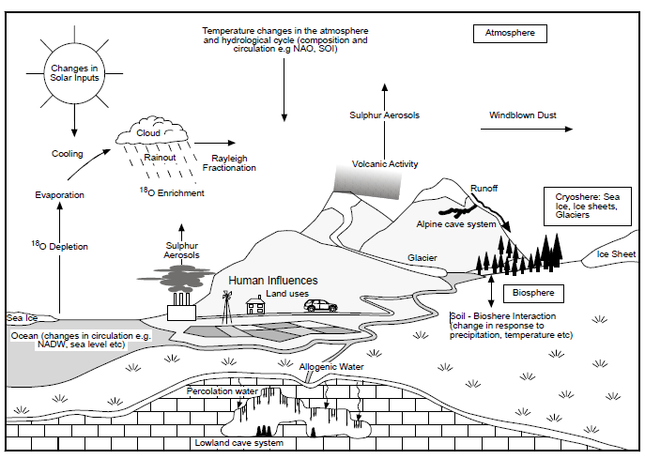
Figure 2.1: Diagram showing the processes which affect δ¹⁸Op (From Fairchild et al. 2006).
i) Rayleigh distillation
Rayleigh distillation is a fractionation process whereby lighter isotopes evaporate faster than heavier ones. It is a predominantly temperature dependent process which causes the removal of moisture from an air mass. When a vapour mass moves to a colder region, it causes the mass to condense and equilibrium fractionation to occur removing heavy isotopes (¹⁸O and ²H from the rain water). The amount of moisture condensed is proportional to the decrease in temperature. Vapour masses may cool through orographic lifting, advection, convection, convergence and frontal lifting (Dansgaard, 1964, Rozanski et al. 1993, Lachniet 2009, Baldini et al. 2010). Rayleigh distillation may also occur as a result of the continental or rainout effect as fractionation increases with distance from source.

ii) The Temperature Effect
The temperature effect is the observed positive correlation between mean annual temperature at a site and the mean annual δ¹⁸O value of precipitation (dδ¹⁸Op/dT), though seasonal effects on δ¹⁸Op may be apparent. δ¹⁸Op values are typically lower in winter as they have undergone enhanced depletion of ¹⁸O and ²H, due to increased Rayleigh distillation of the vapour mass and increased isotopic fractionation at colder temperatures. Values in summer are typically higher, again due to temperature-dependent fractionation (Fleitmann et al. 2004, McDermott 2003, Pape et al. 2010, Ingraham 1998).
iii) The Amount Effect
The amount effect is the observed decrease in δ¹⁸Op values with increased rainfall amount (dδ¹⁸Op/dδ) (Dansgaard, 1964, Rozanski et al. 1993, Lachniet 2009). The amount effect is predominantly observed in monsoonal and tropical regions. The amount effect results in precipitation that is depleted in ¹⁸O and ²H, with increasing monthly, seasonal or annual precipitation. It is due to the preferential loss of heavier isotopes (¹⁸O) or due to isotopic exchange occurring in the rainfall as it precipitates. Higher intensity rainfall, as seen in monsoonal conditions typically have raindrops that are larger in size, these drops take longer to reach isotopic equilibrium with the surrounding ambient layer i.e. atmospheric water vapour, leading to values depleted in δ¹⁸O. These drops which take longer to equilibrate may also be affected by re-evaporation (Fleitmann et al. 2004, McDermott 2003, McDermott et al. 1999, Pape et al. 2010).
iv) The Altitude Effect
The altitude effect is the observed decrease in δ¹⁸Op values with an increase in altitude. This effect leads to depleted values of δ¹⁸Op is associated with the decrease in temperature of condensation and to the progressive Rayleigh distillation as the air mass is lifted over an orographic barrier, leading to the increased rainout and fractionation factors that result from cooler average temperatures at higher elevations (Lachniet 2009, Pape et al. 2010).

v) The Rainout Effect
The rainout or continental effect is the decrease in δ¹⁸Op values with distance from the ocean, whereby an air mass cools in temperature when reaching land leading to rainout. ¹⁸O is heavier and preferentially rains out first, leading to coastal regions typically having higher δ¹⁸O values in precipitation compared to inland regions, which typically have lower δ¹⁸Op values. However, the continental effect may be altered when the air mass moves over a large body of water, leading to the incorporation of high δ¹⁸O continental moisture (Fleitmann et al. 2004, Benjamin 2004).
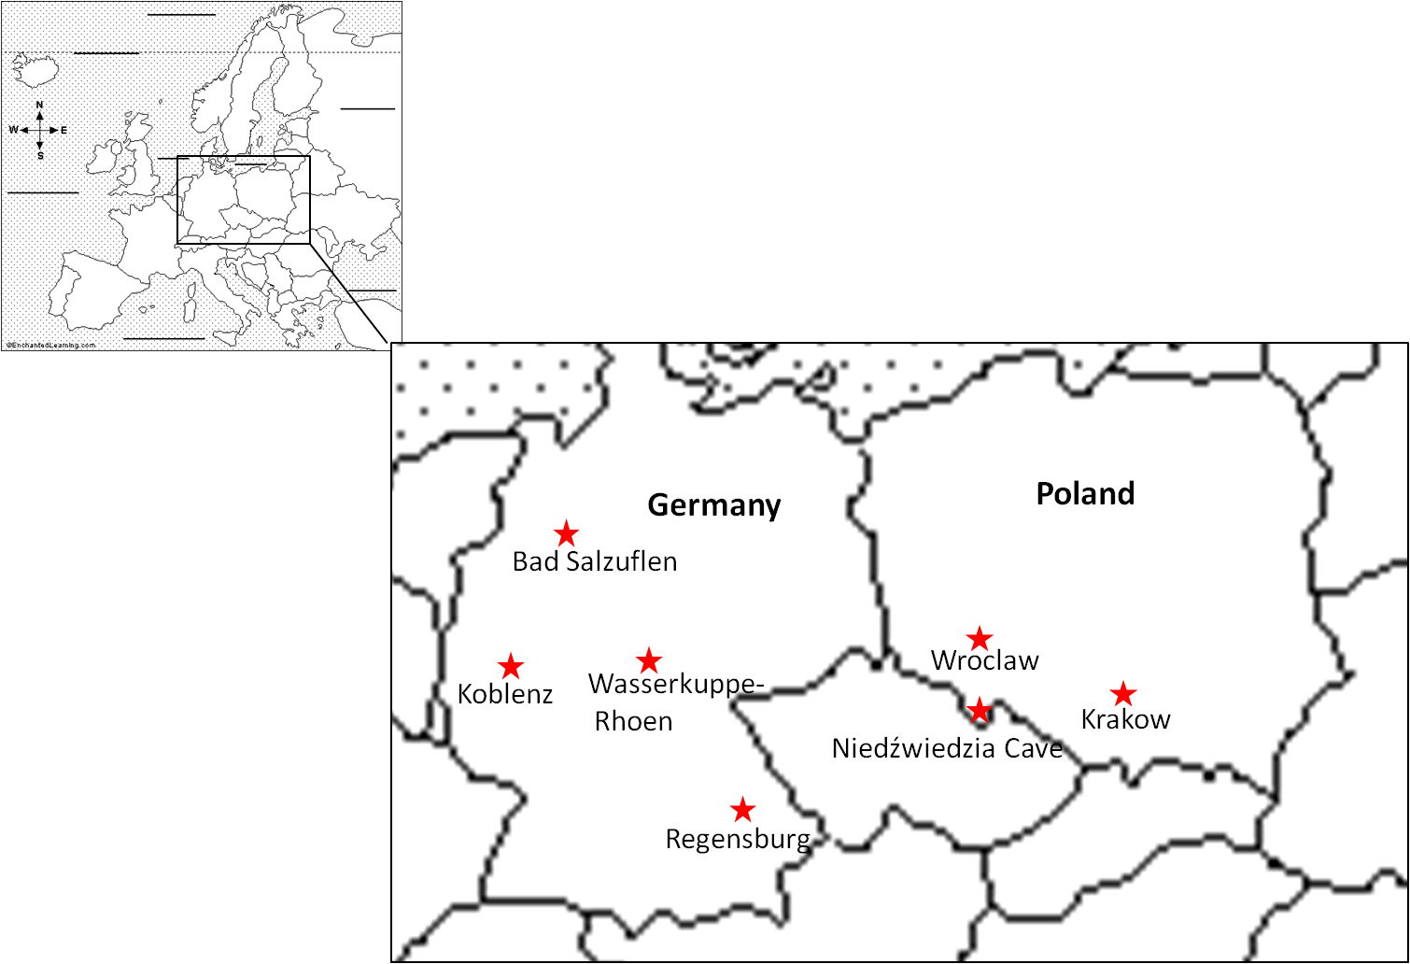
(b)
(a)
Figure 2.2: (a) Map of Europe showing inset box of site locations, (b) GNIP, Górka event and Niedźwiedzia cave sampling locations. GNIP: Bad Salzuflen (N52° 6.00’, E8° 43.48’), Koblenz (N50° 21.00’, E7° 34.48’), Wasserkuppe Rhoen (N50° 30.00’, E9° 57.00’), Regensburg (N49° 1.48’, E12° 6.36’) (Germany), Krakow (N50° 3.36’, E19 50.24’)(Poland); Górka: Wrocław (N51° 6.00’, E16° 53.00’)(Poland); Niedźwiedzia cave (N50˚17.823’, E16˚52.385’) (Poland), area above Germany and Poland filled by dots indicates North Sea and Barents Sea.

    - The North Atlantic Oscillation
A secondary purpose of this chapter was to investigate the relationship between δ¹⁸Op and the North Atlantic Oscillation (NAO) (Figure 2.3). The NAO (Figure 2.3) is one of the leading controls on atmospheric variability in the Northern Hemisphere (Hurrell 1995) and is closely linked with δ¹⁸Op in central Europe, as observed by a significant correlation between rainwater δ¹⁸O and the NAO index (Baldini et al. 2008, 2010).
The NAO, which is associated with changes in the surface westerlies across the Atlantic onto Europe, refers to a “meridional oscillation in atmospheric mass with centers of action near the Icelandic low and the Azores high” (Cook 2003, Hurrell et al. 1997). Although it is evident throughout the year, it is most distinct during boreal winter months (winter months of the Northern Hemisphere: December, January, February and March (DJFM)) when the atmosphere is most dynamically active and accounts for more than one-third of the total variation of the sea level pressure (SLP) field over the North. Oscillations in the NAO cause changes in wind speed and direction over the Atlantic (Figure 2.3 a), affecting the transportation of heat and moisture. As the signature of the NAO is strongly regional, a simple index of the NAO can be defined as the difference between the normalized mean winter (December–March) SLP anomalies at Lisbon, Portugal and Stykkisholmur, Iceland (Figure 2.3 b; Hurrell, 1995, 2003, Cook 2003, Jones et al. 1997). Positive NAO index (NAOI) winters are typically warmer and wetter in northern Europe due to the enhanced westerly flow across the North Atlantic. Storm tracks during boreal winter connect the North Pacific and North Atlantic basins; positive NAO winters are associated with a northeastward shift in Atlantic activity, with more intense and frequent storms around Iceland and the Norwegian Sea (Hurrell 1997). Conversely, negative NAOI winters are cooler and dryer in northern Europe, due to a repression of the westerly flow (Hurrell 1995, Baldini et al. 2008). Gillet et al. (2003) have found that there is a trend in recent decades towards an increase of the boreal winter NAO index which corresponds to lower SLP values over the Arctic and increased SLP values over the subtropical Atlantic. Alterations in the NAOI may be due to a number of responses, including natural variability, internal forcing from greenhouse gases or increased levels of CO₂ (Graf et al. (1995), or potentially external forcing; such as the influence of other circulation teleconnections such as the Quasi-Biennial Oscillation (QBO), Atlantic Meridional Overturning Circulation (AMOC), Pacific El Nino Southern Oscillation (ENSO) (Marshall et al. 2001). Palmer (1999) postulated that an increase in greenhouse gases may be a contributor to the observed upward trend in boreal winter NAOI (Gillet et al. 2003).
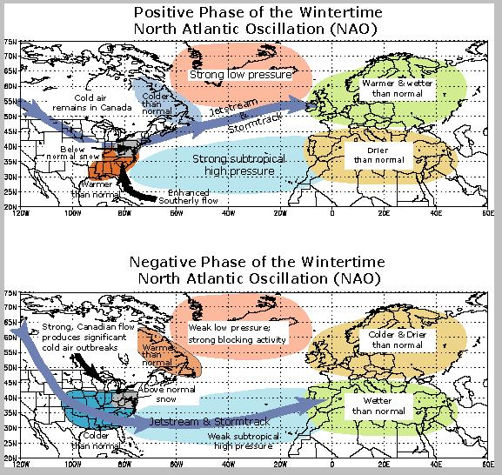
(a)
(b)
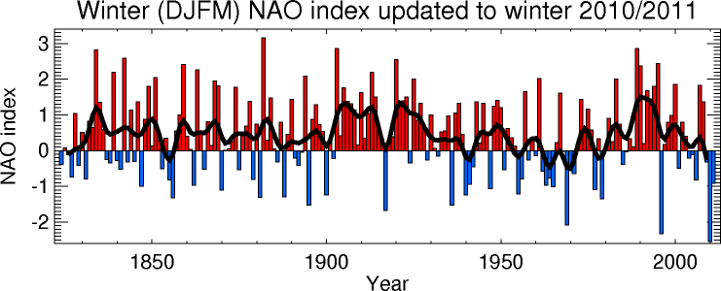
Figure 2.3: (a) Positive and negative phase of the North Atlantic Oscillation (http://www.nc-climate.ncsu.edu/edu/k12/.NAO), (b) The NAOI updated to winter 2010/2011 (Jones et al. 1997).
2.2 Methods
The investigation of isotopic controls was carried out by measuring the stable isotopes ratios of drip-water and rainwater data from Niedźwiedzia cave, and by examining recorded precipitation data from a number of GNIP sites and from event data (Górka et al. 2008) (Figure 2.2). The Niedźwiedzia Cave samples are utilized to investigate whether the drip-water samples are representative of meteoric precipitation above the cave, or whether they were affected by karst hydrology. Due to the abundance of data from a wide assortment of sources utilized within this study (including GNIP, MET, drip-water etc.), it was decided to focus the analysis of the GNIP section on “anomaly data”, which were statistically determined. Back trajectory analyses were then carried out on the Górka and anomaly data to determine the air mass source and determine whether this factored into any anomalous behavior.

2.2.1 Data sites: Niedźwiedzia Cave, GNIP sites and Wrocław
2.2.1.1 Niedźwiedzia Cave

Precipitation samples were collected over a one year period (May 2009-August 2010) on a monthly basis from Niedźwiedzia Cave, southern Poland. Samples were collected using a purpose built precipitation sampling station (Figure 2.4). The precipitation station consisted of a 5L Nalgene high-density polyethylene (HDPE) carboy with spigot equipped with a 19.7cm diameter funnel to collect monthly precipitation. In accordance with GNIP precipitation collection guidelines, a thick layer (0.5cm) of medicinal liquid paraffin was placed in the monthly collection vessel (5L in size) to minimize evaporation. At the end of each month, prior to the collection of samples, the monthly water container was gently agitated to mix the contents without incorporating the paraffin; samples were then transferred into 8ml Nalgene bottles. The 5L collection bottles were then emptied, cleaned, and refilled with paraffin when necessary, to be used again the following month.
Samples were kept refrigerated prior to analysis on a Los Gatos Liquid Water Isotope Analyzer (LWIA) instrument at Durham University. Isotopes were measured relative to Vienna Standard Mean Ocean Water (VSMOW) in units of per mil (‰). The instrument precision of the LWIA is >0.5‰ for δD and >0.1‰ for δ¹⁸O.
In addition to precipitation collection, automated drip counters were also used at the cave site (Figure 2.4). “Stalagmates” were emplaced under the active drip sites where stalagmites Nied08-02, Nied08-04 and Nied08-05 were taken. The Stalagmate monitors are activated every time a drop hits the detection lid, once this “impulse” is recognised the data is then immediately recorded on connected Gemini data loggers. “Pluvimates” rain gauges were also used at the cave. Pluvimates are more sensitive than conventionally used tipping bucket rain gauges, as they can measure instantaneous rain events rather than recording rain data at fixed volume increments. Automated monitors are preferred as they are very high resolution, measuring up to 5 drops per second and can be pre-programmed to the user’s desired settings i.e. time resolution (Collister and Mattey 2008).

Due to the difficulty in reaching the Nied08-02 sample location, it was decided that after the initial site visit, only three months of monitoring would be carried out for this site. Niedźwiedzia cave is discussed in detail in Chapter 3 “Palaeoclimate reconstruction in southern Poland using low-uranium stalagmites from Niedźwiedzia (Bear) cave, Poland”.
(b)
(a)
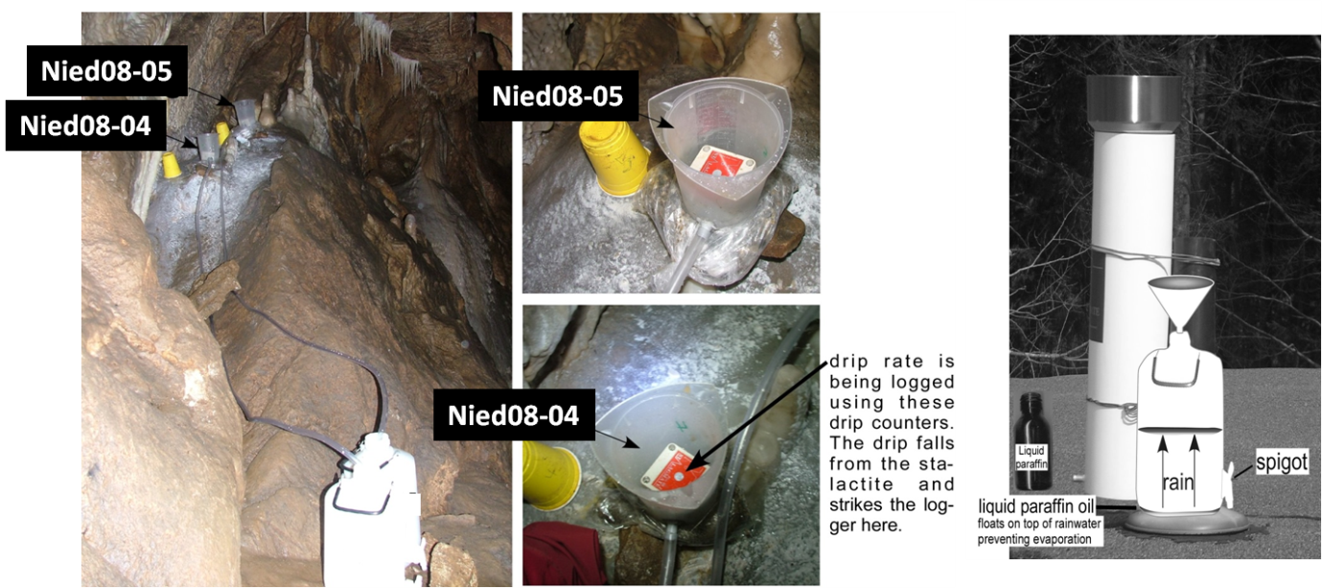
Figure 2.4: (a) Rainwater collection apparatus and (b) Precipitation sampling site and automated drip monitors for Nied08-04 and Nied08-05, Niedźwiedzia cave, southern Poland (put in place by L. and J. Baldini in May 2009). Figure from L. Baldini personal communication.
2.2.1.2 GNIP data
Monthly precipitation data are available from a multitude of published database sources including the Global Network of Isotopes in Precipitation (GNIP), the National Climate Data Center (NCDC), the National Oceanic and Atmospheric Administration (NOAA) and many online sources such as www.wunderground.com. The main source of precipitation data in this study is GNIP data. The GNIP network which is jointly operated by the International Energy Agency (IAEA) and the World Meteorological Organization (WMO) report temporal and spatial information for δ¹⁸O, δD and tritium concentrations (Araguas-Araguas et al. 2000). GNIP stations measure the isotopic composition of precipitation globally, measurements are taken monthly with the midpoint being given as the 15th. The GNIP sampling stations of interest within this study are Krakow in Poland and Regensburg, Koblenz, Wasserkuppe Rhoen and Bad Salzuflen in Germany (Figure 2.2). These sites were selected as they typically have GNIP data for a period longer than ten years and are within relatively close geographical proximity to the Polish cave site. Only δ¹⁸O and δD have been utilised within this study.

2.2.1.3 Wrocław data
Górka et al. (2008) investigated the isotopic composition of sulphates from meteoric precipitation as an indicator of pollutant origin in Wrocław, Poland. As part of their study they collected event data over a one year period from May 2004 to May 2005. The obtained data were normalized using international IAEA standards (VSMOW, VCDT, NBS 127, NBS 18 and NBS 19) (Górka et al. 2008). This data set (Table 2.1) will be used within this study as event data and is referred to as Górka event data. Events are simply defined as separate occasions of rainfall incidence over the study period.

Date | δ¹⁸O_{H2O} | δD_{H2O} | Date | δ¹⁸O_{H2O} | δD_{H2O}
 | (‰) | (‰) |  | (‰) | (‰)
25.05.2004 | −8.8 | −58.1 | 08.11.2004 | −10.6 | −66.8
02.06.2004 | −0.8 | −8.3 | 17.11.2004 | −10.5 | −62.2
15.06.2004 | −3.1 | −26.9 | 06.12.2004 | −11.0 | −71
05.07.2004 | −4.0 | −24.9 | 31.12.2004 | −15.1 | −105
16.07.2004 | −3.8 | −24 | 04.01.2005 | −8.0 | −46.2
22.07.2004 | −4.6 | −28 | 07.01.2005 | −9.8 | −59.4
23.07.2004 | −7.7 | −51.1 | 27.01.2005 | −9.8 | −61.7
16.08.2004 | −11.7 | −77.7 | 01.03.2005 | −16.3 | −115.3
23.08.2004 | −3.4 | −22.8 | 10.03.2005 | −14.8 | −104.5
14.09.2004 | −4.0 | −22.5 | 14.03.2005 | −14.7 | −90.7
28.09.2004 | −2.3 | −12.8 | 23.03.2005 | −9.3 | −62.5
30.09.2004 | −5.6 | −37.1 | 11.04.2005 | −9.9 | −69.6
08.10.2004 | −6.8 | −39.3 | 04.05.2005 | −5.1 | −26.1
11.10.2004 | −6.2 | −32.7 | 11.05.2005 | −9.1 | −63.4
18.10.2004 | −12.3 | −78.4 | 20.05.2005 | −9.4 | −62.3
28.10.2004 | −6.6 | −40 | 25.05.2005 | −7.3 | −42.9

Table 2.1: Górka event data from Wrocław, Poland (Górka et al. 2008).

2.2.2 Statistical analyses
Linear regression analysis provides statistical information on the relationship between a dependent variable and one or more independent variables. In this study regression analysis was performed for a number of purposes. The two main goals were:
1): to determine the relationship between δ¹⁸O and other variables (including temperature, δD, precipitation) in order to produce p-values and r² values for all data using Excel which would determine the dominance of these variable on the δ¹⁸O values. Niedźwiedzia (Table 2.2), GNIP (Table 2.5), Górka events (Table 2.1) (Górka et al. 2008).
2): to isolate the anomalous GNIP data. This was carried out by linear regression analysis for GNIP δ¹⁸O and δD against temperature data. Outliers were identified by assuming a normal distribution; two standard deviations were used to identify the limits between where 95% of the data should lie, and records outside of these limits were labelled as ‘anomalies’. These outliers were then used in the back trajectory analysis.
Additional statistical analysis included a comparison of δ¹⁸O GNIP anomalies and monthly NAO index (NAOI) values, in order to determine whether a relationship between the datasets could be found. Monthly NAO index values (Table 2.10 for the most anomalous NAOI data: Table 2.11: for a complete list of NAOI data 1975-2010) were taken from Hurrell (1995), Jones et al. (1997), Osborn (2004) and Osborn (2006).
Spectral analyses (PAST, Hammer et al. 2001) were carried out on the monthly GNIP anomaly data and NAOI data. Spectral analysis determines whether any time related patterns can be observed within the dataset. The online program PAST was utilized for the spectral analysis; this uses the Lomb periodogram algorithm for unevenly sampled data (Press et al.1992).
A local meteoric waterline (LMWL) for Gόrka event data was produced and compared to the global meteoric waterline (GMWL) (Figure 2.13). The GMWL provides a benchmark against which regional or local waters can be compared and their isotopic composition interpreted (Craig 1961, Leng & Marshall 2004). The GMWL is an equation defined by Craig (1961) is:
δD=8.0*(δ¹⁸O) + 10 per mille
which states that the average relationship between hydrogen (δD) and oxygen isotope (δ¹⁸O) ratios in natural terrestrial waters, expressed as a worldwide average.
A local meteoric water line (LMWL) can be calculated for a given area using stable isotope data. The factors which affect the slope and intercept of this line are; differential fractionation of δD and δ¹⁸O as a function of humidity during primary evaporation of water vapour from the ocean and as a function of secondary evaporation as rain falls from cloud; isotopic fractionation of δD and δ¹⁸O during rainfall or snowfall sublimation, resulting in disproportionate enrichment of δ¹⁸O relative to δD, which leads to a lower slope for the LMWL (Benjamin 2004).
Variation of a LMWL from the GMWL can be quantified by a parameter known as the “deuterium excess” (DE). As expressed by:
DE (‰) = δD (‰)-8* δ¹⁸O (‰).
The deuterium excess depends on relative humidity. If the air mass was transferred to the atmosphere under low-humidity conditions, the air mass will have a larger DE than air masses from colder areas (e.g. Alaska 1.2), while warmer areas (e.g. Israel 23.2) will have a higher DE value (DE values taken from Rozanski et al. 1993;). DE values of less than 10% may indicate the presence of secondary evaporation at a site, as may occur when the amount effect occurs in tropical or monsoonal conditions (Araguas-Araguas et al. 2000).

2.2.3 Back Trajectory Analysis
Back trajectory analyses were made for the anomalous GNIP data and for a number Górka event data. Those discussed within this study typically have abnormally low and high δ¹⁸O and δD values. Back trajectory analysis uses the Hybrid Single Particle Lagrangian Integrated Trajectory (HYSPLIT) Model provided by the National Oceanographic and Atmospheric Administration Air Resources Laboratory (NOAA ARL; Draxler and Rolph 2003). Back trajectory analyses works by using meteorological data that has either been modeled or measured to estimate the history of an air mass to determine the most probable route over a geographical region over a specified period of time, typically in hourly steps. Back trajectories were computed for each site going back 30 days in time from the specified date of interest, using the Reanalysis data set within HYSPLIT. Back trajectory analyses in HYSPLIT provided the air mass history of each site for a specified period of time. HYSPLIT computes trajectories using synoptic scale, wind field data made from the global data assimilation system (GDAS) analysis model (Baldini et al. 2010). The HYSPLIT model used for this thesis computed backward directed trajectories, for the previous 120 hours (5 days) from the selected dates, using the Model Vertical Velocity calculation method, height was measured above mean seal level and trajectories were computed every hour to reduce computation error.

2.3 Results and Discussion
2.3.1 Niedźwiedzia Cave monitoring Data
Rainfall and drip-water monitors collected data at 15 minute intervals from Niedźwiedzia cave site from February-June 2008 (Nied08-02, Figure 2.5) and February 2008-August 2010 (Nied08-04 and Nied08-05, Figures 2.6 and 2.7). Peak rainfall during the monitoring interval (February 2008- August 2010) measured at over 1800 drops per hour in July 2009, generally spring months typically being wetter than winter months (1 drop is equal to 6 micrometres of rainfall). However, due to a lapse in recording from July 2008 to April 2009 and to the relatively short time of monitoring it is difficult to discuss seasonality in detail. Peak drip-water values were >70 drips per hour (1 drip is equal to 0.14mls, Genty and Deflandre, 1998). The baseline value of drip-water per drip site was 3.5ml for Nied08-02 and 1.4ml for Nied08-04 and Nied08-05. The similarity in drip-rate for Nied08-04 and Nied08-05 is expected as field surveys of the cave revealed that these sites were fed by a common fracture.
Comparison of the drip-water and rainfall data indicated that Nied08-04 and Nied08-05 responded quickly to meteoric precipitation events. This relationship can be seen in Figures 2.6 and 2.7, when a peak in rainfall data shows a corresponding asymptotic peak in the drip-water data; this is particularly evident in May 2008 for both Nied08-04 and Nied08-05. The rapid response to rainfall events for these sites indicates that there is a relatively minor storage component. However, at times at these sites, a peak in drip-water data does not correspond to rainfall data; in these instances the increase in drip-rate may be a response to other events such as snow melt. Nied08-05 drip-water data shows some suspected erroneously high data values; therefore it is better to focus an examination of the data for the period of February-June 2008 which displays the rapid response to rain events. Nied08-02 does not display a quick response to rainfall events (Figure 2.5). The drip-water data for Nied08-02 has a baseline value of ~25 drips/ hour with a maximum drip-rate of 70 drips/ hour. This reduced variability as compared to the other sites (~10 to >70 drips/ hour) and the lack of rapid response to rain events indicates that there is a larger storage component at this site. This longer storage capacity may provide low frequency variability data.

Figure 2.5: Monthly drip-water (Stalagmate) and rainfall (Pluvimate) data for Nied08-02 from February to June 2008

Figure 2.6: Monthly drip-water and rainfall data for Nied08-04. Upper panel: February 2008-August 2010, the entire span of monitoring. Lower panel: February-June 2008, the same period of monitoring time as Nied08-02, this section clearly shows the drips rapid response to rainfall.

Figure 2.7: Monthly precipitation and rainfall data for Nied08-05. Upper panel: for February 2008-August 2010 for the entire span of monitoring. Lower panel: February-June 2008 same time span as Nied08-02, this clearly shows the drips rapid response to rainfall.

2.3.2 Niedźwiedzia Cave meteoric precipitation and drip-water samples
Monthly meteoric precipitation (Table 2.2) and drip-water (Table 2.3) samples were collected from above and within Niedźwiedzia cave, respectively. They were then analysed for δ¹⁸Op and δD on a LWIA instrument at Durham University. Data were measured relative to Vienna Standard Mean Ocean Water (VSMOW) in units of per mil (‰).

2.3.2.1 Meteoric precipitation data
The 11 sampled precipitation δ¹⁸O results collected from May 2009 to August 2010 ranged in value from 10.73 to -3.23‰. Unfortunately information from November and December was not available, so it is difficult to evaluate the data in terms of seasonality. Generally the δ¹⁸O values decrease in colder months or when spring snow melt may have occurred. It must be noted that the meteoric precipitation results are cumulative over a one-month period so particularly influential events may have overwritten any smaller ones. The meteoric precipitation, δ¹⁸Op, data were plotted against temperature data taken from Krakow (Figure 2.8). Plotted points and temperature data were taken from the midpoint date of the collection period. On a visual basis, there does appear to be some correlation of the δ¹⁸Op and temperature data and an r² of 0.1984 (Figure 2.9 (b)) which would indicate that the δ¹⁸Op values are somewhat dependent on temperature. The δ¹⁸Op values were also plotted against precipitation (mm) data from Krakow (Figure 2.9 (a)). There was a very weak correlation (r²=0.0647) between the data which would suggest that the precipitation amount is not an important factor affecting δ¹⁸Op values above Niedźwiedzia Cave.

Bottle Label | δ¹⁸O | δD | Start Date | Finish Data
LB6 | -8.7 | ND | 10.05.2009 | 30.05.2009
LB7 | -6.1 | ND | 30.05.2009 | 30.06.2009
LB8 | -6.2 | ND | 30.06.2009 | 24.07.2009
LB11 | -10.08 | -70.12 | 24.07.2009 | 30.08.2009
LB14 | -9.79 | -70.11 | 31.08.2009 | 30.09.2009
LB17 | -9.16 | -70.57 | 01.10.2009 | 31.10.2009
LB20 | ND | ND | 01.11.2009 | 30.11.2009
LB23 | ND | ND | 01.12.2009 | 31.12.2009
LB30 | -10.73 | -74.03 | 01.03.2010 | 31.03.2010
LB33 | -7.20 | -56.27 | 01.04.2010 | 02.05.2010
LB36 | -3.23 | -26.69 | 05.08.2010 | 05.08.2010

Table 2.2: Meteoric precipitation data for Niedźwiedzia Cave, southern Poland. May 2009 to August 2010. ND= No Data.

Figure 2.8: Monthly δ¹⁸Op (‰ VSMOW) values from Niedźwiedzia Cave, with temperature data (°C) from Krakow. Plotted points are located at the midpoint of each collection interval.
(b)
(a)
Figure 2.9: Monthly δ¹⁸Op (‰ VSMOW) values from Niedźwiedzia Cave, (a) for precipitation data (mm), (b) air temperature data (°C) from Krakow.

2.3.2.2 Niedźwiedzia drip-water data
The 23 drip-water samples from Niedźwiedzia cave (May 2009-August 2010) show δ¹⁸O values that range from -10.58 to -11.41‰, with a standard deviation of 0.23‰, and a mean of -11.02‰. δD values range from -70.3 to -79.88‰, with a standard deviation of 2.53‰ with a mean of -73.39‰ (Table 2.3). Linear regression analysis for δ¹⁸O versus δD shows no correlation for the Niedźwiedzia data, with an r² of 0.0522. The δ¹⁸O drip-water values from Niedźwiedzia Cave (Figure 2.10) appear quite consistent throughout the year. This lack of large seasonal variability would imply that the cave drip-water is quite averaged over time.
Bottle Label | Sample ID | Results | Results | Start Date | Finish Data
 |  | δ18O | δD
LB1 | Nied08-04 | -11.1 | ND | 10.05.2009 | 30.05.2009
LB2 | Nied08-04 | -10.9 | ND | 30.05.2009 | 30.06.2009
LB3 | Nied08-05 | -10.9 | ND | 30.05.2009 | 30.06.2009
LB4 | Nied08-04 | -10.9 | ND | 30.06.2009 | 24.07.2009
LB5 | Nied08-05 | -10.8 | ND | 30.06.2009 | 24.07.2009
LB9 | Nied08-04 | -11.26 | -72.8 | 24.07.2009 | 30.08.2009
LB10 | Nied08-05 | -10.76 | -72.8 | 24.07.2009 | 30.08.2009
LB12 | Nied08-04 | -10.69 | -73.0 | 31.08.2009 | 30.09.2009
LB13 | Nied08-05 | -10.58 | -72.7 | 31.08.2009 | 30.09.2009
LB15 | Nied08-04 | -11.17 | -70.7 | 01.10.2009 | 31.10.2009
LB16 | Nied08-05 | -11.13 | -71.0 | 01.10.2009 | 31.10.2009
LB18 | Nied08-04 | -10.81 | -71.7 | 01.11.2009 | 30.11.2009
LB19 | Nied08-05 | -10.82 | -72.1 | 01.11.2009 | 30.11.2009
LB21 | Nied08-04 | -10.93 | -72.9 | 01.12.2009 | 31.12.2009
LB22 | Nied08-05 | -11.41 | -72.0 | 01.12.2009 | 31.12.2009
LB24 | Nied08-04 | -11.17 | -70.3 | 01.01.2010 | 31.01.2010
LB25 | Nied08-05 | -11.16 | -73.0 | 01.01.2010 | 31.01.2010
LB27 | Nied08-05 | -10.87 | -71.09 | 01.02.2010 | 28.02.2010
LB28 | Nied08-04 | -11.13 | -73.41 | 01.03.2010 | 31.03.2010
LB29 | Nied08-05 | -11.07 | -74.61 | 01.03.2010 | 31.03.2010
LB31 | Nied08-04 | -11.05 | -76.13 | 01.04.2010 | 02.05.2010
LB32 | Nied08-05 | -11.33 | -77.80 | 01.04.2010 | 02.05.2010
LB34 | Nied08-04 | -10.90 | -76.48 | 03.05.2010 | 05.08.2010
LB35 | Nied08-05 | -11.25 | -79.88 | 03.05.2010 | 05.08.2010

Table 2.3: Monthly drip-water isotope data from Niedźwiedzia Cave, southern Poland (ND= No Data).

Figure 2.10: δ¹⁸O for Niedźwiedzia Cave drip-water samples, from May 2009-2010.

The δ¹⁸O values of rainfall and drip-water data plotted close to each other in a LMWL for Niedźwiedzia Cave data (Table, 2.4, Figure 2.11). Values of δ¹⁸O and δD for rainfall are slightly more positive in comparison to drip-water results, which may be due to evaporation effects on the rainwater. The values between drip-water and meteoric precipitation are reasonably similar, if one ignores the two points which plot above and to the right of the GMWL. Assuming that the values are generally alike then it can be implied that the drip-water samples do reflect the oxygen isotopic composition of meteoric precipitation at the site. The most anomalous of the rainwater samples has δ¹⁸O and δD values of -3.23 and -26.69‰ respectively (sample LB36, Table 2.2), these values seem erroneously positive so it may assumed that there samples were affected by evaporation in the collection bottle prior to analysis. If these anomalous values were not the result of evaporation of the sample after collection, the positive value may be indicative of a seasonal effect, with summer values having more positive values. A close correlation between the meteoric precipitation and drip-water is expected for Niedźwiedzia Cave due to the rapid response of the drip-water data to rain events, as there is less time for cave hydrology to affect the isotopic composition of the drip-water.
Site | LMWL | r²
Nied08-04 | 1.3840*(δ¹⁸0) + 57.992 | 0.2783
Nied08-05 | 2.0070*(δ¹⁸0) + 52.407 | 0.3471
Niedźwiedzia Rainwater | 6.3970*(δ¹⁸0) + 7.7890 | 0.9773

Table 2.4: LMWL for Niedźwiedzia Cave drip-water and rainwater samples

Figure 2.11: LMWL for Niedźwiedzia Cave. The dashed line is the GMWL.

2.3.3 δ¹⁸O and δD GNIP and Górka data
2.3.3.1 Górka event data
Górka event (Table 2.1) δ¹⁸Op and δDp values are understandably quite variable in comparison to Niedźwiedzia data as they are for event data rather than cumulative monthly data. δ¹⁸Op values range from -16.3 to 0.8‰, with a standard deviation of 4.0‰, and a mean of -8.3‰. Event δDp values range from -115.3 to -8.3‰, with a standard deviation of 27.5‰, and a weighted mean of -53.1‰ over the period of May 2004 to May 2005. The δ¹⁸Op of the Górka data (April 2004 to May 2005) appear to show a seasonal response, with summer months typically having more positive δ¹⁸Op values (Figure 2.12).

Figure 2.12: δ¹⁸O for Górka event
A local meteoric waterline (LMWL) for Gόrka event data was produced from stable isotope data and compared to the global meteoric waterline (GMWL) (Figure 2.13). The LMWL for Górka data is expressed by the following equation
δD= 6.835*( δ¹⁸O)+ 3.109
(r²=0.9761, p=1.01E-16, n=32). There is not much variability along the LMWL compared to the GMWL (Figure 2.13), which indicates that not much fractionation has occurred for Górka meteoric precipitation. If values had plotted further to the right of the GMWL then this would indicate evaporation (Gat 1995), while colder areas would plot farther to the left.
The deuterium excess for Górka had a mean value of 13‰, there was some variability over the Górka event record with a maximum of 27‰, and a minimum was -2‰. This variability may be a reflection of seasonal conditions at the cave with higher DE values indicating warmer conditions and lower DE values reflecting colder conditions.

Figure 2.13: Local Meteoric Water Line (LMWL) for Górka event data with the Global Meteoric Water Line (GMWL). The Górka LMWL and the GMWL are similar.

2.3.3.2 GNIP data
Meteoric precipitation data were obtained from the raw monthly datasets from GNIP. These are quite extensive datasets with values of Krakow from 1975 to 2002, Koblenz 1974-2007, Bad Salzuflen 1978-2006, Regensburg 1978-2007 and Wasserkuppe Rhoen 1978-2007. To standardize the analysis, only data within the most complete interval of 1978-2002 was analysed. The average δ¹⁸O and δD values from all GNIP sites from 1978-2002 were -9.87‰ and -70.4‰, with a standard deviation of 3% and 25% respectively (Figure 2.15). All GNIP sites seem quite variable and show a positive correlation between δ¹⁸O and δD data (Table 2.9).
The Krakow δ¹⁸Op values are also variable, ranging from -19.56 to -4.56‰, with a standard deviation of 3‰ and a weighted average of -9.9‰. Krakow δDp values range from -148.7 to -30.5‰, with a standard deviation of 24.9‰, and an amounted- weighted mean of 70‰. An examination of the δ¹⁸Op values over time shows a seasonal response, with winter months typically having more negative isotopic values and summer having more positive results (Figure 2.14).
δ¹⁸Op and δDp data from 1999 were not included for Krakow as this data set was not averaged mid-month as all other GNIP datasets were. GNIP data could not be obtained for Wrocław so it is not included. The mean δ¹⁸O and δD for each GNIP site is listed in Table 2.9.
Name | Average | Std | Highest | Lowest
δ¹⁸Op (‰)
Krakow | -9.9 | 3 | -19.56 | -4.56
Koblenz | -7 | 2.6 | -21.19 | -1.06
Regensburg | -9.3 | 3.12 | -21.21 | -1.72
Wasserkuppe Rhoen | -9.3 | 2.05 | -19.1 | -4.55
Bad Salzuflen | -7.8 | 1.94 | -18.22 | -2.67
δDp (‰)
Krakow | -70 | 24.9 | -148.7 | -30.5
Koblenz | -43.37 | 19.7 | -161.2 | -9.7
Regensburg | -69.3 | 25.35 | -169.3 | -9.3
Wasserkuppe Rhoen | -63.64 | 16.19 | -143.4 | -26.7
Bad Salzuflen | -54.45 | 15.12 | -143.3 | -19.1
Table 2.5: Collated mean δ¹⁸Op and δDp values for GNIP sites of interest (1978-2002).

Figure 2.14: Monthly Krakow δ¹⁸0 1978-2002. Some seasonality is apparent with more negative results occurring in winter months, with more positive results in summer months.

LMWL were also made for the GNIP sites (Table 2.6, Figure 2.15). Similar to the Górka data there does not appear to be much variability between the GMWL and LMWL for GNIP sites.
GMWL
Figure 2.15: Collated δ¹⁸O and δD data for GNIP sites Bad Salzuflen, Regensburg, Wasserkuppe Rhoen, Germany and Krakow, Poland (1978-2002). The thick black line represents the GMWL, while the variously coloured lines represent the LMWL for each of the GNIP sites.
Site | LMWL | r²
Krakow | 7.7815*(δ¹⁸0) + 6.4151 | 0.9907
Bad Salzuflen | 7.7332*(δ¹⁸0) + 5.8649 | 0.9761
Regensburg | 8.1036*(δ¹⁸0) + 6.6490 | 0.9760
Wasserkuppe Rhoen | 7.8348*(δ¹⁸0) + 9.1353 | 0.9821
Koblenz | 7.6714*(δ¹⁸0) + 2.4788 | 0.9751

Table 2.6: The equations which define the LMWL for the GNIP sites.

2.3.4 Linear regression
Linear regression analysis performed on the raw GNIP data and on Górka event data indicates that δ¹⁸O varies linearly with air temperature (Krakow r²=0.5796, p=1.9032E-209, n=333, Górka events r²=0.5524, p=1.01E-16, n=32) (Table 2.7, Figures 2.16) and δD (r²=0.5898, p=4.6E-200, n=333). Precipitaiton and temperature data from GNIP sites indicated that the δ¹⁸O in precipitation is predominantly controlled by temperature in Central Europe as seen by the correlation of data (e.g. typically r² > 0.5) (Rozanski et al. 1993, Baldini et al. 2008). This is also observed in the correlation of monthly averaged air temperature and precipitation for Krakow (Figure 2.17).
Based on both δ¹⁸O and δD records; a correlation between δ¹⁸O and δD GNIP records confirm reports from other studies which state that the δD record responds to temperature in a similar manner to δ¹⁸O (Rozanski et al. 1993).
GNIP Site | Precipitation |  | Temperature |  | δD
 | r² | P-value | r² | P-value | r² | P-value
Krakow | 0.1013 | 7.90E-118 | 0.5796 | 1.90E-209 | 0.9907 | 8.10E-17
Bad Salzuflen | 0.0724 | 3.11E-86 | 0.2459 | 1.31E-14 | 0.9761 | 1.47E-14
Regensburg | 0.0088 | 1.85E-82 | 0.5001 | 8.60E-72 | 0.9760 | 1.56E-13
Wasserkuppe Rhoen | 0.0430 | 4.51E-98 | 0.3341 | 5.20E-135 | 0.9821 | 6.35E-30
Koblenz | 0.0021 | 3.51E-63 | N/A | N/A | 0.9751 | 0.000224

Table 2.7: Summary of linear regression results between δ¹⁸O and precipitation, temperature and δD for the GNIP sites. Data was collected from 1978-2002. No temperature data was available for Koblenz.

(b)
(a)
R²=0.5524
Figure 2.16: δ¹⁸O vs. Air Temperature for (a) Krakow (1975-2002) and (b) Górka events (May-October 2004). Temperature appears to be an important control on oxygen isotope values with r² values of 0.5796 and 0.552 respectively.

(b)
(a)
Figure 2.17: Monthly averaged Krakow δ¹⁸O plotted against (a) monthly averaged precipitation and (b) monthly averaged temperature. The datasets extend from 1975-2002.
(b)
(a)
Figure 2.18: GNIP precipitation (a) and air temperature (b) data for Bad Salzuflen, Regensburg and Wasserkuppe Rhoen (Germany) and Krakow (Poland) versus monthly δ¹⁸O data (1978-2002). There is a stronger correlation between δ¹⁸O and temperature (r²= 0.4423) than precipitation and δ¹⁸O (r²= 0.0048), which would indicate that temperature is a more dominant control on isotope values.
2.3.5 Back Trajectory analysis results
Back trajectory analyses were carried out for Krakow (GNIP dataset), Wrocław (Górka event data), Poland and, and Bad Salzuflen, Koblenz, Regensburg and Wasserkuppe Rhoen (GNIP datasets), Germany.
Back trajectories were carried out for all Górka event data, however for brevity only the most anomalously positive and negative isotopic events and some examples of more “normal” or months with more average values are discussed (Table 2.8).
Back trajectory analyses for the GNIP sites were carried out using on the δ¹⁸O and δD anomalies as determined by linear regression (Table 2.9).
Date | δ¹⁸O(‰) | δD (‰)
Most “negative” anomalies
01.03.2005 | −16.3 | −115.3
31.12.2004 | -15.1 | -105
Most "positive" anomalies
02.06.2004 | −0.8 | −8.3
28.09.2004 | -2.3 | -12.8
 | "Normal"
23.07.2004 | -7.7 | -51.1
25.05.2004 | -8.8 | -58.1
04.01.2005 | -8 | -46.2
11.05.2005 | -9.1 | -63.4
Table 2.8: Górka event data used in back trajectory analysis
Site | Date | δ¹⁸O(‰) | δD (‰) | Date | δ18O (‰) | δD (‰)
 | Most “negative” anomalies |  |  | Most "positive" anomalies
Krakow | 15/02/1978 | -19.56 | -148.7 | 15/03/1989 | -5.47 | -36.9
Bad Salzuflen | 15/10/1990 | -17.37 | -127.2 | 15/10/1978 | -2.67 | -21.1
Koblenz | 15/02/1986 | -21.19 | -161.2 | 15/07/2003 | -1.06 | -12.6
Regensburg | 15/02/2005 | -21.21 | -169.3 | 15/06/2000 | -1.72 | -9.3
Wasserkuppe Rhoen | 15/01/1985 | -13.43 | -95.8 | 15/06/2003 | -4.55 | -26.7
Table 2.9: The most anomalously positive and negative values of δ¹⁸O and δD for GNIP sites of interest as determined by linear regression analysis.
Back trajectory analysis of the Górka event data revealed that the months having noticeably negative isotope values typically have a moisture source origin from the Atlantic and Scandinavia. Back trajectories were carried out for the 30 days preceding the Górka event. This is the case for the two most negative isotope events 01/03/05 which had a source from the North Atlantic, and 31/12/04 which had a Scandinavian moisture origin (Figure 2.19 (c) and (d)). Isotopes sourced from the North Atlantic and from Scandinavia typically have depleted oxygen isotope values, but these more anomalous depletions may have been exacerbated by the continental and temperature effects; or potentially by the type of precipitation with snow having more depleted oxygen isotope values than rain. Weather information for 01/03/05 revealed that the average temperature on that date was -6°C and that snow fell, which could partially explain this month’s negative isotopic values of -16.3‰ (δ¹⁸O) and -115‰ (δD). The more positive months typically had a moisture source from the Mediterranean (28/09/04) or from an easterly source (02/06/04). These positive values are also partially a response to seasonal conditions with summer months having more positive values as compared to negative winter values as a response to Rayleigh distillation or the temperature effect, or as a response to continental or rainout effects as the air mass has less land to travel over to reach Wrocław providing less opportunity for the heavier isotopes to rain out of the air mass (Figure 2.19 (a) and (b)). Mediterranean sourced air masses are commonly enriched in isotopes as compared to the Baltic Sea (Figure 2.22). The “normal” Górka event months, which are months that had isotope values near the mean of the Górka data set, typically had a source trajectory from the North Atlantic as evidenced from the back trajectory analysis. The mean δ¹⁸O and δD values for Górka were -8.3‰ and -53.1‰ respectively. These values are likely a response to continental effects due the geographical location of the site being inland, and away from any large bodies of water which may allow for re-evaporation of the air mass before reaching Wrocław (Figure 2.20).
From the GNIP back trajectory analyses, anomaly data that had particularly high δ¹⁸O and δD values, similar to the Górka event data tended to have an air trajectory originating from the south (Figure 2.21 (a)). This may be due to a Mediterranean sourced air mass having initially higher δ¹⁸O values than those typically westerly sourced from the North Atlantic Ocean (Figure 2.22). Another factor could be the reduced travel time from the Mediterranean compared to air masses sourced from the Atlantic, which meant that the air mass was less influenced by the rainout effect, which resulted in Krakow precipitation having higher levels of ¹⁸O meaning a less negative δ¹⁸O.
Anomaly data with abnormally low values of δ¹⁸O were most likely the result of a number of factors such as amount, latitude and rainout effects. The sites of interest in this study typically have quite low values of δ¹⁸O compared to typical European meteoric precipitation which may arise as a result of enhanced continental or rainout effects due to their inland location as opposed to sites located near the Atlantic; this is observed on comparison of the study by Baldini et al. (2010) which reported their most negative values of -13.9‰ (δ¹⁸Op) and -107.9‰ (δDp) for Irish event data with the mean of the most negative GNIP values in this study with values of -19.86‰ (δ¹⁸Op) and -153.18‰ (δDp). In months with particularly negative δ¹⁸O values, rainout and the amount effect are apparent causes for the irregularities. In these cases, MET data indicated that there was a high amount of rainfall in a short period of time which may have caused an amount effect, with a further reduction of δ¹⁸O caused by latitude and altitude effects (Figure 2.21 (b)).
One point of note when examining the back trajectory plots for the GNIP anomaly and Górka event data is that many of the months which are abnormally negative show trajectories sourced from a southerly direction, while some positive months appear to have a North Atlantic source; while this appears to be contradictory to above explanations it must be highlighted that trajectories are for the 30 days preceding either the date in question (for Górka events) or are taken from the midpoint of the month (GNIP data sets). Hence, the summaries provided for these analyses are the results of an entire 30 days of trajectories rather than one specific date. However, it is very possible that a negative anomaly month may have a Mediterranean source while a positive month may have an Atlantic sourced air mass, in these cases then the temperature effect is the dominant influence on the precipitation values.

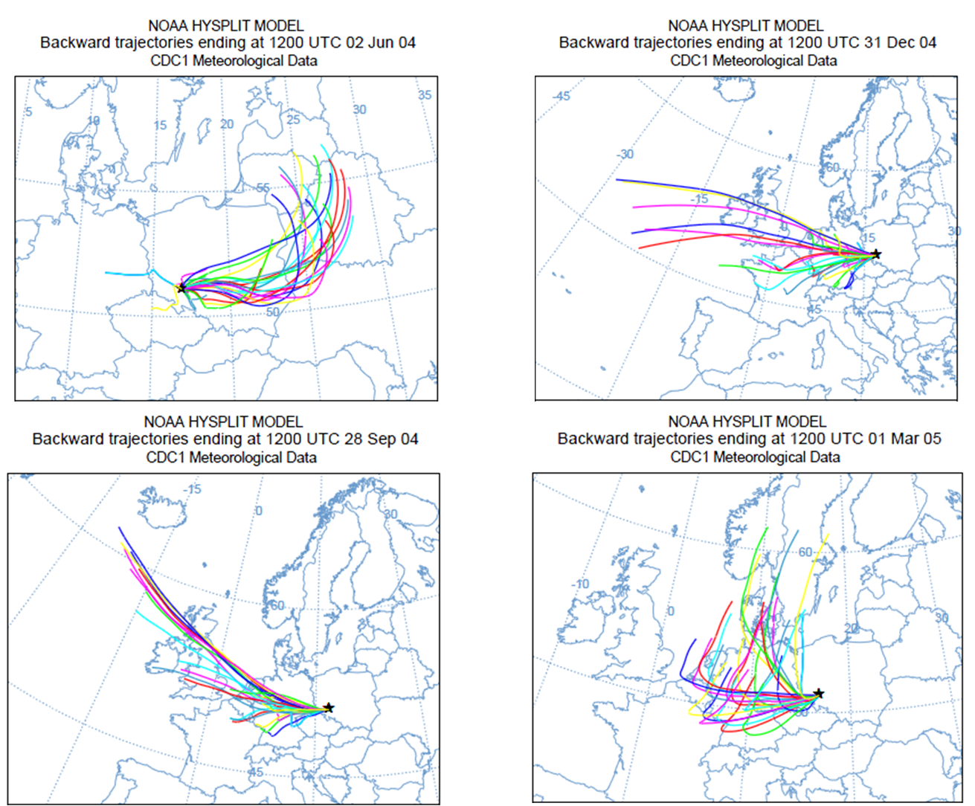
(c)
(a)
(b)
(d)
Figure 2.19: Górka trajectories for the most anomalous data. (a) 02/06/04 and (b) 28/09/04 are examples of the most “positive” Górka data, while (c) 31/12/04 and (d) 01/03/05 are examples of the most “negative” Górka event data. While the trajectories for some of the positive (b) and negative (c) months appear to be from the same source region, i.e. the North Atlantic, when this occurs the source region is less important than the temperature effect, as these abnormally negative or positive results are most likely a response to seasonal variations.
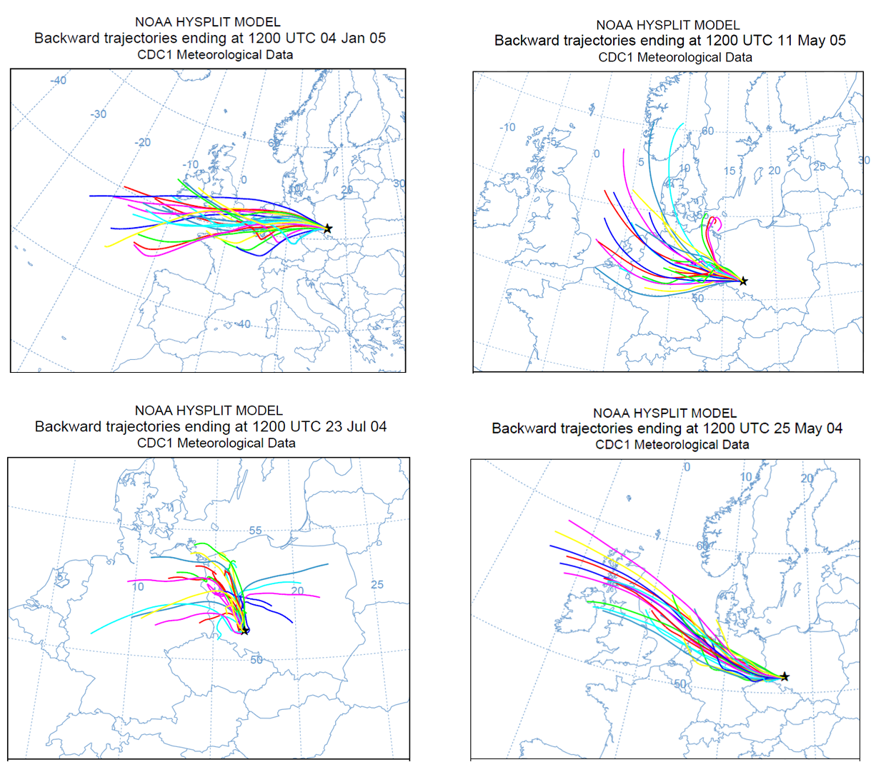
(d)
(c)
(a)
(b)
Figure 2.20: Back trajectories for the most “normal” Górka events. (a) 04/01/05, (b) 23/07/04, (c) 11/05/05 and (d) 25/05/04
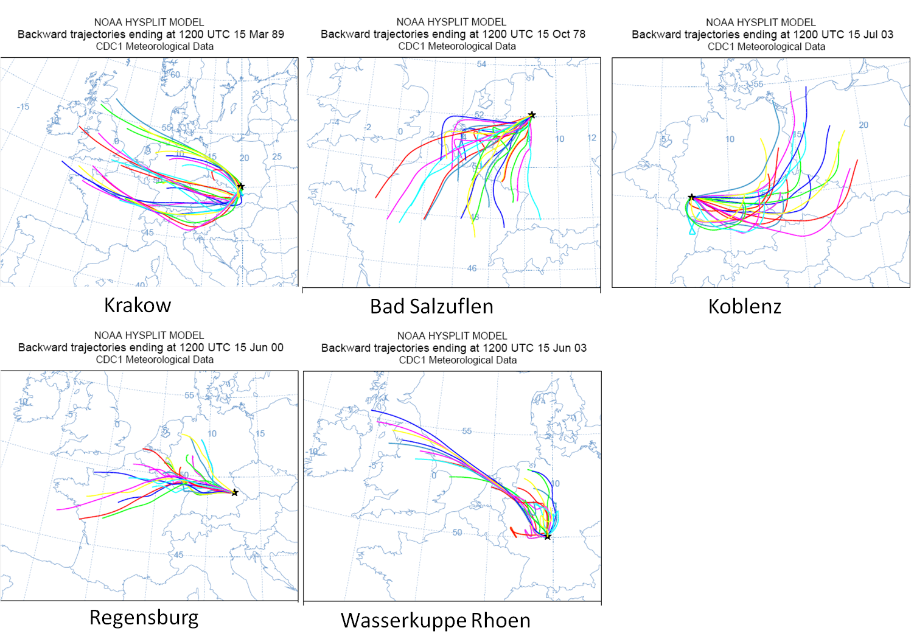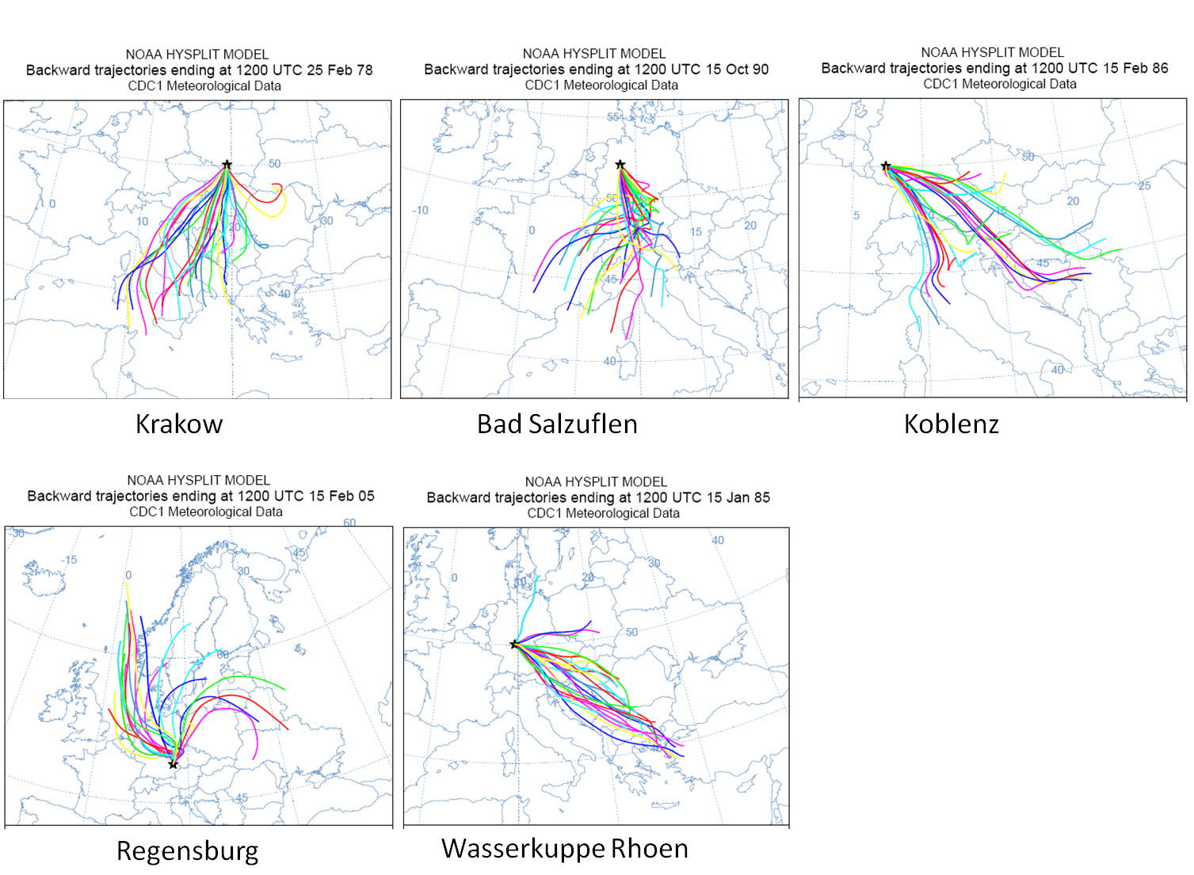
(b)
(a)
Figure 2.21: Anomaly back trajectories from GNIP data (a) displays the more isotopically positive GNIP months, while (b) displays trajectories for the more isotopically negative GNIP months.
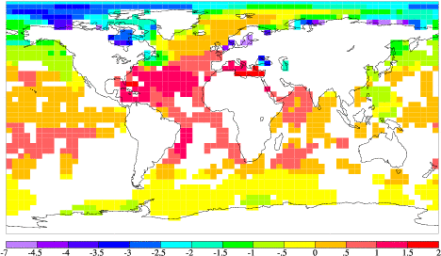
Figure 2.22: Map showing the relative δ¹⁸O (‰ VSMOW) values and variations in world oceans and seas (Schmidt et al. 1999). The Mediterranean is generally very positive, whereas the Baltic Sea is quite negative in δ¹⁸O.

2.3.6 Isotope data and the NAO and QBO
The anomaly GNIP data and Górka data were compared on a monthly basis to the NAO index (NAOI) (Tables 2.10 and 2.11) by using a running correlation to see whether any particularly negative or positive monthly dated could be related to the monthly NAOI (Figure 2.23). A correlation is apparent when peaks are above the zero line, while troughs below the zero line indicate an anti-correlation between the datasets of δ¹⁸O and NAOI values. A comparison of anomalously negative or positive NAOI months with the anomalous GNIP or Górka months revealed that they correlate approximately 50% of the time. To further investigate this, the entire monthly isotope record for Krakow was compared to the monthly NAOI for the same time interval (1978-2002) (Figure 2.23). Results showed an oscillation of variable lengths alternating between a positive and negative correlation (Figure 2.24).
Spectral analysis of the monthly Krakow δ¹⁸O correlation data with monthly NAOI was carried out to see if any temporal patterns could be distinguished. The analysis identified a number of significant peaks .The strongest, peak 3 (Figure 2.24) has a frequency value of approximately 0.04 which in terms of the data correlates to a cycle roughly two years in length (1/0.04= 25 months). This two year cycle is mostly likely related to the Quasi-Biennial Oscillation (QBO) which typically runs for 28 months. Spectral analysis for the other GNIP sites (Appendices 2.5-2.8) revealed cycles which correspond from 25 months to 33 months, so it is likely that the QBO is also a strong influence at these sites. Figure 2.25 plots the Krakow δ¹⁸O-NAOI correlation with QBO data to see whether there is any correlation between these data. This showed an oscillation between the NAO and QBO correlating positively and negatively. This suggests that the relationship between the NAO and the QBO is variable through time and that other yet unidentified factors control the polarity of the relationship between the two. This unidentified forcing mechanism(s) may involve teleconnections with other large scale circulation systems such as the East Asian Monsoon, Scandinavian pattern, or the Pacific Decadal Oscillation.
The QBO is an oscillation, lasting approximately 2 years in length, of zonal wind which dominates variability in the stratosphere above the equator (Figure 2.26). It is characterised by the downward propagating easterly and westerly mean wind regimes of the zonal mean winds in the equatorial stratosphere (Alexander and Holton 1997). The westerly phase is generally shorter and faster than the easterly phase. The cycle length typically has a mean period of 28 to 29 months (Baldwin et al. 2001). The QBO is largely a tropical phenomenon as equatorial waves are generated in the troposphere and propagate upwards through the tropical stratosphere; however it alters the pole to pole stratospheric flow through the adjustment of extratropical waves (Baldwin et al. 2001, Holton and Lindzen 1972).

Year | Month | + NAO | Year | Month | -NAO
1976 | August | 1.92 | 1978 | February | -2.2
1978 | October | 1.93 | 1980 | August | -2.24
1986 | November | 2.29 | 1987 | June | -1.82
1989 | March | 1.85 | 1993 | July | -3.18
1989 | September | 2.05 | 1998 | June | -2.72
1992 | April | 1.86 | 2002 | October | -2.28
1992 | May | 2.63 | 2005 | March | -1.83
1993 | November | 2.56 | 2006 | October | -2.24
1994 | December | 2.02 | 2009 | July | -2.15
 |  |  | 2009 | December | -1.93
 |  |  | 2010 | February | -1.98

Table 2.10: A list of the most anomalously “negative” and “positive” NAO index values from 1975 to 2010 (Hurrell 1995, Jones et al. 1997, Osborn 2004).

Year | Jan | Feb | Mar | Apr | May | Jun | Jul | Aug | Sept | Oct | Nov | Dec
1975 | 0.58 | -0.62 | -0.61 | -1.6 | -0.52 | -0.84 | 1.55 | -0.26 | 1.56 | -0.54 | 0.41 | 0
1976 | -0.25 | 0.93 | 0.75 | 0.26 | 0.96 | 0.8 | -0.32 | 1.92 | -1.29 | -0.08 | 0.17 | -1.6
1977 | -1.04 | -0.49 | -0.81 | 0.65 | -0.86 | -0.57 | -0.45 | -0.28 | 0.37 | 0.52 | -0.07 | -1
1978 | 0.66 | -2.2 | 0.7 | -1.17 | 1.08 | 1.38 | -1.14 | 0.64 | 0.46 | 1.93 | 3.04 | -1.57
1979 | -1.38 | -0.67 | 0.78 | -1.71 | -1.03 | 1.6 | 0.83 | 0.96 | 1.01 | -0.3 | 0.53 | 1
1980 | -0.75 | 0.05 | -0.31 | 1.29 | -1.5 | -0.37 | -0.42 | -2.24 | 0.66 | -1.77 | -0.37 | 0.78
1981 | 0.37 | 0.92 | -1.19 | 0.36 | 0.2 | -0.45 | 0.05 | 0.39 | -1.45 | -1.35 | -0.38 | -0.02
1982 | -0.89 | 1.15 | 1.15 | 0.1 | -0.53 | -1.63 | 1.15 | 0.26 | 1.76 | -0.74 | 1.6 | 1.78
1983 | 1.59 | -0.53 | 0.95 | -0.85 | -0.07 | 0.99 | 1.19 | 1.61 | -1.12 | 0.65 | -0.98 | 0.29
1984 | 1.66 | 0.72 | -0.37 | -0.28 | 0.54 | -0.42 | -0.07 | 1.15 | 0.17 | -0.07 | -0.06 | 0
1985 | -1.61 | -0.49 | 0.2 | 0.32 | -0.49 | -0.8 | 1.22 | -0.48 | -0.52 | 0.9 | -0.67 | 0.22
1986 | 1.11 | -1 | 1.71 | -0.59 | 0.85 | 1.22 | 0.12 | -1.09 | -1.12 | 1.55 | 2.29 | 0.99
1987 | -1.15 | -0.73 | 0.14 | 2 | 0.98 | -1.82 | 0.52 | -0.83 | -1.22 | 0.14 | 0.18 | 0.32
1988 | 1.02 | 0.76 | -0.17 | -1.17 | 0.63 | 0.88 | -0.35 | 0.04 | -0.99 | -1.08 | -0.34 | 0.61
1989 | 1.17 | 2 | 1.85 | 0.28 | 1.38 | -0.27 | 0.97 | 0.01 | 2.05 | -0.03 | 0.16 | -1.15
1990 | 1.04 | 1.41 | 1.46 | 2 | -1.53 | -0.02 | 0.53 | 0.97 | 1.06 | 0.23 | -0.24 | 0.22
1991 | 0.86 | 1.04 | -0.2 | 0.29 | 0.08 | -0.82 | -0.49 | 1.23 | 0.48 | -0.19 | 0.48 | 0.46
1992 | -0.13 | 1.07 | 0.87 | 1.86 | 2.63 | 0.2 | 0.16 | 0.85 | -0.44 | -1.76 | 1.19 | 0.47
1993 | 1.6 | 0.5 | 0.67 | 0.97 | -0.78 | -0.59 | -3.18 | 0.12 | -0.57 | -0.71 | 2.56 | 1.56
1994 | 1.04 | 0.46 | 1.26 | 1.14 | -0.57 | 1.52 | 1.31 | 0.38 | -1.32 | -0.97 | 0.64 | 2.02
1995 | 0.93 | 1.14 | 1.25 | -0.85 | -1.49 | 0.13 | -0.22 | 0.69 | 0.31 | 0.19 | -1.38 | -1.67
1996 | -0.12 | -0.07 | -0.24 | -0.17 | -1.06 | 0.56 | 0.67 | 1.02 | -0.86 | -0.33 | -0.56 | -1.41
1997 | -0.49 | 1.7 | 1.46 | -1.02 | -0.28 | -1.47 | 0.34 | 0.83 | 0.61 | -1.7 | -0.9 | -0.96
1998 | 0.39 | -0.11 | 0.87 | -0.68 | -1.32 | -2.72 | -0.48 | -0.02 | -2 | -0.29 | -0.28 | 0.87
1999 | 0.77 | 0.29 | 0.23 | -0.95 | 0.92 | 1.12 | -0.9 | 0.39 | 0.36 | 0.2 | 0.65 | 1.61
2000 | 0.6 | 1.7 | 0.77 | -0.03 | 1.58 | -0.03 | -1.03 | -0.29 | -0.21 | 0.92 | -0.92 | -0.58
2001 | 0.25 | 0.45 | -1.26 | 0 | -0.02 | -0.2 | -0.25 | -0.07 | -0.65 | -0.24 | 0.63 | -0.83
2002 | 0.44 | 1.1 | 0.69 | 1.18 | -0.22 | 0.38 | 0.62 | 0.38 | -0.7 | -2.28 | -0.18 | -0.94
2003 | 0.16 | 0.62 | 0.32 | -0.18 | 0.01 | -0.07 | 0.13 | -0.07 | 0.01 | -1.26 | 0.86 | 0.64
2004 | -0.29 | -0.14 | 1.02 | 1.15 | 0.19 | -0.89 | 1.13 | -0.48 | 0.38 | -1.1 | 0.73 | 1.21
2005 | 1.52 | -0.06 | -1.83 | -0.3 | -1.25 | -0.05 | -0.51 | 0.37 | 0.63 | -0.98 | -0.31 | -0.44
2006 | 1.27 | -0.51 | -1.28 | 1.24 | -1.14 | 0.84 | 0.9 | -1.73 | -1.62 | -2.24 | 0.44 | 1.34
2007 | 0.22 | -0.47 | 1.44 | 0.17 | 0.66 | -1.31 | -0.58 | -0.14 | 0.72 | 0.45 | 0.58 | 0.34
2008 | 0.89 | 0.73 | 0.08 | -1.07 | -1.73 | -1.39 | -1.27 | -1.16 | 1.02 | -0.04 | -0.32 | -0.28
2009 | -0.01 | 0.06 | 0.57 | -0.2 | 1.68 | -1.21 | -2.15 | -0.19 | 1.51 | -1.03 | -0.02 | -1.93
2010 | -1.11 | -1.98 | -0.88 | -0.72 | -1.49 | -0.82 | -0.42
Table 2.11: NAOI values from January 1975- August 2010 (data was compiled at this date). Values highlighted in blue represent more “positive” NAOI values, whilst red indicates more NAOI “negative” values. (Hurrell 1995, Jones et al. 1997, Osborn 2004).

Figure 2.23: The thirteen point moving correlation between δ¹⁸O and NAO Index data for Krakow. Peaks with a correlation value above zero indicate a positive correlation, while those below the zero line indicate a negative correlation.
25 months

Figure 2.24: Spectral analysis of the 13-point correlation in months between the δ¹⁸O Krakow record and the NAO index, four peaks above the significance level (red lines) are identified. Peak 3 has a frequency of 0.04 which correlates with an approximate two year (25-month) cycle most likely associated with the QBO. The frequency axis is equal to 1/month (PAST, Hammer et al. 2001).

Figure 2.25: Krakow δ¹⁸O-NAOI correlation with the QBO record, the comparison displays an oscillation between positive and negative correlation.
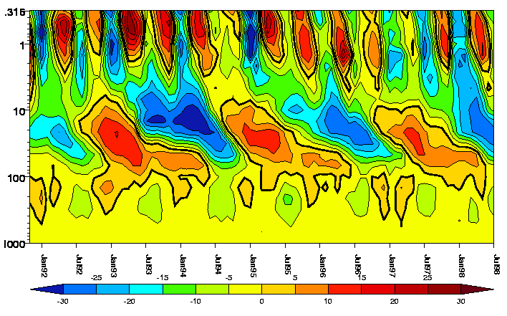
Figure 2.26: An example of the QBO (between 10mb and 100mb in height extent) The monthly zonal mean wind (m/s) against pressure (mb) from the UKMO dataset at 1.25° north of the equator. Easterlies are coloured yellow to blue; westerlies are orange to red.. (From Swinbank and O’Neill 1994).
2.4. Conclusions
The values of oxygen isotopes in meteoric precipitation may be affected by a number of processes such as Rayleigh distillation and the amount effect. This study examines precipitation samples collected from Niedźwiedzia Cave and GNIP stations in Germany and Poland. The purpose of this is to determine the factors which were most dominant at the site, which may have implications for the second part of this study (Chapter 3) in reconstructing palaeoclimate from speleothems at Niedźwiedzia Cave. This is important as oxygen isotopes are commonly used in palaeoclimate studies, so understanding the factors which affect this geochemical climate proxy is vital.
The potential controls on isotope values were evaluated by examining meteoric precipitation data for the sites of interest (Niedźwiedzia Cave, GNIP and Górka sites). The precipitation datasets were then examined using linear regression to determine values that were normal and those that were anomalous. Once these types were recognized, back trajectories were carried out to determine source history.
An examination of monthly rainwater and cave drip-water samples revealed that the cave samples were generally representative of meteoric precipitation above the cave. This was concluded after comparing the cave results with above ground records, i.e. precipitation and air temperature. Analysis of the Pluvimate and Stalagmate recorders also generally corroborate this conclusion as there is a close match between the recorders and meteoric precipitation events. The only exception to this is Nied08-02, where a time lapse is observed between the occurrence of a rainfall event and the cave data recorders recognising said event. This lag is most likely due to a change to a larger storage component for the Nied08-02 site.
The oxygen isotopic values for Niedźwiedzia Cave drip-waters did not show much variability over time; however this is most likely a consequence of the relatively short period of time monitoring cave precipitation. To further investigate this, a recommendation to continue monitoring the cave is suggested, with the addition of monthly temperature data.
The regression analysis revealed that the dominant control on isotopic values for the study sites in Poland and Germany appeared to be the temperature effect, supporting studies by Rozanski et al. (1993) and Baldini et al. (2010). Further statistical analysis of the isotope data revealed the influence of dominant European circulation patterns, the North Atlantic Oscillation (NAO) and the Quasi-Biennial Oscillation (QBO). Spectral analysis revealed a 25-month cycle in the correlation between δ¹⁸Op and NAOI data. This relatively rapid oscillation may be the result of the influence of the Quasi-Biennial Oscillation (QBO)
Back trajectories analysis of anomaly and event data revealed the importance of moisture source to the resulting isotopic composition values. Air masses with a North Atlantic or Scandinavian source were typically isotopically depleted, while Mediterranean sourced air masses were generally enriched. This is due to the combination of a number of effects such as the temperature effect, rainout effect and amount effect.

Chapter 3: Palaeoclimate reconstruction in southern Poland using low-uranium stalagmites from Niedźwiedzia (Bear) cave, Poland.

Abstract
Carbon and oxygen stable isotope profiles from three stalagmite samples from Niedźwiedzia Cave provide palaeoclimate information for southern Poland from the Last Glacial Maximum onwards. Oxygen and carbon stable isotopes results indicate some correlation with the GISP2 record, with the potential to record many climate events including the Younger Dryas Event and the Bølling-Allerød. Isotope cycles of approximately 2,000 years may reflect late Dansgaard-Oeschger and Heinrich events and their Holocene equivalent Bond events from the last glacial into the Holocene. However, low uranium content of the samples limits the accuracy and precision of the uranium series results. Dating results over the three stalagmites yield ages from 1,222-16,145 yrs BP, suggesting that calcite deposition only initiated after local climatic amelioration after the Last Glacial Maximum.

3.1 Introduction
Speleothems are now commonly acknowledged as important sources of palaeoclimate data (McDermott 2004, 2005, Richards 2003, Watanabe et al. 2010). They contain pertinent data for a number of disciplines as they can provide information on vegetation, hydrology, sea level change, water-rock interaction, solar forcing, insolation, annual temperature, rainfall variability, atmospheric circulation changes and human activity using a variety of geochemical proxies such as stable isotope ratios (e.g. δD, δ¹⁸O, δ¹³C), organic acid contents and pollen grains (Fairchild and Treble 2009, Blythe et al. 2008, Borsato et al. 2007, Genty et al. 2003, McDermott 2003, Richards and Dorale 2003, Goede et al. 1998, Dorale et al. 1992).
Speleothems are chiefly composed of macro-crystalline calcite, formed in caves through the slow degassing of CO₂ from calcite super saturated drip-water. Degassing occurs by thermodynamic equilibration as a consequence of the difference between pCO₂ of the soil and that of the cave air, typically 0.1-3.5% and 0.06-0.6% respectively (McDermott 2003). Other minerals may also occasionally precipitate in caves; aragonite may form when drip-waters have elevated Mg/Ca ratios, and is typically associated with high-Mg calcite or where the cave is developed within dolomitic host rocks. Gypsum may also be present, typically near cave entrances where evaporative effects are present. The predominant forms of speleothems are stalagmites, stalactites and flowstones, the less commonly occurring forms include rimstone pools, “rafts,” mammillary calcite wall-coatings, “dog-tooth” spar. Speleothem composition and morphology is a function of fluid flow within the cave system (Hendy 1971, Wiedner et al. 2007, Fairchild et al. 2006, Mattey 2010, McDermott 2003, Hill and Forti 1997).
The speleothem samples in this study were collected from Niedźwiedzia Cave, Poland, by Lisa and James Baldini in 2008. These samples are of relevance to palaeoclimate studies, as Poland has been recognised as a reasonable indicator of mean European values at interannual and interdecadal timescales (Luterbacher et al. 2008). This is observed from the close correlation of data between Poland and Europe, which may be due to the commonly dominant NAO circulation system (Baldini et al. 2008). Niedźwiedzia Cave speleothem samples are capable of preserving post-Last Glacial Maximum (LGM) climate as the LGM ice sheet did not extend as far as the cave (Ehlers and Gibbard 2004). The majority of proxy reconstructions carried out in Poland (Lorenc 2000, Przybylak et al. 2005 and Majorowicz et al. 2004) only extend back to 1500 AD, whereas this study has the potential to go back to over 16,000 BP. Stable isotope analysis has been carried out using a gas source mass spectrometer. Uranium series dating utilised a Neptune multi collector inductively coupled mass spectrometer (MC-ICPMS).

3.1.1 Stable Isotopes
Stable isotope studies in speleothems now typically focus on providing estimates for the timing and extent of major O-isotope-defined climatic events, such as Dansgaard-Oeschger (DO) Events or glacial/interglacial periods, characterised by high signal to noise ratios, rather than the original focus of providing palaeotemperature reconstructions (Winograd et al. 1992, Wang et al. 2001, McDermott 2004, Baldini 2010). Oxygen isotope values reflect atmospheric and hydrological processes, whereas carbon isotope values are related to the terrestrial C cycle and provide information about soil, vegetation and water availability (Spötl and Mattey 2006, Dorale et al. 2002, Johnson et al. 2006 and McDermott 2004). The ratio of ¹⁸O to ¹⁶O, or the δ¹⁸O, forms the cornerstone to the majority of palaeoclimate studies. δ¹⁸O measured from stalagmite carbonate reflects the chemistry of the rainwater and the environment at the time of deposition (Baldini 2010). From the inception of the use of speleothems as palaeoclimate indicators an important requirement has been that the isotopic equilibrium is maintained between the cave drip-water and the deposited calcite, and that kinetic fractionation has not occurred. Criteria are used to ensure that this is the case (Hendy 1971):
1: δ¹⁸O remains constant along the single growth layer while δ¹³C varies irregularly
2: no correlation occurs between δ¹⁸O and δ¹³C along that growth layer.
Hendy postulated that kinetic effects would lead to the progressive enrichment in ¹⁸O and ¹³C as the fluid moved over a stalagmite surface from the point of contact of the drip and argued testing for an absence of covariance of the isotopes along laminae or over time as a test for equilibrium deposition (Scholz and Hoffmann 2008). Dreybrodt and Scholz (2011) also specified that in order for the drip-water to impart a climatic signal on the speleothem calcite it had to have had a drip rate of less than 3000/s, otherwise the carbon and oxygen composition of the cave water may have be altered by CO₂- exchange with cave air. Speleothems formed in isotopic disequilibrium are usually formed if CO₂ degassing occurs rapidly, or if the precipitation is the result of evaporation indicated by a progressive enrichment of δ¹⁸O and δ¹³C values along individual growth layers (Wiedner et al. 2008, Polag et al. 2010).
Conditions of isotopic equilibrium may however be quite uncommon; Mickler et al. (2006) interpreted 165 speleothem isotope records and concluded that over 55% of samples had a positive correlation between δ¹⁸O and δ¹³C. There is support however for the use of speleothems formed under disequilibrium conditions, as these samples may still provide important climatic information for the time of precipitation. For instance, Mühlinghaus et al. (2007) investigated temperature and precipitation records for speleothems formed during disequilibrium conditions the results of which demonstrated the relationship between kinetic enrichment of δ¹³C related to drip rate (Wiedner et al. 2007).

3.1.2 Uranium series dating of speleothems
The predominant method of dating speleothems is uranium-series analysis (Richards and Dorale 2003). Other less commonly used methods include the measurement of visible bands, fluorescent annual bands using spectrofluorometer microscopy (Kurisaki and Yoshimura 2008), radiocarbon dating, and Electron Spin Resonance (ESR) (Muhammed et al. 2002). Uranium series dating of speleothems is based on the extreme fractionation of the parent U isotopes (²³⁸U, ²³⁵U and ²³⁴U) from their long-lived daughters ²³¹Pa and ²³⁰Th in the hydrosphere (Bourdon et al. 2003). The two most precise analytical techniques for the determination of U and Th isotope ratios are multi-collector inductively coupled plasma mass spectrometry (MC-ICP-MS) and thermal ionisation mass spectrometry (TIMS), with precisions between per mill and percent, depending on the U content and the age of the sample (Shen et al. 2001, Richards and Dorale 2003). ICP-MS is advantageous over TIMS as it has greater precision which requires smaller sample sizes which leads to faster sampling. It also allows for the use of an external standard bracketing procedure for corrections of instrumental biases (Hoffmann et al. 2007).
In order to use ²³⁰Th /U dating on speleothems a number of criteria must be met. The most desirable being that no ²³⁰Th was precipitated during the formation of the speleothem; however, if present a correction may be applied (Richards and Dorale 2003, Fensterer et al. 2010). Detrital contamination must be estimated so that this correction value can be applied; this value is based on the ²³⁰Th /²³²Th activity ratio.
For young samples with low uranium content, the MC-ICP-MS technique enables both a higher precision of ²³⁰Th/U-dating and the use of smaller sample sizes (Bourdon et al. 2003, Fensterer et al. 2010).

3.1.3 Trace element analysis
Trace elements have also been recognised for their use as palaeoclimate proxies, as they provide information regarding bioproductivity and particularly palaeohydrological conditions (Baldini, 2010). Recent high resolution studies at seasonal to annual scale, have found evidence for annual cycles in minor and trace elements (Sr, Mg, F, P, Na, Fe, Z, Si) (Fairchild et al. 2001, Treble et al. 2003, Johnson et al. 2006, Fleitmann et al. 2001, Verheyden 2005, Huang et al. 2001, Kuczumow et al. 2003). Verheyden (2005) and Smith et al. (2009) supported the idea that trace element cycles could be used to determine speleothem growth rate by cycle counting in the absence of visible laminae.
Typically speleothem trace element variations occur as a response to hydrochemical processes in the undersaturated zone overlying the cave and the partitioning at the water-calcite interface (Treble et al. 2003, 2005). Fairchild and Treble (2009) discussed the five predominant influences on trace element and indeed speleothem geochemistry, these are:
- Atmospheric input
- Vegetation/soil
- Karstic aquifer
- Primary speleothem crystal growth
- Secondary alteration
Different elements may have different environmental controls (Johnson et al. 2006). These influences may affect the trace element geochemistry directly by atmospheric and bedrock interaction, through recycling while passing through the soil zone or by response to leaching. Phosphorous (P) concentrations in samples frequently show cyclical variations which have been attributed to annual flushing events from the overlying soil and vegetation (Baldini 2010), similarly decreases in P values may indicate a reduction of overlying soil and vegetation. Strontium (Sr) and barium (Ba) tend to correlate positively with increasing calcite growth rates. Their abundances appear to be weakly dependent on the crystal growth rate and on the drip-water chemistry (Johnson et al. 2006, Lea et al. 1994, Morse et al. 1990).
Magnesium (Mg) partitioning between water and calcite appears to be temperature dependent. Some studies have suggested that the annual Mg/Ca oscillations may be caused by seasonal temperature changes (Fairchild et al. 2006, Sinclair et al. 1998, Rosenheim et al. 2004, Gascoyne 1992). Increasingly studies suggest that Mg/Ca variations are thought to reflect hydrological changes. Mg/Ca and Sr/Ca tend to increase during drier periods when residence times are longer; this may be due to enhanced prior calcite precipitation or selective leaching of Sr and Mg during weathering (Baldini 2010, Genty 1996, Fairchild et al. 2001, Treble et al. 2003). Prior calcite precipitation (PCP) has also been recognized as a potential cause of trace element cycles for some elements (e.g. Sr, Ba etc.) and in δ¹³C. Cyclicity in the latter, resulting from the preferential inclusion of ¹²C into degassed CO₂ during the process of prior calcite precipitation (Johnson et al. 2006). PCP-related enrichments in Sr and Mg have been modelled to calculate seasonal and long term variation trends for use as a palaeoaridity proxy (McMillan et al. 2005). Prior calcite precipitation occurs when the calcite-saturated drip-waters encounter a gas phase with a lower pCO₂ than that which they have previously equilibrated with (Fairchild and Treble 2009). The more calcite precipitated from solution prior to speleothem formation, the lower the Ca concentration and the higher the Mg/Ca in the resulting speleothem. This process is typically seen in summer months as a response to seasonal drying in the aquifer, the reduction of water volume and longer residence times in the karst system, leads to enhanced degassing which may occur due to low partition coefficients in the calcite of Mg and Ca (Treble et al. 2008, Fairchild and McMillan 2006).

3.2 Study area, environmental setting of the cave and sample description
3.2.1 Niedźwiedzia Cave
Niedźwiedzia (Bear) Cave (Figure 3.1 and 3.2) is located 5km south of Stronie Slaskie (Seitenberg) in the Kletno Quarry, in the Klesnica Valley of the Śnieżnik metamorphic Massif in the Sudetes Mountains, SW Poland (N50˚17.823’, E16˚52.385’). The cave is approximately 2,230m long with 147 metres of vertical extent, with a mean annual internal temperature of 6˚C. It was discovered in October 1966 during mining of the newly established Kletno III quarry. Initially, only 200 m were known, until exploration in 1982 revealed a total length of over 2 km which was developed on three main levels. The cave began to be developed for tourism in 1975 and was opened to the public in 1983. Climatological investigations conducted in the cave after its discovery in 1966 and later in the 1990s have revealed three climatic zones (Piasecki 1996): (1) the static zone includes most passages and halls in the lower and intermediate levels, (2) dynamic zones near the two entrances, and (3) transition zones between them. This study focuses on samples taken from climatic zone 1; the lower and intermediate levels.

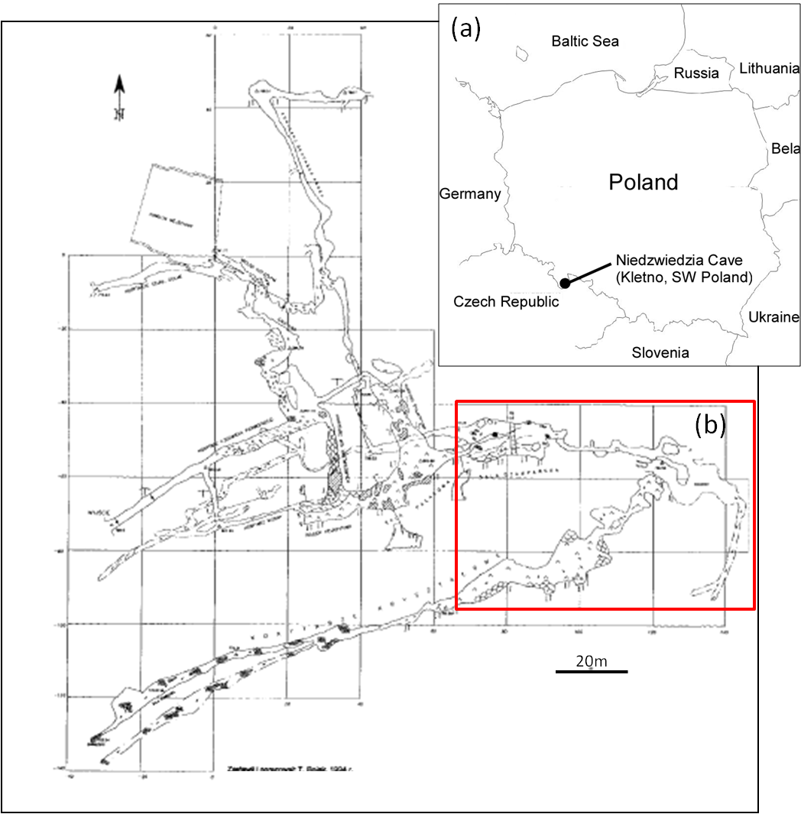
Figure 3.1: Plan of Niedźwiedzia Cave Poland (N50˚17.823’, E16˚52.385’) from Materiały 41. Sympozjum Speleologicznego (Speleological Symposium 41) 2007. Inset box (a) shows Niedźwiedzia’s geographical position. The red box (b) shows the location of Figure 3.2 in relation to the rest of Niedźwiedzia’s Cave plan.
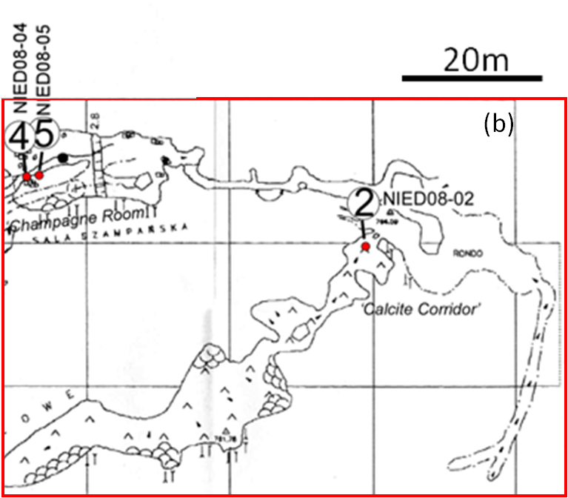
Figure 3.2: Location of speleothem samples Nied08-02, Nied08-04 and Nied08-05 from Niedźwiedzia Cave. Location in relation to the rest of the cave system, shown in Figure 3.1.
3.2.2 Speleothem samples

Stalagmite samples (Figure 3.3) were collected in 2008 from the lower level of the cave (Figure 3.2) by Lisa and James Baldini. High resolution drip rate monitoring equipment (Stalagmate©, Collister and Mattey 2008) were emplaced above each stalagmite. Stalagmate and drip- and rain-water data are discussed further in Chapter 2 of this thesis. Samples were collected if they met the following criteria:

- In-situ, active deposition
- Cylindrical morphology
- Corresponding soda straw stalactite
- White, dense calcite of low detrital content

The three stalagmite samples (Nied08-02 is in two parts; Figure 3.3) range in length from 12 to 18cm in length. The central growth axis of each stalagmite is generally vertical, with some minor switching of direction (Appendix 3.1). The samples are quite well laminated, but do not appear to display visual annual banding. The laminated bands visible within the samples range from translucent, to white opaque and finally to darker tan coloured bands which most likely contain some detrital material.

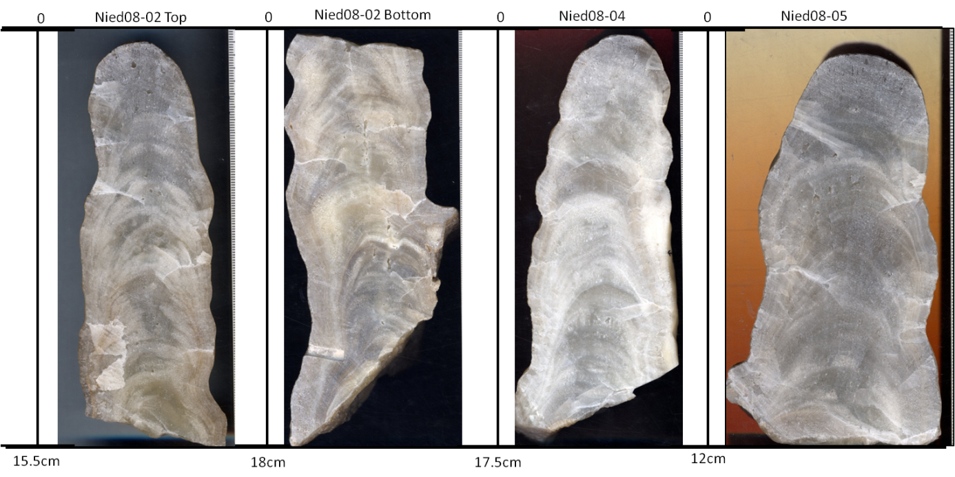
Figure 3.3: Scans of Niedźwiedzia speleothem sample slices from left to right Nied08-02 Top, Nied08-02 Bottom, Nied08-04 and Nied08-05.
3.3 Methods
3.3.1 Microdrilling

Niedźwiedzia speleothem samples Nied08-02, Nied08-04 and Nied08-05 (Figure 3.3), (Nied08-02 was broken in two so in reference to the figures the younger section is Nied08-02 Top and the older section is referred to as Nied08-02 Bottom) were microdrilled using a Proxxon Microdrill at Durham University. Powders used for carbon and oxygen stable isotope analysis were drilled at 2mm intervals with a standard drill bit of 0.3mm in diameter, to a vertical depth of approximately 2mm giving sample weights of approximately 250μg. The powders were then collected using a small scalpel, weighed and transferred into auto sampler exetainer vials. When weighing of a sample revealed the weight to be too low to be accurately measured, a duplicate sample was taken alongside the primary sample location. The drill bit, sample surface and scalpel were cleaned after each drilling using compressed air in order to prevent cross-contamination of samples. Due to the low uranium content of the stalagmites, 1g samples were obtained for uranium series dates. This process was the same as that of the stable isotope work, except a larger drill bit of 0.5mm was used in order to expedite sampling time. This microdrilling provided data at reasonable spatial resolution and at reasonably high accuracy and precision, but at a relatively slow sample throughput (Spötl and Mattey 2006, Fairchild et al. 2006, McDermott 2004, Frappier et al. 2002).

3.3.2 Isotope analysis
The number of samples for oxygen stable isotope analysis for Nied08-02, Nied08-04 and Nied08-05 were 74, 83 and 64 respectively (Please refer to Appendix 3.2 for a full list of weights, distance from Stalagmite top and measurement results). The bottom half of Nied08-02 was not drilled for stable isotope analysis due to time constraints. Samples were digested in a phosphoric acid solution and analysed in the Stable Isotope Laboratory at Durham University, using a Thermo Scientific MAT 253 Stable Isotope Mass Spectrometer System. Isotopic measurements were calibrated to NBS18 (carbonatite), NBS19 (limestone) and Durham laboratory standards LS VEC and DCS01.
3.3.3 Uranium series
The stalagmites used in this study have extremely low ²³⁰Th concentrations, thus the effect of potential contamination with initial ²³⁰Th is significantly large. An age model using uncorrected ²³⁰Th /²³⁸U activity ratios and ²³⁴U /²³⁸U activity ratios is derived from samples with low ²³²Th concentration measured with high precision MC-ICP-MS. Then the dating results of the samples with elevated ²³²Th concentration are compared with the age model to estimate the ²³⁸U /²³²Th activity ratio of the contaminating phase. This enables the derivation of a sample specific ²³⁰Th /²³²Th activity ratio for the correction (Richards and Dorale 2003).
Due to the low uranium content of the samples, approximately 1g was drilled and used for analysis. Ages were derived from a formula by Dickin (2005). Ages were initially calculated based on uncorrected ²³⁰Th /²³⁸U activity ratios and ²³⁴U /²³⁸U activity ratios and corrected ratios, using a bulk earth ²³⁸U /²³²Th activity ratio of 0.8 where decay products of detrital ²³⁸U are assumed to be in secular equilibrium.
Ten samples were drilled for uranium series dating for both Nied08-02 and Nied08-04 and 9 for Nied08-05 (Table 3.1, Figure 3.4). Uranium series analyses were performed in the School of Geological Sciences, University College Dublin on a ThermoFinnigan Neptune MC-ICP-MS and a Nu Instruments MC-ICP-MS at the Open University Uranium-Series Facility (OUUSF). Chemical preparation of the samples followed the method described in Hoffman et al. (2007) and Hoffmann (2008).
Chronologies were then derived using a best-fit spline for Nied08-02 (using the signal analysis program Autosignal) and standard best-fit linear chronologies (using Microsoft Excel) for Nied08-04 and Nied08-05 (Figures 3.5, 3.6 and 3.7).
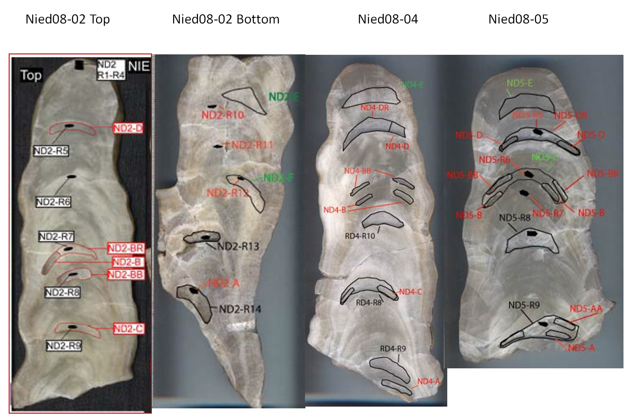
Figure 3.4: Location of uranium-series drill locations. Filled dark areas indicate initial attempts at dating, while unfilled shapes represent a second round of sampling larger amounts of material.
Nied08-02 |  | Nied08-04 |  | Nied08-05
Sample | Distance from Top | Sample | Distance from Top | Sample | Distance from Top
 | (mm) |  | (mm) |  | (mm)
ND2-D | 31.2 | ND4-E | 8.0 | ND5-E | 11.0
ND2-BR | 84.0 | ND4-D | 33.1 | ND5-D | 29.2
ND2-B | 84.0 | ND4-DR | 33.1 | ND5-DR | 29.2
ND2-BB | 96.3 | ND4-BB | 60.6 | ND5-BB | 45.0
ND2-C | 118.0 | ND4-B | 66.5 | ND5-C | 45.0
ND2-E | 170.0 | RD4-R10 | 77.0 | ND5-B | 46.1
ND2-F | 210.0 | RD4-R8 | 110.0 | ND5-R8 | 70.0
ND2-R13 | 240.0 | ND4-C | 111.5 | ND5-R9 | 107.0
ND2-R14 | 270.0 | RD4- R9 | 145.0 | ND5-AA | 109.1
ND2-A | 284.5 | ND4-A | 162.0
Table 3.1: Uranium series sample locations (distance from top of stalagmite in mm), see Figure 4 for the position of each sample.

3.3.4 Trace element analysis

Trace element analyses were then carried out on the remaining speleothem powder samples from stable isotope analysis. The number of samples run for trace element analysis was 50, 70 and 60 for Nied08-02, Nied08-04 and Nied08-05 respectively (Appendix 3.3). Samples for trace element analysis were digested in a dilute solution of nitric acid, before being analysed on a Thermo X-Series2 ICP-MS at Durham University.

3.4. Results and discussion

3.4.1 Chronology
A chronology based on the uranium series dates (Table 3.2, Figures 3.5, 3.6 and 3.7) was used as a reference point to the stable isotope and trace element data (Appendices 3.3-3.6). However, as mentioned previously, due to the extremely low uranium content of these samples the accuracy of the chronology is somewhat uncertain. The errors range from ±95 to ±3111. Uranium series dates that displayed as clear outliers (e.g. ND2-B which gave a date of 40,627 yrs BP) were removed from the data set to improve the chronology (removed samples are shown in red in Table 3.2). Another issue with the Niedźwiedzia samples that was revealed through the uranium series dating, was the high (compared to Th produced in situ) detrital contamination of the samples as revealed by the high ²³²Th content.
Figure 3.5: Autosignal best spline fit chronology for Nied08-02 (x-axis is distance from top of stalagmite, y-axis is yrs BP).

Figure 3.6: Excel linear plot chronology for Nied08-04

Figure 3.7: Excel linear plot chronology for Nied08-05

Name | Distance | ± | ²³⁴U/²³⁸U | Error | ²³⁰Th/²³⁴U | Error | ²³⁰Th/²³²Th | Error | Age (corr.) | ± (2s)
 | mm | mm |  |  |  |  |  |  | yrs BP | yrs
ND2-D | 31.2 | 2.5 | 1.1606 | 0.0071 | 0.0175 | 0.0004 | 38.866 | 1.9434 | 1927 | 95
ND2-BR | 84 | 3 | 1.155 | 0.0047 | 0.02299 | 0.0005 | 17.8468 | 0.838 | 2539 | 104
ND2-B | 84 | 1.5 | 1.159 | 0.0056 | 0.31304 | 0.0048 | 66.1785 | 2.8699 | 40627 | 1458
ND2-BB | 96.3 | 2.5 | 1.1416 | 0.0066 | 0.02896 | 0.0012 | 10.3335 | 0.6491 | 3206 | 279
ND2-C | 118 | 3 | 1.137 | 0.0081 | 0.02077 | 0.0011 | 4.6408 | 0.3164 | 2291 | 233
ND2-E | 170 | 2.5 |  |  |  |  | 9.2785 | 0.0504 | 3111 | 299
ND2-F | 210 | 3 |  |  |  |  | 19.5641 | 0.1654 | 3749 | 166
ND2-R13 | 240 | 3 |  |  |  |  |  |  | 3829
ND2-R14 | 270 | 3 |  |  |  |  |  |  | 5303
ND2-A | 284.5 | 1.5 | 1.1011 | 0.0058 | 0.04822 | 0.0007 | 7.2986 | 0.3115 | 5391 | 156
ND4-E | 8 | 1.5 |  |  |  |  | 12.6352 | 0.1656 | 4545 | 325
ND4-D | 33.06 | 2.5 | 1.1562 | 0.0055 | 0.06641 | 0.0134 | 15.9545 | 2.7902 | 7492 | 3111
ND4-DR | 33.06 | 2.5 | 1.1654 | 0.0107 | 0.90919 | 0.0031 | 28.8915 | 1.6341 | 10298 | 727
ND4-BB | 60.6 | 1.5 | 1.1074 | 0.0329 | 0.30349 | 0.0051 | 47.0969 | 2.0713 | 39243 | 1424
ND4-B | 66.5 | 1.5 | 1.2489 | 0.0041 | 0.01427 | 0.0003 | 8.7153 | 0.4053 |  | NC
RD4-R10 | 77 | 2.5 |  |  |  |  |  |  | 6914
RD4-R8 | 110 | 3 |  |  |  |  |  |  | 7153
ND4-C | 111.45 | 1.5 | 1.1874 | 0.0066 | 0.05536 | 0.001 | 4.3284 | 0.1939 | 6207 | 222
RD4- R9 | 145 | 3 |  |  |  |  |  |  | 7602
ND4-A | 162 | 1.5 | 1.2493 | 0.0066 | 0.13806 | 0.0022 | 5.4609 | 0.2435 | 16145 | 599
ND5-E | 11 | 1.5 |  |  |  |  | 6.3433 | 0.1813 | 1222 | 191
ND5-D | 29.2 | 2.5 | 1.2032 | 0.0076 | 0.03621 | 0.0057 | 4.7697 | 0.6732 | 4022 | 1273
ND5-DR | 29.2 | 2.5 | 1.2277 | 0.0144 | 0.02527 | 0.0028 | 12.4912 | 1.3657 | 2793 | 614
ND5-BB | 45 | 1.5 | 1.1671 | 0.0102 | 0.07247 | 0.0037 | 9.4347 | 0.6475 | 8201 | 867
ND5-C | 45 | 1.5 |  |  |  |  |  |  | 3924
ND5-B | 46.1 | 1.5 | 1.1469 | 0.0052 | 0.07457 | 0.0016 | 4.3992 | 0.2074 | 8449 | 367
ND5-R8 | 70 | 2.5 |  |  |  |  |  |  | 7669
ND5-R9 | 107 | 2.5 |  |  |  |  |  |  | 8358
ND5-AA | 109.1 | 1.5 | 1.1747 | 0.0053 | 0.0823 | 0.0014 | 51.3049 | 2.2821 | 9360 | 323
ND5-A | 112.9 | 1.5 | 1.262 | 0.0075 | -0.00127 | -0.02 | 1.6936 | 0.0754

Table 3.2: Uranium series results for Niedźwiedzia Cave speleothem samples. Samples in red, considered erroneous outliers, were removed from the data set used to compile chronologies. While samples in green (ND2-BB and ND2-C) were averaged to make ND2-BB-C (2,749 yrs BP) used in the chronology.

3.4.2 Stable isotopes
Stable isotope analysis revealed only a weak correlation between δ¹⁸O and δ¹³C for Niedźwiedzia samples Nied08-02 (R²= 0.07) and Nied08-05 (R²= 0.305) (Figure 3.10). However, Nied08-04 had a reasonably positive correlation with an R² value of 0.6. The lack of correlation between δ¹³C and δ¹⁸O for Nied08-02 and Nied08-05, suggests that kinetic effects only played a minor role during stalagmite growth. As kinetic effects are excluded as the primary cause of stable isotope variability in these samples, changes in the isotopic composition of the calcite most likely depend on variation in meteoric precipitation and temperature during calcite formation (Mangini et al. 2005). The variability observed within the speleothem record for Niedźwiedzia Cave may be a response due to the effects of the North Atlantic Oscillation (NAO). Luterbacher et al. (2008) recognized a close interaction between Polish climate and the NAO. Recognizing an NAO response in these samples is important as Luterbacher postulated that Polish palaeoclimate proxies should be reasonable indicators of European conditions. The variability of isotopic composition of these samples over the record may reflect the variability and strength of the NAO index (NAOI) through time. Low NAOI periods are characterised by colder and drier winters with reduced precipitation amounts, conversely high NAOI periods are connected with wetter, warmer winters. Kaiser et al. (2005) found that a positive NAOI accompanied by δ¹⁸O values gave values which were 1-2‰ heavier than average. Unfortunately sample resolution used within this study is too low to distinguish NAOI values.
Examination of the stable isotope analysis revealed some cyclicity and peaks in the data that may be due to notable climatic events, please refer to section 3.4.3 for more detailed interpretation of these results.
Another observation made from the stable isotope data examination revealed a gradual warming from post Last Glacial Maximum towards the Holocene. A recommendation for future work would include higher resolution analysis to determine whether the NAO was in fact responsible for the variability of the record, and to see if the higher resolution analyses could be used to examine the extent of the post LGM warming and to observe whether there were any possible anthropogenic factors involved.
The range of δ¹⁸O values (Figure 3.8) was -11.18 to -5.44‰ for Nied08-02, -10.71 to -4.99‰ for Nied08-04 and -8.79 to -5.51‰ for Nied08-05. δ¹³C (Figure 3.9) results were -9.7 to -7.1‰ for Nied08-02, -8.97 to -7.34‰ for Nied08-04 and -11.09 to -7.05‰ for Nied08-05. Please refer to Appendices 3.4, 3.5 and 3.6 for a full list of stable isotope results for all samples. Nied-04 has higher isotope variability and a closer correlation between δ¹⁸O and δ¹³C than Nied08-02 and Nied08-05,existing drip logger data (Chapter 2) suggests that this could be a reflection of each individual drip’s recharge hydrology.

Figure 3.8: Combined oxygen isotope results for Niedźwiedzia samples. Oxygen results show clear cycles through time, which may be evidence of DO or Bond cycles.

Figure 3.9: Combined carbon isotope results for Niedźwiedzia samples. The carbon data lacks the clear cyclicity of the oxygen data (Figure 3.8), however a very gradual warming of data towards the present day may be observed.

Figure 3.10: δ¹³C vs. δ¹⁸O for Niedźwiedzia speleothem samples. Results show a lack of correlation between δ¹³C and δ¹⁸O.
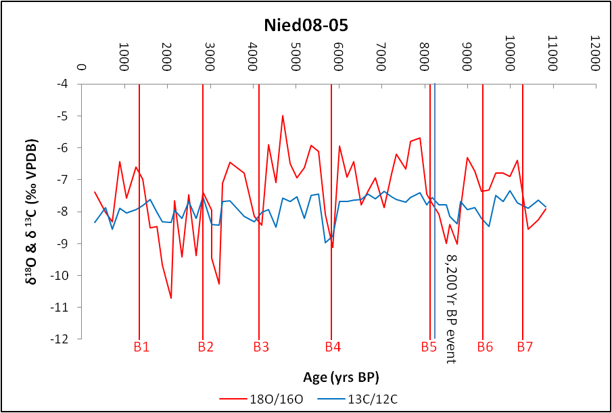
(a)
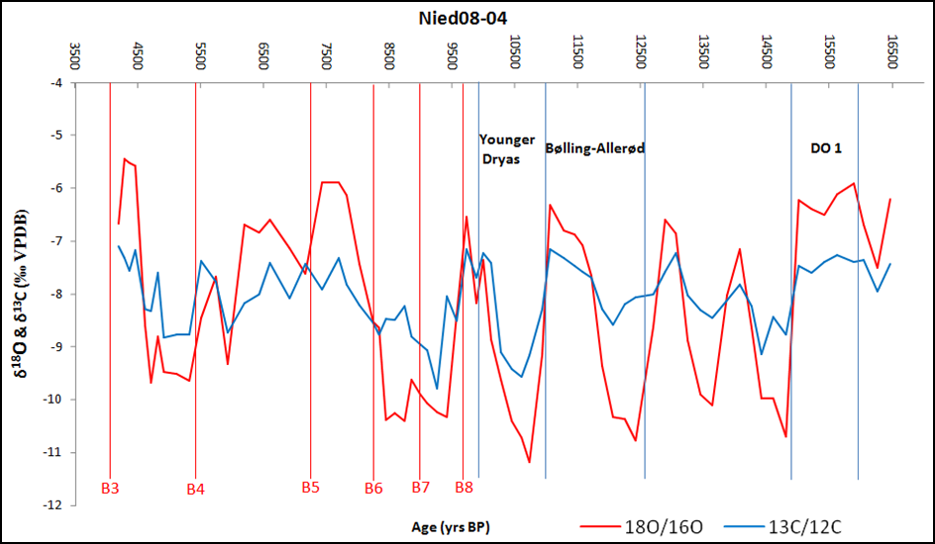
(b)
Figure 3.11: (a)-(c) Stable isotope data displaying possible climate events (B1 through B8 represent Bond Events 1 to 8) for Niedźwiedzia Cave, Poland (a): Nied08-02, (b): Nied08-04 and (c): Nied08-05.

(c)
Figure 3.11: (a)-(c): Stable isotope data displaying possible climate events (B1 through B8 represent Bond Events 1 to 8) for Niedźwiedzia Cave, Poland (a): Nied08-02, (b): Nied08-04 and (c): Nied08-05.

3.4.3 Comparison with other proxy records and notable climate events
Examination of the stable isotope data revealed some cyclicity (Figure 3.11). This is particularly noticeable for Nied08-04 (Figure 3.11-b) where oscillating cycles occurred approximately every ~2,000 years, which may be evidence of Bond events (Figure 3.11). The cyclic nature of the isotope data, especially for the oxygen isotopes, displays an oscillation between warmer and colder conditions which is expected if these cycles are in fact representative of Bond events.
When all three stalagmite isotope results are plotted together (Figure 3.8 and 3.9), they cover the time period of present day to 16,145 yrs BP. The oldest data points postdate the Last Glacial Maximum (LGM) (25,000-19,000 yrs BP) by a few thousand years, so it is conceivable that permafrost conditions were still very much present in this area. Ehlers and Gibbard (2004) displayed the extent of the LGM in the Northern Hemisphere (Figure 3.12); according to this map Niedźwiedzia Cave was not covered by glaciers.
Figure 3.12: From Ehlers and Gibbard (2004); the maximum extent of the Northern Hemisphere Last Glacial Maximum (LGM) ice sheets (areas in white).

The Niedźwiedzia data covers many important climatic events (e.g. the Younger Dryas, Bølling-Allerød, Little Ice Age and Medieval Warm Period; Figure 3.13), and though the chronology is not completely trust worthy, some of the events do appear to be apparent in the data set. Figure 3.13 displays isotope data from the Greenland Ice core project (GRIP), Northern Greenland Ice core project (NGRIP) and Greenland Ice sheet project 2 (GISP2) with prominent palaeoclimate events (Rasmussen et al. 2006).

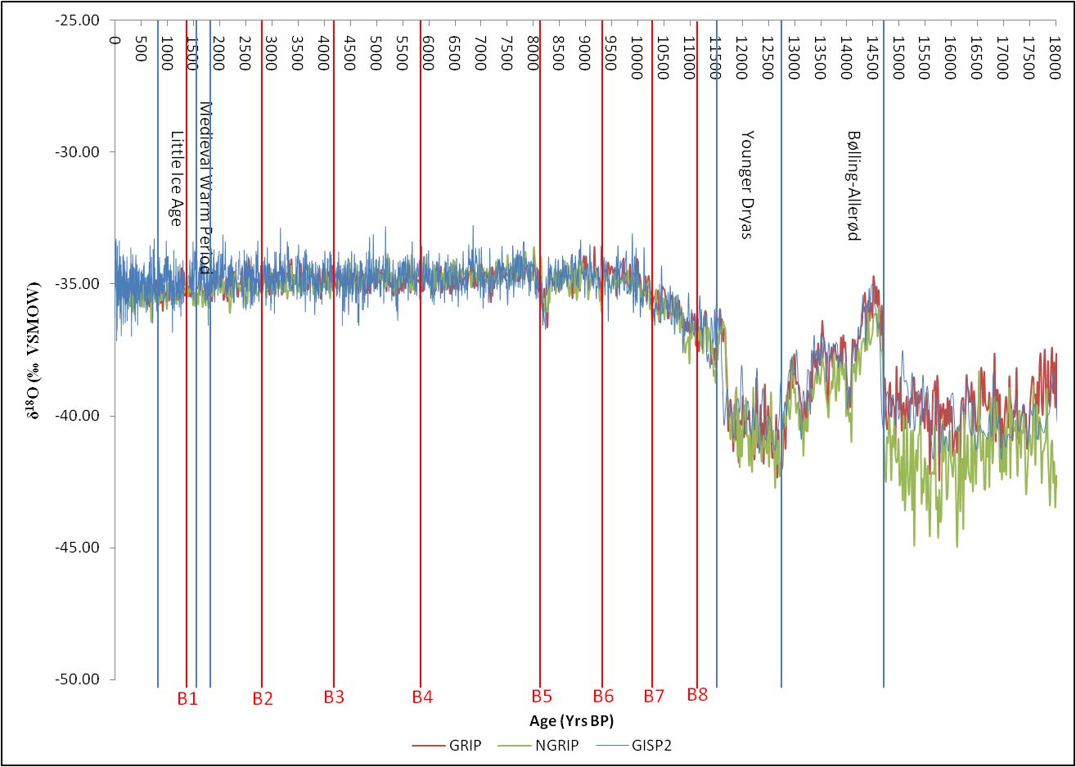
Figure 3.13: GRIP, NGRIP and GISP2 oxygen isotope records showing the Bølling-Allerød (warm conditions), Younger Dryas Event (return to almost glacial conditions), Little Ice Age and the Medieval Warm Period and Bond events (B1-8) climate events (Data from Rasmussen et al. 2006).

3.4.3.1 Dansgaard-Oeschger, Bond and Heinrich Events
Dansgaard-Oeschger (DO; Figure 3.14) events are rapid climate events that occurred in the last glacial from 110,000 to 15,000 years BP, they occurred 25 times during this period, with a quasi-periodical rate of 1,470 years. DO events are thought to be the result of changes in thermohaline circulation of the North Atlantic Ocean, to solar forcing or “binge-purge” cycles of ice sheets (Maslin et al. 2001). Evidence for DO events are typically seen in the Greenland ice cores (from Greenland Ice Core Project GRIP), which date back to the Eemian interglacial (the last interglacial) and have been corroborated by the appearance these events in the Green Ice Sheet Project 2 (GISP2) isotope record (Grootes et al. 1993, Grootes and Stuiver 1997). DO events are recognised as rapid warming episodes, generally lasting a number of decades, followed by a gradual cooling period which may last a few hundred years. Heinrich events, which are seen in Ice Rafted Debris (IRD), contain six distinct events H1-H6. They have been documented to occur prior to some DO events. Heinrich events are notable for the release of fresh water flow into oceans, which resulted in the decrease of δ¹⁸O preserved in Northern European and Asian speleothem samples, suggesting a decrease in global temperature or rising ice volume (Bar-Matthews et al. 1997). It is most likely that only DO 1 (Figure 3.11a, Figure 3.14) is recorded within the Niedźwiedzia dataset, as the remainder of DO events are older than the Niedźwiedzia Cave samples.
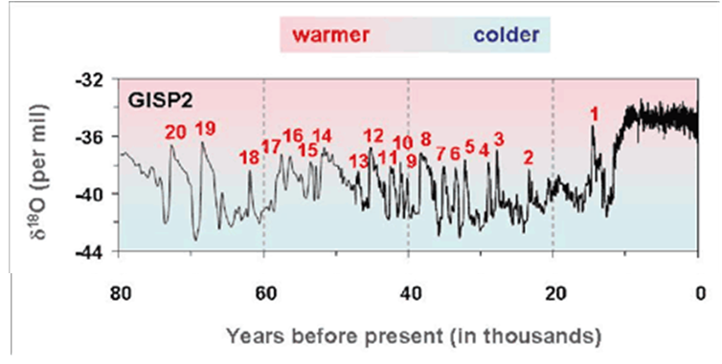
Figure 3.14: Modified from Grootes et al. (1993). The δ¹⁸O record from the GISP2 ice core in Greeland, showing 20 of the observed Dansgaard-Oeschger events during the last glacial period (80,000 yrs BP to present).
Bond et al. (1997, 2001) postulated a Holocene continuation of Dansgaard-Oeschger cycles. These Holocene equivalents typically present as “1500-year” cycles (Wanner at al. 2008). A number of global studies have shown the existence of Bond events, however, their temporal structure and spatial representation are not uniform (Wanner et al. 2008, Andrews et al. 2006, Debret et al. 2007). The causes for these cycles have been attributed to many factors, including enhanced meridional circulation (Greenland; O’Brien et al. 1995); deep-water flow intensified (reduced) during warm (cold) periods i.e. MWP (LIA) (south Iceland basin; deMenocal et al. 2000); variations in North Atlantic drift ice which may have influenced the Indian Ocean Monsoon indirectly, by way of a monsoon-Eurasian snow-cover link during the Early Holocene (southern Oman; Fleitmann et al. 2003); increases in temperature and moisture corresponded to intervals of elevated solar output and reduced NA ice-bearing waters and vice versa (western Alaska; Hu et al. 2003). A correlation has been shown between Bond Cycles and Scandinavian glacial advance and retreat (Matthews et al. 2005) and the European Alps (Wanner et al. 2000, 2008). Eight Bond events (Figure 3.13) have been recognised, some of which correspond to other climate events e.g. Bond event 3= 4,200 yr BP event, Bond event 5= 8,200 yr BP event, Bond event 8= coincident with the end of the Younger Dryas. Bond events display cycles of warm and cold conditions and are seen within the Niedźwiedzia record, particularly for Nied08-04 and Nied08-05 samples (Figures 3.11 b and 3.11c).
3.4.3.2. Bølling-Allerød Event
The Bølling-Allerød interstadial (Figure 3.13) event occurred from 14,700 to 12,700 yrs BP. It was characterised by warm, moist conditions gradually becoming cooler towards the Younger Dryas. It may be subdivided through the inclusion of the Older Dryas which occurs between the Bølling oscillation (14,650-14,000 yrs BP) and the Allerød oscillation (14,100- 12,900 yrs BP) (Yu et al. 2001). Nied08-04 data does display some cyclicity during the Bølling-Allerød interval which may show all three subdivisions of the Bølling-Allerød (Figures 3.11 and 3.13).
3.4.3.3. Younger Dryas Event
The Younger Dryas Event (Figure 3.13) took place from 12,800-11,500 yrs BP and was a relatively short climatic event lasting 1,300±70 years. The Younger Dryas displayed an abrupt return to near glacial conditions after the Bølling-Allerød that punctuated the transition from glacial to interglacial climates. Nied08-04 displays a cooling in oxygen isotope values at the Bølling-Allerød-Younger Dryas transition (Figure 3.11).
3.4.3.4. The 8,200 ky BP event
The 8,200 ky BP event (Bond et al. 1997) marked a sudden decrease in global temperatures, which lasted from two to four centuries. It was less extreme in negative, colder values than the Younger Dryas. Evidence of this can potentially be seen in Nied08-04 and Nied08-05 (Figure 3.11). However, resolution is too low to confidently confirm the appearance of such a distinctive climate event decrease in temperature.
3.4.3.5. Little Ice Age and the Medieval Warm Period
The Little Ice Age (LIA) occurred from AD 1350 or 1450 to AD 1900 depending on measurement type and follows the Medieval Warm Period (MWP) which is thought to have taken place AD 950-1250. Evidence for these events are found in the GISP2 record through a number of parameters (e.g. CO2, stable isotopes etc.). Resolution for this time period is unfortunately too low in the Niedźwiedzia record to observe either the LIA or the MWP.
3.4.4 Trace elements
Initially the trace elements analysed were Mg, P, Ca, Sr, Y, Ba, Pb, Th and U. However, due to extremely low concentrations of P, Th, Y, Pb and U isotopes these data were excluded, as values were too low to be measured on the X-Series2. Hence only Mg, Ca, and Sr will be discussed here.
Speleothem trace element results for Mg/Ca and Sr/Ca for NIed08-04 and Nied08-05 were plotted against the δ¹³C results and the uranium series dating results to see if any cycles through time were apparent (Figure 3.15). Some cycles are evident, particularly in relation to the Mg data. The Mg/Ca and Sr/Ca data seem to correlate quite well with δ¹³C, suggesting that PCP has occurred above the drip sites to some extent, as this is most likely a reflection of hydrological conditions. Peaks of higher δ¹³C values may be a reflection of higher levels of bio-productivity above the cave, this may be due to increased vegetation above the cave or “spring-flush” from snow melt or high rain levels which flush dissolved organic matter from the soil zone into the cave system, which may be due to the organic input of variables above the cave becoming more important than precipitation during these peaks. The periods which display PCP conditions may be correlated with climate events, for instance a positive correlation of Mg/Ca with δ¹³C for Nied08-04 (Figure 3.15) at approximately 12,000 yrs BP may be a response to the Bølling-Allerød warming event. However, as trace element analysis resolution is very low this cannot be confirmed.
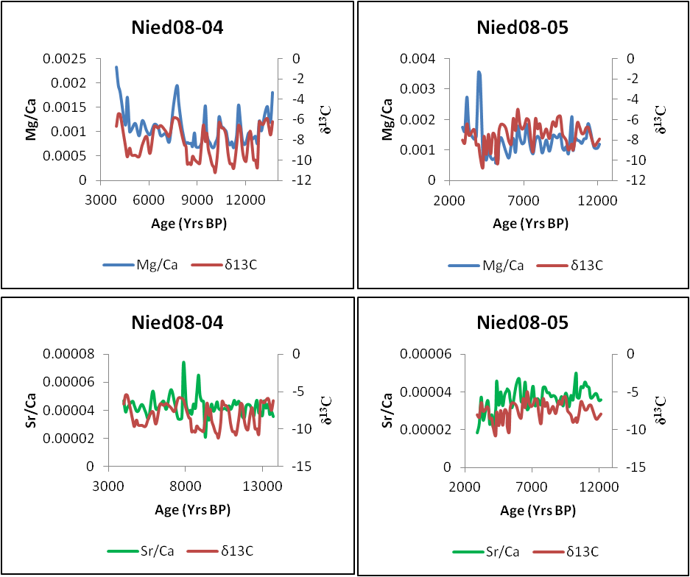
Figure 3.15: Trace elements; Mg/Ca and Sr/Ca versus δ¹³C for Niedźwiedzia Nied08-04 and Nied08-05 speleothem samples. A correlation between the samples indicates prior calcite precipitation (PCP) conditions, whereas anti-correlations indicate the influence of bio-productivity above the karst system.

3.5. Conclusion
Three stalagmite samples from Niedźwiedzia Cave in southern Poland provide a continuous 16,000 year record of stable isotope variability, which can be interpreted in terms of palaeoclimate change. However, due to the low uranium and high detrital content (relative to the amount of secondary ²³⁰Th) of the samples these correlations should be considered as preliminary. Further calibrations of the Niedźwiedzia data with radiocarbon dating or carbon bomb spike data would be recommended to add confidence to the chronologies determined from uranium series dating. However, the data contained within this thesis, while not completely precise, are of relevance as palaeoclimate data in Poland is quite limited. The majority of studies typically only extend to ca. 1500 AD (Majorowicz et al. 2004, Przybylak et al. 2005). The stable isotope data for Niedźwiedzia Cave dates from post LGM. This data is of importance as Polish data may be a good representation of average European climate signals. As much of Europe was covered by glaciers and permafrost conditions post Last Glacial Maximum (LGM), which limited the growth of speleothems and thus palaeoclimate indicators, this Niedźwiedzia Cave data may provide a key insight into European conditions during this period. The data covers a time period which contains many significant climate events. The most clearly recognised events within the record are: cycles which may represent Bond events, and signature warming and cooling associated with the Bølling-Allerød and the Younger Dryas Event. The data does cover other key events such as the 8,200ka event, the Little Ice Age and the Medieval Warm Period; however data resolution is insufficient to properly display them within the Niedźwiedzia Cave record.
Overall, stable isotope analyses show a colder period of time following the LGM, with oscillations between warmer and colder periods of time, with a gradual warming towards present. Trace element analysis indicated periods of prior calcite precipitation which may correlate with warmer periods of time, such as the Bølling-Allerød.

Chapter 4: Thesis Conclusions
This thesis examined stable isotope values from stalagmite samples from Niedźwiedzia Cave, southern Poland to provide a palaeoclimate reconstruction and precipitation data from this cave and recorded precipitation data from Germany and Poland to examine the factors which may alter these isotope results. The purpose of the modern cave climate monitoring and precipitation data is to understand the potential elements which may alter isotope results, by understanding the attributing factors one can then calibrate the reconstructed palaeoclimate record, and have a better understanding the processes and resulting values.
The results of the stable isotope analysis yielded a palaeoclimate reconstruction for the last 16,000 years for Niedźwiedzia cave, Poland. Uranium series dating provided a chronology for this data, however the precision of this data is questionable due to the low uranium and high detrital content of the samples, factors which increase dating errors. Analysis of the oxygen and carbon isotope data revealed cycles within the data which may correspond to Bond events. As the Niedźwiedzia record dates from after the Last Glacial Maximum to present, a number of other notable climate events such as the Younger Dryas Event and Bølling- Allerød may also be recorded. For instance, the Nied08-04 isotope record displays a cooling during the transition between the Bølling-Allerød and the Younger Dryas Event which has been recognised in other records such as GRIP and GISP.
The uncertainty associated with the uranium series dates is indeed problematic in confidently attributing peaks observed within the record to particular and recognizable events which are seen in other records. However, observed cyclicities and peaks are still evidence of climate events. It is recommended to further investigate the chronology to positively associate the stable isotope results with these notable events.
Trace element analysis of the speleothem samples suggest that prior calcite precipitation (PCP) may have occurred at the drip-sites, this is observed through the correlation of Ma/Ca and Sr/Ca date with carbon isotope values. PCP typically occurs during drier periods of time, or when the cave drip-water has longer residence times. As such, when a positive correlation between trace elements and carbon isotopes is observed within the Niedźwiedzia record, suggesting PCP conditions this may indicate drier, warmer intervals in the record.
Examination of the precipitation data concluded that temperature, rainout and the amount effects were found to exert the greatest control on precipitation falling at Polish and German sites. The origin of the moisture air mass as revealed through back trajectory analysis was also a major influence on precipitation oxygen isotope ratios. Precipitation results with a moisture mass which originated from the Mediterranean typically had quite low δ¹⁸O values, while those originating from a Scandinavian source had much more negative δ¹⁸O values.
The monitoring data from Niedźwiedzia cave provides further information which can be used to calibrate the palaeoclimate reconstruction for recent stalagmite growth in the cave. The variability of isotopic composition of the Niedźwiedzia drip-water samples over the record may reflect the variability and strength of the NAO index (NAOI) through time. Low NAOI periods are characterised by colder and drier winters with reduced precipitation amounts, conversely high NAOI periods are connected with wetter, warmer winters. Trace element cycles which reflect PCP conditions at the time of stalagmite precipitation, may be compared to the NAOI to determine whether drier periods of time are visible in both accounts. Unfortunately the resolution of trace element analysis here is too low to determine annual scale cycles. Spectral analysis of the precipitation data showed a cycle of approximately two years in length, this is most likely the result of the Quasi-Biennial Oscillation (QBO) which is one of the dominant circulation patterns in Europe. A strong oscillating correlation with the NAOI was also observed from analysis of the precipitation data.
Higher resolution drilling of the speleothem samples is also recommend with the aim of determining whether the NAOI can be recognised within the stalagmites as well as the precipitation data.
4.1 Recommendations for further work
Further work which is suggested for use with regard to the Niedźwiedzia speleothem samples includes:
- Luminescence banding: If annual luminescent cycles are present this would provide further high resolution dating information for the samples that may be then correlated with short-term climate event (Baker et al. 2008, Baker et al. 2003, McGarry and Baker 2000, Shopov et al. 1994).
- Petrography: petrographic analysis of the speleothems would provide information on systematic textural variation that may be related to drip-water variability over time, and potentially the degree of saturation identified by crystal structure, as posited by McDermott (1999).
- Laser ablation: laser ablation of the speleothems may provide trace element cycle information at much higher resolution than the trace element analysis by microdrill carried out within this study, with the possibility of identifying annual scale bands (Fleitmann et al. 2003).
- X-Ray mapping: x-ray fluorescence mapping would also provide higher resolution data of speleothem trace elements, which may be correlated with the isotope data to define high resolution temporal variability within the samples (Baker et al. 2008).
- Carbon bomb spike: the speleothem samples from Niedźwiedzia were collected under actively dripping drip-sites. However, chronologies suggest that there may have been some growth hiatuses. In order to confirm that the stalagmite samples were actively growing when collected, the identification of the radiocarbon bomb spike and calibration the results to the Niedźwiedzia data set would be recommended, especially as the precision of the uranium series chronologies are questionable.
- Radiocarbon dating: although the radiocarbon dating of stalagmites is rarely done, in this case it may have advantages over the more conventional uranium series approach. The dead carbon correction is believed to be essentially constant over time periods similar to those of this study; the correction could be gleaned by obtaining radiocarbon dates at the same horizons as low error uranium series dates.
- If higher resolution trace element cycles (annual or even seasonal scale) are found within the dataset, then a comparison of these cycles with drip-water stable isotope variations and the NAOI is recommended to see if a correlation between the NAOI and the cave stalagmite samples can be made.
- A comparison between the higher resolution trace element data with automated drip-rate is recommended, to see if the trace element analyses that indicate PCP conditions are recognised in the monthly precipitation data i.e. whether drier conditions are reflected within the Stalagmate data.
- Continued monitoring of Niedźwiedzia Cave, with the inclusion of temperature monitoring, and the expansion of monitoring to neighbouring caves is recommend to further examine the relationship between cave drip-water and meteoric precipitation about the cave site(s).

Appendices:
Appendix 2.1: Thirteen point correlation for Bad Salzuflen

Appendix 2.2: Thirteen point correlation for Koblenz

Appendix 2.3: Thirteen point correlation for Regensburg

Appendix 2.4: Thirteen point correlation for Wasserkuppe Rhoen

Appendix 2.5: Koblenz spectral analysis

Peak at 0.035= 28 month cycle

Appendix 2.6: Wasserkuppe Rhoen spectral analysis
Peak at 0.035= 28 month cycle

Appendix 2.7: Bad Salzuflen spectral analysis
Peak at 0.04= 25 month cycle

Appendix 2.8: Regensburg spectral analysis
Peak at 0.025= 33 month cycle

Appendix 3.1: Niedźwiedzia speleothem samples with growth axes
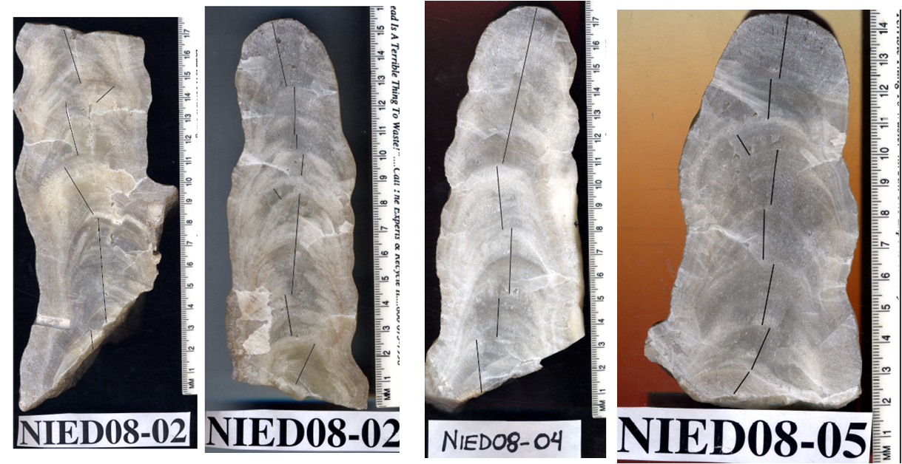

Appendix 3.2: List of stable isotope samples
Nied08-02 Top |  | Nied08-04 |  | Nied08-05
Sample | Distance from top | Sample | Distance from top | Sample | Distance from top
 | (mm) |  | (mm) |  | (mm)
N2T-1 | 0.0 | N4-1 | 0.0 | N5-1 | 0.0
N2T-2 | 3.0 | N4-2 | 2.0 | N5-2 | 3.0
N2T-3 | 5.0 | N4-3 | 4.0 | N5-3 | 5.0
N2T-4 | 7.5 | N4-4 | 6.0 | N5-4 | 7.0
N2T-5 | 10.0 | N4-5 | 9.5 | N5-5 | 9.0
N2T-6 | 12.0 | N4-6 | 11.5 | N5-6 | 11.5
N2T-7 | 12.5 | N4-7 | 14.0 | N5-7 | 13.5
N2T-8 | 15.5 | N4-8 | 16.0 | N5-8 | 15.5
N2T-9 | 17.0 | N4-10 | 20.0 | N5-9 | 17.5
N2T-10 | 17.0 | N4-12 | 24.0 | N5-10 | 19.0
N2T-11 | 19.0 | N4-14 | 27.5 | N5-11 | 21.5
N2T-12 | 23.0 | N4-16 | 32.0 | N5-12 | 22.5
N2T-13 | 25.0 | N4-18 | 35.5 | N5-13 | 24.5
N2T-14 | 27.0 | N4-20 | 40.0 | N5-14 | 26.5
N2T-15 | 28.0 | N4-22 | 44.0 | N5-15 | 28.5
N2T-17 | 30.5 | N4-24 | 47.0 | N5-16 | 30.5
N2T-18 | 32.0 | N4-26 | 52.0 | N5-17 | 33.0
N2T-19 | 35.0 | N4-28 | 56.0 | N5-18 | 33.0
N2T-20 | 37.0 | N4-30 | 60.0 | N5-19 | 35.0
N2T-21 | 38.5 | N4-32 | 64.0 | N5-20 | 36.0
N2T-22 | 40.5 | N4-33 | 66.0 | N5-21 | 38.0
N2T-23 | 42.5 | N4-34 | 69.0 | N5-22 | 42.0
N2T-24 | 47.0 | N4-35 | 72.0 | N5-23 | 45.0
N2T-25 | 49.5 | N4-36 | 73.5 | N5-24 | 47.0
N2T-26 | 51.0 | N4-37 | 75.0 | N5-25 | 49.0
N2T-27 | 53.0 | N4-38 | 77.0 | N5-26 | 51.0
N2T-28 | 54.5 | N4-39 | 79.0 | N5-27 | 53.0
N2T-29 | 57.0 | N4-40 | 80.5 | N5-28 | 55.0
N2T-30 | 59.0 | N4-41 | 82.5 | N5-29 | 57.0
N2T-31 | 60.5 | N4-42 | 84.0 | N5-30 | 59.0
N2T-32 | 63.0 | N4-43 | 86.0 | N5-31 | 61.0
N2T-33 | 65.0 | N4-44 | 88.0 | N5-32 | 63.0
N2T-34 | 67.0 | N4-45 | 90.0 | N5-33 | 65.0
N2T-35 | 69.0 | N4-46 | 92.0 | N5-34 | 67.0
N2T-36 | 71.0 | N4-47 | 94.0 | N5-35 | 69.0
N2T-37 | 73.0 | N4-48 | 95.5 | N5-36 | 71.0
N2T-38 | 75.0 | N4-49 | 97.0 | N5-37 | 73.0
N2T-39 | 77.0 | N4-50 | 99.0 | N5-38 | 75.0
N2T-40 | 79.0 | N4-51 | 101.0 | N5-39 | 77.0
N2T-41 | 82.0 | N4-52 | 103.0 | N5-40 | 79.0
Nied08-02 Top |  | Nied08-04 |  | Nied08-05
Sample | Distance from top | Sample | Distance from top | Sample | Distance from top
 | (mm) |  | (mm) |  | (mm)
N2T-42 | 83.0 | N4-53 | 104.5 | N5-41 | 81.5
N2T-43 | 85.0 | N4-54 | 107.0 | N5-42 | 83.5
N2T-44 | 87.0 | N4-55 | 108.5 | N5-43 | 85.0
N2T-45 | 89.0 | N4-56 | 111.0 | N5-44 | 87.5
N2T-46 | 91.0 | N4-57 | 113.0 | N5-45 | 89.0
N2T-47 | 92.5 | N4-58 | 114.5 | N5-46 | 91.5
N2T-48 | 94.5 | N4-59 | 116.0 | N5-47 | 93.5
N2T-49 | 95.0 | N4-60 | 118.0 | N5-48 | 95.0
N2T-50 | 98.0 | N4-61 | 120.0 | N5-49 | 97.0
N2T-51 | 101.0 | N4-62 | 122.0 | N5-50 | 99.0
N2T-52 | 104.0 | N4-63 | 124.0 | N5-51 | 100.0
N2T-53 | 107.0 | N4-64 | 127.0 | N5-52 | 102.0
N2T-54 | 109.0 | N4-65 | 129.0 | N5-53 | 103.0
N2T-55 | 110.0 | N4-66 | 131.0 | N5-54 | 105.0
N2T-56 | 113.0 | N4-67 | 133.0 | N5-55 | 107.0
N2T-57 | 114.5 | N4-68 | 135.0 | N5-56 | 109.0
N2T-58 | 115.0 | N4-69 | 137.0 | N5-57 | 111.0
N2T-59 | 116.0 | N4-70 | 139.5 | N5-58 | 113.0
N2T-60 | 118.0 | N4-71 | 141.5 | N5-59 | 115.0
N2T-61 | 120.0 | N4-72 | 143.5 | N5-60 | 117.0
N2T-62 | 122.0 | N4-73 | 145.0 | N5-61 | 119.0
N2T-64 | 124.0 | N4-74 | 147.0 | N5-62 | 122.0
N2T-65 | 126.5 | N4-75 | 149.0 | N5-63 | 125.0
N2T-66 | 128.5 | N4-76 | 151.0 | N5-64 | 127.0
N2T-67 | 130.0 | N4-77 | 153.0
N2T-68 | 132.0 | N4-78 | 155.0
N2T-69 | 134.0 | N4-79 | 157.0
N2T-70 | 136.0 | N4-80 | 159.5
N2T-71 | 138.5 | N4-81 | 161.0
N2T-72 | 141.0 | N4-82 | 163.0
N2T-73 | 142.5 | N4-83 | 165.0
N2T-74 | 145.0
Appendix 2: List of Stable Isotopes (continued from previous page)

Appendix 3.3: List of Trace element samples
Nied08-02 Top |  | Nied08-04 |  | Nied08-05
Sample | Distance from Top | Sample | Distance from Top | Sample | Distance from Top
 | (mm) |  | (mm) |  | (mm)
N2T-1 | 0.0 | N4-1 | 0.0 | N5-2 | 3.0
N2T-2 | 3.0 | N4-2 | 2.0 | N5-3 | 5.0
N2T-4 | 7.5 | N4-3 | 4.0 | N5-4 | 7.0
N2T-5 | 10.0 | N4-5 | 9.5 | N5-5 | 9.0
N2T-6 | 12.0 | N4-6 | 11.5 | N5-7 | 13.5
N2T-10 | 17.0 | N4-7 | 14.0 | N5-8 | 15.5
N2T-11 | 19.0 | N4-8 | 16.0 | N5-9 | 17.5
N2T-12 | 23.0 | N4-10 | 20.0 | N5-10 | 19.0
N2T-13 | 25.0 | N4-12 | 24.0 | N5-11 | 21.5
N2T-14 | 27.0 | N4-14 | 27.5 | N5-12 | 22.5
N2T-15 | 28.0 | N4-16 | 32.0 | N5-13 | 24.5
N2T-17 | 30.5 | N4-18 | 35.5 | N5-14 | 26.5
N2T-18 | 32.0 | N4-20 | 40.0 | N5-15 | 28.5
N2T-19 | 35.0 | N4-22 | 44.0 | N5-16 | 30.5
N2T-20 | 37.0 | N4-24 | 47.0 | N5-17 | 33.0
N2T-21 | 38.5 | N4-26 | 52.0 | N5-18 | 33.0
N2T-22 | 40.5 | N4-28 | 56.0 | N5-19 | 35.0
N2T-26 | 51.0 | N4-30 | 60.0 | N5-20 | 36.0
N2T-27 | 53.0 | N4-32 | 64.0 | N5-21 | 38.0
N2T-28 | 54.5 | N4-33 | 66.0 | N5-22 | 42.0
N2T-30 | 59.0 | N4-34 | 69.0 | N5-23 | 45.0
N2T-31 | 60.5 | N4-35 | 72.0 | N5-24 | 47.0
N2T-33 | 65.0 | N4-36 | 73.5 | N5-25 | 49.0
N2T-34 | 67.0 | N4-37 | 75.0 | N5-26 | 51.0
N2T-35 | 69.0 | N4-38 | 77.0 | N5-27 | 53.0
N2T-36 | 71.0 | N4-39 | 79.0 | N5-28 | 55.0
N2T-39 | 77.0 | N4-40 | 80.5 | N5-29 | 57.0
N2T-40 | 79.0 | N4-41 | 82.5 | N5-30 | 59.0
N2T-41 | 82.0 | N4-42 | 84.0 | N5-31 | 61.0
N2T-43 | 85.0 | N4-43 | 86.0 | N5-32 | 63.0
N2T-46 | 91.0 | N4-44 | 88.0 | N5-33 | 65.0
N2T-47 | 92.5 | N4-45 | 90.0 | N5-34 | 67.0
N2T-51 | 101.0 | N4-46 | 92.0 | N5-35 | 69.0
N2T-53 | 107.0 | N4-47 | 94.0 | N5-36 | 71.0
N2T-54 | 109.0 | N4-48 | 95.5 | N5-37 | 73.0
N2T-55 | 110.0 | N4-49 | 97.0 | N5-38 | 75.0
N2T-58 | 115.0 | N4-50 | 99.0 | N5-39 | 77.0
N2T-59 | 116.0 | N4-51 | 101.0 | N5-40 | 79.0
N2T-60 | 118.0 | N4-52 | 103.0 | N5-41 | 81.5
N2T-61 | 120.0 | N4-53 | 104.5 | N5-42 | 83.5
Nied08-02 Top |  | Nied08-04 |  | Nied08-05
Sample | Distance from Top | Sample | Distance from Top | Sample | Distance from Top
 | (mm) |  | (mm) |  | (mm)
N2T-62 | 122.0 | N4-54 | 107.0 | N5-43 | 85.0
N2T-65 | 126.5 | N4-55 | 108.5 | N5-44 | 87.5
N2T-66 | 128.5 | N4-56 | 111.0 | N5-45 | 89.0
N2T-67 | 130.0 | N4-57 | 113.0 | N5-46 | 91.5
N2T-68 | 132.0 | N4-58 | 114.5 | N5-47 | 93.5
N2T-69 | 134.0 | N4-59 | 116.0 | N5-48 | 95.0
N2T-70 | 136.0 | N4-60 | 118.0 | N5-49 | 97.0
N2T-72 | 141.0 | N4-61 | 120.0 | N5-50 | 99.0
N2T-73 | 142.5 | N4-62 | 122.0 | N5-52 | 102.0
N2T-74 | 145.0 | N4-63 | 124.0 | N5-53 | 103.0
 |  | N4-64 | 127.0 | N5-54 | 105.0
 |  | N4-65 | 129.0 | N5-55 | 107.0
 |  | N4-66 | 131.0 | N5-56 | 109.0
 |  | N4-67 | 133.0 | N5-57 | 111.0
 |  | N4-68 | 135.0 | N5-58 | 113.0
 |  | N4-69 | 137.0 | N5-59 | 115.0
 |  | N4-70 | 139.5 | N5-60 | 117.0
 |  | N4-71 | 141.5 | N5-62 | 122.0
 |  | N4-72 | 143.5 | N5-63 | 125.0
 |  | N4-73 | 145.0 | N5-64 | 127.0
 |  | N4-74 | 147.0
 |  | N4-75 | 149.0
 |  | N4-76 | 151.0
 |  | N4-77 | 153.0
 |  | N4-78 | 155.0
 |  | N4-79 | 157.0
 |  | N4-80 | 159.5
 |  | N4-81 | 161.0
 |  | N4-82 | 163.0
 |  | N4-83 | 165.0
Appendix 3: List of trace element samples (continued from previous page)

Appendix 3.4: Stable isotope results Nied08-04
Name | Weight | Distance | δ13C | δ18O | Name | Weight | Distance | δ13C | δ18O
 | (mg) | (mm) | v-pdb | v-pdb |  | (mg) | (mm) | v-pdb | v-pdb
N4-1 | 242 | 0.0 | -6.67636 | -7.10047 | N4-49 | 245 | 97.0 | -8.86975 | -7.41795
N4-2 | 254 | 2.0 | -5.44239 | -7.32853 | N4-50 | 254 | 99.0 | -9.63 | -9.10
N4-3 | 270 | 4.0 | -5.51567 | -7.56563 | N4-51 | 249 | 101.0 | -10.4095 | -9.42328
N4-4 | 238 | 6.0 | -5.56452 | -7.17984 | N4-52 | 252 | 103.0 | -10.72 | -9.56
N4-5 | 264 | 9.5 | -8.6001 | -8.29101 | N4-53 | 256 | 104.5 | -11.1804 | -9.15704
N4-6 | 264 | 11.5 | -9.67676 | -8.32416 | N4-54 | 264 | 107.0 | -9.15 | -8.28
N4-7 | 237 | 14.0 | -8.81602 | -7.58975 | N4-55 | 273 | 108.5 | -6.3178 | -7.15271
N4-8 | 254 | 16.0 | -9.48234 | -8.81846 | N4-56 | 263 | 111.0 | -6.80 | -7.33
N4-10 | 244 | 20.0 | -9.51946 | -8.76722 | N4-57 | 250 | 113.0 | -6.87274 | -7.45914
N4-12 | 247 | 24.0 | -9.64159 | -8.77526 | N4-58 | 243 | 114.5 | -7.09 | -7.58
N4-14 | 263 | 27.5 | -8.45941 | -7.37776 | N4-59 | 257 | 116.0 | -7.64653 | -7.69725
N4-16 | 265 | 32.0 | -7.67389 | -7.76958 | N4-60 | 242 | 118.0 | -9.36 | -8.29
N4-18 | 236 | 35.5 | -9.33188 | -8.72503 | N4-61 | 242 | 120.0 | -10.3392 | -8.58437
N4-20 | 249 | 40.0 | -6.69199 | -8.16944 | N4-62 | 274 | 122.0 | -10.36 | -8.19
N4-22 | 247 | 44.0 | -6.83952 | -8.00367 | N4-63 | 247 | 124.0 | -10.7837 | -8.06395
N4-24 | 247 | 47.0 | -6.60015 | -7.40388 | N4-64 | 254 | 127.0 | -8.61 | -8.00
N4-26 | 275 | 52.0 | -7.14239 | -8.08304 | N4-65 | 235 | 129.0 | -6.59038 | -7.58874
N4-28 | 241 | 56.0 | -7.62504 | -7.43 | N4-66 | 237 | 131.0 | -6.85 | -7.23
N4-30 | 255 | 60.0 | -5.89573 | -7.91124 | N4-67 | 250 | 133.0 | -8.88636 | -8.0308
N4-32 | 241 | 64.0 | -5.88791 | -7.32451 | N4-68 | 245 | 135.0 | -9.90 | -8.30
N4-33 | 267 | 66.0 | -6.13607 | -7.82383 | N4-69 | 261 | 137.0 | -10.1057 | -8.45176
N4-34 | 271 | 69.0 | -7.43 | -8.22 | N4-70 | 266 | 139.5 | -8.03 | -8.12
N4-35 | 235 | 72.0 | -8.52389 | -8.55222 | N4-71 | 247 | 141.5 | -7.15314 | -7.82785
N4-36 | 243 | 73.5 | -8.63 | -8.77 | N4-72 | 235 | 143.5 | -8.64 | -8.23
N4-37 | 258 | 75.0 | -10.3783 | -8.47888 | N4-73 | 250 | 145.0 | -9.98648 | -9.13895
N4-38 | 274 | 77.0 | -10.25 | -8.50 | N4-74 | 239 | 147.0 | -9.98 | -8.44
N4-39 | 239 | 79.0 | -10.4144 | -8.22972 | N4-75 | 237 | 149.0 | -10.7007 | -8.77727
N4-40 | 243 | 80.5 | -9.62 | -8.81 | N4-76 | 261 | 151.0 | -6.22 | -7.47
N4-41 | 246 | 82.5 | -9.90929 | -8.95912 | N4-77 | 275 | 153.0 | -6.394 | -7.59376
N4-42 | 267 | 84.0 | -10.08 | -9.07 | N4-78 | 239 | 155.0 | -6.49 | -7.39
N4-43 | 258 | 86.0 | -10.2385 | -9.79903 | N4-79 | 247 | 157.0 | -6.11067 | -7.25921
N4-44 | 241 | 88.0 | -10.32 | -8.05 | N4-80 | 261 | 159.5 | -5.91 | -7.40
N4-45 | 242 | 90.0 | -8.37929 | -8.50902 | N4-81 | 240 | 161.0 | -6.67831 | -7.36168
N4-46 | 246 | 92.0 | -6.53 | -7.15 | N4-82 | 248 | 163.0 | -7.51 | -7.95
N4-47 | 240 | 94.0 | -8.16826 | -7.68921 | N4-83 | 261 | 165.0 | -6.20935 | -7.43904
N4-48 | 265 | 95.5 | -7.35 | -7.23

Appendix 3.5: Stable isotope results for Nied08-02
Name | Weight | Distance | δ13C | δ18O | Name | Weight | Distance | δ13C | δ18O
 | (mg) | (mm) | v-pdb | v-pdb |  | (mg) | (mm) | v-pdb | v-pdb
N2-2 | 263 | 3.0 | -8.60 | -8.31 | N2-39 | 273 | 77 | -9.64 | -8.51
N2-3 | 167 | 5.0 |  |  | N2-40 | 262 | 79 | -8.11 | -8.22
N2-4 | 267 | 7.5 | -9.28 | -8.48 | N2-41 | 247 | 82 | -9.78 | -8.23
N2-5 | 243 | 10.0 |  |  | N2-42 | 249 | 83 | -9.46 | -7.87
N2-6 | 268 | 12.0 | -9.24 | -7.74 | N2-43 | 237 | 85 | -8.98 | -8.13
N2-7 | 257 | 12.5 |  |  | N2-44 | 240 | 87 | -9.02 | -8.55
N2-8 | 252 | 15.5 | -9.51 | -8.11 | N2-45 | 258 | 89 | -8.58 | -8.16
N2-9 | 256 | 17.0 |  |  | N2-46 | 268 | 91 | -8.16 | -8.05
N2-10 | 262 | 17.0 | -9.40 | -8.13 | N2-47 | 246 | 93 | -9.78 | -8.49
N2-11 | 240 | 19.0 | -9.29 | -8.33 | N2-48 | 248 | 95 | -8.68 | -8.10
N2-12 | 240 | 23.0 | -9.19 | -8.17 | N2-49 | 210 | 95 | -9.21 | -7.91
N2-13 | 271 | 25.0 | -9.66 | -8.79 | N2-50 | 275 | 98 | -9.15 | -7.85
N2-14 | 242 | 27.0 | -8.80 | -8.05 | N2-51 | 251 | 101 | -9.03 | -8.13
N2-15 | 235 | 28.0 | -8.69 | -8.04 | N2-52 | 217 | 104 | -8.30 | -7.94
N2-17 | 267 | 30.5 | -8.59 | -8.03 | N2-53 | 240 | 107 | -8.45 | -7.87
N2-18 | 263 | 32.0 | -8.78 | -8.43 | N2-54 | 238 | 109 | -8.69 | -7.83
N2-19 | 263 | 35.0 | -9.36 | -8.50 | N2-55 | 235 | 110 | -8.79 | -8.23
N2-20 | 250 | 37.0 | -8.99 | -8.22 | N2-56 | 259 | 113 | -8.16 | -8.05
N2-21 | 238 | 38.5 | -9.01 | -8.37 | N2-57 | 235 | 115 | -7.81 | -8.40
N2-22 | 259 | 40.5 | -8.87 | -8.30 | N2-58 | 245 | 115 | -7.06 | -5.51
N2-23 | 275 | 42.5 | -8.76 | -8.42 | N2-59 | 266 | 116 | -8.77 | -8.29
N2-24 | 273 | 47.0 | -8.54 | -8.06 | N2-60 | 240 | 118 | -8.18 | -7.96
N2-25 | 259 | 49.5 | -8.77 | -8.03 | N2-61 | 237 | 120 | -9.06 | -7.67
N2-26 | 240 | 51.0 | -11.10 | -7.75 | N2-62 | 247 | 122 | -8.43 | -8.38
N2-27 | 247 | 53.0 | -9.56 | -8.02 | N2-64 | 258 | 124 | -8.14 | -8.04
N2-28 | 272 | 54.5 | -8.94 | -8.15 | N2-65 | 237 | 127 | -7.69 | -8.00
N2-29 | 236 | 57.0 | -8.23 | -8.01 | N2-66 | 257 | 129 | -9.58 | -8.60
N2-30 | 270 | 59.0 | -10.34 | -7.99 | N2-67 | 271 | 130 | -8.00 | -8.04
N2-31 | 243 | 60.5 | -9.19 | -8.07 | N2-68 | 264 | 132 | -8.50 | -7.67
N2-32 | 245 | 63.0 | -8.73 | -8.16 | N2-69 | 248 | 134 | -8.92 | -7.77
N2-33 | 248 | 65.0 | -8.73 | -8.16 | N2-70 | 267 | 136 | -8.51 | -7.76
N2-34 | 263 | 67.0 | -8.86 | -8.26 | N2-71 | 247 | 139 | -8.88 | -8.01
N2-35 | 246 | 69.0 | -8.15 | -7.89 | N2-72 | 235 | 141 | -8.92 | -7.25
N2-36 | 247 | 71.0 | -10.17 | -7.93 | N2-73 | 241 | 143 | -8.45 | -7.43
N2-37 | 240 | 73.0 | -9.31 | -8.00 | N2-74 | 235 | 145 | -9.44 | -6.67
N2-38 | 239 | 75.0 | -9.26 | -8.23

Appendix 3.6: Stable isotope results for Nied08-05
Name | Weight | Distance | δ13C | δ18O | Name | Weight | Distance | δ13C | δ18O
 | (mg) | (mm) | v-pdb | v-pdb |  | (mg) | (mm) | v-pdb | v-pdb
N5-1 | 237 | 0.0 | -7.38 | -8.34 | N5-33 | 260 | 65.0 | -8.09 | -8.97
N5-2 | 242 | 3.0 | -8.01487 | -7.87 | N5-34 | 266 | 67.0 | -9.12 | -8.76
N5-3 | 253 | 5.0 | -8.32 | -8.55 | N5-35 | 268 | 69.0 | -5.94 | -7.68
N5-4 | 207 | 7.0 | -6.42 | -7.90 | N5-36 | 237 | 71.0 | -6.91 | -7.67
N5-5 | 256 | 9.0 | -7.57 | -8.04 | N5-37 | 245 | 73.0 | -6.42 | -7.64
N5-6 | 260 | 11.5 | -6.60 | -7.93 | N5-38 | 265 | 75.0 | -7.79 | -7.63
N5-7 | 254 | 13.5 | -6.98 | -7.81 | N5-39 | 266 | 77.0 | -7.37 | -7.44
N5-8 | 242 | 15.5 | -8.51 | -7.61 | N5-40 | 247 | 79.0 | -6.93 | -7.59
N5-9 | 245 | 17.5 | -8.46 | -8.01 | N5-41 | 271 | 81.5 | -7.86 | -7.36
N5-10 | 257 | 19.0 | -9.66 | -8.32 | N5-42 | 245 | 83.5 | -6.80 | -7.53
N5-11 | 236 | 21.5 | -10.71 | -8.34 | N5-43 | 262 | 85.0 | -6.20 | -7.61
N5-12 | 269 | 22.5 | -7.66 | -7.95 | N5-44 | 261 | 87.5 | -6.67 | -7.71
N5-13 | 256 | 24.5 | -9.42 | -8.20 | N5-45 | 239 | 89.0 | -5.80 | -7.56
N5-14 | 266 | 26.5 | -7.46 | -7.67 | N5-46 | 246 | 91.5 | -5.68 | -7.40
N5-15 | 237 | 28.5 | -9.37 | -8.21 | N5-47 | 275 | 93.5 | -7.44 | -7.78
N5-16 | 276 | 30.5 | -7.38 | -7.54 | N5-48 | 265 | 95.0 | -7.74 | -7.56
N5-17 | 275 | 33.0 | -7.96 | -8.40 | N5-49 | 256 | 97.0 | -8.09 | -7.78
N5-18 | 255 | 33.0 | -9.46 | -8.40 | N5-50 | 254 | 99.0 | -8.99 | -7.79
N5-19 | 256 | 35.0 | -10.27 | -8.42 | N5-51 | 227 | 100.0 | -8.40 | -8.15
N5-20 | 235 | 36.0 | -7.12 | -7.68 | N5-52 | 252 | 102.0 | -9.01 | -8.37
N5-21 | 245 | 38.0 | -6.45 | -7.65 | N5-53 | 237 | 103.0 | -7.90 | -7.68
N5-22 | 248 | 42.0 | -6.79 | -8.14 | N5-54 | 264 | 105.0 | -6.31 | -7.93
N5-23 | 240 | 45.0 | -8.14 | -8.31 | N5-55 | 261 | 107.0 | -6.73 | -7.87
N5-24 | 265 | 47.0 | -8.42 | -8.01 | N5-56 | 263 | 109.0 | -7.37 | -8.21
N5-25 | 252 | 49.0 | -5.90 | -7.94 | N5-57 | 265 | 111.0 | -7.31 | -8.46
N5-26 | 235 | 51.0 | -7.08 | -8.49 | N5-58 | 243 | 113.0 | -6.79 | -7.50
N5-27 | 235 | 53.0 | -4.99 | -7.58 | N5-59 | 254 | 115.0 | -6.78 | -7.67
N5-28 | 240 | 55.0 | -6.49 | -7.68 | N5-60 | 242 | 117.0 | -6.90 | -7.34
N5-29 | 275 | 57.0 | -6.94 | -7.52 | N5-61 | 241 | 119.0 | -6.39 | -7.72
N5-30 | 245 | 59.0 | -6.62 | -8.21 | N5-62 | 274 | 122.0 | -8.55 | -7.89
N5-31 | 239 | 61.0 | -5.91 | -7.48 | N5-63 | 241 | 125.0 | -8.24 | -7.64
N5-32 | 263 | 63.0 | -6.11 | -7.45 | N5-64 | 254 | 127.0 | -7.91 | -7.85

References
Alexander, M.J. & Holton, J.R. (1997). A Model Study of Zonal Forcing in the Equatorial Stratosphere by Convectively Induced Gravity Waves. Journal of Atmospheric Science, 54, p. 408-419.

Alley, R.B., Meese, D.A., Shuman, C.A., Grow, A.J:, Taylor, K.C., Grootes, P.M., White, J.W.C., Ram, M., Waddington, E.D., Mayewski, P.A., Zielinski, G.A. (1993). Abrupt increaae in snow accumulation at the end of the Younger Dryas event. Nature, 362, p. 527-529.

Alley, R.B. (2000). The Younger Dryas cold interval as viewd from central Greenland. Quaternary Science Review, 19, p. 213-226.

Andrews, J.T., Jennings, A.E., Moros, M., Hillaire-Marcel, C., Eberle, D. (2006). Is there a pervasive Holocene ice-rafted debris (IRD) signal in the northern North Atlantic? The answer appears to be either no, or it depends on the proxy!. PAGES News 14/2, 7–9.

Araguas-Araguas, L., Froehlich, K. And Rozanski, K. (2000). Deuterium and oxygen-18 isotope composition of precipitation and atmospheric moisture. Hydrological Processes, 14, 1341-1355.

Baker, A., Asrat, A., Fairchild, I.J., Leng, M.J., Wynn, P.M., Bryant, C., Genty, D. and Umer, M. (2007). Analysis of the climate signal contained within δ¹⁸O and growth rate parameters in two Ethiopian stalagmites. Geochimica et Cosmochimica Acta, 71, 2975-2988.
Baker, A., Smart, P.L., Edwards, R.L., and Richards, D.A. (1993). Annual growth banding in a cave stalagmite. Nature 364, 518-520.

Baker, A., Smith, C.L., Jex, C., Fairchild, I.J., Genty, D. And Fuller, L. (2008). Annually laminated Speleothems: a Review. International Journal of Speleogy, 37, p. 193-206.

Baldini, J.U.L. (2010). The geochemistry of cave calcite deposits as a record of past climate, The Sedimentary Record, 8, 4-10.

Baldini, L. M., McDermott, F., Foley, A. M. and Baldini, J. U. L. (2008). Spatial variability in the European winter precipitation δ¹⁸O-NAO relationship: Implications for reconstructing NAO-mode climate variability in the Holocene, Geophysical Research Letters, 35, L04709.
Baldwin, M. P., Gray, L. J., Dunkerton, T. J., Hamilton, K., Haynes, P. H., Randel, W. J., Holton, J. R., Alexander, M. J., Hirota, I., Horinouchi, T., Jones, D. B. A., Kinnersley, J. S., Marquardt, C., Sato, K. and Takahashi, M. (2001) The Quasi-Biennial Oscillation, Reviews of Geophysics, 39, 179-229.
Benjamin, L. (2004). Development of a local meteoric water line for southeastern Idaho, western Wyoming, and south-central Montana. USGS Scientific Investigations report, 2004-5126.
Blyth, A.J., Baker, A., Collins, M.J., Penkman, K.E.H., Gilmour, M.A., Moss, J.S., Genty, D. and Drysdale, R. N. (2008). Molecular organic matter in speleothems and its potential as an environmental proxy, Quaternary Science Review, 27, 905-921.

Bond, G., Showers, W., Cheseby, M., Lotti, R., Almasi, P., deMenocal, P., Priore, P., Cullen, H., Hajdas, I., Bonani, G. (1997). A pervasive millennial scale cycle in the North Atlantic Holocene and glacial climates. Science, 294, p. 2130–2136.

Bond, G., Kromer, B., Beer, J., Muscheler, R., Evans, M.N., Showers, W., Hoffmann, S., Lotti-Bond, R., Hajdas, I., Bonani, G. (2001). Persistent solar influence on North Atlantic climate during the Holocene. Science, 278, p. 1257-1266.

Borsato, A., Frisia, S., Fairchild, I. J., Somogiy, A. and Susini, J. (2007). Trace element distribution patterns in annual stalagmite laminae mapped by micrometerresolution X-ray fluorescence: incorporation of colloidally-transported species. Geochimica et Cosmochimica Acta, 71, 1494–1512.

Bourdon, B., Turner, S., Henderson, G.H. and Lundstom, C.C. (2003). Introduction to U-series Geochemistry. Reviews in Mineralogy and Geochemistryv. 52;1; p. 1-21

Brownlee, K.A. (1960). Statistical theory and methodology in Science and Engineering. New York. John Wiley.
Clark, I. and Fritz, P. (1997). Environmental isotopes in Hydrology. Lewis publishers, New York.
Cook, E.R. (2003). Multi-proxy reconstructions of the North Atlantic Oscillation (NAO) index: A critical review and a new well-verified winter NAO index reconstruction back to AD 1400, in The North Atlantic Oscillation: Climatic significance and environmental impact, Geophysical Monograph, 134, 63-79.
Craig, H. (1961) Isotopic variation in meteoric waters, Science, 133, 1702-1703.
Dansgaard, W. (1964) Stable isotopes in precipitation, Tellus, 16, 4, 436-468.
Davis, A. (2010). Identifying the controls on oxygen isotope ratios in meteoric precipitation in Poland. Unpublished BSc dissertation. Durham University.
Dickin, A.P. (2005). Radiogenic Isotope Geology, Cambridge University Press.

Diefendorf, A.F. and Patterson, W.P. (2005). Survey of stable isotope values in Irish surface wayers. Journal of Paleoliminology, 34, 257-269.

Don, J. (1989). Geologic evolution of the Sneiznik Massif and the cave: - Jaskinia Niedźwiedzia w Kletnie, in Jahna, A. (ed.), Polska Akademia Nauk Odzial We Wroclawiu: Kozlowskiego, St. & Wiszniowskiej, T. Wroclaw, p. 58-79.

Dorale, J.A., Edwards, R.L., and Onac, B.P. (2002). Stable isotopes as environmental
indicators in speleothems. In: Karst Processes and the Carbon Cycle. Final Report of
IGCP 379 (Yuan, D. & Zhang, C., Eds.), Geological Publishing House, Beijing, 107-120.

Draxler, R.R. and Rolph, G.D., (2010) HYSPLIT (HYbrid Single-Particle Lagrangian Integrated Trajectory) Model access via NOAA ARL READY Website (http://ready.arl.noaa.gov/HYSPLIT.php). NOAA Air Resources Laboratory, Silver Spring, MD.
Dreybrodt, W. and Scholz, D. (2011). Climatic dependence of stable carbon and oxygen isotope signals recorded in speleothems: From soil water to speleothem calcite. Geochimica et Cosmochimica Acta, 75, 734-752.

Fairchild, I.J. and Treble, P.C. (2009). Trace elements in speleothems as recorders of environmental change. Quaternary Science Reviews, 28, 449–468.

Fairchild, I.J. and McMillan, E.A. (2006). Speleothems as indicators of wet and dry periods. International Conference Aqua in Med’06.

Fairchild, I.J., Smith C.L., Baker A., Fuller L., Spotl C., Mattey D., McDermott F. and E.I.M.F. (2006). Modification and preservation of environmental signals in speleothems, Earth-Science Reviews, 75(1-4): 105–153

Fairchild, I.J., Baker, A., Borsato, A., Frisia, S., Hinton, R.W., McDermott, F., and Tooth, A.F. (2001). Annual to sub-annual resolution of multiple trace element trends in speleothems, Journal of the Geological Society of London, v. 158, p. 831-841.
Fensterer, C., Scholz, D., Hoffmann, D., Mangini, A. and Pajon, J.M. (2010). ²³⁰Th /U-dating of a late Holocene low uranium speleothem from Cuba.IOP Conf. Series: Earth and Environmental Science, 9,012015.

Fairchild, I.J. and Treble, P.C. (2009). Trace elements in speleothems as recorders of environmental change. Quaternary Science Reviews, 28, 449–468.

Fairchild, I.J. and McMillan, E.A. (2006). Speleothems as indicators of wet and dry periods. International Conference Aqua in Med’06.

Fairchild, I.J., Smith C.L., Baker A., Fuller L., Spotl C., Mattey D., McDermott F. and E.I.M.F. (2006). Modification and preservation of environmental signals in speleothems, Earth-Science Reviews, 75(1-4): 105–153

Fairchild, I.J., Baker, A., Borsato, A., Frisia, S., Hinton, R.W., McDermott, F., and Tooth, A.F. (2001). Annual to sub-annual resolution of multiple trace element trends in speleothems, Journal of the Geological Society of London, v. 158, p. 831-841.
Fensterer, C., Scholz, D., Hoffmann, D., Mangini, A. and Pajon, J.M. (2010). 230Th /U-dating of a late Holocene low uranium speleothem from Cuba.IOP Conf. Series: Earth and Environmental Science, 9,012015.

Fleitmann, D., Treble, P., Cruz Jr, F., Cole, J. and Cobb, K. (2001). White paper on”Speleothem-based climate proxy records”.

Fleitmann, D., Burns, S.J., Mudelsee, M., Neff, U., Kramers, J., Mangini, A., Matter, A. (2003). Holocene forcing of the Indian monsoon recorded in a stalagmite from southern Oman. Science 300, 1737–1739

Fleitmann, D., Burns, S.J., Mangini, A., Mudelsee, M., Kramers, J., Villa, I., Neff, U., Al-Subbary, A.A., Buettner, A., Hippler, D. and Mattey, A. (2007). Holocene ITCZ and Indian monsoon dynamics recorded in stalagmites from Oman and Yemen (Socotra). Quaternary Science Review, 26, p. 170-188.
Frappier, A., Sahagian, D., Gonzalez, L.A. and Carpenter, S.J. (2002).El Nino events recorded by stalagmite carbon isotopes. Science, 298, 565.

Gat, J.R. (1995). Isotopes in fresh and saline lates. In: Lerman, A., Imboden, D.M.m gat, J.R. (Eds.). Physics and Chemistry of Lakes, second ed., Springer, New York, p. 139-165.

Gascoyne, M. (1992). Trace element partition coefficients in the calcite–
water system and their palaeoclimatic significance in cave studies, J. Hydrol. 61 (1983) 231.

Genty, D., Blamart, D., Ouahdi, R., Gilmour, M., Baker, A., Jouzel, J., and van Exter, S. (2003). Precise dating of Dansgaard-Oeschger climate oscillations in western Europe from stalagmite data: Nature, v. 421, p. 833–837.

Gillet, N.P., Graf, H.F., and Osborn, T.J. (2003). Climate change and the North Atlantic Oscillation. Geophysical Monograph, 134, p. 193-209.
Goede, A., McCulloch, M., McDermott, F., and Hawkesworth, C. (1998). Aeolian contribution to strontium and strontium isotope variations in a Tasmanian speleothem. Chemical Geology, 149, 37–50.

Gozhik, P., Lindner, L. And Marks, L. (2010). Late Early and early Middle Pleistocene limits of Scandinavian glaciations in Poland and Ukraine. Quaternary International, in press, p. 1-7.

Grootes, P.M. and Stuiver, M. (1997). Oxygen 18/16 variability in Greenland snow and ice core with 10-3- to 105- year time resolution. Journal of Geophysical Research, 102, p. 22 455- 26 470.
Grootes, P.M., Stuiver, M., White, J.W.C., Johnsen, S., and Jouzel, J. (1993). Comparison of oxygen isotope records from the GISP2 and GRIP Greenland ice cores. Nature, 366, p. 552-554.

Hendy, C.H. (1971), The isotopic geochemistry of speleothems: Part 1. The calculation of the effects of different modes of formation on the isotopic composition of speleothems and their applicability as paleoclimatic indicators, Geochim. Cosmochim. Acta 35 (1971) 805–824.

Górka, M., Jędrysek, M-O. and Strąpoć, D., (2008) Isotopic composition of sulphates from meteoric precipitation as an indicator of pollutant origin in Wroclaw (SW Poland), Isotopes in Environmental Healthy Studies, 44, 177-1188.
Hammer, Ø., Harper, D.A.T., and P. D. Ryan, 2001. PAST: Paleontological Statistics Software Package for Education and Data Analysis. Palaeontologia Electronica 4(1): 9pp
Hays, P.D. and Grossman, E.L. (1991). Oxygen isotopes in meteoric calcite cements as indicators of continental palaeoclimate. Geology, 19, 441-444.
Hill, C., and Forti, P. (1997). Cave Minerals of the World: Huntsville: National Speleological Society.

Hill, T. and Lewicki, P. (2007). Statistics Methods and Applications. Statsoft, Tulsa, OK.
Hoffman, D.L., Prytulak, J., Richards, D.A., Elliott, T., Coath, C.D., Smart, P.L. and Scholz, D. (2007). Procedures for accurate U and Th isotope measurements by high precision MC-ICPMS. International Journal of Mass Spectrometry, 264, 97-109.

Holton, J.R. amd Lindzen, R.S. (1972). An updated theory for the Quasi-Biennial cycle of the tropical stratosphere. Journal of the Atmospheric Science, 29, 1076-1080.
Hoffman, D.L., Prytulak, J., Richards, D.A., Elliott, T., Coath, C.D., Smart, P.L. and Scholz, D. (2007). Procedures for accurate U and Th isotope measurements by high precision MC-ICPMS. International Journal of Mass Spectrometry, 264, 97-109.

Hu, C., Hendserson, G.M., Huang, J., Chen, Z. and Johnson K.R. (2008). Report of a three-year monitoring programme at Heshang Cave, Central China. International Journal of Speleology, 37,143-151.

Hu, F.S., Kaufman, D., Yoneji, S., Nelson, D., Shemesh, A., Huang, Y., Tian, J., Bond, G., Clegg, B., Brown, T. (2003). Cyclic variation and solar forcing of Holocene climate in the Alaskan subarctic. Science 301, 1890–1893.

Huang, H.M., Fairchild, I.J., Borsato, A., Frisia, S., Cassidy, N.J., McDermott, F., and Hawkesworth, C.J. (2001). Seasonal variations in Sr, Mg and P in moderen speleothems (Grotta di Ernesto, Italy), Chem.Geol. 175 (3-4), 429-448.

Hurrell, J.W., (1995) Decadal trends in the North Atlantic Oscillation and relationships to regional temperature and precipitation, Science, 269, 676-679.
Hurrell, J.W., Kushnir, Y., Ottersen, G. and Visbeck, M., eds. (2003) The North Atlantic Oscillation: Climate Significance and Environmental Impact ; Geophysical Monograph Series
IAEA/WMO (2006). Global Network of Isotopes in Precipitation. The GNIP Database. Accessible at: http://www.iaea.org/water.
Ingraham, N.L. (1998). Isotopic variations in precipitation. In: Kendall, C., McDonnell, J. (Eds.), Isotopic Tracers in Catchment Hydrology. Elsevier, Amsterdam, 97-118.
Johnson, K.R., Hu, C.Y., Belshaw, N.S. and Henderson, G.M. (2006). Seasonal trace-element and stable-isotope variations in a Chinese speleothem: The potential for high-resolution paleomonsoon reconstruction. Earth and Planetary Science Letters, 244: 394-407.
Johnson, K.R., Hu, C.Y., Belshaw, N.S. and Henderson, G.M. (2006). Seasonal trace-element and stable-isotope variations in a Chinese speleothem: The potential for high-resolution paleomonsoon reconstruction. Earth and Planetary Science Letters, 244: 394-407.

Jones, P. D., and A. Moberg (2003), Hemispheric and large-scale surface air temperature variations: An extensive revision and an update to 2001, Journal of Climatology, 16, 206– 223.

Jones, P. D., T. Jonsson, and D. Wheeler (1997), Extension to the North Atlantic Oscillation using early instrumental pressure observations from Gibraltar and south-west Iceland, International Journal of Climatology, 17, 1433–1450.

Kaiser, J., Lamy, F., Hebbeln, D. (2005). A 70-kyr sea surface temperature record off southern Chile (Ocean Drilling Program Site 1233). Paleoceanography 20.

Kuczumow et al 2003 Kuczumow, A., Genty, D., Chevallier, P., Nowak, J., Ro, C.-U. (2003). Annual resolution analysis of a SW-France stalagmite by Xray synchrotron microprobe analysis, Spectrochimica Acta Part B, 58, 851–865.

Kurisaki, K. And Yoshimura, K. (2008). Novel dating methods for speleothems with microscopic fluorescent annual layers. Anal Sci., 24 (1), 93-8.

Lachniet, M.S., (2009) Climatic and environmental controls on speleothem oxygen-isotope values, Quaternary Science Reviews, 28, 412-434
Lea, D.W and Martin , P.A. (1994).A rapid mass spectrometric method for the simultaneous analysis of barium, cadmium, and strontium in foraminifera shells, Geochim. Cosmochim. Acta 60 (16) (1996) 3143–3149.

Leng, M.J. and Marshall, J.D. (2004). Palaeoclimate interpretation of stable isotope data from lake sediment archives. Quaternary Science Reviews, 23, 811-831.

Luterbacher, J., Xoplaki, E., Kuttel, M., Zorita, E., Gonzalez-Rouco, F.J., Jones, P.D., Stossel, M., Rutishauser, T., Wannrer, H., Wibig, J. And Przybylak, R.(2008). Climate change in Poland in the past centuries and its relationship to European climate: evidence from reconstructions and coupled climate models.

Mangini, A., Spotl, C and Verdes, P. (2005). Reconstruction of temperature in the Central Alps during the past 2000 years from a δ18O stalagmite record. Earth and Planetary Science Letters, 235, p. 741-751.

Marshall, J., Kushnir, Y., battisti, D., Chang, P., Czaja, A., Dickson, R., Hurrell, J., McCartney, M., Saravanan, R. And Visbeck, M. (2001). North Atlantic climate variablilty: Phenomena, impacts and mechanisms. International journal of climatology, 21, 1863-1898.

Materiały 41. Sympozjum Speleologicznego (Speleological Symposium 41) 2007.

Mattey, D., Lowry, D., Duffet, J., Fisher, R., Hodge, E. And Frisia, S. (2008). A 53 year seasonally resolved oxygen and carbon isotope record from a modem Gibraltar speleothem: Reconstructed drip water and relationship to local precipitation. Earth and Planetary Science Letters, 269: 80-95.

Mattey, D, Fairchild, I.J., Atkinson, T.C., Latin, J-P., Ainsworth, M. and Durell, R. (2010). Seasonal microclimate control of calcite fabrics, stable isotopes Gibraltar and trace elements in modern speleothem from St Michaels Cave, Geological Society, London, Special Publications 2010; v. 336; p. 323-344
Matthews, J.A., Briffa, K.R. (2005). The ‘Little Ice Age’: re-evaluation of an evolving concept. Geografiska Annaler, 87 A, 17–36.

McDermott, F. (2004). Palaeo-climate reconstruction from stable isotope variations in speleothems:a review. Quaternary Science Reviews, 23: 901-918.

McDermott, F., Schwarcz, H.P., Rowe, P.J. (2005). 6. Isotopes in speleothems. In: Leng, M.J. (Ed.) Isotopes in Palaeoenvironmental Research. Springer, Dordrecht, The Netherlands.

McGarry, S.F., and Baker, A. (2000). Organic acid fluorescence: applications to
speleothem palaeoenvironmental reconstruction. Quaternary Science Reviews 19,1087-1101.

McMillan, E.A.m Fairchild, I.J., Frisia, S., Borsato, A. and McDermott, F. (2005). Annual trace element cycles in calcite-aragonite speleothems: evidence of drought in the western Mediterranean 1200-1100 yr BP. Journal of Quaternary Science, Vol. 20, p. 423-433.

Mickler,P.J., Stern, L.A. and Banner, J.L. (2006). Large kinetic isotope effects in modern speleothems. GSA Bulletin, v. 118, no. 1-2, p. 65-81.

Miorandi, r., Borsato, A., Frisia, S., Fairchild, I.J. and Detlev, K.R. (2010). Epikarst hydrology and implications for stalagmite capture of climate changes at Grotta di Ernesto (NE Italy): results from long-term monitoring. Hydrological Processes, 24, 3101-3114.

Morse, J.W. and Bender, M.L. (1990) Partition coefficients in calcite: examination of factors influencing the validity of experimental results and their application to natural systems, Chem. Geol. 82, p. 265–277.

Muhammad, R.F., Yoshida, D., Tani, A. and Smart, P.L. (2002). Implications of Electron Spin Resonance and Uranium series dating techniques on speleothems in the Kinta and Lenggong Valleys, West Malayasia. ESR Applications, Vol. 18, p. 19-26.

Mühlinghaus, C., Scholz, D. And Mangini, A. (2007). Temperature and precipitation records from stalagmites grown under disequilibrium conditions: A first approach. Advances in speleothem research, PAGES News, 16

O’Brien, S.R., Mayewski, P.A., Meeker, L.D., Meese, D.A., Twickler, M.S., Whitlow, S.I. (1995). Complexity of Holocene climate as reconstructed from a Greenland ice core. Science 270, 1962–1964.

Osborn, T. J. (2004) Simulating the winter North Atlantic Oscillation: the roles of internal variability and greenhouse gas forcing, Climate Dynamics, 22, 605-623.
Osborn, T. J. (2006) Recent variations in the winter North Atlantic Oscillation, Weather, 61, 353-355.
Palmer, T.N. (1999). A nonlinear dynamical perspective on climate prediction. Journal of Climate, 12, 575-597.
Pape, J.R., Banner, J.L., Mack, L.E., Musgrove, M. and Guilfoyle, A. (2010) Controls on oxygen isotope variability in precipitation and cave drip waters, central Texas, USA, Journal of Hydrology, 385, 203-215.
Piasecki, J. (1996). Warunki termiczne w Jaskini Niedwiedziej, w: Masyw OnieOnika (Thermic conditions in Bear Cave): Masyw OnieOnika zmiany w Orodowisku przyrodniczym, Wydawnictwa PAE, rozdz. 11 Warzawa, p. 207-218.
Polag, D., Scholz, D., Mühlinghaus, C., Spötl, C., Schröder-Ritzrau, A., Segl, M. and Mangini, A. (2010). Stable isotope fractionation in speleothems: Laboratory experiments. Chemical Geology, 279, p. 31-39.
Press, W.H., Teukolsky, S.A., Vetterling, W.T. &. Flannery, B.P. (1992). Numerical Recipes in C. Cambridge University Press.
Rasmussen, S.O., Andersen, K.K., Svensson, A.M., Steffensen, J.P., Vinther, B.M., Clausen, H.B., Siggaard-Andersen, M.-L., Johnsen, S.J., Larsen, L.B., Dahl-Jensen, D., Bigler, M., Rothlisberger, R., Fischer, H., Goto-Azuma, K., Hansson, M.E., and Ruth, U. (2010). A new Greenland ice core chronology for the last glacial termination. Journal of Geophysical Research, 111.

Rosenheim, B.E., Swaet, P.K., Thorrold, S.R., Willenz, P., Berry, L., Latkoczy, C. (2004). High-resolution Sr/Ca records in sclerosponges calibrated to temperature in situ. Geology 32, 145–148.

Rozanski, K., Araguas-Araguas, L. and Gonfiantini, R. (1993) Isotopic patterns in modern global precipitation, In Climate Change in Continental Isotopic Record, ed.
Ruddiman, W. (2001). Earth’s Climate: Past and Future, New York. W.H. Freeman and company.
Schmidt, G.A., Bigg, G. R. and Rohling, E. J. (1999) Global Seawater Oxygen-18 Database, http://data.giss.nasa.gov/o18data/.
Scholz, D. and Hoffman, D.L. (2008) ²³⁰Th/U-dating of fossil reef corals and speleothems. Quaternary Science Journal (Eiszeitalter und Gegenwart) 57, 52-77.

Shen, C-C, Edwards, L.E., Cheng, H., Dorale, J.A., Thomas, R.B., Bradley Moran, S., Weinstein, S.E. and Edmonds, H.N. (2001). Uranium and thorium isotopic and concentration measurements by magnetic sector inductively coupled plasma mass spectrometry. Chemical Geology, 185, 165-178.
Sinclair, D.J., Kinsley, L.P. and McCulloch, M.T. (1998). High resolution analysis of trace elements in corals by laser ablation ICP-Ms. Geochim. Cosmochim. Acta, 62, 1889-1901.

Smith, C.L., Fairchild, I.J., Spötl, C., Frisia, S., Borsato, A., Moreton, S.G. and Wynn, P.M. (2009). Chronology building using objective identification of annual signals in trace element profiles of stalagmites. Quaternary Geochronology, 4, p-11-21.

Spötl, C. and Mattey, D. (2006). Stable isotope microsampling of speleothems for palaeoenvironmental studies: A comparison of microdrill, micromill and laser ablation techniques. Chemical Geology, 235, 48-58.

Spötl, C. and Mangini, A. (2002). Stalagmite from the Austrian Alps reveals Dansgaard-Oeschger events during isotope stage 3: Implications for the absolute chronology of Greenland ice cores. Earth and Planetary Science Letters, 203: 507-518

Sweeney, J.C. (1985). The changing synoptic origins of Irish precipitation. Transactions of the Institute of British Geographers, Vol.10, pp. 467-480

Swinbank, R. & O'Neill, A. (1994). A stratosphere-troposphere data assimilation System.
Monthly Weather Review Vol. 120, pp. 686-702.

The National Oceanic and Atmospheric Association (NOAA) Climate Prediction Centre - http://www.cpc.noaa.gov/products/precip/CWlink/pna/nao_index.html.
The National Oceanic and Atmospheric Association (NOAA) Quasi-Biennial Oscillation Data: http://www.esrl.noaa.gov/psd/data/correlation/qbo.data.
Thompson, D.W.J., Wallace, J.M. (2001). Regional climate impacts of the Northern Hemisphere annular mode. Science 293, 85–89.
Treble, P., Shelley, J.M.G. and Chappell, J. (2003). Comparison of high resolution sub-annual records of trace elements in a modern (1911-1992) speleothem with instrumental climate data from southwest Australia. Earth and Planetary Science Letters, 216: 141-153.

Verheyden, S. (2005). Trace elements in speleothems: a short review of the state of the art. Speleogenesis, Online scientific journal.

Wang, Y., Cheng, H., Edwards, R.L., He, Y., Kong, X., An, Z., Wu,. J.,Kelly, M.J:, Dykoski, C.A., Li, X. (2005). The Holocene Asian monsoon: links to solar changes and the North Atlantic climate. Science, 308, p. 854-857.
Wang, Y., Cheng, H., Edwards, R.L., Kong, X., Shao, X., Chen, S., Wu,J., Jiang, X., Wang, X., An, Z. (2008). Millenial- and orbital- scale changes in the East Asian Monsoon over the past 224,000 years. Nature, 451, p. 1090-1093.
Watanabe, Y., Matsuoka, H., Sakai, S. Ueda, J., Yamada, M., Ohsawa, S., Kiguchi , M., Satomura, T., Nakai, S., Brahmantyo, B., Maryunani, K.A., Tagami, T., Takemura, K., Yoden, S.(2010). Comparison of stable isotope time series of stalagmite and meteorological data from West Java, Indonesia. Palaeogeography, Palaeoclimatology, Palaeoecology, 293 (2010), 90–97
Wiedner, E., Scholz, D., Mangini, A., Polag, D., Mühlinghaus, C., and Segl, M. (2008). Investigation of the stable isotope fractionation in speleothems with laboratory experiments. Quaternary International 187, 15-24.

Williams, P.W. and Fowler, A. (2002). Relationship between oxygen isotopes in rainfall, cave percolation waters and speleothem calcite at Waitomo, New Zealand. Journal of hydrology (New Zealand), 41, 53-70.
Winograd, I.J., Coplen, T.B., Landwehr, J.M., Riggs, A.C., Ludwig, K.R., Szabo, B.J., Kolesar, P.T., Revesz, K.M. (1992). Continuous 500,000-year climate record from vein-calcite in Devils Hole, Nevada. Science, 258, 255–260.

Yancheva, G., Nowaczyk, N.R.,Mingram, J., Dulski, P., Schettler, G., Negendank, J.F.W., Liu, J., Sigman, D.M., Peterson, L.C., Haug, G.H. (2007). Influence of the intertropical convergence zone on the East Asian monsoon. Nature, 445, p. 74-77.
Yu, Z. And Eicher, U. (2001). Three Amphi-Atlantic century-scale cold events during the Bølling-Allerød warm period. Geographie physique et Quaternaire.

Zhang, P., Cheng, H., Edwards, R.L., Chen, F., Wang, Y., Yang, X., Liu. J., Tan, M., Wang, X., Liu, J., An, C., Dai, Z., Zhou, J., Zhang, D., Jia, J., Jin, L., Johnson, K.R. (2008). A test of climate, sun, and culture relationships from an 1810- year Chinese cave record. Science, 332, p. 940-942.

