The Hitchhiker’s Guide to
Protein Expression, Purification and Characterisation


A thesis submitted for the degree of Master of Philosophy

By

Emily Mowbray Cardew

Under the supervision of Dr. Ehmke Pohl and Dr. Paul Denny

Department of Biosciences, Durham University

2017

Don’t forget your towel.

Abstract

Protein crystallography, a science in its own right, has been and still is a tool vital to our understanding of the workings of life at a cellular level. Despite living in a modern era, disease is common worldwide and antibiotic resistance is on the rise. It is therefore vital to use all tools at our disposal to tackle the problems the future holds. The aims of this thesis were to explore the key experimental stages preceding protein crystallisation, develop new ways in which we can characterise protein samples and to expand current knowledge of potential drug targets in a variety of pathogenic organisms, harmful to both humans and animals. A novel series of assay kits, namely the Durham Screens, were developed to assess protein thermal stability in a variety of solute conditions, with the potential outcome of improving protein purification and crystallisation. Furthermore, the expression purification and characterisation of potential drug targets in both eukaryotic apicomplexan parasites and pathogenic gram-negative bacteria has been explored and developed. A wide variety of protein samples have been tested using the Durham Screens and an optimised protocol proposed. Apicomplexan serine palmitoyltransferase, from a variety of species, has been successfully cloned into expression vectors and both small- and large-scale expression and purification experiments, followed by biophysical characterisation, has been completed. A bioreactor-scale expression system was developed for a potential bacterial drug target, along with an exploration into possible purification strategies. Overall, the data presented in this thesis endorses the Durham Screens as an extremely useful tool in the biophysical characterisation of protein samples in a pre-crystallisation context. Apicomplexan serine palmitoyltransferase has been validated as a potential therapeutic drug target, with molecular features distinct from its human protein counterpart. The expression and purification of Bordetella pertussis RisA has been optimised, ready for future characterisation experiments. Future work includes the potential development of a fourth thermal stability screen, optimising the expression of apicomplexan serine palmitoyltransferase and further characterising RisA to strengthen understanding of Bordetella pertussis virulence regulation.

Acknowledgements

Firstly, I would like to express my sincere gratitude to my supervisors Dr. Ehmke Pohl and Dr. Paul Denny for their constant support, guidance and enthusiasm throughout my project. I sincerely appreciate their efforts in accommodating my studies. I would like to extend my gratitude to our laboratory technician, Ian Edwards, for his advice, and to fellow colleagues in the laboratory for making this project an enjoyable and rewarding experience.

I would like to additionally acknowledge and thank Dr. Adrian Brown for his knowledge and assistance with mass spectrometry analysis, Dr. Stefanie Freitag-Pohl for her help and expertise in running circular dichroism and thermal shift assay experiments, the DBS Genomics service within the Department of Biosciences for their sequencing efforts, the Department of Chemistry Mass Spectrometry service for their mass spectrometry efforts, and Loïc Coutte for kindly sending me the plasmids that enabled my work on RisA. Furthermore, I would like to acknowledge and thank Andrew Heyworth, Christopher Moon and Rebecca Eno for donating protein samples that facilitated my thermal shift assay data collection. Gratitude must also go to Daniel Middleton and Daniel Bruce for technical assistance in the lab.

Penultimately, I would like to acknowledge and thank the Biotechnology and Biological Sciences Research Council (BBSRC) for funding this project.

My final thanks go to my friends, in particular Alison, Kasia and Claire, for putting the fun into postgraduate life, to my grandparents who have always been there for me, to James Sharley for his unwavering support and love, and finally to my Mum for always inspiring and believing in me.

Statements of Originality

I hereby certify that, to the best of my knowledge and belief, the content of this thesis represents the original work of the named author. The intellectual content of this thesis is the product of my own work. The work presented was conducted in the Department of Biosciences at Durham University between August 2015 and July 2017. This thesis does not infringe upon copyright or proprietary rights and no material has been previously published or written, except where references are made. This dissertation has not previously been submitted to any other university or institution for a higher qualification.

Statements of Copyright

The copyright of this thesis rests with the author. No quotation from it should be published without prior consent from the author, and information derived from it should be acknowledged.

Table of Contents

List of Figures 1
List of Tables 5
List of Appendices 7
List of Abbreviations 8
List of Units 11
Notes for this Thesis 12
Thesis Overview: Introduction to Protein Crystallography 13
Chapter I: The Development and Testing of a Novel Protein Thermal Stability Screening Kit 19
1.1. Introduction 20
1.1.1. Introduction to the Thermal Shift Assay 20
1.1.2. The Workings of a Thermal Shift Assay 21
1.1.3. The Design of the Durham Screens 23
1.1.3.1. The Durham Salt Screen 25
1.1.3.2. The Durham pH Screen 25
1.1.3.3. The Durham Osmolyte Screen 26
1.2. Materials and Methods 28
1.2.1. Durham Screens Solutions 28
1.2.2. Thermal Shift Assay Protocol 32
1.2.3. Thermal Shift Assay Data Analysis 34
1.2.4. Alternative Protocol: Prometheus NT.48 DSF Machine (NanoTemper) 36
1.3. Durham Screens Thermal Shift Assay Results and Discussion 38
1.3.1. Bovine Serum Albumin 38
1.3.2. Cellular Retinoic Acid Binding Protein II 39
1.3.3. Erythrin Domain of Membrane-Bound Ferritin A 41
1.3.4. EthR 42
1.3.5. Glutathione S-Transferase 1 44
1.3.6. Hen Egg White Lysozyme 46
1.3.7. Peroxidase 48
1.3.8. Serine Palmitoyltransferase 50
1.3.8.1. Comparison of Thermal Shift Assay Data to Known Crystallisation Conditions 50
1.3.8.2. Comparison of Thermal Shift Assay Data of Different Constructs 52
1.3.9. Protein Melting Temperature Data Collected with the Prometheus NT.48 Machine 53
1.3.9.1. Comparison of Hen Egg White Lysozyme Protein Melting Temperature Data Collected with the 7500 FAST and Prometheus NT.48 Machines 53
1.3.9.2. Advantages and Disadvantages of the Prometheus NT.48 Machine 58
1.4. Conclusions 60
1.5. Future Work for Further Development of the Durham Screens 63
Chapter II: Characterisation of the Serine Palmitoyltransferase from Apicomplexan Parasites 65
2.1. Introduction 66
2.1.1. The Apicomplexa Phylum of Protozoan Parasites 66
2.1.2. Introduction to Toxoplasma gondii, an Intracellular Eukaryotic Parasite 67
2.1.2.1. Toxoplasma gondii Life Cycle 67
2.1.3. Infection by Toxoplasma gondii: Toxoplasmosis 68
2.1.3.1. Toxoplasma gondii in Meat-Producing Animals 69
2.1.3.2. Toxoplasma gondii in Drinking Water 69
2.1.3.3. Toxoplasma gondii in Blood, Organ and Stem Cell Donors 70
2.1.4. Toxoplasmosis Symptoms, Diagnosis and Treatment 70
2.1.4.1. Symptoms 70
2.1.4.2. Treatment 71
2.1.4.3. Toxoplasma gondii Seropositivity and Neuropsychiatric Diseases 73
2.1.5. Current Outlook on Toxoplasmosis Infections in Humans: Prevention and Intervention Strategies 74
2.1.6. The Biology of Sphingolipids 76
2.1.6.1. Overview of Sphingolipid Synthesis, Structure and Function 76
2.1.7. Serine Palmitoyltransferase 79
2.1.7.1. Sphingolipids and Serine Palmitoyltransferase in Parasitic Protozoa 81
2.1.7.2. Looking to the Future: Serine Palmitoyltransferase as a Prospective Drug Target in Apicomplexan Parasites 82
2.2. Materials and Methods ……………………………………………………………………………84
2.2.1. Genes of Interest for Expression 84
2.2.2. Plasmids Used 86
2.2.3. Escherichia coli Strains Used 87
2.2.4. Antibiotics Used for Selection 87
2.2.5. Cloning 87
2.2.5.1. Transformation 87
2.2.5.2. Glycerol Stock Preparation 88
2.2.5.3. MiniPrep 88
2.2.5.4. Agarose Gel Electrophoresis 89
2.2.5.5. Polymerase Chain Reaction 89
2.2.5.6. Agarose Gel Extraction 90
2.2.5.7. pOPINS3C Restriction Digest 90
2.2.5.8. In-Fusion Cloning 91
2.2.6. Small-Scale Protein Expression and Batch Purification 92
2.2.6.1. Streaking Glycerol Stocks 92
2.2.6.2. Starter Cultures 92
2.2.6.3. Expression Cultures 92
2.2.6.4. Bacterial Cell Lysis 93
2.2.6.5. Nickel-NTA Agarose Batch Purification 93
2.2.6.6. Sodium Dodecyl Polyacrylamide Gel Electrophoresis 94
2.2.7. Large-Scale Protein Expression and Column Protein Purification 95
2.2.7.1. Streaking Glycerol Stocks 95
2.2.7.2. Starter Cultures 95
2.2.7.3. Expression Cultures 95
2.2.7.4. Bacterial Cell Lysis 95
2.2.7.5. Immobilised Metal Affinity Chromatography 96
2.2.7.6. Protein Concentration 96
2.2.7.7. Size Exclusion Chromatography 96
2.2.8. Mass Spectroscopy 97
2.2.9. Circular Dichroism 97
2.2.10. Enzymatic Activity Assay 98
2.2.10.1. Reaction Scheme 98
2.2.10.2. In vitro Activity Assay 98
2.2.10.3. Mass Spectrometry Analysis 98
2.2.11. Thermal Shift Assay with Durham Screens 98
2.2.12. Protein Crystallisation Trials 99
2.3. Results and Discussion 100
2.3.1. Sequence Alignments and Structural Bioinformatics Analysis 100
2.3.2. Successful In-Fusion Cloning 104
2.3.3. Small-Scale Expression Trials 104
2.3.4. Large-Scale Expression and Purification 105
2.3.5. Mass Spectrometry Confirmation of Protein Molecular Weight 106
2.3.6. Investigation of Protein Fold Using Circular Dichroism 109
2.3.7. Validation of In vitro Enzyme Activity 110
2.3.8. Analysis of Serine Palmitoyltransferase Thermal Stability 113
2.3.9. Protein Crystallisation Trials 113
2.4 Conclusions………………………………………………………………………………………………...113
2.5 Future Work for the Characterisation and Crystallisation of Apicomplexan Serine Palmitoyltransferase…………………………………………………………………………………………114
Chapter III: The RisA Response Regulator from a Bordetella pertussis Two-Component Regulatory System 117
3.1. Introduction 118
3.1.1. Bacterial Two-Component Regulatory Systems 118
3.1.2. Bordetella pertussis; the Causative Agent of Whooping Cough 119
3.1.2.1. Bordetella pertussis as a Gram-Negative Pathogen 119
3.1.2.2. Symptoms, Diagnosis and Treatment of Whooping Cough 119
3.1.2.3. Current Worldwide Outlook on Whopping Cough 119
3.1.3. Two-Component Regulatory Systems and Virulence Gene Expression in Bordetella pertussis 120
3.1.3.1. Regulation of Virulence Genes in Bordetella pertussis 120
3.1.3.2. Improving our Understanding of Control of Virulence in Bordetella spp. 120
3.2. Materials and Methods 122
3.2.1. Constructs, Plasmids, Escherichia coli Strains and Antibiotics Used for Expression 122
3.2.2. Preparation of Cells for Expression 122
3.2.3. Small-Scale Protein Expression and Batch Purification 123
3.2.3.1. Streaking Glycerol Stocks 123
3.2.3.2. Starter Cultures and Expression Cultures 123
3.2.3.3. Bacterial Cell Lysis 123
3.2.3.4. Nickel Agarose Batch Purification 124
3.2.4. Large-Scale Protein Expression and Column Protein Purification 124
3.2.4.1. Large-Scale Expression 124
3.2.4.2. Bacterial Cell Lysis 125
3.2.4.3. Immobilised Metal Affinity Chromatography 125
3.2.4.5. Anion and Cation Exchange Chromatography 125
3.2.5. Optimisation of Harbinger LEX-48TM Bioreactor Protein Expression 126
3.2.6. Mass Spectrometry 126
3.3. Results and Discussion 127
3.3.1. Bioinformatics Analysis of Bordetella pertussis RisA Amino Acid Sequence 127
3.3.2. Successful Small-Scale Expression of Native and Mutant RisA 130
3.3.3. Successful Large-Scale Expression and Purification of RisA 132
3.3.4. Optimisation of RisA Expression in a Harbinger LEX-48TM Bioreactor 136
3.3.5. Mass Spectrometry Confirmation of Protein Molecular Weight 141
3.4 Conclusions…………………………………………………………………………………………………141
3.5 Future Work for the Characterisation of RisA from Bordetella pertussis……..143
Thesis Conclusions 146
References 147
Appendices 165

List of Figures

Figure 1: A flow diagram illustrating the key experimental steps preceding protein crystallisation. 17
Figure 2: A melting curve depicting the protein unfolding process and SYPRO Orange fluorescence during a TSA. The protein is coloured purple and the SYPRO Orange is represented as orange dots. 23
Figure 3: An overview of the TSA protocol used (adapted from Boivin et al., 2013). 33
Figure 4: A screenshot of the .csv file inputted into NAMI. Column A refers to the temperature reading, followed by the well number in column B. Columns C-G hold the SYPRO Orange emissions data, where each column represents a different filter present in the RT-PCR machine (Appendix 2). Most important is column E, or Filter C, which was used for data analysis in all cases (except for EthR protein). 34
Figure 5: The user-friendly data input window of NAMI. A .csv file is uploaded (here, the Salt Screen data for lysozyme), followed by a .sol file that details the conditions in each well of the screen. Looking at Figure 4, the user indicates to NAMI that the temperature values are column 1 and the temperature offset is 23; this means that 23 will be added to every number in the first column to convert the numbers to the actual temperatures sampled (24-96˚C). Furthermore, the user inputs that column 5 corresponds to Filter C data, the well numbers are column 2, and that 96 wells (the whole plate) have been used. Finally, the temperature increment multiplier is set to 1 as the temperature gradient increased 1˚C per minute. The settings can then be applied and data analysis begins. 35
Figure 6: The colour scale used in the tabulated data output from NAMI, including the multiphase denaturation and no signal colours. 36
Figure 7: A diagram, taken from www.nanotemper-technologies.com, detailing the capillary format of the Prometheus NT.48 machine. 37
Figure 8: The uninterpretable color-coded tabulated results of the Durham Salt screen run on BSA. NAMI couldn’t detect a signal or detected two melting points in a majority of wells because SYPRO Orange was most likely bound to BSA and fluorescently active from the outset of the assay. 38
Figure 9: A ribbon diagram highlighting the multiple solvent-exposed hydrophobic binding sites of BSA as ball-and-stick models. The ribbon diagram is based on the crystal structure published by Sekula et al., 2013 and deposited in the PDB under accession code 4JK4. Multiple ligands resolved in the final crystal structure (including triethylene glycol, pentaethylene glycol, di(hydroxyethyl)ether and 2-hydroxy-3,5,-diiodo-benzoic acid) are additionally shown as ball-and-stick models binding to the surface hydrophobic residues. 39
Figure 10: The color-coded tabulated results of the Durham Salt Screen run on HsCRABPII. 40
Figure 11: The color-coded tabulated results of the Durham pH Screen run on HsCRABPII. 41
Figure 12: The color-coded results table of the pH Screen run on erythrin. In particular, note wells F4 and C8 and F4 which are discussed. 42
Figure 13: Results of the MtEthR Salt Screen assay. In particular, note wells B1-B12 and D8 which are discussed. 43
Figure 14: Results of the MtEthR pH Screen assay. In particular, note wells C2, D1-D3 and D6 which are discussed. 43
Figure 15: Color-coded tabulated results of the Durham Salt Screen run on AmGST-F1. 45
Figure 16: Color-coded tabulated results of the Durham pH Screen run on AmGST-F1. 45
Figure 17: Color-coded tabulated results of the Durham Osmolyte Screen run on AmGST-F1. 46
Figure 18: Color-coded tabulated results of the Durham Salt Screen run on GgHEWL. 47
Figure 19: Color-coded tabulated results of the Durham Osmolyte screen run on GgHEWL. 48
Figure 20: Results of the Durham Salt screen run on A. rusticana peroxidase. 49
Figure 21: Results of the Durham Osmolyte screen run on A. rusticana peroxidase. 49
Figure 22: The results of the TgSPT1 F6 Salt Screen TSA. 51
Figure 23: The results of the TgSPT1 H6 Salt Screen TSA. 51
Figure 24: Graph comparing the curves produced using the raw data generated by both the 7500 FAST and Prometheus NT.48 machines. 7500 FAST data is coloured orange and Prometheus NT.48 is coloured purple. The two curves have separate y axis due to the intrinsic protein fluorescence being calculated as a ratio of fluorescence at both 350 nm and 330 nm. 57
Figure 25: A summary of the life cycle of T. gondii. 67
Figure 26: The general structure of a sphingolipid with the sphingoid base backbone (C18) shown in black, the variable head group is shown as an X in orange and the fatty acid tail is shown in purple with R corresponding to the Cx chain. When the head group, X, is simple a hydrogen atom (H) then the molecule is a ceramide. To name a few, head groups can include amino acids and sugar monomers and polysaccharides. 76
Figure 27: A summary of the key steps of sphingolipid biosynthesis. This diagram ends at ceramide, a divergence point in the synthesis pathway from which a variety of complex sphingolipids can be produced (see Figure 29). Please note, this flow diagram does not detail balanced chemical reactions or enzyme catalysts, but simply illustrates the main synthesis steps found in all sphingolipid-producing organisms. 77
Figure 28: A balanced reaction scheme for the ubiquitous first committed step of sphingolipid biosynthesis catalysed by SPT. 78
Figure 29: An illustration of the variety of complex sphingolipids that can be produced following ceramide synthesis. 78
Figure 30: A ribbon diagram representing the structure of SpSPT (PDB file 2JG2) (Yard et al., 2007), detailing a homodimeric structure. One monomer is shown in blue, the other in green. PLP is detailed as a stick model bound at the interface of the two subunits. 80
Figure 31: The proposed catalytic mechanisms for SpSPT. 80
Figure 32: The diagram illustrating the final structure of the SPT expression constructs, within the pOPINS3C vector, upon completion of cloning. When the constructs are expressed, the tag is N-terminal. 86
Figure 33: The layout of the 96 PEGs Suite Screen crystallisation conditions amongst four 24-well plates. 99
Figure 34: The ESPript 3.0 MSA detailing the secondary structural elements of SpSPT aligned with the novel Toxoplasma SPTs. 101
Figure 35: (A) A ribbon diagram representing the homology model of TgSTP1, based on the crystallised prokaryotic SpSPT. The structure details a homodimer with on monomeric subunit in red and the other in blue. The N- and C-termini of each monomer are labelled. (B) A close-up of the active site of one monomer, detailing PLP bound adjacent to the highly-conserved lysine residue. 103
Figure 36: SDS-PAGE analysis of cell lysate samples from small-scale expressions of CmSPT, EtSPT and PfSPT. A purple arrow indicates the approximate weight of recombinantly tagged apicomplexan SPT (~60 kDa). Lane 1: ladder; lane 2: empty pOPINS3C control; lane 3: CmSPT; lane 4: EtSPT; lane 5: PfSPT. The gel is representative of protein expressed in 30 mL of culture. 105
Figure 37: SDS-PAGE analysis of pooled fractions from IMAC purification. A purple arrow indicates the approximate weight of recombinantly tagged TgSPT (~60 kDa). Lane 1: ladder; lane 2: TgSPT1 F6; lane 3: ladder, lane 4: TgSPT2. The gel is representative of protein expressed in 2 L of culture. 106
Figure 38: The ESI spectra for (A) TgSPT1 E6, (B) TgSPT1 F6, (C) TgSPT1 H6 and (D) TgSPT2. 108
Figure 39: The CD spectrum for tagged TgSPT2, generated by the CAPITO server. 109
Figure 40: (A) The LC-MS spectrum for the pure 25 mM KDS sample in methanol. At a retention time of 3.6454 minutes there is a dominant peak at 300.3 m/z with 100% relative abundance, representing KDS. (B) The accurate mass spectrum of the same sample of KDS agrees with the LC-MS data as there is a peak at 100% relative abundance at 300.2902 m/z. 111
Figure 41: The LC-MS spectra for the palmitoyl-CoA activity assays for (A) TgSPT1 E6, (B) TgSPT1 F6 and (C) TgSTP2. All three spectra are at a similar retention time (3.6453-3.6692 minutes) and feature a dominant peak at 300.6-301.5 m/z with 100% relative intensity. These peaks are evidence of KDS. 112
Figure 42: Illustration of the workings of a prokaryotic TCS, such as EnvZ-OmpR. 118
Figure 43: The pairwise sequence alignment of the DNA-binding domains of EcOmpR and BpRisA. Identical residues are highlighted in green to emphasise the 63.6% sequence identity. 128
Figure 44: The ESPript 3.0 alignment of the DNA-binding domains of EcOmpR sequence and secondary structure to novel BpRisA. 128
Figure 45: The 3D model of BpRisA based on MtPrrA, generated by Phyre². The ribbon diagram is rainbow colour-coded from the N- to C-terminus. 129
Figure 46: The pairwise sequence alignment of full-length MtPrrA and BpRisA, suggesting 37.3% sequence identity. The conserved aspartic acid phosphorylation site is highlighted in bold and purple. 130
Figure 47: SDS-PAGE analysis of a small-scale expression (30 mL) of all three BpRisA constructs. A purple arrow indicates the approximate weight of recombinantly His₆-tagged BpRisA (~30 kDa). Lane 1: ladder; lane 2: non-induced control; lane 3: induced native RisA; lane 4: induced RisA D60E; lane 5: induced RisA D60N. 131
Figure 48: SDS-PAGE analysis of a small-scale (30 mL) Ni²⁺ agarose batch purification of native BpRisA. A purple arrow indicates the approximate weight of recombinantly His₆-tagged BpRisA (~30 kDa). Lane 1: ladder; lane 2: soluble fraction before purification; lane 3: wash 1; lane 4: wash 2; lane 5: elution 1; lane 6: elution 2; lane 7: elution 2; lane 8. 132
Figure 49: (A) Chromatogram for the IMAC purification of BpRisA cell lysate. The purple curve depicts the elution of BpRisA against an imidazole gradient show in in grey. (B) SDS-PAGE analysis of four fractions from IMAC purification. A purple arrow indicates the approximate weight of recombinantly His₆-tagged BpRisA (~30 kDa). Lane 1: ladder; lanes 2-5: fractions. This gel is representative of protein expressed in 2 L of culture. 133
Figure 50: Chromatogram for the anion exchange (MonoQ) purification of BpRisA. 134
Figure 51: Chromatogram for the cation exchange (MonoS) purification of BpRisA. 135
Figure 52: SDS-PAGE analysis of SEC purification of BpRisA. A purple arrow indicates the approximate weight of recombinantly His₆-tagged BpRisA (~30 kDa). Lane 1: ladder; lanes 2: fraction. 136
Figure 53: The general set-up of the bench-top Harbinger LEX-48TM Bioreactor, taken from www.epiphyte3.com/LEX. 136
Figure 54: IMAC chromatograms for all nine expression conditions, (A) induction density 0.7-0.8, (B) induction density 1.3-1.4 and (C) induction density 1.9-2.0, with the imidazole elution gradient in grey. (D) SDS-PAGE analysis of fractions from all nine IMAC purifications. Each gel represents protein recovered from 1.5 L of expression culture. Lane 1: ladder; lanes 2-5: samples from four 1 mL fractions. 140
Figure 55: The MALDI spectrum for an IMAC-purified sample of BpRisA showing a peak at 29,744.5 Da that corresponds to the predicted MW of the POI. 141

List of Tables

Table 1: A summary of the biochemical, chemical and physical parameters that can affect the success of a protein crystallisation experiment. 15
Table 2: A summary of the frequency of occurrence of the five most common buffer molecules resolved in X-ray crystal structures in the PDB. Frequency with respect to a total of 106,403 X-ray crystal structures. Numbers correct on the 1st June 2016. 26
Table 3: The composition of the Durham Salt Screen. The final concentration (1 X) of the assay is shown below. The 96 deep-well block contains twice these concentrations (2 X), only to be diluted to half by addition of protein and probe. 29
Table 4: The composition of the Durham pH Screen. As per Table 3, the table details the final concentration of the assay. 30
Table 5: The composition of the Durham Osmolyte Screen. As per Table 3 and Table 4, this table details the final concentration of the assay. 31
Table 6: Summary of the two different TgSPT1 truncations used for TSA analysis. 50
Table 7: The average T_{m} values across all 96-wells of the Durham Salt, pH and Osmolyte screens for both the F6 and H6 constructs of TgSPT1. 52
Table 8: Comparison of T_{m} data for wells A1-B12 of all three Durham Screens, using 2 mg/mL HEWL in water, collected with the 7500 FAST and Prometheus NT.48 machines. 54
Table 9: The difference in T_{m} values calculated from the 7500 FAST and Prometheus NT.48 data. The T_{m} differences we calculated by subtracting the 7500 FAST value from the Prometheus NT.48 value. Outliers have been highlighted in red. 55
Table 10: The average differences in T_{m} values for sets of 12 wells. For the purpose of calculating these averages, two data outliers were not used (highlighted in red in Table 9). 55
Table 11: A summary of the key drugs used to treat acute, chronic and congenital toxoplasmosis. 72
Table 12: A summary of simple behavioural changes that can be implemented in daily life to avoid contact and possible infection with T. gondii. 75
Table 13: The key details of the eight SPT genes/proteins featured in this chapter. 85
Table 14: The composition of the components of a DNA agarose gel. 89
Table 15: The 5’ primer extensions that facilitated subsequent In-Fusion cloning reactions. The extension was followed by the typical complementary primer sequence that will anneal to the ORF during PCR. 90
Table 16: The temperature and time settings of the conventional PCR reactions carried out. 90
Table 17: The table below details the composition of all In-Fusion Cloning reactions. The volumes of vector and insert used were determined based on the estimated NanoDrop concentrations. The total reaction volume was made up to 10 μL using MilliQ H₂O. 91
Table 18: The composition of the stacking and resolving solutions used to make one 1.0 mm thick 10-well SDS-PAGE gel. 94
Table 19: Summary of the predicted MWs for both tagged and cleaved protein samples, compared to the ESI peaks observed. 108
Table 20: Summary allowing comparison of the LC-MS spectral data for the palmitoyl-CoA in vitro activity assays. 112
Table 21: The amino acid sequence lengths and MWs of native full-length and tagged BpRisA. 122
Table 22: The induction densities and times chosen to be tested for bioreactor expression optimisation. 126
Table 23: The results of the bioreactor optimisation experiments. The first two columns detail the fixed parameters chosen for the optimisation. The following three columns detail average values of actual recorded densities and masses. 138

List of Appendices

Appendix 1: The stock solutions made for the Durham screens. All stock solutions were made with water, except where otherwise stated. All solutions were filter-sterilised through 0.22 µm filters and stored at 4˚C. 165
Appendix 2: The filters present in the Applied Biosystems 7500 FAST system that was used to run the TSAs. 168
Appendix 3: The .sol files for the Durham Salt, pH and Osmolyte Screens are printed below. The .sol files can be inputted into NAMI to assist with TSA data analysis. 168
Appendix 4: Summary of all the data sets collected for the Durham Screens. 173
Appendix 5: The amino acid sequence identities for all eight full-length apicomplexan SPTs and SpSPT. 174
Appendix 6: The genotypes of all the E. coli bacterial strains that feature in this thesis. 174
Appendix 7: Composition of all types of media used throughout this thesis. 174
Appendix 8: The primers used for the conventional PCR of the eight SPT constructs, prior to In-Fusion cloning. All primers are written in the 5’→3’ direction. The sequence in bold represents the primer extensions (Table 15) required for successful In-Fusion cloning, followed by the primer sequence specific to the construct. 175
Appendix 9: The primers used for sequencing the SPT In-Fusion cloning constructs for expression. All primers are written in the 5’→3’ direction. 176
Appendix 10: The compositions of all of the buffers used for SPT protein purification work, both small- and large-scale. All buffers were filtered and degassed before use. 176
Appendix 11: The PEGs Suite Screen of 96 protein crystallisation conditions. 177
Appendix 12: The multiple sequence alignment of all eight full-length apicomplexan SPT amino acid sequences, along with crystallised SpSPT for reference, generated using Clustal Omega. The sequence alignment illustrates the truncations generated for expression; all sequence in bold represents residues of the truncated sequences of the apicomplexan SPTs. Any residues preceding the bold amino acids can be assumed to form the transmembrane domain. It is evident that SpSPT does not possess such transmembrane helices. The catalytically active Lys265 of SpSPT is highlighted in green; this residue is clearly highly conserved throughout all SPTs, as shown by the sequence alignment. 179
Appendix 13: A list of all the SPT glycerol stocks made during the In-Fusion cloning experiments. 181
Appendix 14: The primers used for sequencing the RisA constructs for expression. All primers are written in the 5’→3’ direction. 181
Appendix 15: The compositions of all of the buffers used for RisA protein purification work, both small- and large-scale. All buffers were filtered and degassed before use. 182
Appendix 16: The pairwise sequence alignment of full-length EcOmpR and BpRisA. Identical residues are highlighted in green to emphasise the 64.1% sequence identity. Note also the key aspartic aid residue, heighted in purple, in a highly conserved VLDLML motif. 183

List of Abbreviations

∆T_{m} | shift in protein melting temperature
1,8-ANS | 8-anilino-1-naphthalenesulfonic acid
2D | two-dimensional
3D | three-dimensional
AGE | agarose gel electrophoresis
Amp | ampicillin
Amp^{R} | ampicillin resistance
AOS | α-oxoamine synthase
APS | ammonium persulfate
BSA | bovine serum albumin
Cam | chloramphenicol
Cam^{R} | chloramphenicol resistance
CD | circular dichroism
CNS | central nervous system
CoA | coenzyme A
CPM | 7-diethylamino-3-(4’maleimidylphenyl)-4-methylcoumarin
CRABPII | cellular retinoic acid binding protein type II
DCVJ | 9-(2,2-dicyanovinyl)julolidine
DEOP | dragon explorer of osmoprotection-associated pathways
DHFR | dihydrofolate reductase
DHPS | dihydropteroate synthase
DNA | deoxyribonucleic acid
DSC | differential scanning calorimetry
DSF | differential scanning fluorimetry
EDTA | tris-acetate-ethylenediaminetetraacetic acid
ER | endoplasmic reticulum
ESI | electrospray ionisation
ESI-LC | electrospray ionisation liquid chromatography
FPLC | fast protein liquid chromatography
Fur | ferric uptake regulator
GPCR | G-protein-coupled receptor
GST | glutathione S-transferase
GUI | graphical user interface
HEWL | hen egg white lysozyme
His₆ | hexa-histidine
HIV | human immunodeficiency virus
HK | histidine kinase
HRV | human rhinovirus
IMAC | immobilised metal ion affinity chromatography
IPTG | isopropyl β–D-1-thiogalactopyranoside
KDS | 3-ketodihydrosphingosine
LB | luria broth
LED | light-emitting diode
MALDI | matrix-assisted laser desportion/ionisation
MBFA | membrane-bound ferritin A
MIR | multiple isomorphous replacement
MME | monomethyl ether
MS | mass spectrometry
MSA | multiple sequence alignment
MST | microscale thermophoresis
MW | molecular weight
MWCO | molecular weight cut-off
NDSB | non-detergent sulfobetaine
NTA | nitrilotriacetic acid
OD₆₀₀ | optical density at 600 nm
OPPF | Oxford Protein Production Facility
ORF | open reading frame
PB | power broth
PCR | polymerase chain reaction
PDB | protein data bank
PEG | polyethylene glycol
pK_{a} | acid dissociation constant
PLP | pyridoxal-5’-phosphate
POI | protein of interest
qPCR | quantitative PCR
RA | retinoic acid
RNA | ribonucleic acid
RR | response regulator
RT | room temperature
RT-PCR | real-time polymerase chain reaction
SAXS | small-angle X-ray scattering
SBDD | structure-based drug design
SDS-PAGE | sodium dodecyl sulfate polyacrylamide gel electrophoresis
SEC | size exclusion chromatography
SOC | super optimal broth with catabolite repression
SPR | surface plasmon resonance
SPT | serine palmitoyltransferase
SUMO | small ubiquitin-like modifier
TAE | tris-acetate-ethylenediaminetetraacetic acid
TB | terrific broth
TCS | two-component regulatory system
T_{m} | protein melting temperature
tRNA | transfer ribonucleic acid
TSA | thermal shift assay
UV | ultra-violet
vags | virulence-activated genes
vrgs | virulence-repressed genes
wHTH | winged helix-turn-helix

List of Units

g | acceleration
Å | angstrom
Da | daltons
˚C | degrees celsius
g | gram
kb | kilobases
kDa | kilodaltons
L | litre
m/z | mass to charge ratio
μg | microgram
μL | microlitre
μM | micromole
mAU | milli absorbance unit
mA | milliamps
mg | milligram
mL | millilitre
mM | millimole
M | molar
g/mol | molar mass
ng | nanogram
nm | nanometre
% | percent
rpm | revolutions per minute
V | volts
(v/v) | volume for volume
(w/v) | weight for volume

Notes for this Thesis

Please note that all chemicals and materials used were purchased from Sigma Aldrich unless otherwise stated. Additionally, the autoclave cycle used for sterilisation was 121˚C for 20 minutes throughout. Finally, the time period “overnight” always refers to a length of time of 16-18 hours.
Thesis Overview: Introduction to Protein Crystallography

Throughout the last century, protein crystallography has endowed scientists with an understanding of the biophysical nature of the protein components of living organisms. Protein crystallisation, once merely a method for protein purification, combined with X-ray diffraction in the 1930’s to establish the field of protein crystallography; a multi-disciplinary science that unites biologists, chemists, engineers and physicists. The first key step to obtaining a three-dimensional (3D) protein structure by crystallography is to obtain high-quality, ordered, diffracting crystals. The crystals are then exposed to high-intensity X-rays and the diffraction pattern is collected and used to determine a detailed 3D electron density map of the macromolecule. Protein crystallography is a powerful science that should not be underestimated. From characterising the human immunodeficiency virus (HIV)-1 reverse transcriptase (Davies et al., 1991) and illuminating the infection mechanism of the HIV retrovirus (Sarafianos et al., 2009), to revealing the inner workings of the β₂-adrenergic G-protein-coupled receptor (GPCR) (Rasmussen et al., 2007) and uncovering the mechanics of protein synthesis in vivo (Brown et al., 2014; Ramakrishnan, 2011), the revelations from protein crystallography contribute greatly to our understanding of life.

Protein crystallisation can be traced back to 1840 when Friedrich Ludwig Hünefeld documented the observation of crystalline material in samples of earthworm blood (Hünefeld, 1840). His observations were, in fact, of hemoglobin crystals and represent the beginning of the field of biocrystallogenesis. Hünefeld’s findings prompted deliberate attempts to crystallise material, leading to the publication of the first protocol for growing protein crystals of human hemoglobin by Otto Funke in 1851 (Funke, 1851). The eminent works of Hünefeld and Funke triggered an era of crystallisation pursuits in the early half of the 20th century, leading to protocols for the crystallisation of the peptide hormone insulin, the biomedically important diphtheria toxin and several key enzymes including ribonuclease, pepsin and trypsin (Giegé, 2013). However, at this point in history crystallisation was a means of protein purification and characterisation; the realm of structure determination was untouched and believed to be impossible.

1934 was a historic year as John Desmond Bernal and Dorothy Crowfoot (now known as Dorothy Hodgkin) reported the first diffraction pattern of a protein crystal (Bernal and Crowfoot, 1934). This publication marks the emergence of the field of protein crystallography; using X-ray photographs of protein crystals to unearth the structures of the macromolecules that are essential for life. Herein, Hodgkin described a novel method of mounting the protein crystal in a capillary to keep the crystals moist during data collection; unknowingly she devised the standard method for crystal mounting, used commonly until the development of cryo-protection techniques.

During the early half of the 20th century, structural biology pioneers focused on establishing and developing methods for structure determination. Growing crystals was not the main focus as proteins available in large amounts were crystallised in bulk using established purification protocols and previously determined crystallisation methods. However, by the mid-20th century, the production of novel crystals of interesting proteins was becoming problematic. Many protein crystals were obtained by chance in the dawning of the era of biocrystallogenesis, when the intricacies of the underlying process were unknown. Many crystallisation efforts documented the importance of salts, organic solvents, pH, temperature and metal ions for the crystallisation process; the works of Franz Hofmeister and Arda Green started to unveil the complexities of protein crystallography. Hofmeister systematically studied the effects of salts on protein stability and solubility, ranking the relative influence of ions on the physical behaviour of proteins in the Hofmeister Lyotropic Salt Series (Hofmeister, 1890). Following on from his work, Green studied horse haemoglobin solubility as a function of pH, ionic strength and temperature and deduced an empirical relationship between protein solubility and ionic strength (Green, 1931; Green, 1932). Scientists were now starting to understand the interplay between several parameters, summarised in Table 1, that influence the outcome of a protein crystallisation experiment. The understanding of such relationships allowed scientists to devise new crystallisation procedures. Improvements in crystallisation procedures, to yield crystals suitable for structure determination, occurred in parallel with advances in X-ray crystallographic methods.

Table 1: A summary of the biochemical, chemical and physical parameters that can affect the success of a protein crystallisation experiment.
Biochemical | Chemical | Physical
The Protein Itself  Protein State (homogeneity)  Protein Origin  Protein Modifications (in vivo)  Genetic Variants (mutants) | Protein Purity  Protein Concentration  Protein Alterations (deliberate)  Salts  Organic Molecules  Polymers  Ionic Liquids  Buffer  pH  Supersaturation  Ligands  Additives  Detergents | Temperature  Time (for nucleation)  Pressure  Magnetic Field  Electric Field  Gravitational Field  Vibrations/Sounds  Sample Volumes  Experimental Set-Up  Contact Surfaces

The first resolved 3D protein structure, published in 1958, was of myoglobin (Kendrew et al., 1958). The 3D structure of human haemoglobin, also a heme-containing protein that combines reversibly with molecular oxygen, soon followed (Muirhead and Perutz, 1963). These structures highlighted, for the first time, the power of protein crystallography and the depth of knowledge to be gained from such work. Those publications triggered great interest amongst scientists to engage in objective-focused projects to, for example, unearth how particular enzymes functioned or understand the mechanics of protein synthesis. From the 1960’s onwards there was a surge in the publication of resolved crystal structures, including the peptide hormone insulin (Blundell et al., 1971), transfer ribonucleic acid (RNA) (tRNA) (Sussman et al., 1978) and deoxyribonucleic acid (DNA) topoisomerase (Stewart et al., 1998).

Nowadays, protein crystallography is a field that has widespread applications and implications; from characterising protein-protein, protein-ligand and protein-DNA interactions, to engineering binding affinity, characterising structure-function relationships, and aiding drug development through structure-based drug design (SBDD) (Hol, 2015; Shoichet and Kobilka, 2012). There is an additional focus on developing high-throughput methods (Blundell et al., 2002) and, furthermore, protein crystallography can be used to explore the functionality of commercial enzymes and characterise membrane proteins (Kobilka, 2011).

As summarised in Figure 1, several experimental steps precede protein crystallisation trials. After identifying the protein of interest, a protein sample must be obtained. A sample of a target protein can be obtained by isolating the protein from its original source or by cloning the gene of interest into an over-expression system. This thesis focuses on the latter method. Cloning provides many advantages as an altered form of the gene can be used to the benefit of the expression, purification and characterisation processes. For example, the original gene of interest can be mutated, truncated or used in a fusion construct. Subsequently, the protein must be purified and a protein sample must meet several criteria to be eligible for crystallisation; the protein sample must be homogenous, soluble, folded, stable, (catalytically) active and monodisperse (Chayen and Saridakis, 2008; McPherson and Cudney, 2014). It is standard practice to optimise expression and purification protocols until all criteria are met. Once a pure sample is acquired, biophysical characterisation of the sample is often performed alongside crystallisation attempts. Obtaining information such as mass spectrometry (MS) data and circular dichroism (CD) data about protein fold can help verify structural findings. Protein crystallisation is regarded as a field of research that is governed by a multitude of biological, chemical and physical parameters. However, protein crystallisation is not a predictable process; optimisation of crystallisation can be pursued but there is no way to pre-determine successful crystallisation conditions.
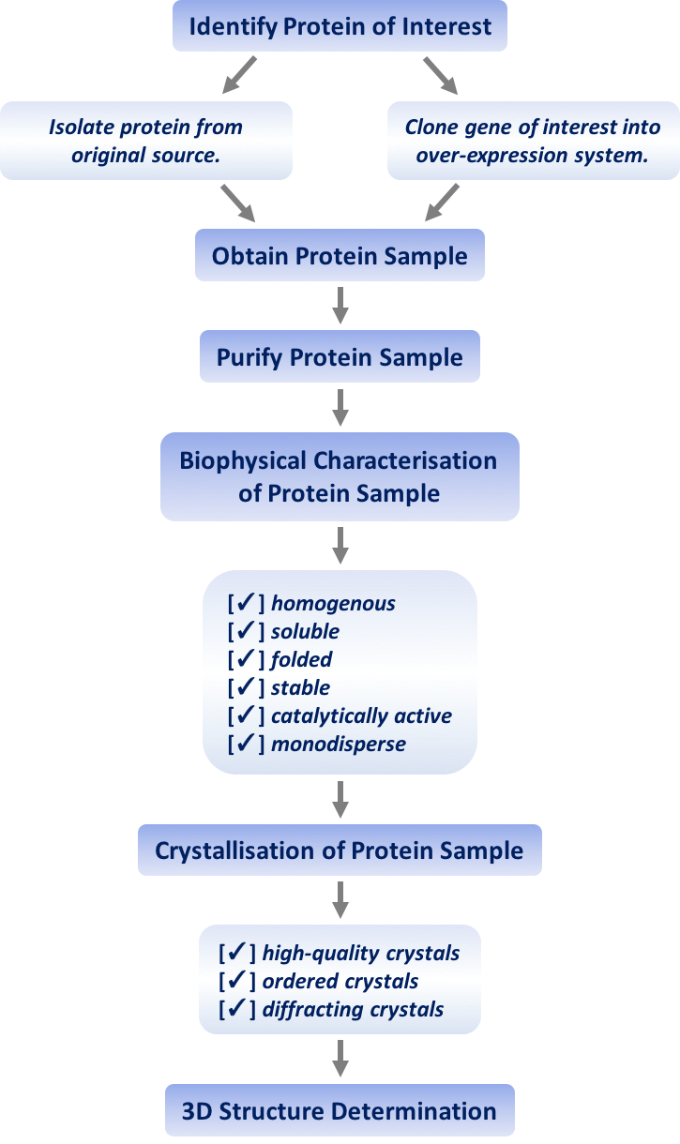
Figure 1: A flow diagram illustrating the key experimental steps preceding protein crystallisation.
The underlying theme of this thesis is the characterisation and crystallisation of biologically significant proteins that are potential drug targets. This thesis details the key stages in attaining a protein sample for crystallisation, namely cloning, expression, purification, and characterisation. The four stages are addressed across three chapters. Protein characterisation is described in Chapter I in terms of measuring protein thermal stability with the Durham Screens in a thermal shift assay (TSA). A wide range of interesting proteins feature in the first chapter. Cloning and expression are reported in Chapter II with regards to Toxoplasma gondii serine palmitoyltransferase (SPT), a potential drug target in apicomplexan parasites. Finally, expression and purification, in particular the optimisation of, are detailed in Chapter III with regards to RisA protein from a two-component regulatory system (TCS) in Bordetella pertussis.
Chapter I: The Development and Testing of a Novel Protein Thermal Stability Screening Kit

This chapter details the application of a high-throughput fluorescence-based assay to the analysis of the thermal stability of protein. The Durham series of thermofluor screens have been designed and developed to identify optimal conditions for protein stability, therefore increasing the likelihood of crystallisation. The Durham Screens have recently been commercialised by Molecular Dimensions Ltd. and marketed as a thermofluor kit to aid in the optimisation of crystallisation. In this chapter, the rationale for the design of each screen will be explained. Protocols for running the assay in multiple bench-top machines will be presented, along with methods for data analysis. Finally, initial data collected using a wide range of protein samples is presented and discussed.

1.1. Introduction

1.1.1. Introduction to the Thermal Shift Assay

A TSA, also known as differential scanning fluorimetry (DSF) or thermofluorometry, is a fluorescence-based assay with extensive applications to studying proteins in solution. Briefly, TSAs have been reported to optimise protein stability for characterisation and crystallisation (Boivin et al., 2013; Ericsson et al., 2006; Vedadi et al., 2006), investigate ligand-binding (Lo et al., 2004; Senisterra et al., 2008), and study DNA-binding (Rupesh et al., 2014).

As a protein scientist investigating the functional and structural aspects of a particular protein, producing a pure homogeneous sample is crucial for subsequent biochemical and biophysical experiments, including crystallisation and crystal structure determination. Despite the availability of general strategies, optimisation of protein production is often experimentally taxing. Low protein stability often corresponds to low purification yields and possible protein degradation or aggregation, all of which are not conducive to crystallisation success (Chayen, 2014). To optimise the expression and purification processes, there are several options. One can change the expression strain or design and produce new constructs that experiment with mutations, truncations or fusions. The latter, however, is not an option if the native and/or full-length protein is of interest. Comparably, running a TSA is a desirably time-efficient high-throughput assay that has low protein and compound consumption. If a purified protein is unstable under certain physiochemical conditions, altering the components of its soluble environment has the potential to slow down and even hinder the unfolding process and therefore increase stability. There are several recognised experiments that assess thermal stability, such as CD against a temperature gradient. CD requires specialist equipment and protein at a reasonably high concentration (mg/mL) (Bertucci et al., 2010). However, a TSA is an inexpensive “fuss-free” method which can be run on many standard real-time polymerase chain reaction (PCR) (RT-PCR) machines. Exploring the pH, buffer, salt and additive conditions available to your protein is often the most cost-effective experiment for optimising protein purification, characterisation and crystallisation.

Understanding protein stability is essential for successful structural studies. To further justify the methodology presented in this chapter, multiple publications have generated a link between stabilising conditions in a TSA and conditions that produce diffracting crystals. Additionally, a TSA is a comparatively reproducible method for investigating protein thermal stability.

1.1.2. The Workings of a Thermal Shift Assay

A non-covalent fluorescent dye is employed to probe protein unfolding during a TSA. The first use of environmentally-sensitive dyes to monitor protein thermal unfolding was by Poklar et al. (1997) followed by the first microplate format of a TSA, facilitating high-throughput, by Pantoliano et al. (2001). More specifically, SYPRO Orange (Thermo Fisher Scientific), a dye originally developed as a stain for native, two-dimensional (2D) and denaturing polyacrylamide gels, enabling the detection of as little as 1 ng of protein (Steinberg et al., 1996a and Steinberg et al., 1996b), is used. Adverse to its original purpose, the fluorescence of SYPRO Orange acts as a proxy for protein thermal denaturation in the context of a TSA. Other fluorescent dyes such as 8-anilino-1-naphthalenesulfonic acid (1,8-ANS), 7-diethylamino-3-(4’maleimidylphenyl)-4-methylcoumarin (CPM), 9-(2,2-dicyanovinyl)julolidine (DCVJ) and Nile Red, for example, can be used in a TSA (Alexandrov et al., 2008; Hawe et al., 2008; Semisotnov et al., 1991; Vollrath et al., 2014). However, these dyes present several issues including the dye competing with ligand for binding pockets and the dye binding to ligand to result in quenched fluorescence. The aforementioned issues are not associated with SYPRO Orange; combined with the excitation and emission wavelengths that are conveniently compatible with most quantitative PCR (qPCR) machines, SYPRO Orange is predominantly used in TSAs.

During a TSA, protein and probe mixture is exposed to ultra-violet (UV) light, facilitating the measurement of fluorescence, and subjected to an increasing temperature gradient that leads to protein unfolding. Protein unfolding is a step-wise process that progressively exposes hydrophobic parts of the protein, defined energetically as a process during which the energy associated with the increase in temperature becomes greater than the strength of the intramolecular forces that govern 3D protein conformation (Boivin et al., 2013).

Summarised by Figure 2, the non-covalent dye used in a TSA takes advantage of the protein unfolding process. SYPRO Orange fluorescence is quenched in aqueous solution. However, as the hydrophobic protein core is exposed during the unfolding process, SYPRO Orange binds non-specifically to hydrophobic amino acids and emits a fluorescence signal; an increase in fluorescence corresponds to protein unfolding. A fluorescence maximum is reached when all protein is denatured. A protein melting temperature (T_{m}) can then be calculated based on the maximum of the first derivative in a defined region of interest. The T_{m} is characterised as the temperature at which half the protein sample is unfolded, and half is folded. A T_{m} calculated from a TSA experiment gives a very good indication of protein stability and is generally accepted to be similar to the actual melting temperature of a protein (Reinhard et al., 2013). Following the peak of fluorescence, the protein continues to denature under high temperatures and eventually aggregates. Protein structure at high temperatures is not well characterised but is hypothesised to be aggregates, random coils and/or fibrils. Protein aggregation is based on hydrophobic interactions, meaning the SPYRO Orange is displaced and a decrease in fluorescence is observed.
Figure 2: A melting curve depicting the protein unfolding process and SYPRO Orange fluorescence during a TSA. The protein is coloured purple and the SYPRO Orange is represented as orange dots.
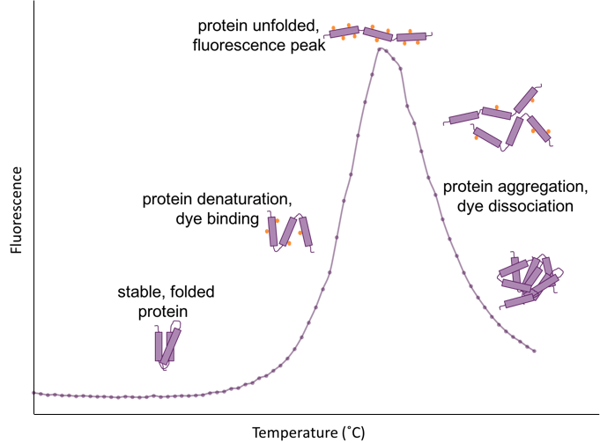
In this chapter, TSAs were applied to the measurement of protein thermal stability in a range of known solutions to ascertain optimum conditions for protein stability and therefore crystallisation. A series of three screens, namely the Durham Screens, were designed to meticulously identify the salt, additive, pH and buffer conditions that thermally stabilise a protein. The experimental results allow the design of tailor-made protein crystallisation trays, and additionally present the opportunity to modify and improve the protein purification protocol. As a simple, inexpensive assay that tests multiple conditions simultaneously, a TSA is a powerful protein stability research tool, especially when combined with the rapid data analysis performed by NAMI (Grøftehauge et al., 2015).

1.1.3. The Design of the Durham Screens

Three 96-well screens, namely the Durham Salt, pH and Osmolyte Screens, were designed and used to assess the thermal stability of pure protein samples. From a crystallographer’s perspective, the ideal use for the Durham Screens is prior to crystallisation, to ascertain stabilising conditions that should be carried forward to bespoke crystallisation trials. The screens could also be used at a point where one has pure protein, to ascertain if the conditions of purification could be altered to optimise protein stability, and therefore yield, throughout the purification and characterisation processes.

Collectively, the screens include an extensive array of physiological and non-physiological compounds and cover a wide range of concentrations and pH values. Small molecules often contribute to protein folding, aggregation and solubility; ligand-induced protein stabilisation is a well-accepted phenomenon (Yeh et al., 2005). In this context, a ligand can be defined as a specific compound, such as a substrate or a substrate analogue that is biologically relevant to the protein, or a non-specific ligand that simply aids in crystallisation. For example, a ferric uptake regulator (Fur) dimer from Pseudomonas aeruginosa has been crystallised with four zinc ions (Zn²⁺) bound (Pohl et al., 2003). Two of these Zn²⁺ ions were described as functionally important, while the other two were considered relevant for crystal packing only (Pohl et al., 2003).

The concept of ligand-induced protein stabilisation is evidenced by the high proportion of entries in the protein data bank (PDB) that have ligands associated with them (Berman et al., 2000); as of 1st June 2016, 86,356 out of a total of 106,403 X-ray structures (~81%) had ligands associated with them (inclusive of metal ions). The set of three Durham Screens exploits the concept of ligand-induced protein stabilisation to probe for the specific requirements of a particular protein to be stable, soluble and active. Surveying salt type and concentration, buffer type and concentration, pH, and additive type and concentration as separate parameters, the Durham Screens serve as a comprehensive tool for the analysis of protein stability. The Durham Screens are here being used in the context of a TSA to quantify ligand-induced conformational stabilisation by measuring a shift in T_{m}, denoted ∆T_{m}, where a positive shift correlates to an increase in protein stability by the reduction of conformational freedom.

An extensive range of widely used and commercially available small molecules is explored in the three screens, and the rational for the design of each screen is discussed in the following sections.

1.1.3.1. The Durham Salt Screen

The Salt Screen is designed to incorporate several main groups of salts, namely: chaotropic reagents (that disrupt hydrogen bonds network), (common laboratory) salts, monovalent ions, multivalent ions, chelating agents, transition metals, heavy metals and reducing agents. Chaotropic reagents at relatively low concentrations have the ability to prevent protein aggregation, while reducing agents are capable of stabilising free cysteine residues on the surface of a protein. Furthermore, as many proteins bind metals in vivo to facilitate correct folding and catalytic activity, adding to their protein stability, an extensive range of transition metal salts were included, covering monovalent and multivalent species. Heavy metal compounds, including magic triangle used for experimental phasing (Beck et al., 2008), were included as such heavy-atom reagents are often used in crystal soaking experiments. Heavy-atom derivatives allow the determination of experimental phases by multiple isomorphous replacement (MIR), producing a solution to the phase problem when no suitable search model is available (Rupp, 2009).

1.1.3.2. The Durham pH Screen

Buffers most commonly used in the lab and most commonly found in crystal structures in the PDB (Newman et al., 2004) were the starting point for the pH Screen; Table 2 details the frequency of five of the most commonly crystallised buffer molecules in the PDB. The regular occurrence of ordered buffer molecules within protein structures infers a stabilising effect of not only pH, but specific buffer molecules themselves. The five buffers displayed in Table 2, along with 23 others, feature in the Durham pH Screen.

Table 2: A summary of the frequency of occurrence of the five most common buffer molecules resolved in X-ray crystal structures in the PDB. Frequency with respect to a total of 106,403 X-ray crystal structures. Numbers correct on the 1st June 2016.
Buffer Molecule | PDB Code | Frequency
phosphate ion | PO4 | 4,340
MES | MES | 953
TRIS | TRS | 931
acetic acid | ACY | 737
citric acid | CIT | 698

The design of the screen specifically allows for the deconvolution of the effects of the chemical nature of the buffer and pH. For each buffer selected, three pH values were chosen based upon the acid dissociation constant (pK_{a}) at 25˚C ± 0.5 pH units. For example, HEPES has a pk_{a} of 7.5 at 25˚C, so pH values of 7.0, 7.5 and 8.0 were included in the screen. For buffer molecules with two pK_{a} values (e.g. bisTRIS propane), two sets of three pH values based around the two pK_{a} values were included in the screen. Overall, a wide pH range of 4.1-10.9 is covered with many overlapping pH values, omitting extremely acidic and alkaline environments in which proteins will most likely not be biologically active. With multiple pH values for each buffer and overlapping pH values, the design of the screen specifically facilitates the deconvolution of the effects of buffer and pH.

1.1.3.3. The Durham Osmolyte Screen

Osmolytes, or compatible solutes, are generally highly soluble molecules that are proven more likely to induce protein stabilisation than destabilisation (Yancey, 2005). Furthermore, from a crystallography perspective, osmolytes are of particular interest as they are valuable cryoprotectants used during the crystal harvesting, mounting and storage processes (Garman and Owen, 2006). The osmolyte screen was designed based on distinguished groups of osmolytes found in the literature. Organic osmolytes can be classed as zwitterionic, non-charged or anionic solutes (Roberts, 2005). More specifically, the Durham osmolyte screen included eight sub-classes of compatible solutes: glycerol, sugars and polyols, non-detergent sulfobetaines (NDSBs), betaines and their analogues, organophosphates, dipeptides, amino acids and their derivatives, and a selection of other various compounds. Once the afore listed subclasses of osmolytes were identified, the literature was searched alongside the PDB and the Dragon Explorer of Osmoprotection-Associated Pathways (DEOP) database of osmoprotectants (Bougouffa et al., 2014). The selection of a specific compound for the screen depended on a multitude of factors; most important were commercial availability, as many organophosphates originally identified could not be purchased, reasonable cost and compound solubility, as the screen is in the liquid state.

1.2. Materials and Methods

1.2.1. Durham Screens Solutions

Table 3, Table 4 and Table 5 detail the compositions of the Durham Salt, pH and Osmolyte Screens, respectively. Appendix 1 lists the stock solutions that were prepared and then diluted to make a 2 X stock of each screen in a 96 deep-well block. All solutions and the 96 deep-well blocks were stored at 4˚C.

Table 3: The composition of the Durham Salt Screen. The final concentration (1 X) of the assay is shown below. The 96 deep-well block contains twice these concentrations (2 X), only to be diluted to half by addition of protein and probe.
12 | 0.2 M Na₃ citrate | 0.2 M (NH₄)₂SO₄ | 0.2 M NH₄Cl | 0.2 M KCl | 0.4 M NaI | 1 mM  CoCl₂ | 2 mM EuCl₃ | 5 mM β-mercapto ethanol
11 | 0.5 M Na₃ citrate | 0.4 M (NH₄)₂SO₄ | 0.4 M NH₄Cl | 0.5 M KCl | 0.1 M NaBr | 0.5 mM MnCl₂ | 2 mM SmCl₃ | 5 mM  TCEP pH 7.5
10 | 5 mM Gu-HCl | 0.6 M (NH₄)₂SO₄ | 0.6 M NH₄Cl | 0.2 M Na₂SO₄ | 0.4 M NaBr | 5 mM MnCl₂ | 2 mM NdCl₃ | 5 mM DTT
9 | 0.2 M Gu-HCl | 0.8 M (NH₄)₂SO₄ | 0.8 M NH₄Cl | 0.4 M Na₂SO₄ | 1.5 M NaBr | 0.1 mM NiCl₂ | 2 mM PrCl₃ | 5 mM Na₂MoO₄
8 | 0.4 M Gu-HCl | 1.0 M (NH₄)₂SO₄ | 1.0 M NH₄Cl | 0.6 M Na₂SO₄ | 0.1 M NaF | 1 mM  NiCl₂ | 2 mM La(NO₃)₃ | 5 mM Na₂WO₄
7 | 0.6 M Gu-HCl | 1.5 M (NH₄)₂SO₄ | 1.5 M NH₄Cl | 0.8 M Na₂SO₄ | 0.4 M NaF | 0.1 mM ZnCl₂ | 2 mM magic triangle  pH 7.0 | 5 mM Na₃VO₄
6 | 0.8 M Gu-HCl | 0.2 M Na₂ malonate | 0.2 M NaCl | 1.0 M Na₂SO₄ | 0.02 M CsCl | 1 mM  ZnCl₂ | 5 mM  EGTA  pH 7.5 | 5 mM Na₂HPO₄
5 | 1.0 M  Gu-HCl | 0.4 M Na₂ malonate | 0.4 M NaCl | 0.2 M MgSO₄ | 0.5 M CsCl | 5 mM SrCl₂ | 5 mM  EDTA pH 7.5 | 2 mM LuCl₃
4 | 3.0 M  Gu-HCl | 0.6 M Na₂ malonate | 0.6 M NaCl | 0.4 M MgSO₄ | 0.2 M RbCl | 5 mM CaCl₂ | 1 mM CdSO₄ | 2 mM YbCl₃
3 | 4 M urea | 0.8 M Na₂  malonate | 0.8 M NaCl | 0.6 M MgSO₄ | 0.5 M RbCl | 5 mM MgCl₂ | 0.1 mM CuSO₄ | 2 mM HoCl₃
2 | water | 1.0 M Na₂ malonate | 1.0 M NaCl | 0.8 M MgSO₄ | 0.2 M LiCl | 0.4 M  MgCl₂ | 1 mM CuSO₄ | 2 mM DyCl₃
1 | water | 1.5 M Na₂ malonate | 1.5 M NaCl | 1.0 M MgSO₄ | 0.5 M LiCl | 0.1 M NaI | 0.1 mM CoCl₂ | 2 mM GdCl₃
 | A | B | C | D | E | F | G | H

Table 4: The composition of the Durham pH Screen. As per Table 3, the table details the final concentration of the assay.
12 | 100 mM succinic acid  pH 5.4 | 100 mM malonic acid  pH 6.2 | 100 mM maleic acid  pH 6.7 | 100 mM ACES  pH 7.3 | 100 mM MOPS  pH 7.6 | 100 mM EPPS  pH 8.5 | 100 mM bisTRIS propane pH 9.5 | 100 mM CAPS  pH 10.9
11 | 100 mM succinic acid  pH 4.9 | 100 mM malonic acid  pH 5.7 | 100 mM maleic acid  pH 6.2 | 100 mM ACES  pH 6.8 | 100 mM MOPS  pH 7.1 | 100 mM EPPS  pH 8.0 | 100 mM bisTRIS propane pH 9.0 | 100 mM CAPS  pH 10.4
10 | 100 mM succinic acid pH 4.4 | 100 mM malonic acid  pH 5.2 | 100 mM maleic acid  pH 5.7 | 100 mM ACES  pH 6.3 | 100 mM MOPS  pH 6.6 | 100 mM EPPS  pH 7.5 | 100 mM bisTRIS propane pH 8.5 | 100 mM CAPS  pH 9.9
9 | 100 mM acetic acid pH 5.2 | 100 mM propionic acid pH 5.3 | 100 mM MES  pH 6.6 | 100 mM bisTRIS  pH 7.1 | 100 mM imidazole pH 7.6 | 100 mM tricine  pH 8.5 | 100 mM TAPS  pH 8.9 | 100 mM glycine  pH 10.2
8 | 100 mM acetic acid pH 4.7 | 100 mM propionic acid pH 4.8 | 100 mM MES  pH 6.1 | 100 mM bisTRIS  pH 6.6 | 100 mM imidazole pH 7.1 | 100 mM tricine  pH 8.0 | 100 mM TAPS  pH 8.4 | 100 mM glycine  pH 9.7
7 | 100 mM acetic acid pH 4.2 | 100 mM propionic acid pH 4.3 | 100 mM MES  pH 5.6 | 100 mM bisTRIS  pH 6.1 | 100 mM imidazole pH 6.6 | 100 mM tricine  pH 7.5 | 100 mM TAPS  pH 7.9 | 100 mM glycine  pH 9.2
6 | 100 mM citric acid pH 5.1 | 100 mM tartaric acid pH 5.3 | 100 mM succinic acid pH 6.6 | 100 mM ADA  pH 7.1 | 100 mM PIPES  pH 7.3 | 100 mM HEPES  pH 8.0 | 100 mM bicine  pH 8.7 | 100 mM CHES pH 9.8
5 | 100 mM citric acid pH 4.6 | 100 mM tartaric acid pH 4.8 | 100 mM succinic acid pH 6.1 | 100 mM ADA  pH 6.6 | 100 mM PIPES  pH 6.8 | 100 mM HEPES  pH 7.5 | 100 mM bicine  pH 8.2 | 100 mM CHES pH 9.3
4 | 100 mM citric acid pH 4.1 | 100 mM tartaric acid pH 4.3 | 100 mM succinic acid pH 5.6 | 100 mM ADA  pH 6.1 | 100 mM PIPES  pH 6.3 | 100 mM HEPES  pH 7.0 | 100 mM bicine  pH 7.7 | 100 mM CHES pH 8.8
3 | 4 M urea | 100 mM malic acid pH 5.3 | 100 mM citric acid pH 6.5 | 100 mM sodium cacodylate pH 6.7 | 100 mM phosphate pH 7.3 | 100 mM bisTRIS propane pH 7.6 | 100 mM TRIS  pH 8.7 | 100 mM boric acid pH 9.6
2 | water | 100 mM malic acid pH 4.8 | 100 mM citric acid pH 6.0 | 100 mM sodium cacodylate pH 6.2 | 100 mM phosphate pH 6.8 | 100 mM bisTRIS propane pH 7.1 | 100 mM TRIS  pH 8.2 | 100 mM boric acid pH 9.1
1 | water | 100 mM malic acid pH 4.3 | 100 mM citric acid pH 5.5 | 100 mM sodium cacodylate pH 5.7 | 100 mM phosphate pH 6.3 | 100 mM bisTRIS propane pH 6.6 | 100 mM TRIS  pH 7.7 | 100 mM boric acid pH 8.6
 | A | B | C | D | E | F | G | H

Table 5: The composition of the Durham Osmolyte Screen. As per Table 3 and Table 4, this table details the final concentration of the assay.
12 | 25 mM  D-maltose | 15 mM myo-inositol | 2 mM adenine | 10 mM hydroxy ectoine | 10 mM acetyl choline | 10 mM Gly-Gly | 50 mM  L-lysine  HCl | 15 mM  L-histidine
11 | 250 mM D-maltose | 135 mM myo-inositol | 50 mM pyrimidine | 100 mM hydroxy ectoine | 100 mM acetyl choline | 100 mM Gly-Gly | 200 mM  L-lysine  HCl | 60 mM  L-histidine
10 | 200 mM  D-sorbitol | 200 mM L-arabinose | 50 mM pyridine | 10 mM ectoine | 10 mM taurine | 10 mM Ala-Leu | 25 mM  L-arginine | 50 mM  β-alanine
9 | 1 M  D-sorbitol | 1 M L-arabinose | 200 mM NDSB-256 | 100 mM ectoine | 100 mM taurine | 100 mM Ala-Leu | 12 mM  L-arginine | 200 mM β-alanine
8 | 20 mM xylitol | 10 mM D-trehalose | 200 mM NDSB-221 | 20 mM sodium butyrate | 10 mM hypo  taurine | 10 mM Ala-Gly | 50 mM  5-oxo  proline | 50 mM  L-alanine
7 | 160 mM xylitol | 65 mM D-trehalose | 200 mM NDSB-211 | 250 mM sodium butyrate | 100 mM hypo  taurine | 100 mM Ala-Gly | 200 mM 5-oxo  proline | 200 mM  L-alanine
6 | 10% glycerol | 50 mM D-glucose | 200 mM NDSB-201 | 20 mM methyl butyrate | 10 mM carnitine | 10 mM Ala-Ala | 50 mM  L-proline | 50 mM trimethyl glycine
5 | 20% glycerol | 500 mM D-glucose | 200 mM NDSB-195 | 250 mM methyl butyrate | 100 mM carnitine | 100 mM Ala-Ala | 200 mM  L-proline | 200 mM trimethyl glycine
4 | 30% glycerol | 25 mM D-galactose | 25 mM D-mannitol | 1 mM spermine HCl | 10 mM sarcosine | 3 mM glyphosate | 50 mM L-glutamine | 50 mM glycine
3 | 4 M urea | 250 mM D-galactose | 250 D-mannitol | 1 mM spermidine | 100 mM sarcosine | 25 mM glyphosate | 200 mM L-glutamine | 200 mM glycine
2 | water | 50 mM D-sucrose | 10 mM maltitol | 2 mM dipicolinic acid | 100 mM TMAO | 10 mM choline | 15 mM  L-glutamic acid | 30 mM  L-citrulline
1 | water | 500 mM D-sucrose | 70 mM maltitol | 10 mM dipicolinic acid | 750 mM TMAO | 100 mM choline | 120 mM  L-glutamic acid | 140 mM  L-citrulline
 | A | B | C | D | E | F | G | H
1.2.2. Thermal Shift Assay Protocol

Figure 3 summarises the protocol. Firstly, 2 X screen solutions were pipetted into 96 deep-well blocks. A Screenmaker 96+8 Xtal (Innovadyne) was used to transfer 10 μL of each screen condition into a 96-well semi-skirted PCR plate for FAST systems (StarLab). 4 μL of 5,000 X SYPRO Orange in DMSO (Thermo Fisher Scientific) was added to 1 mL of pure 0.5-2.0 mg/mL protein sample; protein purity was verified by sodium dodecyl polyacrylamide gel electrophoresis (SDS-PAGE) prior to the assay. Subsequently, 10 μL of protein and probe mixture was pipetted into each well. The final components of each well were 1 X screen solution, 10 X SYPRO Orange, and half the original protein concentration. The plate was then sealed with an advanced polyolefin seal for qPCR (StarLab) and centrifuged at 1,000 rpm for 2 minutes before being loaded onto a 7500 FAST RT-PCR system (Applied Biosystems). The programme used was as follows: a temperature gradient of 24-96˚C was sampled, increasing 1˚C per minute, with a fluorescence reading being taken in every well at every temperature increment. The assay takes advantage of the excitation and emission maxima of SYPRO Orange at 470 nm and 569 nm, respectively (Steinberg et al., 1996a). Hence, a 455-485 nm wavelength range was consistently used for excitation, and emission was collected between 567-596 nm, with the exception being 505-535 nm for one protein, EthR (Tatum, 2015). Appendix 2 details the filters present in the RT-PCR machine used. On completion of the assay, raw data was exported as a .csv file for analysis. The whole process, summarised in Figure 3, takes less than two hours.
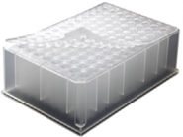
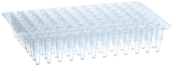
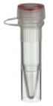

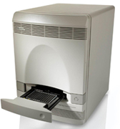
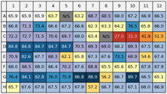
Figure 3: An overview of the TSA protocol used (adapted from Boivin et al., 2013).
5000 X SYPRO Orange in DMSO
protein at 0.5-2.0 mg/mL
2 X Durham Salt, pH or Osmolyte screen
4 μL
Protein in 20 X SYPRO Orange
96-well semi-skirted PCR plate for FAST systems
10 μL per well
1 X Durham Screen + 10 X SYPRO Orange + half original protein concentration
(20 μL total)
10 μL per well using Screenmaker 96+8 Xtal (Innovadyne)
centrifuge 1,000 RPM, 2 minutes, 4˚C
7500 Fast RT-PCR System
24-96˚C gradient, 1˚C per minute
excitation: 455-485 nm
emission: 567-596 nm or 505-535 nm
1 mL
export data
data analysis in NAMI

1.2.3. Thermal Shift Assay Data Analysis

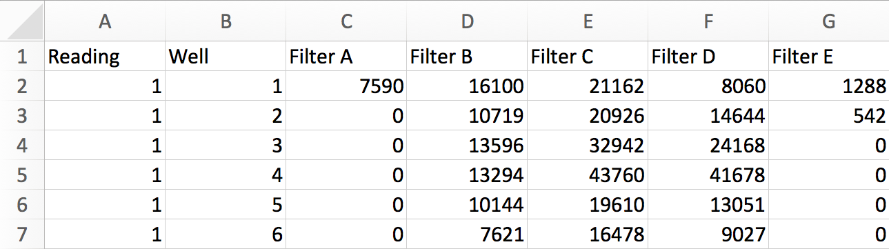
NAMI, a rapid high-throughput graphical user interface (GUI)-based Python programme, was used for TSA data analysis and interpretation (Grøftehauge et al., 2015). Raw data as a .csv file (Figure 4) was used as the input into the programme. When analysing Durham Screens data, a .sol file was also uploaded that specified the contents of each well to facilitate further data analysis options in NAMI. The .sol files were written using a simple comma-separated-values format (Appendix 3).
Figure 4: A screenshot of the .csv file inputted into NAMI. Column A refers to the temperature reading, followed by the well number in column B. Columns C-G hold the SYPRO Orange emissions data, where each column represents a different filter present in the RT-PCR machine (Appendix 2). Most important is column E, or Filter C, which was used for data analysis in all cases (except for EthR protein).

Following the upload of .csv and .sol files, the user indicates which columns contain the temperatures, well numbers, and SYPRO Orange emissions data to be analysed (Figure 5). Looking at Figure 4, column 5 corresponds to Filter C data that was analysed in all cases expect one, EthR, for which Filter A was used. Subsequently, the settings can be applied and data analysis is initiated. NAMI operates through python, allowing the data analysis and T_{m} determination to be observed in the control terminal window.
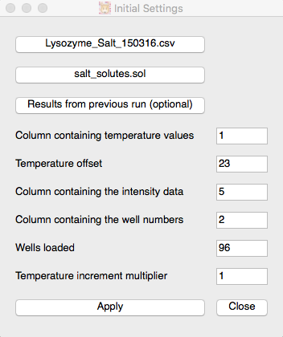
Figure 5: The user-friendly data input window of NAMI. A .csv file is uploaded (here, the Salt Screen data for lysozyme), followed by a .sol file that details the conditions in each well of the screen. Looking at Figure 4, the user indicates to NAMI that the temperature values are column 1 and the temperature offset is 23; this means that 23 will be added to every number in the first column to convert the numbers to the actual temperatures sampled (24-96˚C). Furthermore, the user inputs that column 5 corresponds to Filter C data, the well numbers are column 2, and that 96 wells (the whole plate) have been used. Finally, the temperature increment multiplier is set to 1 as the temperature gradient increased 1˚C per minute. The settings can then be applied and data analysis begins.
The output of data analysis is a melting curve for the protein sample in each well and a T_{m} value calculated based upon the maximum of the first derivative in a region of interest (Hajizadeh, 2014), where more than one region of interest corresponds to more than one melting point. This method is more accurate than using the midpoint of the transition curve to estimate a T_{m} (Vedadi et al., 2006). The region of interest is defined independently by NAMI. The T_{m} values are generated in a results.csv file. T_{m} data are then (optionally) converted into a color-coded tabular representation of the 96-well plate, where colours yellow to red indicate a decrease in melting temperature and protein destabilisation, and colours light blue to dark blue indicate an increase in melting temperature and protein stabilisation (Figure 6). Furthermore, green specifies the detection of two melting temperatures meaning that the sample has undergone a multi-phase thermal denaturation. This could be explained by a multi-domain protein or a sample containing a mixture of proteins, the latter being unlikely in this case. Finally, N/S (grey) denotes no signal detected due to either protein denaturation occurring before the start of the assay or a lack of protein present in the well. The T_{m} values presented in the color-coded table are coloured based on a comparison to a reference temperature which, in this case, is always an average of the water readings (wells A1 and A2 of all three screens). The user additionally specifies how different a T_{m} value must be from the reference value in order for it to be counted as significant. The colour-coded T_{m} table produced by NAMI is a highly efficient way of initially analysing and comparing the results of the screens.
Figure 6: The colour scale used in the tabulated data output from NAMI, including the multiphase denaturation and no signal colours.
increasing protein stability
decreasing protein stability
reference temperature
multiphase protein denaturation
no signal (N/S)

With rapid automatic data analysis and a colour-coded results output, NAMI facilitates the simple and timely identification of protein stabilising conditions that can be utilised to improve protein purification or carried forward to crystallisation trials.

1.2.4. Alternative Protocol: Prometheus NT.48 DSF Machine (NanoTemper)

The main purpose of this experiment was to ascertain if the TSA protocol presented in Section 1.2.2. could be adapted for use with other machines. The Prometheus NT.48 DSF machine (NanoTemper) was used to collect T_{m} data for hen egg white lysozyme (HEWL) with all three Durham Screens. Using the Prometheus NT.48 machine can be described as a native DSF technique because no dye is required. The Prometheus NT.48 measures intrinsic protein fluorescence from tryptophan and tyrosine residues over a temperature gradient as a proxy for monitoring protein unfolding (Temel et al., 2016). Similarly, in the original protocol presented in Section 1.2.2., SYPRO Orange is used as a proxy to measure protein denaturation.

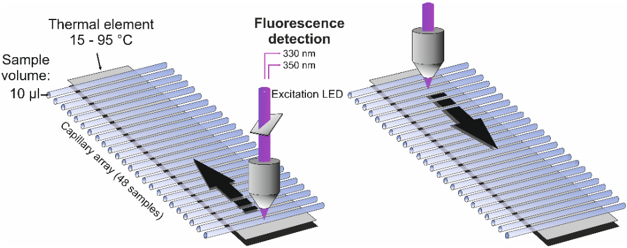
The capacity of the Prometheus NT.48 machine used was 48 capillaries, each with a volume of 10 μL, with a requirement for the capillaries to be filled and loaded into the machine individually and by hand. For each screen condition being tested a 20 μL sample, consisting of 10 μL of protein and 10 μL of the screen condition, was prepared to allow easy loading of the capillaries by capillary action (Figure 7).
Figure 7: A diagram, taken from www.nanotemper-technologies.com, detailing the capillary format of the Prometheus NT.48 machine.

The programme used was a temperature gradient of 20-95˚C, increasing at 2˚C per minute. Using an excitation wavelength of 280 nm, fluorescence emission was measured at both 330 nm and 350 nm every three seconds throughout the assay. Intrinsic protein fluorescence will depend on the amino acid content and fold of the protein in question. Before the experiment begins, the Prometheus NT.48 machine performs a test screen to record initial fluorescence signals. This allows for the light-emitting diode (LED) power to be altered (from a default setting of 10%) so that the level of initial fluorescence recorded is within a suitable detection range for the experiment. NAMI was not used for data analysis in this case; software accompanying the machine analysed the data and used the first derivative of the change in ratio of 350/330 nm emission to calculate a T_{m}.

1.3. Durham Screens Thermal Shift Assay Results and Discussion

The three Durham Screens have been extensively tested on a wide range of proteins; Appendix 4 shows a comprehensive list of the 24 assays run to date using 9 different proteins. Data for each of the 9 proteins is presented below in Sections 1.3.1.-1.3.8. and was collected on the 7500 FAST machine. In Section 1.3.9., data collected with the Prometheus NT.48 machine is presented, discussed and compared with data collected on the 7500 FAST machine.

1.3.1. Bovine Serum Albumin

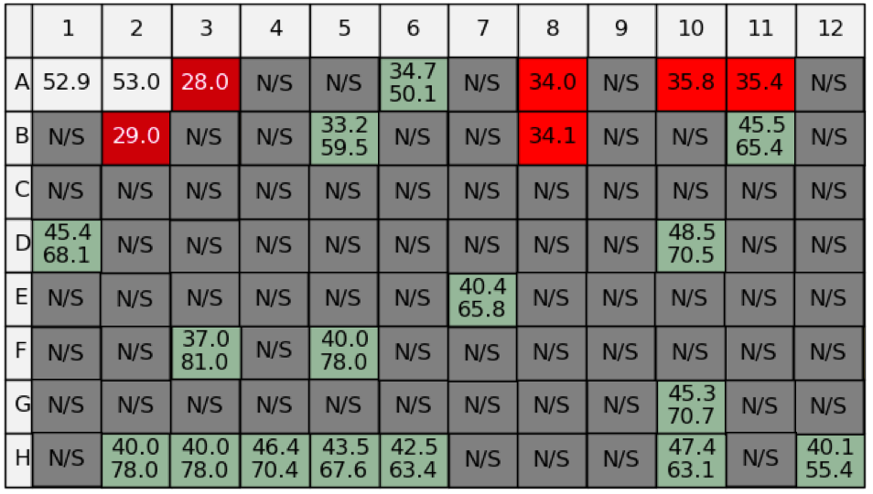
Bovine serum albumin (BSA) (Alfa Aesar) is a protein derived from cows commonly used as a standard in Bradford assays for protein concentration determination (Bradford, 1976). As a well-characterised and commonly used standard protein, the Durham Screens were tested on BSA. However, the results were abnormal and the colour-coded table could not be interpreted (Figure 8).
Figure 8: The uninterpretable color-coded tabulated results of the Durham Salt screen run on BSA. NAMI couldn’t detect a signal or detected two melting points in a majority of wells because SYPRO Orange was most likely bound to BSA and fluorescently active from the outset of the assay.

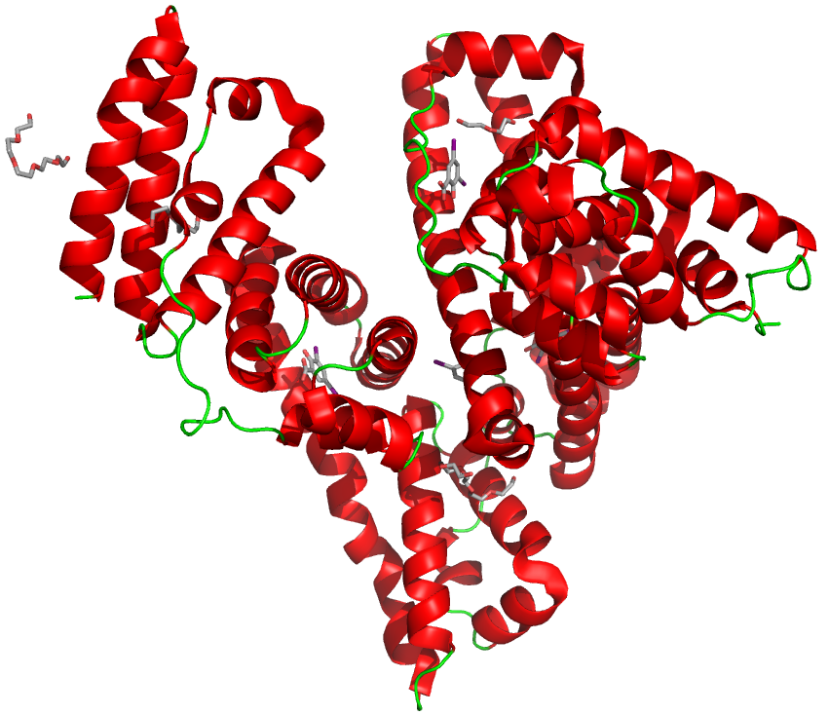
The BSA data collected revealed the issue of using a protein with a high level of solvent-exposed hydrophobic groups (Figure 9) in a TSA with SYPRO Orange. If a protein naturally has exposed hydrophobic side-chains then any TSA data collected with SYPRO Orange will be unintelligible; SYPRO Orange binds to the hydrophobic side-chains and emits a fluorescence signal when protein denaturation has not yet been triggered by the temperature gradient.
Figure 9: A ribbon diagram highlighting the multiple solvent-exposed hydrophobic binding sites of BSA as ball-and-stick models. The ribbon diagram is based on the crystal structure published by Sekula et al., 2013 and deposited in the PDB under accession code 4JK4. Multiple ligands resolved in the final crystal structure (including triethylene glycol, pentaethylene glycol, di(hydroxyethyl)ether and 2-hydroxy-3,5,-diiodo-benzoic acid) are additionally shown as ball-and-stick models binding to the surface hydrophobic residues.

This experiment provides the opportunity to potentially explore the use of other dyes (mentioned earlier in Section 1.1.2.) in the assay.

1.3.2. Cellular Retinoic Acid Binding Protein II

Cellular retinoic acid (RA) binding protein type II (CRABPII) is a small cytosolic protein that binds RA and transfers it to the nucleus. RA is essential for the regulation of vertebrate cell growth and differentiation (Li, 1999; Newcomer et al., 1998). The CRABPII sample used for TSA data collection in this thesis was from Homo sapiens, recombinantly expressed in Escherichia coli, and the results have been compared to two major publications featuring crystal structures also of the human protein form.

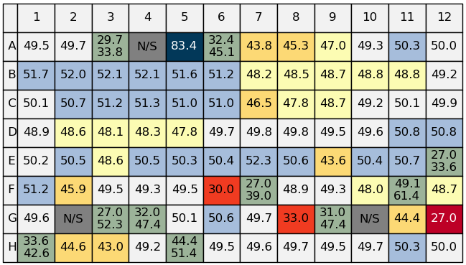
Chen et al., 1998, crystalized apo-HsCRABPII in 0.1M Tris-HCl pH 8.0, 0.2 M sodium acetate and 30% (v/v) polyethylene glycol (PEG) 8000. A later publication details the crystallisation of apo-HsCRABPII in 0.1 M bisTRIS propane pH 6.5 and 30% (v/v) PEG 4000 and CRABPII in complex with RA in 0.1 M sodium citrate / citric acid pH 5.4, 0.2 M ammonium acetate and 30% (v/v) PEG 4000 (Vaezeslami et al., 2006). Looking at the Salt Screen data (Figure 10), sodium malonate (wells B1-B6) offers a particularly stabilising affect at concentrations 0.2-1.5 M. Sodium chloride at 0.2-1.0 M (wells C2-C6) is also a top stabilising additive for HsCRABPII. Ammonium acetate does not feature in the screen. However, both ammonium sulfate (wells B7-B12) and ammonium chloride (wells C7-C12) destabilise HsCRABPII; ammonium in general may be a destabilising additive for this protein.
Figure 10: The color-coded tabulated results of the Durham Salt Screen run on HsCRABPII.

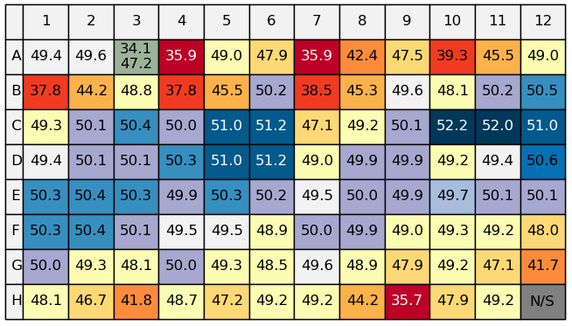
The pH Screen results show a general trend that extremely acidic and extremely alkaline conditions destabilise HsCRABPII. The mid-section of the tabulated results (rows C-F of Figure 11) are generally stabilising conditions and correspond to a pH range of 5.5-8.5. This range of pH stability coincides with the recorded pHs of crystallisation being 5.4, 6.5 and 8.5 (Chen et al., 1998; Vaezeslami et al., 2006). Specifically, the pH Screen shows maleic acid to be the most stabilising buffer at all the pH values (wells C10-C12). Succinic acid, ADA and phosphate buffers are also favourable (wells C4-C6, D4-D6 and E1-E3, respectively). BisTRIS propane features in the screen, in wells F1-F3, and stabilises the sample at pH values 6.6, 7.1 and 7.6, very similar to the aforementioned crystallisation condition of pH 6.5.
Figure 11: The color-coded tabulated results of the Durham pH Screen run on HsCRABPII.

Overall, there is an excellent correlation between the pH Screen data and the pH and buffer conditions HsCRABPII has been previously crystallised. Thus, this data is a perfect example of the validity of using the Durham Screens to help direct crystallisation experiments.

1.3.3. Erythrin Domain of Membrane-Bound Ferritin A

Here, the protein sample tested was the purified erythrin domain of the multimeric membrane-bound ferritin A (MBFA) protein from Brucella suis, a gram-negative pathogen that causes a highly contagious zoonosis called brucellosis in humans and other animals (Andrews, unpublished). MBFA is an essential iron homeostasis protein, thus presenting an opportunity to study the stability of a potential brucellosis drug target (Almirón and Ugalde, 2010).

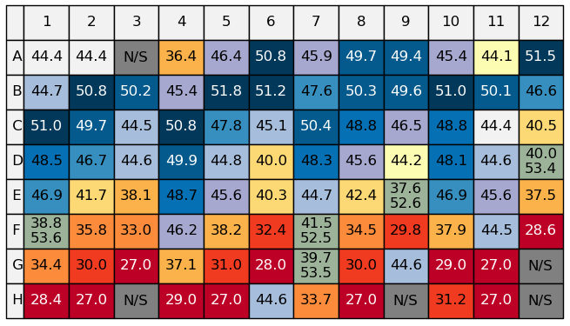
The pH data set, summarised in Figure 12, was specifically interesting. The assay revealed a trend that the protein favours acidic environments and becomes thermally unstable in alkaline conditions. The erythrin domain was being purified in HEPES pH 7.0 buffer, corresponding to well F4, with a T_{m} of 46.2˚C; here the sample is only marginally stabilised. The results prompted a change in purification buffer to MES pH 6.0, represented by well C8 with a T_{m} of 48.8˚C, resulting in a greatly increased yield of pure protein from less than 1 mg/mL to greater than 3 mg/mL.
Figure 12: The color-coded results table of the pH Screen run on erythrin. In particular, note wells F4 and C8 and F4 which are discussed.

This data set is a key example of the use of the Durham Screens in a pre-crystallisation setting to improve purification to generate a greater quantity of protein for further biophysical and structural studies.

1.3.4. EthR

Figure 13 and Figure 14 show the results for the Salt and pH Screens, respectively, run on EthR protein from Mycobacterium tuberculosis, the causative agent of tuberculosis. EthR is a transcriptional repressor involved in down-regulating the activation of prodrug ethionamide and, as a potential drug target, has been characterised both functionally and structurally (Frénois et al., 2006).
Figure 13: Results of the MtEthR Salt Screen assay. In particular, note wells B1-B12 and D8 which are discussed.
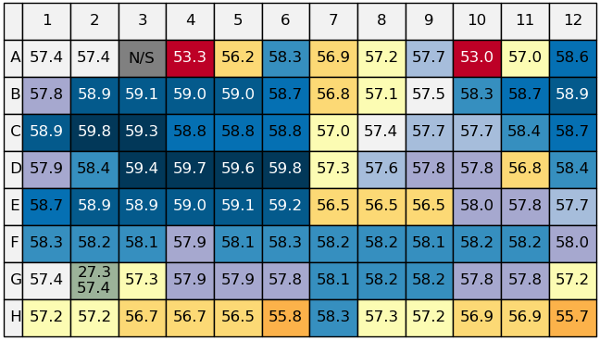
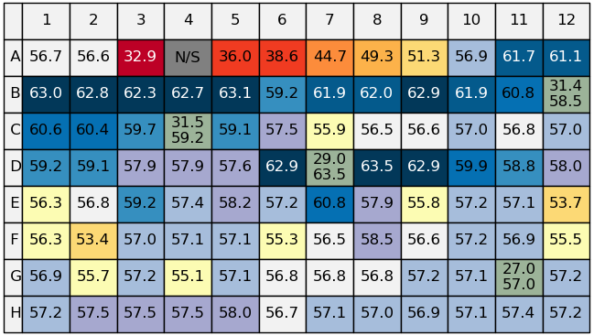
This data in particular allows for the comparison of thermally stabilising conditions and known crystallisation conditions. M. tuberculosis EthR was successfully crystallised in 0.17 M ammonium sulfate, 0.085 M sodium cacodylate pH 6.5, 15% (v/v) glycerol and 45% (v/v) PEG (Frénois et al., 2004). On comparison with the results of the Salt and pH Screens, which feature both ammonium sulfate and sodium cacodylate, MtEthR is stabilised by ammonium sulfate (wells B7-B12 in Figure 13) and is also stabilised by sodium cacodylate buffer (wells D1-D3 in Figure 14)
Figure 14: Results of the MtEthR pH Screen assay. In particular, note wells C2, D1-D3 and D6 which are discussed.
Interestingly, citric acid pH 6.0 and ADA pH 7.1 (wells C2 and D6 in Figure 14) offer the most thermal stability to MtEthR in the pH Screen. However, those two buffers are not prevalent in the literature for biophysical and structural EthR studies. Additionally, sodium malonate (wells B1-B6 in Figure 13) and 0.6 M sodium sulfate (well D8 in Figure 13) maximise protein thermal stability in the Salt Screen. Ammonium sulfate features in the crystallisation conditions so sulfate, in general, may increase MtEthR thermal stability.

The MtEthR salt and pH data sets evidence a link between thermal stability and crystallisation conditions as conditions that significantly stabilised MtEthR correlate well with known crystallisation conditions for MtEthR. Such data reinforces the connection between thermal stability and crystallisation likelihood, further promoting the use of the Durham Screens to aid protein studies.

It is noteworthy that a different wavelength range was used for the collection of fluorescence emission in the case of EthR; fluorescence was detected between 505-535 nm as opposed to 455-485 nm. A possible explanation for this phenomenon is that the exact binding mode of SYPRO Orange to EthR, which will affect the fluorescence emission signal, is unknown and unpredictable. It is not possible to determine whether SYPRO Orange binding occurs when EthR is partially or fully unfolded. EthR binds hydrophobic compounds in vivo (Tatum, 2015), and having a natural affinity for hydrophobic molecules may influence the binding of SPYRO Orange to EthR in the context of a TSA.

1.3.5. Glutathione S-Transferase 1

Here, the protein sample tested was the glutathione S-transferase (GST) 1 from black-grass species Alopecurus myosuroides, a major weed of wheat in Europe (Reade and Cobb, 2002). GST-1 is thought to play a role in the development of multiple herbicide resistance in black-grass, leading to negative implications on the agricultural industry. A GST-1 orthologue from Zea mays has been crystallised in 0.1 M MES pH 6.0, 0.3 M magnesium acetate, 5 mM lactoylglutathione and 22% (v/v) PEG (Neuefeind et al., 1997).

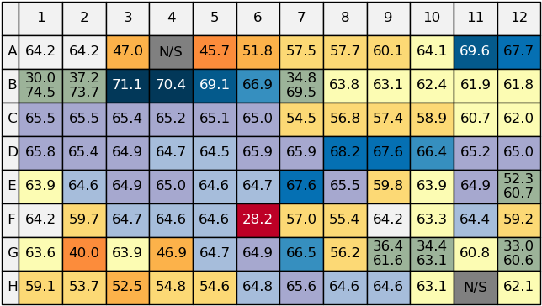
As evident in Figure 15, 0.2-0.5 M sodium citrate (wells A11-A12) and 0.4-0.8 M sodium malonate (wells B3-B5) were particularly stabilising, along with Na₂SO₄ and NaF (wells D8-D10 and E7, respectively).
Figure 15: Color-coded tabulated results of the Durham Salt Screen run on AmGST-F1.
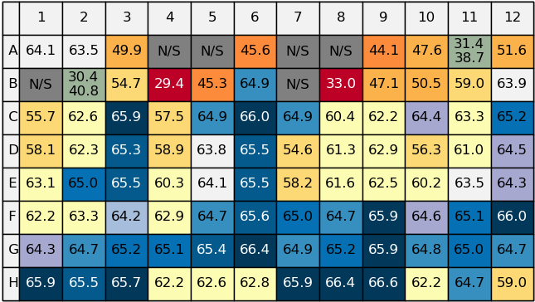
Interestingly, MES pH 6.1 destabilised AmGST-F1 (well C8 of Figure 16), whereas buffers at a higher pH conferred greater thermal stability; for example, boric acid pH 8.6-9.6 and glycine pH 9.2-10.2 (wells H1-H3 and H7-H9, respectively).
Figure 16: Color-coded tabulated results of the Durham pH Screen run on AmGST-F1.
The osmolyte screen results, shown in Figure 17, highlight 1 mM D-sorbitol (well A9) and 750 mM TMAO (well E1) as significantly stabilising conditions. Conversely, 10 mM dipicolinic acid (well D1) and 10 mM Ala-Ala (well F6) significantly reduced the thermal stability of AmGST-F1. The effect of such additives is noteworthy for future crystallisation efforts.
Figure 17: Color-coded tabulated results of the Durham Osmolyte Screen run on AmGST-F1.
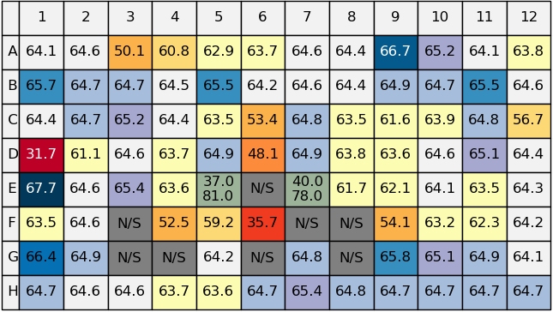
The stark differences observed between the ZmGST-F1 crystallisation conditions and the thermally stabilising conditions of AmGST-F1 could be explained by the relatively low sequence identity of only 48% (pairwise sequence alignment using Needle (McWilliam et al., 2013)); this sequence difference is too large to infer any similarity between the 3D protein folds of AmGST-F1 and ZmGST-F1. Importantly, the TSA data gathered using all three Durham Screens could most certainly guide future crystallisation trials of AmGST-F1 as several salts, buffers and additives have been identified as stabilising agents for this particular protein.

1.3.6. Hen Egg White Lysozyme

HEWL, like BSA in Section 1.3.1., is a fully studied and characterised protein. An electron density map of HEWL from Gallus gallus published in 1965 describes the crystals being grown at pH 4.7 in the presence of 1 M NaCl (Blake et al., 1965); G. gallus, a bird species commonly known as the Red Junglefowl, is the widely accepted primary progenitor of the domestic chicken. Currently, there are over 350 refined X-ray crystal structures of GgHEWL deposited in the PDB, covering monoclinic (Harata, 1994), orthorhombic (Sukumar et al., 1999), tetragonal (Vaney et al., 1996) and triclinic (Walsh et al., 1998) crystal forms. Generally, GgHEWL crystallises at an acidic pH of approximately 4.0-5.0. Sodium acetate buffer with a sodium nitrate additive yields monoclinic crystals, whereas a sodium acetate buffer with a sodium chloride additive produces tetragonal crystals (De la Mora et al., 2011; Harata, 1994). Furthermore, HEWL has been recorded crystallising in the presence of additives such as sucrose and sorbitol (Datta et al., 2001).

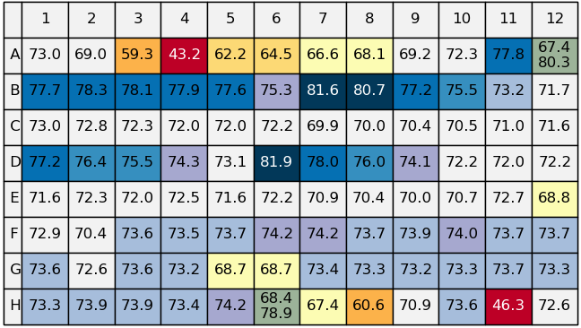
Figure 18 displays the results for the Durham Salt Screen. GgHEWL was most stabilised by 0.6-1.5 M (NH₄)₂SO₄ (wells B7-B10) and 0.4-1.0 M Na₂SO₄ (wells D6-D9); sulfate ions appear to be particularly stabilising. Interestingly, all NaCl concentrations tested did not significantly thermally stabilise or destabilise HEWL (wells C1-C6). Interestingly, 5 mM sodium tungstate and 5 mM TCEP were distinct destabilisers in the Salt Screen (wells H8 and H11, respectively).
Figure 18: Color-coded tabulated results of the Durham Salt Screen run on GgHEWL.

As evidenced by Figure 19, sucrose and sorbitol both thermally stabilise HEWL; 1 mM D-sorbitol (well A9) yielded a ∆T_{m} value of +8.95˚C, while 500 mM sucrose (well B1) produced a ∆T_{m} value of +7.75˚C. This TSA data supports the published use of such additives in the X-ray crystallography of GgHEWL (Datta et al., 2001).
Figure 19: Color-coded tabulated results of the Durham Osmolyte screen run on GgHEWL.
Overall, the results of the Durham Screens for HEWL have revealed many additives that are thermally stabilising but do not appear in the literature for HEWL crystallisation. HEWL is an exceptionally well-studied protein that is amenable to crystallisation in multiple crystal forms; its relatively high crystallisability could be explained by the many stabilising conditions unearthed by the Durham Screens.

1.3.7. Peroxidase

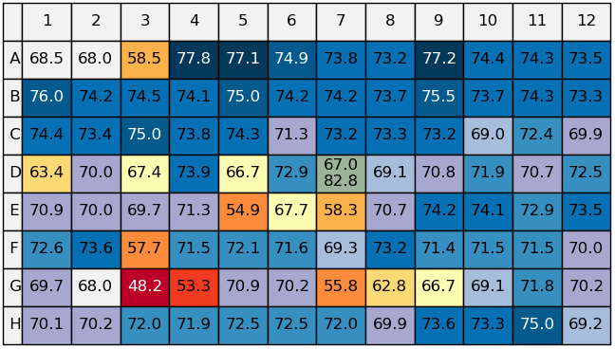
Peroxidase from Armoracia rusticana (horseradish) is an extensively studied oxidoreductase enzyme that has previously been biophysically and structurally characterised (Berglund et al., 2002; Henriksen et al., 1998). A. rusticana peroxidase has been successfully crystallised in 0.1 M cacodylate buffer pH 6.5 and 0.1 M (NH₄)H₂PO₄ (Henriksen et al., 1998) and also 0.1 M sodium cacodylate pH 6.5, 0.2 M calcium acetate and 20% (v/v) PEG 8000 (Carlsson et al., 2005).

Looking at the Salt Screen data (Figure 20), A. rusticana peroxidase is significantly stabilised by both 5mM CaCl₂ (well F4) and 5 mM SrCl₂ (well F5). This coincides with the use of calcium in previous structural studies. Various other transition metal salts also stabilised peroxidase, including NiCl₂ and MnCl₂.

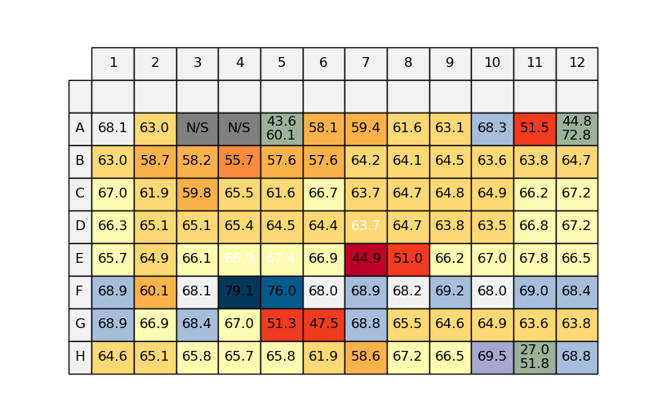
Figure 20: Results of the Durham Salt screen run on A. rusticana peroxidase.
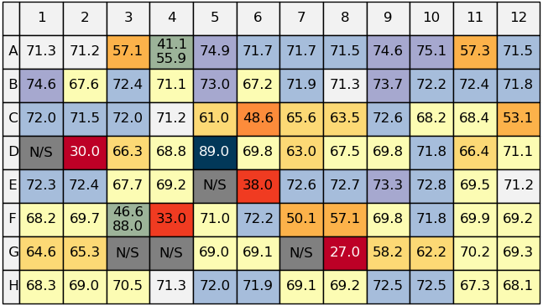
From the Osmolyte Screen data (Figure 20), A. rusticana peroxidase is significantly destabilised by 2 mM dipicolinic acid (well D2), 3mM glyphosate (well F4) and 50 mM 5-oxoproline (well G8). Most stabilising is 250 mM methyl butyrate (well D5). Many sugars and their derivatives confer a positive ∆T_{m}, such as xylitol, D-sorbitol and maltitol.
Figure 21: Results of the Durham Osmolyte screen run on A. rusticana peroxidase.

Generally, the TSA results for A. rusticana peroxidase illustrate the potential benefits of including osmolyte compounds in crystallisation trials. Many molecules in the Osmolyte Screen conferred a positive ∆T_{m} for A. rusticana peroxidase, yet there is very little record of such sugars and amino acids being used in the literature.

1.3.8. Serine Palmitoyltransferase

SPT is an enzyme that catalyses the first step of sphingolipid biosynthesis in all eukaryotes, plants, fungi and some bacteria (Riethmüller et al., 2006). Toxoplasma gondii is an obligate intracellular parasite that causes toxoplasmosis; TgSPT is viewed as a potential drug target due to the role of sphingolipids in the infection process of apicomplexan parasites (Coppens, 2013). SPT from a variety of Apicomplexan parasites is discussed in more depth in Chapter II of this thesis. However, for TSA analysis in this chapter, two different constructs of TgSPT1 were used, namely F6 and H6. Table 6 summarises the key differences between the two constructs used.
Table 6: Summary of the two different TgSPT1 truncations used for TSA analysis.
Construct | Truncation | aaN | aaC | Truncated Protein (kDa)
TgSPT1 F6 | ∆158 | 159 | 571 | 45.98
TgSPT1 H6 | ∆180 | 181 | 571 | 43.29

1.3.8.1. Comparison of Thermal Shift Assay Data to Known Crystallisation Conditions

Bacterial SPT from Sphingomonas paucimobilis has been crystallised (Yard et al., 2007), while mammalian and apicomplexan SPT remains to be structurally studied. SpSPT and TgSTP1 have a sequence similarity of 25.8% (Appendix 5) (pairwise sequence alignment using Needle (McWilliam et al., 2013)), implying that structural similarities are not expected. While the overall fold of the enzymes will be conserved, there will be significant differences in terms of loops and local arrangements. The bacterial form is a soluble homodimer with both subunits contributing to catalysis. Contrastingly, the eukaryotic homologues are hypothesised to be membrane-bond heterodimers where one subunit is regulatory and the other is catalytically active. The TgSPT constructs that feature in this thesis have had the N-terminal membrane-spanning domain removed. This stark difference in active conformation and localisation between prokaryotic and eukaryotic SPT is evident in the contrasting TSA results presented below.

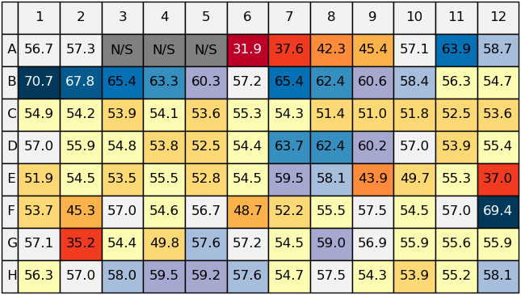
The SpSPT sample for crystallisation was dialysed into 10 mM Tris pH 7.5, 150 mM NaCl and 25 μM pyridoxal-5’-phosphate (PLP) following purification. The sample crystallised in 0.10 M HEPES pH 6.5, 0.11 M MgCl₂ and 21% (v/v) PEG 3350 (Yard et al., 2007). Salt screen data for both F6 and H6 constructs is shown in Figure 22 and Figure 23, respectively.
Figure 22: The results of the TgSPT1 F6 Salt Screen TSA.
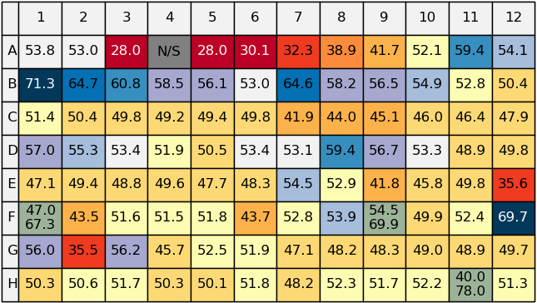
As illustrated in Figure 22 and Figure 23, both the F6 and H6 constructs are thermally destabilised by all concentrations of NaCl and MgCl₂ in the Durham Salt Screen (wells C1-C6 and F2-F3 respectively).
Figure 23: The results of the TgSPT1 H6 Salt Screen TSA.

Overall, the conditions in which SpSPT was crystallised contradict the most stabilising conditions for TgSPT F6 and H6 in the Durham Screens. Such differences in stabilising conditions can be explained by the contrasting predicted structural differences between eukaryotic and prokaryotic SPT. With such low-level sequence identity (25.8%), completely unrelated crystallisation conditions are to be expected.
1.3.8.2. Comparison of Thermal Shift Assay Data of Different Constructs

Following on from Section 1.3.8.1., it is valuable to compare results for different constructs of the same protein. The F6 and H6 constructs of TgSPT1 differ at their N-terminus; F6 is missing 158 (∆158) residues and H6 is missing 180 (∆180) resides, making H6 the shorter construct (Table 6). The constructs differ in long-term stability, solubility and catalytic activity (Thye, 2014); understanding thermal stability differences between the two constructs could help explain the differences in such key parameters for crystallisation.

Generally, when comparing the results tables for the F6 and H6 TSA results (Figure 22 and Figure 23), the color-coding is very similar; both SPT constructs are stabilised by the same conditions. Particularly stabilising Salt Screen conditions for both constructs include 0.5 M sodium citrate (well A11), 0.8-1.5 M sodium malonate (wells B1-B3) and 1 mM CoCl₂ (well F12).

A common theme is that the F6 T_{m} values are higher than the equivalent T_{m} values for the H6 construct; this is evidenced by the average T_{m} value for each construct across the 96 wells of each screen. As shown in Table 7, the average T_{m} value of the F6 Salt and pH Screens is distinctly higher than the average for the equivalent H6 assays. However, the osmolyte screen results show very little difference.
Table 7: The average T_{m} values across all 96-wells of the Durham Salt, pH and Osmolyte screens for both the F6 and H6 constructs of TgSPT1.
 | Average T_{m} Across All 96 Wells (˚C)
 | Salt | pH | Osmolyte
TgSPT1 F6 | 54.9 | 49.9 | 52.5
TgSPT1 H6 | 50.7 | 45.4 | 52.6

Overall, the F6 construct is the most soluble, stable and catalytically active construct and is therefore the most desirable crystallisation target (Thye, 2014). Therefore, the expression and purification work in Chapter II specifically utilises the F6 construct of TgSPT1. The TSA data collected using the Durham Screens in this chapter supports the choice to work with TgSPT1 F6 and aids in the explanation of the greater stability and solubility of the F6 construct compared to other N-terminal truncations.

1.3.9. Protein Melting Temperature Data Collected with the Prometheus NT.48 Machine

For the purpose of initially testing the suitability of the Prometheus MT.48 machine for collecting T_{m} data with the Durham Screens, only wells A1-B12 (the first 24 conditions) of each screen were run. In total, 72 screen conditions were tested using HEWL protein dissolved in water at a concentration of 2 mg/mL. HEWL was chosen as it is a standard protein for which complete data sets have been collected for all three screens using the 7500 FAST system (Section 1.3.6.).

1.3.9.1. Comparison of Hen Egg White Lysozyme Protein Melting Temperature Data Collected with the 7500 FAST and Prometheus NT.48 Machines

The data produced can easily be compared to the data originally collected using the 7500 FAST machine. Table 8 lists the data collected on both the 7500 FAST and Prometheus NT.48 machines for wells A1-B12 of all three Durham Screens. The differences in the T_{m} values are presented in Table 9 and Table 10 shows the average differences in T_{m} values for sets of 12 wells.
Table 8: Comparison of T_{m} data for wells A1-B12 of all three Durham Screens, using 2 mg/mL HEWL in water, collected with the 7500 FAST and Prometheus NT.48 machines.
Well | T_{m} (˚C)
Well | Salt |  | pH |  | Osmolyte
Well | 7500 FAST RT-PCR | Prometheus NT.48 | 7500 FAST RT-PCR | Prometheus NT.48 | 7500 FAST RT-PCR | Prometheus NT.48
A1 | 73.0 | 76.2 | 73.4 | 76.3 | 68.5 | 76.6
A2 | 69.0 | 76.4 | 72.6 | 76.4 | 68.0 | 76.6
A3 | 59.3 | 57.6 | 58.8 | 61.9 | 58.5 | 61.7
A4 | 43.2 | 46.3 | 71.2 | 74.9 | 77.8 | 81.0
A5 | 62.2 | 64.1 | 73.3 | 76.2 | 77.1 | 79.6
A6 | 64.5 | 67.2 | 72.0 | 75.6 | 74.9 | 77.4
A7 | 66.6 | 68.8 | 73.1 | 76.9 | 73.8 | 76.1
A8 | 68.1 | 71.0 | 72.8 | 76.9 | 73.2 | 75.7
A9 | 69.2 | 72.3 | 72.3 | 76.4 | 77.2 | 80.3
A10 | 72.3 | 73.9 | 72.1 | 75.9 | 74.4 | 77.2
A11 | 77.8 | 78.9 | 71.9 | 76.3 | 74.3 | 78.0
A12 | 80.3 | 74.6 | 71.6 | 75.8 | 73.5 | 76.5
B1 | 77.7 | 32.4 | 72.8 | 76.9 | 76.0 | 76.5
B2 | 78.3 | 80.6 | 72.9 | 77.0 | 74.2 | 76.6
B3 | 78.1 | 80.5 | 72.2 | 75.9 | 74.5 | 77.8
B4 | 77.9 | 77.7 | 73.2 | 77.0 | 74.1 | 77.1
B5 | 77.6 | 76.8 | 74.2 | 77.0 | 75.0 | 79.7
B6 | 75.3 | 74.1 | 72.3 | 76.0 | 74.2 | 77.4
B7 | 81.6 | 84.5 | 72.6 | 76.3 | 74.2 | 77.4
B8 | 80.7 | 51.9 | 72.5 | 76.3 | 73.7 | 77.2
B9 | 77.2 | 72.6 | 71.3 | 75.5 | 75.5 | 80.1
B10 | 75.5 | 79.6 | 71.9 | 75.7 | 73.7 | 75.5
B11 | 73.2 | 78.0 | 71.0 | 76.2 | 74.3 | 74.2
B12 | 71.7 | 76.6 | 70.4 | 74.3 | 73.3 | 76.1

Table 9: The difference in T_{m} values calculated from the 7500 FAST and Prometheus NT.48 data. The T_{m} differences we calculated by subtracting the 7500 FAST value from the Prometheus NT.48 value. Outliers have been highlighted in red.
Well | Difference in T_{m} (˚C)
Well | Salt | pH | Osmolyte
A1 | 3.2 | 2.9 | 8.1
A2 | 7.4 | 3.8 | 8.6
A3 | -1.7 | 3.1 | 3.2
A4 | 3.1 | 3.7 | 3.2
A5 | 1.9 | 2.9 | 2.5
A6 | 2.7 | 3.6 | 2.5
A7 | 2.2 | 3.8 | 2.3
A8 | 2.9 | 4.1 | 2.5
A9 | 3.1 | 4.1 | 3.1
A10 | 1.6 | 3.8 | 2.8
A11 | 1.1 | 4.4 | 3.7
A12 | -5.7 | 4.2 | 3.0
B1 | -45.3 | 4.1 | 0.5
B2 | 2.3 | 4.1 | 2.4
B3 | 2.4 | 3.7 | 3.3
B4 | -0.2 | 3.8 | 3.0
B5 | -0.8 | 2.8 | 4.7
B6 | -1.2 | 3.7 | 3.2
B7 | 2.9 | 3.7 | 3.2
B8 | -28.8 | 3.8 | 3.5
B9 | -4.6 | 4.2 | 4.6
B10 | 4.1 | 3.8 | 1.8
B11 | 4.8 | 5.2 | -0.1
B12 | 4.9 | 3.9 | 2.8

Table 10: The average differences in T_{m} values for sets of 12 wells. For the purpose of calculating these averages, two data outliers were not used (highlighted in red in Table 9).
Wells | Average Difference in T_{m} (˚C)
Wells | Salt | pH | Osmolyte
A1-A12 | 1.8 | 3.7 | 3.8
B1-B12 | 1.5 | 3.9 | 2.7

The raw data suggests that the Prometheus NT.48 instrument generally generates a T_{m} value higher than that of the 7500 FAST machine. Looking more closely at the differences between the two data collections, when outliers are discounted (highlighted in red in Table 9) then the difference in calculated T_{m} values ranges from ±0.1-8.6˚C, with the average difference in T_{m} being 2.9˚C. Excluding the two outliers, only seven out of 70 (10%) of the 7500 FAST T_{m} values are higher than the Prometheus NT.48 T_{m} values. Therefore, there is a general trend that the Prometheus NT.48 machine records a higher T_{m} value than the 7500 FAST machine for the same sample of 2 mg/mL HEWL in water.

The outliers are discounted from the data analysis as, with no experimental repeats, it is assumed that they are due to experimental errors such as the capillaries not filling properly or the presence of bubbles in the capillaries.

With one method using a fluorescent dye and the other measuring intrinsic protein fluorescence, differences in the calculated T_{m} values are certainly to be expected. The pattern of a higher T_{m} being generated by the Prometheus NT.48 machine can be explained by intrinsic protein fluorescence simply occurring later in the unfolding process than SYPRO Orange binding to hydrophobic regions. Figure 24 shows the melting curves for A1 of the Salt Screen, produced using raw data from both instruments. The shapes of the curves show that hydrophobic regions are exposed, triggering SYPRO Orange fluorescence, before the intrinsic fluorescence is detected. Looking at the graph in Figure 24, it is clear that the onset of protein melting occurs at a higher temperature in the dye-free method. Given that SPYRO Orange and intrinsic protein fluorescence are both proxies for protein melting, a protein sample will generally show greater thermal stability in the dye-free assay.
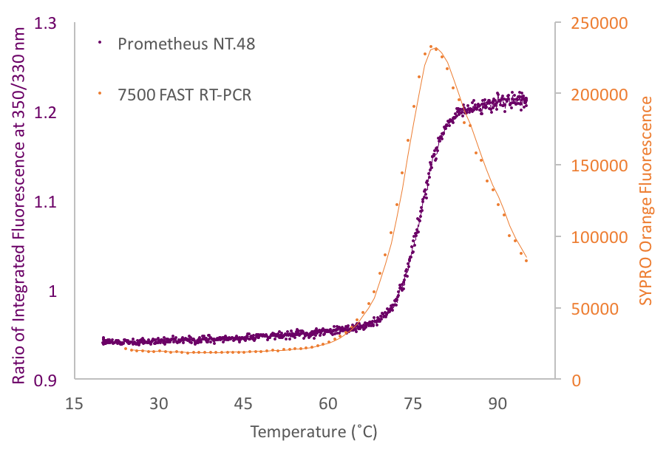
Figure 24: Graph comparing the curves produced using the raw data generated by both the 7500 FAST and Prometheus NT.48 machines. 7500 FAST data is coloured orange and Prometheus NT.48 is coloured purple. The two curves have separate y axis due to the intrinsic protein fluorescence being calculated as a ratio of fluorescence at both 350 nm and 330 nm.
It is worth noting that, from the curves in Figure 24, the Prometheus NT.48 machine collects more data points per assay as fluorescence is measured every three seconds throughout the assay. Furthermore, the intrinsic protein fluorescence reaches a maximum and levels out as once the protein is unfolded intrinsic protein fluorescence will continue to be detected. Comparably, the SYPRO Orange fluorescence peaks and subsequently decreases due to protein aggregation and dye dissociation at high temperatures.

Overall the results from the preliminary Prometheus NT.48 experiments are encouraging and show that the standard TSA protocol described in Section 1.2.2. can be applied to other machines and data can be successfully collected and interpreted in more than one way.

1.3.9.2. Advantages and Disadvantages of the Prometheus NT.48 Machine

Generally, compared to the protocol in Section 1.2.2., the protocol for using the Prometheus NT.48 machine is not significantly different. Sample preparation is much the same, minus the addition of dye, with low sample consumption. The Prometheus NT.48 machine can explore a temperature range of 15.0-96.0˚C with time increments of 0.1-7.0˚C per minute, meaning that a thermal cycle can be designed to suit a specific protein and/or experiment. Furthermore, the Prometheus NT.48 can detect protein unfolding with as little as 5 μg of a pure sample protein with both tryptophan and tyrosine residues. A key advantage of using the Prometheus NT.48 machine to collect TSA data is the dye-free nature of the method that imposes no buffer restrictions, so even detergents could be used in the sample. This opens the door to the thermal analysis of membrane proteins, something which the use of SYPRO Orange prohibits. A further key advantage of the Prometheus NT.48 machine is the ultra-high resolution. Multiple and minute unfolding events (e.g. the consecutive unfolding of protein domains) can be detected. Additionally, far more data points are collected (Figure 24) and data is collected quicker at a rate of every three seconds during an assay.

The fact that the Prometheus NT.48 machine depends on intrinsic protein fluorescence could pose problems depending on the amino acid sequence and fold of a specific target protein. However, any issues are seemingly negated by the Prometheus NT.48 being able to monitor protein unfolding through only tyrosine residues if a protein is tryptophan-free. The minimum protein amount increases from 5 μg to 100 μg in this case, but 100 μg is still a very achievable amount in most circumstances. The ability to alter the power of the LED used for excitation of the sample also means that every experiment can be fine-tuned to suit a specific protein sample.

Arguably, the Prometheus NT.48 is not a high-throughput method, not at least in comparison to the 96-well format of the 7500 FAST machine. The NT.48 model used in this chapter can collect data for (a maximum of) 48 capillaries per assay, meaning two runs would be necessary to record a full data set for a 96-well Durham Screen. Each capillary additionally had to be filled and loaded one-at-a-time and by hand. An alternative model of the Prometheus machine is available; the Prometheus NT.Plex uses capillary chips of 24 capillaries that can be filled manually in one step from a pre-prepared 384-well plate. The NT.Plex model certainly increases the efficiency of loading the machine but it halves the throughput again meaning that four runs would now be needed to record a full data set for a 96-well Durham Screen.

Using the Prometheus NT.48 is not directly compatible with data analysis in NAMI; raw data extracted from the Prometheus NT.48 would have to be altered to suit the input for NAMI. However, the software that accompanies the Prometheus machine is sufficient to conduct conclusive data analysis.

A more practical and economic comparison of the two technologies would conclude that the cost of the Prometheus NT.48 apparatus is prohibitive for a majority of research laboratories. However, given that a large proportion of research facilities will already own a thermal cycler of some sort, the only further cost to performing TSAs would be plastic, consumable 96-well plates. The Prometheus NT.48/NT.Plex equipment, however, entails the use of relatively expensive consumable capillaries. Overall, the use of an RT-PCR machine is undoubtedly the more economic choice, in terms of both time and money.

1.4. Conclusions

Overall, the TSA data produced from the use of the Durham Screens is extremely informative. Thus far, connections between TSA data collected for this thesis and successful crystallisation conditions (where appropriate) have been established. Furthermore, the screens have presented the opportunity to optimise protein purification to attain further concentrated pure protein samples. Additionally, the TgSPT results provide a direction for future crystallisation trials. Due to the ease of the assay and the rapid data analysis provided by NAMI, the use of the Durham Screens to assess thermal stability, within the context of increasing crystallisation likelihood or improving the protein expression and purification, is worthwhile. For any protein scientist and/or crystallographer, acquiring thermal stability data using the Durham Screens would merely be another string to their research bow; understating the specific requirements for a protein to be folded, soluble and active is key to successful functional and structural characterisation.

NAMI proved to be a very efficient data analysis tool, providing a quantitative comparison across a wide range of conditions. Minimal data manipulation was required as NAMI processed raw data and a full data analysis run is completed within minutes. The color-coded tabular results summary is an effective and digestible way of presenting the T_{m} data. However, NAMI was initially developed to process the raw data output from the 7500 FAST apparatus and a limitation is that NAMI is not guaranteed to be able to process the raw data from other qPCR machines.

A significant limitation of performing TSAs with the 7500 FAST apparatus is that evaluating the thermal stability of multimeric proteins may be challenging. If protein unfolding of distinct protein chains occurs simultaneously then accurate TSA data can be collected for dimeric proteins, such as EthR and SPT (Sections 1.3.4. and 1.3.8.). However, interpretable data using the 7500 FAST system may be suboptimal for higher multimers (trimeric, tetrameric etc. proteins) where the dissociation of a large multi-protein complex can yield multiple melting temperatures. The 7500 FAST apparatus is not sensitive enough to accurately detect such complex melting patterns, nor is NAMI equipped to process multiple transitions into a multi-phase denaturation curve with two or more discrete T_{m} values. However, as proven in this chapter, exploring the potential apparatus space can negate this issue. As in Section 1.2.4., the Prometheus NT.48 machine provides an ultra-high resolution dye-free method for TSA data collection, with accompanying data analysis software that can detect and process multiple melting points. This kind of protocol adaptation that utilises alternative equipment opens up the possibility to assess multi-phase protein denaturation patterns in the context of the Durham Screens.

The TSA data for BSA, presented in Section 1.3.1., highlighted the issue of using SYPRO Orange with a protein that has a high level of solvent-exposed hydrophobic groups. However, the dye-free protocol using the Prometheus NT.48 machine counteracts this issue and also opens up the possibility to explore the use of other fluorescent dyes such as 1,8-ANS and Nile Red (as stated in Section 1.1.2.). Overall, there is a limitation to the types of proteins that can be tested using the original protocol presented in Section 1.2.2. of this chapter. In particular, it would be difficult to thermally assess the stability of membrane proteins in a dye-dependent TSA experiment; detergents, generally included as solubilising agents for membrane proteins, could interact with and disrupt the fluorescence signal of SYPRO Orange. However, using a dye-free system removes any restrictions on the screen conditions. Furthermore, while protein-ligand interactions have successfully been studied in a TSA context in this chapter, protein-protein and protein-DNA interactions have not been explored. Protein-DNA interactions pose the potential issue of SYPRO Orange binding to the DNA and also the issue of DNA fluorescence interfering with the fluorescence signal from the non-covalent dye. Protein-protein interactions yield a more complex data analysis problem as simultaneous protein melting events will produce a convoluted melting curve that is difficult to interpret.

When comparing TSA hits to known crystallisation conditions of proteins, there is a general distinct lack of use of osmolyte compounds in protein crystallisation. Yet, most proteins studied in this chapter where stabilised by multiple molecules in the Osmolyte Screen. Perhaps use of the Osmolyte Screen in a pre-crystallisation context could increase the scope of compounds trialled in initial crystallisation trays and therefore increase the diversity of crystallisation conditions used, ultimately increasing the likelihood of crystallisation. Many crystallographers may not consider adding sugars, betaines, organophosphates, dipeptides or amino acids to their crystallisation experiments; however, the TSA data from the Durham Osmolyte Screen suggests that it could be a worthwhile investment.

The highly adaptable nature of the TSA protocol described in Section 1.2.2. allows the experimental procedure to be modified to suit many common bench-top thermal cyclers (RT-PCR/qPCR/DSF machines). While several arguments can be made for and against the proposed TSA methodology, it seems that any problem posed can be solved due to the highly adaptable nature of the experimental protocol and ability to use a range of bench-top machines for data collection.

1.5. Future Work for Further Development of the Durham Screens

Protein stability is the key parameter impacting the success of all the stages of work of a protein scientist, from protein expression and purification, through to characterisation and storage. With several experimental techniques available to measure protein stability, a protein scientist must choose the most approximate experiments to, in most cases, minimise sample consumption. Common methods for assessing protein stability are differential scanning calorimetry (DSC), which imposes a high sample consumption, and CD, which entails limited buffer conditions. In contrast, as shown in this thesis, TSA offers a low sample consumption assay that is relatively quick to run after a simple assay preparation. The work conducted for this chapter reinforces the premise that a TSA is an efficient and economical methodology to assess protein stability in both pre- and post-crystallisation contexts.

As the Durham Screen are a recent addition to the landscape of thermofluor kits, there is limited data to evidence a correlation between the use of the Durham Screens and successful crystallisation. However, the data presented in this chapter is the first data that established a link between the use of the Durham Screens and optimisation of protein purification and successful crystallisation. Future collection of more data sets, using an ever-diverse range of protein targets (in terms of protein size, origin and function) will only strengthen this link and further prove the worth of utilising the Durham Screens.

With the Durham Salt and pH Screens currently available through Molecular Dimensions Ltd., the Osmolyte screen is to be commercialised in the imminent future. Future work could include the design and production of a fourth screen, namely the Durham Cofactor Screen, to extend the range of small molecules explored when investigating protein thermal stability with the Durham Series of Screens. However, composing a cofactor screen might be the most challenging as initial research shows that some of the most biologically interesting and relevant compounds are insoluble in water or commercially unavailable to purchase.

It would be worthwhile to further experiment with other thermal cycler machines to further establish the flexibility of the original protocol. Examples of apparatus that the protocol could be adapted for in the future include Rotor Gene (Qiagen) RT-PCR machines and a Mic qPCR Cycler (Bio Molecular Systems). Adapting the protocol to a wider variety of machines will only increase the practicality of the assay.

An interesting branch of future research would be the adaptation of NAMI to process raw data from machines other than the 7500 FAST cycler. The ultimate goal is for NAMI to be a universal TSA data analysis tool, capable of processing raw data from a number of common bench-top thermal cyclers. A starting point would be to work on NAMI processing the raw data collected using the Prometheus NT.48 machine in this chapter or, alternatively, looking at how to automatically read and convert raw data into a NAMI-compatible format. An additional improvement to NAMI would be to enable the programme to detect and analyse multiple denaturation events, thus allowing the assessment of the thermal stability of multi-domain and even multimeric proteins.

An additional valuable area of future work would be to explore the use of the dye-free TSA protocol to study membrane proteins. The dye-free conditions mean that detergents can be included in the screen conditions, therefore theoretically allowing the thermal stability of membrane proteins to be tested in the presence of the Durham Screens. Broadening the use of the dye-free protocol to include the analysis of membrane proteins simply increases the scope of proteins whose thermal stability can be characterised using the Durham Screens.
Chapter II: Characterisation of the Serine Palmitoyltransferase from Apicomplexan Parasites

This chapter details the research conducted into the serine palmitoyltransferase enzyme, that catalyses the first committed step of de novo sphingolipid biosynthesis, from a range of apicomplexan parasites. Due to stark differences between human and parasite protein, this enzyme has been identified as a potential drug target in apicomplexan parasites and therefore uncovers new possibilities for the design and development of novel therapeutics for several neglected diseases. As a potential drug target, there is a strong need for the characterisation and crystallisation of apicomplexan serine palmitoyltransferase proteins. This chapter presents and discusses the initial cloning, expression, purification and characterisation data for eight novel parasitic orthologues.

2.1. Introduction

2.1.1. The Apicomplexa Phylum of Protozoan Parasites

The eukaryotic phylum Apicomplexa groups together approximately 6,000 unicellular organisms of medical and veterinary importance (Sato, 2011), including the causative agents of malaria. Despite being obligate parasites (i.e. not free-living) of humans and other animals, many apicomplexan species are non-pathogenic to their host. Employing complex life cycles, involving both sexual and asexual phases of reproduction, apicomplexan parasites often infect both secondary and primary hosts.

Apicomplexan organisms are united by a conserved apical complex of highly specialised organelles, including secretory organelles called micronemes and rhoptries, and polar rings composed of microtubules involved in a conserved mechanism of actin-based motility (Blackman and Bannister, 2001). This apical complex plays pivotal roles in interactions with the host cell and subsequent invasion. Many apicomplexan parasites also hold an up to four-membraned plastid organelle, the apicoplast, that is essential for parasite survival (Arisue and Hashimoto, 2013). Hypothesised to originate from red algae and acquired by secondary endosymbiosis, the apicoplast is non-photosynthetic and suspected to be involved in isoprenoid, haeme and lipid biosyntheses (Striepen, 2011; van Dooren and Striepen, 2013). The unique apical complex and apicoplast offers multiple interesting, yet challenging, opportunities for therapeutic intervention.

Overall, the Apicomplexa phylum embodies a diverse range of parasites that have evolved to adapt to a variety of hosts and forge highly specialised relationships. This chapter focuses on one particular member of the Apicomplexa phylum, namely T. gondii; nevertheless, the following content is relevant to other parasitic species, such as the genera Plasmodium, Cryptosporidium and Eimeria.

2.1.2. Introduction to Toxoplasma gondii, an Intracellular Eukaryotic Parasite

T. gondii, first observed in 1908 in the rodent Ctenodactylus gundi (Nicolle and Manceaux, 1908), is regarded as one of Earth’s most successful parasites. Emanating from the eukaryotic Apicomplexa phylum, T. gondii is a spore-forming obligate intracellular parasite that utilises members of the Felidae (cat) family as definitive primary hosts, with all other warm-blooded animals (including humans) being intermediate hosts (Dubey, 2009). Currently, more than 30 species of birds and 300 species of mammals are known hosts for T. gondii (Flegr et al., 2014).

2.1.2.1. Toxoplasma gondii Life Cycle

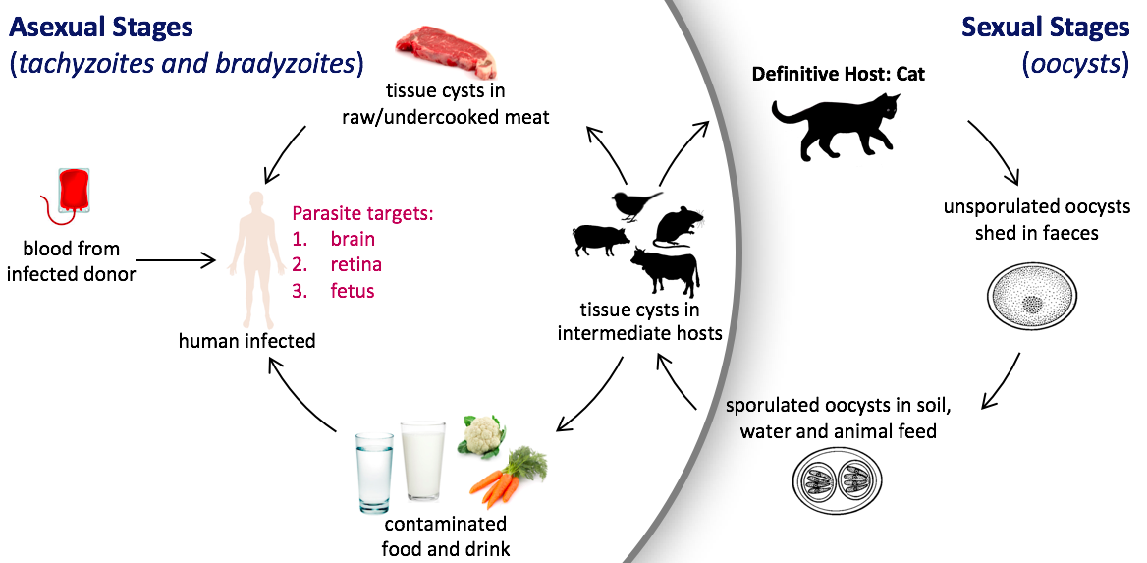
T. gondii employs a complex life cycle, revolving around three main infectious stages; rapidly dividing and invasive tachyzoites, slowly dividing bradyzoites that persist in tissue cysts, and sporozoites that are protected in oocysts. Summarised in Figure 25, the asexual part of the life cycle involves tachyzoites and bradyzoites, whereas the sexual stage comprises of environmentally resistant oocysts (Dubey et al., 1998; Dubey, 2008; Flegr et al., 2014; Tenter et al., 2000). T. gondii has the ability to infect a variety of nucleated cells, yet the parasite develops sophisticated relationships with specific host cell-types, depending on the life cycle stage, to establish an infection.
Figure 25: A summary of the life cycle of T. gondii.

Upon ingestion of a tissue cyst by a Felidae primary host, the cyst wall is digested by proteolytic enzymes in the intestine. One tissue cysts can hold hundreds of bradyzoites that undergo asexual reproduction to form infective tachyzoites. Alternatively, the bradyzoites undergo sexual reproduction to form oocysts; this stage of sexual reproduction only occurs in enterocyte cells of the primary host (Jones and Dubey, 2010; Kaye, 2011). Oocysts are produced by schizogony and gametogony; sporozoites undergo asexual reproduction by multiple fissions and subsequently develop into male and female gametes that fuse to form a zygote. Unsporulated oocysts, shed by cats in their faeces, can survive in most environmental conditions, commonly in soil, for months and even years. Soil invertebrates spread the oocysts through the environment and carry them onto food, causing intermediate hosts to become infected. Contact with sporulated environmental oocysts or consumption of tissue cysts are predominant modes of parasitic transmission into humans. The asexual conversion from bradyzoites to tachyzoites occurs within the human host. Enzymes dissolve the cyst wall, resulting in cyst rupture to release highly infectious tachyzoites. The rapidly multiplying tachyzoites infiltrate the human body and actively penetrate host cells, whilst protected by a self-made parasitophorous vacuole to allow host immune system evasion (Kaye, 2011). Tachyzoites cross the blood-brain, blood-retina and maternal-fetal barriers. The tachyzoites can then re-convert asexually to dormant bradyzoites enclosed in tissue cysts, favourably occupying skeletal muscle, brain tissue and the retina (Dlugońska, 2014; Dubey, 2009; Hill and Dubey, 2002; Jones and Dubey, 2010; Kaye, 2011; Tenter et al., 2000).

2.1.3. Infection by Toxoplasma gondii: Toxoplasmosis

Approximately one third of the worldwide human population is infected with T. gondii, culminating in a disease called toxoplasmosis. Specifically, an estimated 16-40% of people in the UK and USA are infected with T. gondii, with this number increasing to 50-80% in Central and South America and Continental Europe (Hill and Dubey, 2002). Globally, cats are the primary source of infection for humans (Flegr et al., 2014). Routes of parasitic transmission are numerous, including contact with infected cat faeces and contaminated soil, ingestion of infected animals, particularly raw or under-cooked meat, and consumption of contaminated milk or water (Dubey, 2008). Less common means of parasite transmission include organ transplant, haematopoietic stem cell transplant or blood transplant from an infected donor.

2.1.3.1. Toxoplasma gondii in Meat-Producing Animals

Considered as one of the world’s most important food-borne parasites, T. gondii is the second-leading cause of foodborne illness-related death and hospitalisation in the United States of America, culminating in approximately 4,000 hospitalisations and at least 300 deaths per year (Jones and Dubey, 2012; Lewis et al., 2015). Pigs, sheep, goats and free-ranging poultry are amongst the meat-producing and game animals that most commonly transmit T. gondii to humans (Jones and Dubey, 2012; Tenter et al., 2000). The human consumption of organic meat produce, attractive as animals are raised outdoors, on organic feed, with restricted use of antibiotics, is potentially increasing T. gondii transmission to humans (Jones and Dubey, 2012). Given their higher exposure to the great outdoors and habitual wildlife on rural and isolated farms, organically-reared animals have a proven higher rate of infection by T. gondii alongside being exposed to atypical virulent strains of the parasite. This trend is well illustrated in the case of organically-farmed pigs, where studies in Italy, the Netherlands and the USA revealed infection rates of up to 95.2% in organically-raised pigs, compared to 16-36% in intensive piggeries (Bacci et al., 2015; Dubey et al., 2012a; van der Giessen et al., 2007).

2.1.3.2. Toxoplasma gondii in Drinking Water

Toxoplasmosis is estimated to generate the highest disease burden of all foodborne illnesses (Karanis et al., 2013). Only recently has the spread of T. gondii via water been considered as a serious threat to public health after waterborne outbreaks worldwide in Brazil, Canada, French Guiana and India (Baldursson and Karanis, 2011); infection of marine mammals and contamination of seawater and freshwater is more common than previously thought (Jones and Dubey, 2010). The most detrimental outbreak, in Province of British Columbia in Canada, was estimated to have infected 2,894-7,718 individuals in Greater Victoria between 1994-1995 (Bowie et al., 1997). Such outbreaks highlight the persistent nature of T. gondii oocysts in the environment, allowing the parasite to prevail as both foodborne and waterborne threats to public health.

2.1.3.3. Toxoplasma gondii in Blood, Organ and Stem Cell Donors

Toxoplasmosis is a life-long disease and most patients experience no symptoms. With an estimated 33% of blood donors worldwide testing seropositive for T. gondii (Foroutan-Rad et al., 2016), screening for toxoplasmosis in organ, blood and stem cell donors should be a medical necessity but is not routine. Brazil is considered one of the world’s most prevalent countries for toxoplasmosis, with approximately 75% of blood donors testing seropositive. Such high seroprevalence correlates well to a high infection rate of native Brazilian animals, including sheep, goats and pigs, that commonly feature in the diet of Brazilian people (Dubey et al., 2012b). With limited awareness of toxoplasmosis, and inconsistences with the testing for and diagnosis of toxoplasmosis, T. gondii is more complicated than just a food- and water-borne pathogen.

2.1.4. Toxoplasmosis Symptoms, Diagnosis and Treatment

2.1.4.1. Symptoms

Toxoplasmosis can induce a wide spectrum of clinical symptoms in humans. A majority of infections (approximately 80%) are asymptomatic due to immunocompetent hosts; such infections are termed latent. Mild flu-like symptoms of headache, muscle pain, fever and lymphadenopathy may be experienced (Fabiani et al., 2013). Acute infections acquired after birth have been linked to ocular lesions and loss of vision. However, in immunocompromised patients and congenitally infected patients, retaining chronic infections, symptoms are more severe and can involve multiple organs. Toxoplasmosis is the second-most common infection in AIDS sufferers (Karanis et al., 2013); 10% of AIDS patients in the USA, and 30% in Europe, die of toxoplasmosis (Hill and Dubey, 2002). Tachyzoites disseminating through the body can invade a variety of cell types. Tissue cysts can form in visceral organs, including the lungs, liver and kidneys. In particular, T. gondii favours muscular and neural tissue, such as the brain, eyes, and skeletal and cardiac muscle (Jones and Dubey, 2010). For patients retaining chronic infections, symptoms can include mental retardation and blindness. More specifically, long-term T. gondii infections in skeletal muscle, the retina and the brain can result in retinochoroiditis, hydrocephalus, convulsions, intra-cerebral calcification, lymphadenopathy and encephalitis (Hill and Dubey, 2002).

There are an estimated 190,100 cases of congenital toxoplasmosis per annum globally (Opsteegh et al., 2015). Tachyzoites can cross the placenta and infect the fetus during any stage of a pregnancy. Transmission during the first trimester is low (<6%), increasing to 60-81% by the third trimester (Chaudhry et al., 2014). However, infection during the early stage of pregnancy is more serious than in the second or third trimesters (Chaudhry et al., 2014; Kaye, 2011). Severe cases of congenital infection can lead to spontaneous abortion or stillbirth (Hill and Dubey, 2002). If a congenitally infected fetus survives childhood, retinochoroiditis and neurological and systemic disease are likely.

With livestock, the main issue stems from congenital toxoplasmosis inducing the abortion or stillbirth of offspring. This problem is particularly eminent with sheep and goats in countries such as New Zealand, France, Norway and the United Kingdom.

2.1.4.2. Treatment

The few available treatments for toxoplasmosis are often not tolerated or induce undesirable side-effects (Guerina et al., 1994). Table 11 details several drugs that consistently feature in the literature, along with their mechanisms of action and side effects. A recurring theme is the use of drugs that interfere with folate biosynthesis to ultimately prevent the synthesis of DNA and therefore subsequent cell growth; such drugs inhibit the enzymes dihydrofolate reductase (DHFR) and dihydropteroate synthase (DHPS).
Table 11: A summary of the key drugs used to treat acute, chronic and congenital toxoplasmosis.
Common Side-Effects | Abdominal pain, diarrhea, dizziness, headache, itching, loss of appetite, nausea, vomiting. | Abdominal pain, diarrhea, nausea, vomiting. | Abdominal pain, contact dermatitis, diarrhea, nausea, skin rash, vomiting. | Acne, amnesia, depression, headache, hypertension, insomnia, nausea, weight gain, vomiting. | Decrease in blood cells, liver inflammation, loss of appetite, nausea, skin ash. | Fever, insomnia, skin rash. | Abdominal cramps, diarrhea, dry mouth, drowsiness, fever, headache, nausea, skin rash, vomiting, weight loss. | Diarrhea, nausea, stomach ache, vomiting. | Diarrhea, drowsiness, fever headache, loss of appetite, nausea, skin rash. | Abdominal pain, depression, fever, hair loss, headache, insomnia, muscle weakness, skin rash. | Abdominal cramps, diarrhea, nausea, skin rash, vomiting. | Changes in taste, diarrhea, nausea, skin rash, vomiting.
Mechanism of Action | Selectively inhibits cytochrome bc₁ complex in parasitic electron transport chain to collapse mitochondrial membrane potential. | Binds to 50S ribosomal subunit, inhibiting translation of mRNA and therefore protein synthesis. | Binds to 50S ribosomal subunit, inhibiting translation of mRNA and therefore protein synthesis. | Mimics hormones to suppress inflammatory responses of the immune system. | Competitively inhibits DHPS in folate biosynthesis to prevent DNA synthesis. | Folic acid derivative that does not require activation by DHFR. Decreases toxic effects of folate deficiency caused by sulfonamides/pyrimethamine. | Inhibits DHFR in folate biosynthesis to prevent DNA synthesis. | Not clearly defined, but thought to bind to ribosome and inhibit protein synthesis and cell growth. | Competitively inhibits DHPS in folate biosynthesis to prevent DNA synthesis. | Competitively inhibits DHPS in folate biosynthesis to prevent DNA synthesis. | Competitively inhibits DHPS in folate biosynthesis to prevent DNA synthesis. | Inhibits DHFR in folate biosynthesis to prevent DNA synthesis.
Class of Drug | naphthoquinone,  anti-parasitic | antibiotic | antibiotic | steroid, corticosteroid | sulfone antibiotic | folinic acid | anti-malarial,  anti-protozoal | macrolide antibiotic | sulfonamide antibiotic | sulfonamide antibiotic | sulfonamide antibiotic | antibiotic
Name of Drug | Atovaquone | Azithromycin | Clindamycin | Dexamethasone | Diaminodiphenylsulfone | Leucovorin | Pyrimethamine | Spiramycin | Sulfadiazine | Sulfadoxine | Sulfamethoxazole | Trimethoprim

Two key drug combinations for the treatment of toxoplasmosis are pyrimethamine and sulfadiazine or pyrimethamine and leucovorin. These two synergistic combinations are the most potent treatments currently available but they are classed as teratogens. Atovaquone is an alternative drug for those patients who are allergic to sulfonamide drugs. Spiramycin is used especially in pregnant women; the drug is available in Europe, Canada and Mexico but is still considered experimental in the USA. Spiramycin reduces transmission of the parasite from the mother to the fetus from the point that the drug is taken onwards, however it does not reduce the severity of the disease already transmitted to the fetus before the drug was taken.

There are multiple published clinical trials investigating various treatment regimens for toxoplasmosis (Rajapakse et al., 2013). The drugs used act against the multiplying invasive tachyzoites, to some extent. Unfortunately, there are currently no drugs that can target tissue cysts and there is no cure for a persistent T. gondii infection.

2.1.4.3. Toxoplasma gondii Seropositivity and Neuropsychiatric Diseases

An asymptomatic chronic toxoplasmosis infection in immunocompetent individuals is now considered a risk factor for neurological disorders (Ngoungou et al., 2015). Neuropsychiatric involvement in congenitally infected and immunocompromised toxoplasmosis patients elicits symptoms of depression and anxiety. Recently, the prevalence of latent toxoplasmosis has been correlated with a range of neurophysiologies, including psychosis, schizophrenia, bipolar disorder, Parkinson’s disease and epilepsy (Fabiani et al., 2013; Flegr et al., 2014; Ngoungou et al., 2015). T. gondii infections induce cellular, anatomical, immunological, and neurotransmitter changes which play roles in the development of neurological conditions. Following initial infection, T. gondii commonly resides in the central nervous system (CNS), optimally situated to alter neurotransmitter pathways, induce an immune response and stimulate the endocannabinoid system, leading to psychological, behavioural and motor symptoms that manifest in mental illnesses. Intra-neuronal T. gondii tissue cysts have been shown to directly modulate neuronal function, resulting in hypo- and hyper-responsive neurons (Haroon et al., 2015). It is hypothesised that the parasite dysregulates calcium (Ca²⁺) signalling to affect the excitability of neurones; infected neurones have depleted Ca²⁺ stores in the endoplasmic reticulum (ER) (Arrizabalaga et al., 2004; Kim et al., 2008). Numerous studies in recent years, using serological, behavioural, neurodevelopmental, pharmacological and epidemiological methods, have attempted to validate the link between toxoplasmosis and other pathologies. However, the neurobiological mechanisms used by T. gondii to infiltrate the CNS are far from being uncovered.

2.1.5. Current Outlook on Toxoplasmosis Infections in Humans: Prevention and Intervention Strategies

The global disease burden from T. gondii infections warrants implementation of intervention strategies. The most susceptible, and therefore the focus of intervention schemes, are pregnant women, transplant patients and immunocompromised individuals. However, the general public should not be discounted. Infection rates reflect cultural habits worldwide (Hill and Dubey, 2002), and proposed intervention strategies, summarised in Table 12, are relatively simple. For example, the education of pregnant women and the general public to increase awareness of toxoplasmosis and trigger changes in behaviour, such as avoiding raw meat products, washing fruit and vegetables before consumption, and executing thorough personal hygiene after gardening (Jones and Dubey, 2012; Opsteegh et al., 2015). Furthermore, educating cat owners about toxoplasmosis to impart the careful disposal of cat litter using gloves, encourage timely neutering and limit hunting outdoors (Opsteegh et al., 2015). Methods of meat decontamination, such as freezing meat to -12˚C or below for two days, and adequately cooking meat products to above 67˚C (Hill and Dubey, 2002; Kay, 2011), can be employed. Ideally, food animals and cats would be vaccinated against T. gondii. However, with no vaccine commercially available, focus rests on preventing contamination of food animals and their environment. Increasing biosecurity to reduce infection of food animals is problematic due to the growing trend of organic farming. Additionally, controlling the stray cat population has limited feasibility. Therefore, tackling meat-borne transmission to humans is a practical choice. The education of pregnant women, alongside the general public, and the simple decontamination of meat products are realistic and achievable means of prevention of T. gondii transmission in the near-future.

Table 12: A summary of simple behavioural changes that can be implemented in daily life to avoid contact and possible infection with T. gondii.
Do’s | Don’ts
- Wear gloves to change cat litter and change cat litter daily.  - Feed pet cats store-bought tinned or dry food only.  - Avoid stray cats.  - Wear gardening gloves.  - Wash hands after gardening, handling cat litter, and after handling raw meat products and raw fruit and vegetables.  - Wash raw fruits and vegetables, and peel where possible before consumption.  - Decontaminate meat by cooking it to at least 67˚C. | - Do not eat raw or undercooked meat, raw eggs or unpasteurised milk.  - Do not drink untreated water, particularly when travelling.  - Do not feed pet cats raw meat.  - Do not let pet cats hunt outdoors.  - Do not ingest untreated water from rivers, lakes, streams and ponds, even during recreational activity.

The topic of prenatal and neonatal screening and treatment is a stand-alone issue. Despite the potential to aid in reducing T. gondii transmission, screening is only undertaken in areas of “high-risk”. For example, France and Austria have prenatal screening (Hill and Dubey, 2002), and neonatal screening is available in Brazil and some regions of the USA. However, neonatal screening was terminated in Denmark due to a lack of demonstrable benefit and there is no screening available during pregnancy in the United Kingdom (Opsteegh et al., 2015). Additionally, screening for seropositivity in blood, organ and stem cell donors is not routine. Customary testing for toxoplasmosis in donors and during pregnancy should be implemented globally; however, this is a highly debated and sadly an unrealistic initiative as regions of low-risk argue that the cost of routine screening for toxoplasmosis would outweigh the benefits.

2.1.6. The Biology of Sphingolipids

2.1.6.1. Overview of Sphingolipid Synthesis, Structure and Function

All eukaryotes, alongside plants, fungi and some bacteria, produce sphingolipids consisting of a sphingoid base backbone linked to a charged head group (Figure 26). Sphingolipid metabolism is indispensable for eukaryotic life, with sphingolipids contributing towards conventional cellular function as both important structural elements of cellular membranes and as bioactive signalling molecules (Hannun et al., 2001; Lowther et al., 2012).
Figure 26: The general structure of a sphingolipid with the sphingoid base backbone (C18) shown in black, the variable head group is shown as an X in orange and the fatty acid tail is shown in purple with R corresponding to the Cx chain. When the head group, X, is simply a hydrogen atom (H) then the molecule is a ceramide. To name a few, head groups can include amino acids and sugar monomers and polysaccharides.

Figure 27 details the general pathway of sphingolipid biosynthesis. The specifics of synthesis vary between plants, animals, fungi and bacteria; synthesis even differs between species of the same kingdom. However, the first committed step of de novo sphingolipid biosynthesis is conserved across all sphingolipid-producing organisms; the condensation of L-serine and palmitoyl coenzyme A (CoA), catalysed by SPT, to generate 3-ketodihydrosphingosine (KDS) (Figure 28)
Figure 27: A summary of the key steps of sphingolipid biosynthesis. This diagram ends at ceramide, a divergence point in the synthesis pathway from which a variety of complex sphingolipids can be produced (see Figure 29). Please note, this flow diagram does not detail balanced chemical reactions or enzyme catalysts, but simply illustrates the main synthesis steps found in all sphingolipid-producing organisms.
L-serine
palmitoyl-CoA
+
ceramide
dihydroceramide
↓
3-ketodihydrosphingosine
↓
dihydrosphingosine
↓
↓

Figure 28: A balanced reaction scheme for the ubiquitous first committed step of sphingolipid biosynthesis catalysed by SPT.

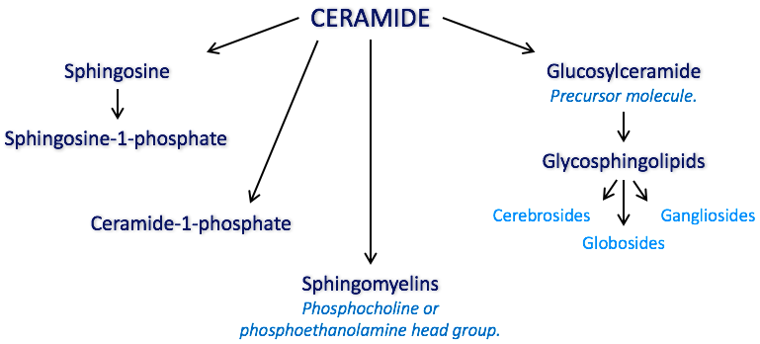
KDS is subsequently acylated to form dihydroceramide, followed by a reduction to yield ceramide. Ceramide is an important precursor for all complex sphingolipids, illustrated by Figure 29, including sphingomyelin and glycosphingolipids (Hannun et al., 2001; Lowther et al., 2012). In mammalian cells, sphingolipid synthesis, unlike the synthesis of other lipids, is compartmentalised between the ER and the Golgi apparatus, with ceramide metabolism continuing in the Golgi. Eukaryotic sphingolipids synthesis and, in particular, the first committed step catalysed by SPT, are of particular interest for this thesis.
Figure 29: An illustration of the variety of complex sphingolipids that can be produced following ceramide synthesis.
L-serine
palmitoyl-CoA
+
3-ketodihydrosphingosine
CO₂ + HS–CoA
serine palmitoyltransferase

Sphingolipids function in a range of cellular processes as signalling molecules, including the stress response, cell proliferation and differentiation, apoptosis, angiogenesis and endocytosis (Hanada, 2005; Heung et al., 2006). Sphingolipids additionally play a structural role in the cell; sphingolipid content of membranes alters membrane fluidity and affects the activity of membrane-resident proteins (Hannun et al., 2001).

Overall, sphingolipid biosynthesis represents a complex network of integrated pathways that carefully control the cellular levels of bioactive sphingolipids. Despite the evident variation in sphingolipid synthesis, the first rate-limiting step is common to all sphingolipid-producing organisms studied to date (Lowther et al., 2012). This initial step of sphingolipid biosynthesis, identified as a potential drug target in apicomplexan parasites (Coppens, 2013; Mina and Denny, 2017), is of prime interest for this research project.

2.1.7. Serine Palmitoyltransferase

As previously stated, SPT catalyses the first committed step of sphingolipid synthesis. The reaction involves a Claisen-like condensation between L-serine and palmitoyl-CoA, in a PLP-dependent manner, to form KDS (Lowther et al., 2012). SPT belongs to the α-oxoamine synthase (AOS) family of PLP-dependent enzymes (Tidhar and Futerman, 2013) that generally catalyse the condensation of a specific amino acid with an acyl-CoA substrate (Yard et al., 2007).

The first structural insight into SPT was gained from the crystallisation of Gram-negative bacterial Sphingomonas paucimobilis SPT (SpSPT) (Yard et al., 2007). The crystal structure, at 1.3 Å, revealed a soluble, symmetrical, homodimeric protein. An active site lysine, Lys265, was identified in each subunit, involved in essential covalent interactions with the pyridine ring of the PLP cofactor. One SpSPT monomer can be described in three domains; an N-terminal domain, a central catalytic domain, and a C-terminal domain. At the interface of the two interlocking subunits is the central catalytic domain of one subunit and the N-terminal domain of the other subunit. Hence, the catalytic site is composed of residues from both subunits (Figure 30).
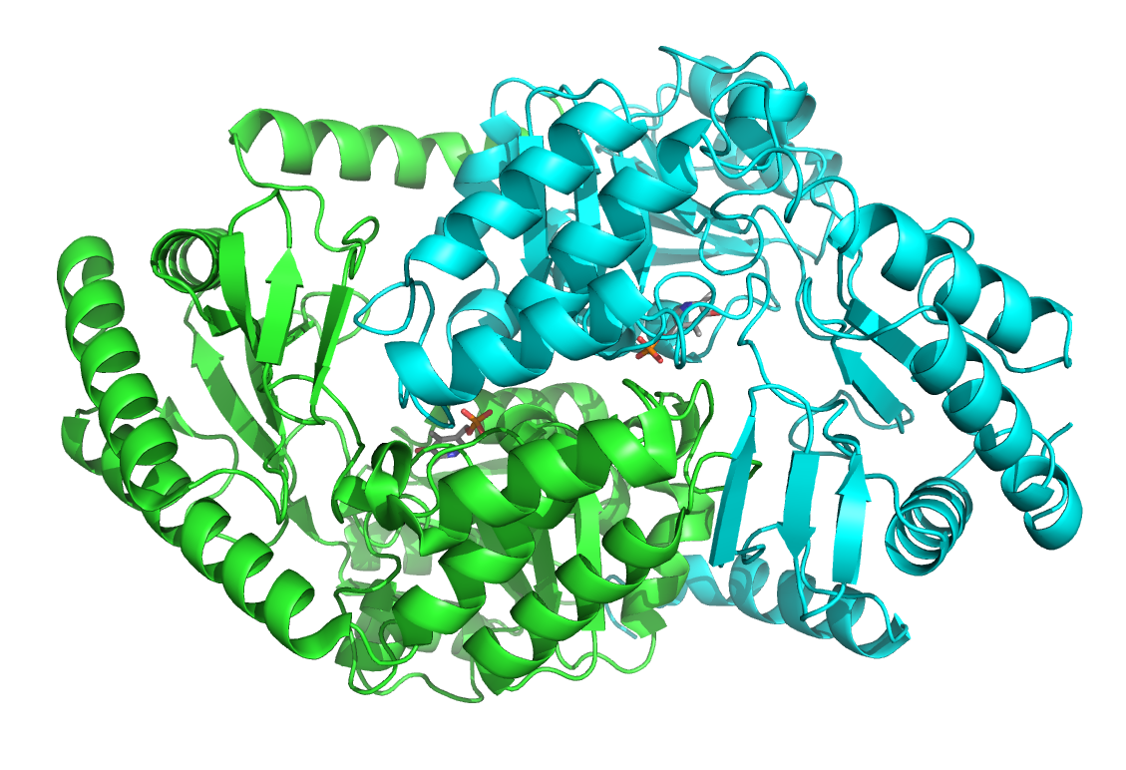
Figure 30: A ribbon diagram representing the structure of SpSPT (PDB file 2JG2) (Yard et al., 2007), detailing a homodimeric structure. One monomer is shown in blue, the other in green. PLP is detailed as a stick model bound at the interface of the two subunits.
From SpSPT structural studies, a catalytic mechanism has been hypothesised as follows (Figure 31). Starting with the holo form of the enzyme, PLP is bound to Lys265 an internal aldimine via a Schiff base. Through transamination, L-serine becomes an external aldimine. Subsequently, deprotonation yields a quinonoid intermediate that attacks the incoming acyl-CoA substrate. The product, KDS, is then released and STP returns to the holo form consisting of an internal aldimine (Lowther et al., 2012).
Figure 31: The proposed catalytic mechanisms for SpSPT.
Subsequently, homologues of SpSPT from Sphingomonas wittichii (Raman et al., 2010) and Sphingobacterium multivorum (Ikushiro et al., 2009) have been crystallised as homodimers. Contrastingly, Saccharomyces cerevisiae SPT (ScSPT) (Buede et al., 1991; Nagiec et al., 1994) and human SPT (Nagiec et al., 1996; Weiss and Stoffel, 1997) have been characterised as membrane-bound heterodimers of SPT1 and SPT2 subunits (historically called LCB1 and LCB2, respectively), localised to the ER. However, eukaryotic SPT has not yet been structurally characterised.

Heterodimeric SPT, first characterised in S. cerevisiae, is embedded in the ER membrane due to an N-terminal transmembrane domain. The catalytically active portion of the protein remains on the cytosolic face of the ER membrane. ScSPT2 holds the active site residues to bind PLP; the active site lysine is conserved amongst many AOS enzymes (Nagiec et al., 1994). However, such an active site conformation is not present in ScSPT1, indicating a regulatory role for the SPT1 subunit (Buede et al., 1991). Nonetheless, both SPT1 and SPT2 are essential for catalytically active SPT. Mammalian SPT has also been characterised, consisting of SPT1 and SPT2 or SPT1 and SPT3, where the SPT3 is a second isoform of SPT2 (Hornemann et al., 2006; Hornemann et al., 2009). SPT1 is, again, non-catalytic in mammals due to a hypothesised substantial degradation of the ancestral active site (Yard et al., 2007). Both yeast and mammalian SPT bind small proteins to instil optimal catalytic activity and confer acyl-CoA substrate specificity; these small proteins are not essential for SPT activity (Gable et al., 2000; Han et al., 2009; Harmon et al., 2013). Overall, SPT research has revealed multiple layers of complexity to SPT organisation and regulation.

2.1.7.1. Sphingolipids and Serine Palmitoyltransferase in Parasitic Protozoa

Sphingolipids are regarded as key regulators of pathogenesis (Heung et al., 2006). Central to the establishment of infection is the adhesion of parasites to host cells. Distinct sphingolipid-rich membrane microdomains, or lipid rafts, are essential to the invasion process and, hence, are attractive potential drug targets (Riethmüller et al., 2006). Sphingolipid-rich microdomains control virulence, adhesion and invasion by housing lipid-anchored molecules required for signalling and infectivity. Additionally, lipid rafts are involved in vesicle trafficking, motility and cell signalling. The importance of sphingolipids in pathogenesis makes understanding differences between mammalian and non-mammalian sphingolipid biosynthesis crucial for drug development (Goldston et al., 2012; Hanada, 2005; Zhang et al., 2010).

De novo sphingolipid biosynthesis has been evidenced in T. gondii (Azzouz et al., 2002). T. gondii SPT genes were identified using bioinformatics; searches of the complete annotated T. gondii genome uncovered two highly related and tandemly encoded genes, with 66% protein sequence identity (Appendix 5), that displayed similarity to bacterial SPT (Mina et al., 2017). TgSPT also shows a closer evolutionary relationship to bacterial than mammalian SPT, despite being eukaryotic. The main different between TgSPT and bacterial SPT is an N-terminal extension that houses a predictable transmembrane domain, allowing localisation of TgSPT to the ER membrane. Detailed sequence analysis and preliminary experiments indicate that TgSPT is radically different to all other eukaryotic SPT, studied to date (Mina et al., 2017).

2.1.7.2. Looking to the Future: Serine Palmitoyltransferase as a Prospective Drug Target in Apicomplexan Parasites

Sphingolipid biosynthesis is crucial for parasite viability. Apicomplexan parasites house unique lipid homeostatic pathways with attractive therapeutic targets, such as SPT (Coppens, 2013; Mina and Denny, 2017). Significant differences between apicomplexan and human SPT allow TgSPT to be viewed as a potential drug target, where TgSPT could be selectively inhibited to reduce parasite infectivity whilst leaving host proteins unharmed. Additionally, the inhibition of SPT, which naturally diminishes KDS, has been evidenced to slow the growth of Leishmania major kinetoplastid parasites and reduce their infectivity (Denny et al., 2004); this highlights the potential for novel drug targets for a range of other important human diseases.

Toxoplasmosis in meat-producing animals negatively impacts the agricultural industry. Additionally, the widespread prevalence of toxoplasmosis in humans emanates to devastating disease in many cases; existing therapies are poorly tolerated and frequently induce side-effects (Sonda and Hehl, 2006). Worldwide, there is urgent need to develop a cost-effective treatment and vaccine for the prevention and eradication of toxoplasmosis.
2.2. Materials and Methods

2.2.1. Genes of Interest for Expression

This chapter focuses on eight orthologous SPT proteins from a variety of eukaryotic, protozoan organisms. Six SPTs are from the following Apicomplexan parasites of humans and other animals: Cryptosporidium muris, Eimeria tenella, Plasmodium falciparum, Plasmodium vivax and T. gondii. The remaining two SPTs are from a model protozoan organism, Tetrahymena thermophila. The six Apicomplexan SPTs are all N-terminal truncations. Previous work on TgSPT1 (Thye, 2014), along with the TSA data presented in Section 1.3.8., concluded that the Δ158 truncation was the most promising for large-scale expression, purification and crystallisation. Truncations of CmSPT, EtSPT, PfSPT, PvSPT and TgSPT2 are all based on the TgSPT1 Δ158 truncation that omits the N-terminal transmembrane domain to increase protein solubility and long-term stability whilst retaining enzymatic activity. A multiple sequence alignment (MSA) generated using Clustal Omega (Sievers et al., 2011) guided the production of such truncations.

Table 13 summarises details of the eight SPT sequences featured in this chapter. All are N-terminal truncations apart from the T. thermophila orthologues; as uncharacterised proteins, it is not known if they are membrane-bound or cytosolic in vivo.
Table 13: The key details of the eight SPT genes/proteins featured in this chapter.
Truncated Protein (Da) | 46,250 | 46,668 | 47,265 | 46,655 | 45,981 | 46,728 | 67,743 | 53,593
Truncated Protein (aa) | 414 | 423 | 416 | 415 | 413 | 419 | 608 | 475
aaC | 548 | 588 | 572 | 571 | 571 | 577 | 609 | 476
aaN | 135 | 166 | 157 | 157 | 159 | 159 | 2 | 2
Truncation | ∆134 | ∆165 | ∆156 | ∆156 | ∆158 | ∆158 | ∆1 | ∆1
Full Length Protein (Da) | 61,013 | 64,798 | 65,533 | 64,689 | 63,650 | 64,699 | 67,874 | 53,724
Full Length Protein  (aa) | 548 | 588 | 572 | 571 | 571 | 577 | 609 | 476
Truncated Sequence (bp) | 1,242 | 1,269 | 1,248 | 1,245 | 1,242 | 1,257 | 1,824 | 1,425
Full Length Sequence (bp) | 1,647 | 1,767 | 1,719 | 1,716 | 1,716 | 1,734 | 1,830 | 1,431
Protein | CmSPT | EtSPT | PfSPT | PvSPT | TgSPT1 | TgSPT2 | TtSPT1 | TtSPT2

2.2.2. Plasmids Used

GenScript codon-optimised and cloned the SPT genes into pUC57 plasmids. Plasmids were delivered as a dry pellet of ~4 μg of DNA. The plasmids were centrifuged at 6,000 g for 1 minute, reconstituted in 20 μL of MilliQ H₂O, and thoroughly mixed before storage at -20˚C.

pOPINS3C from the pOPIN suite of expression vectors, created at the Oxford Protein Production Facility (OPPF) (Berrow et al., 2007), was used for expression. The plasmid itself contains a tag with the following features: a hexa-histidine (His₆) sequence, a small ubiquitin-like modifier (SUMO) protein and an incomplete human rhinovirus (HRV) 3C cleavage site. The His₆ sequence facilitates immobilised metal affinity chromatography (IMAC) purification (Section 2.2.7.5.), the SUMO protein aids protein stability and the cleavage site enables removal of the tag by HRV 3C protease. The His₆-SUMO-3C tag is 115 residues long and has a total molecular weight (MW) of 13,214 Da.

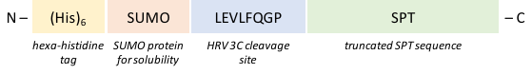
The pOPINS3C plasmid was linearised, using Kpn I and Hind III restriction enzymes, and the SPT open reading frames (ORFs) were cloned into the vector so that the tag became N-terminal and the cleave site was completed. Figure 32 depicts the structure of the expression construct within the pOPINS3C plasmid upon completion of cloning.
Figure 32: The diagram illustrating the final structure of the SPT expression constructs, within the pOPINS3C vector, upon completion of cloning. When the constructs are expressed, the tag is N-terminal.

All pUC57 and pOPINS3C plasmids used contain a gene for ampicillin (Amp) resistance (Amp^{R}).

2.2.3. Escherichia coli Strains Used

Library Efficiency DH5αTM competent cells (Invitrogen, Thermo Fisher Scientific) or Stellar competent cells (Clontech) were used throughout the initial cloning experiments (Section 2.2.5.). Subsequently, RosettaTM II DE3 (Novagen, Merck) competent cells were used for the expression of the SPT constructs. RosettaTM II DE3 cells are BL21 derivatives designed for the enhanced expression of eukaryotic proteins; they contain seven tRNAs rarely used in E. coli so that translation is not limited by the typical codon usage of E. coli. The seven rare tRNA genes (for codons AGA, AGG, AUA, CUA, GGA, CCC and CGG) are supplied on the chloramphenicol (Cam)-resistant (Cam^{R}) plasmid pRARE2 (a pACYC184-derived plasmid). The tRNA genes are driven by their native promoters. RosettaTM II DE3 cells contain a chromosomal copy of T7 RNA polymerase under the control of the lacUV5 promoter, facilitating the production of target protein, using isopropyl β–D-1-thiogalactopyranoside (IPTG) as an inducer, from genes cloned into appropriate T7 expression vectors. The detailed genotypes of all bacterial strains used in this thesis are listed in Appendix 6.

2.2.4. Antibiotics Used for Selection

Based on the plasmids and cells used, media was always supplemented with 100 μg/mL Amp. Media was additionally supplemented with 34 μg/mL Cam to select for RosettaTM II DE3 cells during protein expression.

2.2.5. Cloning

2.2.5.1. Transformation

Luria broth (LB) agar plates supplemented with 100 μg/mL Amp were prepared (Appendix 7). The pUC57 plasmids, ordered from GenScript, containing the SPT ORFs, were transformed into DH5αTM competent cells using heat shock.

For heat shock, 50 μL of cells were mixed with ~100 ng DNA and incubated on ice for 30 minutes. The cells were then subjected to a 42˚C water bath for 45 seconds, followed by 2 minutes on ice. 450 μL super optimal broth with catabolite repression (SOC) media was then added and the cells were set to shake at 200 rpm, 37˚C, for 45 minutes.

Subsequently, 100 μL of culture was spread onto one plate. The culture was then centrifuged at 4,000 g for 2 minutes. The supernatant was discarded and the cell pellet was resuspended in 100 μL fresh SOC media. The 100 μL of re-suspended culture was spread onto a second plate. Plates were sealed with parafilm and incubated at 37˚C overnight. Colonies formed on the plates overnight if the transformation was successful.

The following day, 10 mL LB cultures supplemented with 100 μg/mL Amp were inoculated with one colony from the plates. Cultures were left to shake overnight at 200 rpm, 37˚C.

2.2.5.2. Glycerol Stock Preparation

Glycerol stocks of DH5αTM competent cells containing the pUC57 plasmid were made, using the overnight LB cultures. Glycerol stocks were always prepared using 500 μL 50% glycerol and 500 μL of LB culture in a 1.5 mL microcentrifuge tube. Glycerol stocks were kept at -80˚C.

2.2.5.3. MiniPrep

5 mL of overnight LB culture (from transformation) was centrifuged at 4,000 g for 5 minutes. A GeneJET Plasmid MiniPrep Kit (Thermo Fisher Scientific) was used to purify the plasmid DNA. The manufacturers protocol was followed. The concentrations of MiniPrep samples were estimated using a NanoDrop 2000 (Thermo Scientific) and a sample of the purified DNA was analysed by agarose gel electrophoresis (AGE) (Section 2.2.5.4.).

2.2.5.4. Agarose Gel Electrophoresis

As detailed in Table 14, 0.8% agarose solution was prepared by adding 4 g agarose powder to 500 mL Tris-acetate-ethylenediaminetetraacetic (EDTA) acid (TAE) buffer. The 0.8% agarose solution was sterilised by autoclaving. 30mL of 0.8% agarose solution was used per 8-well gel, supplemented with 0.01% (v/v) ethidium bromide to enable visualisation of the DNA bands under UV light. After the gel had been poured and set, it was placed in an electrophoresis tank and fully submerged in TAE buffer.

Table 14: The composition of the components of a DNA agarose gel.
Agarose Gel Component | Composition
TAE Buffer | 40 mM Tris base, 20 mM acetic acid, 1 mM EDTA
0.8% Agarose Solution | 4 g agarose powder in 500 mL TAE buffer, supplemented with 0.01% (v/v) ethidium bromide

DNA samples were prepared by mixing 5 μL of DNA sample with 1 μL of 6 X DNA Gel Loading Dye (Thermo Fisher Scientific). Samples were loaded into the gel alongside GenRuler 1 kb DNA Ladder (Thermo Fisher Scientific). All agarose gels were run at 100 V and 400 mA for 45 minutes, and subsequently imaged using a Transilluminator 2000 UV light source (Bio-Rad).

2.2.5.5. Polymerase Chain Reaction

Forward and reverse primers were designed and ordered from Sigma-Aldrich Custom Oligos to facilitate amplification of the SPT ORFs from the amplified and purified pUC57 plasmids. As detailed in Table 15, the primers had 5’ additional extensions to enable subsequent In-Fusion cloning (Section 2.2.5.8.). Appendix 8 details all the primers designed and ordered for the In-Fusion cloning of the eight SPTs.
Table 15: The 5’ primer extensions that facilitated subsequent In-Fusion cloning reactions. The extension was followed by the typical complementary primer sequence that will anneal to the ORF during PCR.
Primer | Extension
Forward | 5’ – AAGTTCTGTTTCAGGGCCCG – 3’ | (20 bp)
Reverse | 5’ – ATGGTCTAGAAAGCTTTA – 3’ | (18 bp)
PCR reactions were performed using a ³Prime Thermal Cycler (Techne). Each reaction contained 12.5 μL of 2X CloneAmp HiFi PCR Premix (Clontech), 20 ng template DNA and 0.5 μM of both forward and reverse primers. Reactions were made up to a total reaction volume of 25 μL with MilliQ H₂O. Table 16 summarises the details of the PCR cycle. Steps 2-4 were cycled 30 times. Gradient PCR was used, allowing a range of annealing temperatures to be sampled whilst all other parameters remained constant.

Table 16: The temperature and time settings of the conventional PCR reactions carried out.
Step |  | Time (seconds) | Temperature (˚C)
1 | Initial Denaturation | 60 | 98
2 | Denaturation | 10 | 98
3 | Annealing | 15 | gradient dependent
4 | Elongation | 80 | 72
5 | Final elongation | 5 minutes | 72
6 | Final Hold | ∞ | 4

All PCR reactions were subsequently analysed by AGE (Section 2.2.4.5.).

2.2.5.6. Agarose Gel Extraction

PCR product was extracted from agarose gels using a GeneJET Gel Extraction Kit (Thermo Fisher Scientific). The manufacturers protocol was followed and the concentration of extracted DNA was estimated using a NanoDrop.

2.2.5.7. pOPINS3C Restriction Digest

24 μL of purified pOPINS3C plasmid stock was incubated at 37˚C, overnight with 3 μL of Kpn I and 3 μL of Tango buffer. The digest was analysed by AGE (Section 2.2.5.4.) and the linearised plasmid was purified by gel extraction (Section 2.2.5.6.). 24 μL of purified linearised pOPINS3C plasmid was, again, incubated at 37˚C overnight with 3 μL of Hind III and 3 μL of appropriate buffer. The linearised plasmid was similarly analysed by AGE and purified by gel extraction (Sections 2.2.5.4. and 2.2.5.6.), ready for use in In-Fusion cloning reactions (Section 2.2.5.8.).

2.2.5.8. In-Fusion Cloning

Purified PCR product was used directly in In-Fusion Cloning reactions. The In-Fusion reactions allowed the insertion of the SPT ORFs into the pOPINS3C expression vector, in frame for transcription, with the N-terminal tag (see Figure 32) and a complete HRV 3C cleavage site. In-Fusion reactions were set up according to Table 17; the total volume of vector and insert added did not exceed 7 μL and the total reaction volume was made up to 10 μL using MilliQ H₂O. Positive and negative controls were always simultaneously set up. In-Fusion Cloning reactions were incubated in a 50˚C dry bath for 15 minutes.

Table 17: The table below details the composition of all In-Fusion Cloning reactions. The volumes of vector and insert used were determined based on the estimated NanoDrop concentrations. The total reaction volume was made up to 10 μL using MilliQ H₂O.
Component | Quantity
5X In-Fusion HD Enzyme Premix | 2 μL
Linearised pOPINS3C Vector | ~30 ng
Purified PCR Product | ~60 ng
Sterilised MilliQ H₂O | x

2.5 μL of In-Fusion reaction was transformed into Stellar competent cells using heat shock (Section 2.2.5.1.). Overnight cultures were grown from the transformants; glycerol stocks were made (Section 2.2.5.2.) and the transformed DNA was purified by MiniPrep (Section 2.2.5.3.). Samples of the MiniPrep were analysed by AGE and concentration was evaluated using NanoDrop (Section 2.2.5.4.).

In-Fusion cloning results were validated by DNA sequencing completed by the DBS Genomics facility in the Department of Biosciences, Durham University. Appendix 9 details the primers used for sequencing. Once confirmed as successful, purified samples of the In-Fusion cloning product were transformed into RosettaTM II DE3 competent cells using heat shock (Section 2.2.5.1.) and glycerol stocks were made (Section 2.2.5.2.).

2.2.6. Small-Scale Protein Expression and Batch Purification

Appendix 7 details the media used in the following expression experiments. The compositions of all buffers used in the SPT purification and characterisation experiments are detailed in Appendix 10.

2.2.6.1. Streaking Glycerol Stocks

LB agar plates supplemented with 100 μg/mL Amp and 34 μg/mL Cam were prepared (Appendix 7). Glycerol stocks of RosettaTM II DE3 competent cells transformed with In-Fusion cloning product were streaked onto the plates using sterile loops. The plates were incubated at 37˚C overnight to allow colony growth.

2.2.6.2. Starter Cultures

Power broth (PB) (Molecular Dimensions) was prepared as detailed in Appendix 7. One colony was used to inoculate 10 mL of PB in a sterile 500 mL Falcon tube. Starter cultures were grown at 37˚C, 200 rpm, until an optical density at 600 nm (OD₆₀₀) of 0.5-1.0 was reached. The OD₆₀₀ was measured as frequently as needed. The cultures were then stored at 4˚C overnight.

2.2.6.3. Expression Cultures

Overnight ExpressTM Instant Terrific Broth (TB) (Novagen, Merck) autoinduction media was used for expression. TB was prepared as detailed in Appendix 7. 600 μL PB starter culture was used to inoculate 30 mL TB media (1:50 inoculation ratio) in 200 mL sterile conical flasks. TB expression cultures were grown at 37˚C, 150 rpm, until an OD₆₀₀ of 0.5 was reached; the OD₆₀₀ was measured as frequently as needed to gauge the correct culture density for induction. The temperature was then reduced to 25˚C and the cultures were left to shake at 150 rpm for 22-24 hours.

2.2.6.4. Bacterial Cell Lysis

Cells were harvested by centrifugation at 3,000 g, 4˚C, for 10 minutes. The supernatant was discarded and the cell pellet was resuspended in 2 mL lysis buffer (Appendix 10) per 1 g cell pellet. 4 μL DNase I (Invitrogen, Thermo Fisher Scientific) was added per 1 mL of cell lysate, along with one EDTA-free protease inhibitor table (Roche) per 10 mL of cell lysate. The cells were vortexed until a homogenous solution was formed, before incubation on ice for 20 minutes. Sonication with a SONOPULS HD 2070 Ultrasonic Homogeniser (Bandelin) for 6 X 15 seconds (90 seconds total), at 37% amplitude power and one pulse per second (0.5 seconds active, followed by 0.5 seconds passive) completed the cell lysis. The cell lysate was kept on ice for a minimum of 15 seconds between each of the 6 sonications. The cell lysate was subsequently centrifuged again at 6,000 g, 4˚C, for 30 minutes to pellet the insoluble fraction. The soluble fraction was collected and filtered using 0.22 μm syringe filters.

2.2.6.5. Nickel-NTA Agarose Batch Purification

A 50% slurry of nickel (Ni²⁺)-nitrilotriacetic acid (NTA) agarose was made using resuspension buffer (Appendix 10). 1 mL 50% slurry was centrifuged at 500 g for 5 minutes. The supernatant was removed and the Ni²⁺-NTA agarose was incubated with 2 mL of wash buffer 1 for 10 minutes at room temperature (RT), shaking at 100 rpm, before centrifugation at 500 g for 5 minutes. Supernatant was removed and ~2 mL cell lysate was added before incubation for 45 minutes at RT, 100 rpm. The agarose was then centrifuged at 500 g for 5 minutes and the supernatant removed. 2 mL wash buffer 2 was added to wash the Ni²⁺-NTA agarose using the same method as before. Subsequently, 1 mL elution buffer was incubated with the Ni²⁺-NTA agarose for 10 minutes at RT, 100 rpm, before supernatant was removed after centrifugation at 500 g for 5 minutes. The elution process was repeated a further three times. All supernatant samples (two wash steps and four elution steps) were retained for SDS-PAGE analysis (Section 2.2.6.6.), alongside a sample of the unpurified cell lysate.

2.2.6.6. Sodium Dodecyl Polyacrylamide Gel Electrophoresis

As detailed in Table 18, SDS-PAGE gels were cast by hand using resolving and stacking solutions. Running buffer of 25 mM Tris pH 8.5, 192 mM glycine and 0.1% (w/v) SDS was also prepared.

Table 18: The composition of the stacking and resolving solutions used to make one 1.0 mm thick 10-well SDS-PAGE gel.
Resolving Solution |  | Stacking Solution
Component | Volume | Component | Volume
30% acrylamide | 2.50 mL | 30% acrylamide | 0.95 mL
Resolving Buffer | 2.40 mL | Stacking Buffer | 1.20 mL
MilliQ H₂O | 0.90 mL | MilliQ H₂O | 1.20 mL
10% (w/v) ammonium per sulfate (APS) | 62.50 μL | 10% (w/v) APS | 31.10 μL
TEMED | 6.25 μL | TEMED | 3.11 μL

Samples were prepared by adding Tris-Glycine SDS Sample Buffer (Invitrogen, Thermo Fisher Scientific) at a 1:1 ratio (e.g. 20 μL protein sample plus 20 μL sample buffer), before boiling at 95˚C in a dry bath for 10 minutes. 10 μL of SpectraTM Multicolour Broad Range Protein Ladder (Thermo Fisher Scientific), followed by 10 μL of each protein sample, were loaded onto the gel. SDS-PAGE gels were run at 180 V for 1 hour before staining with Quick Coomassie Stain (Generon). Gels were then imaged using a Gel Dock XR System (Bio-Rad).

2.2.7. Large-Scale Protein Expression and Column Protein Purification

2.2.7.1. Streaking Glycerol Stocks

As per Section 2.2.6.1., glycerol stocks were streaked out onto LB agar plates and incubated overnight.

2.2.7.2. Starter Cultures

PB was prepared as detailed in Appendix 7. Starter cultures of 20 mL PB, in 200 mL sterile conical flask, were inoculated with one colony each. Starter cultures were left to shake at 37˚C, 200 rpm, until an OD₆₀₀ of 0.5-1.0 was reached. The cultures were then stored at 4˚C overnight. One starter culture was prepared for every expression culture.

2.2.7.3. Expression Cultures

TB was prepared as in Appendix 7. 500 mL aliquots of TB, in sterile 2 L baffled flasks, were inoculated with 10 mL of starter culture (1:50 inoculation ratio). Expression cultures were grown at 37˚C, 150 rpm, until an OD₆₀₀ of 0.5 was reached. The temperature was then reduced to 25˚C and the cultures were left to shake at 150 rpm for 22-24 hours.

Cells were harvested by centrifugation at 4,000 g and 4˚C for 30 minutes. The supernatant was discarded and the cell pellets were transferred to sterile 50 mL Falcon tubes. All cell pellets were weighed before storage at -80˚C.

2.2.7.4. Bacterial Cell Lysis

Cell pellets were thawed on ice before resuspension in 2 mL lysis buffer (Appendix 10) per 1 g cell pellet. 4 μL DNase I was added per 1 mL of cell lysate, along with one EDTA-free protease inhibitor table per 10 mL of cell lysate. The cells were vortexed until a homogenous solution was formed, before incubation on ice for 20 minutes. Sonication with a SONOPULS HD 2070 Ultrasonic Homogeniser for 5 X 1 minute (5 minutes total), at 37% amplitude power and one pulse per second completed the cell lysis. The cell lysate was kept on ice for a minimum of 1 minute between each of the 5 sonications. Lysate was subsequently centrifuged at 42,000 g and 4˚C for 30 minutes to pellet the insoluble fraction. The soluble fraction was collected and filtered using 0.22 μm syringe filters.

2.2.7.5. Immobilised Metal Affinity Chromatography

An ÄKTA Fast Protein Liquid Chromatography (FPLC) system (GE Healthcare) was used for large-scale column-based protein purification. Initially, a 1 mL HisTrap FF column (GE Healthcare) was utilised. This column contains Ni²⁺-NTA for the purification of histidine-tagged recombinant proteins (Figure 32) by IMAC. Appendix 10 details the compositions of all the purification buffers used. The column was first equilibrated with wash buffer before the filtered cell lysate was loaded onto the column. Subsequently, a 0-100% gradient of elution buffer was applied to the column, at 1 mL/minute, to elute the His₆-tagged SPT in 1 mL fractions. Column flow-through and protein-containing fractions were collected for analysis by SDS-PAGE (Section 2.2.6.6.).

2.2.7.6. Protein Concentration

Following SDS-PAGE verification of the protein contents of collected fractions, SPT-containing samples were pooled together and concentrated using a Vivaspin concentrator with a 10 kDa MW cut-off (MWCO). The sample was centrifuged at 4,000 g until the desired volume was reached. The sample was frequently aspirated by pipetting to reduce the likelihood of protein aggregation at the filter. Protein was concentrated to a volume of ~1-3 mL and a NanoDrop estimated protein concentration.

2.2.7.7. Size Exclusion Chromatography

A 120 mL HiLoad 16/60 Superdex 75 column (GE Healthcare) was used in conjunction with the ÄKTA FPLC system to purify SPT by size exclusion chromatography (SEC). In preparation for SEC, protein was dialysed overnight in dialysis buffer (Appendix 10) using a Slide-A-Lyzer dialysis cassette with a 10 kDa MWCO, and concentrated down to a volume of ~2 mL the following day using a Vivaspin spin concentrator with a 10 kDa MWCO. The column was first equilibrated with SEC buffer before ~2 mL of sample was loaded. The column was run at 1 mL/minute and 2 mL fractions were collected. Column flow-through and protein-containing fractions were collected for analysis by SDS-PAGE (Section 2.2.6.6.). Pure SPT protein was concentrated using a Vivaspin spin concentrator with a 10 kDa MWCO and protein concentration was estimated by NanoDrop.

2.2.8. Mass Spectroscopy

100 μL of purified protein was dialysed against MilliQ H₂O using Slide-A-Lyzer dialysis cassettes with a 10 kDa MWCO. A 50 μL aliquot of dialysed protein was added to 50 μL acetonitrile and 1 μL formic acid. The sample was then submitted to the Mass Spectrometry service within the Department of Chemistry, Durham University, for analysis by matrix-assisted laser desportion/ionisation (MALDI) and electrospray ionisation (ESI).

2.2.9. Circular Dichroism

An aliquot of purified protein, at ~1 mg/mL, was dialysed against CD buffer (Appendix 10) using a Slide-A-Lyzer dialysis cassette with a 10 kDa MWCO. A J-810 Spectropolarimeter (Jasco) was used to run the CD experiments between 190-260 nm in a 2 mm cuvette. A blank run was taken first using CD buffer. The protein sample was then analysed. For each sample, three runs were always performed and an average taken. The blank data was subtracted from the protein data to create the final CD spectrum that was analysed using the online CAPITO server (Wiedemann et al., 2013).

2.2.10. Enzymatic Activity Assay

2.2.10.1. Reaction Scheme

All steps of the activity assay were performed in Protein Lo-Bind microcentrifuge tubes (Eppendorf). Reactions were carried out in a total volume of 1 mL. Palmitoyl-CoA and L-serine substrates were added to SPT protein. A control without acyl-CoA substrate was also included.

2.2.10.2. In vitro Activity Assay

Protein was first dialysed overnight into activity assay buffer (Appendix 10) using a Slide-A-Lyzer dialysis cassette with a 10 kDa MWCO. The reaction was designed to contain 20 mM L-serine, 1.6 mM acyl-CoA and 20 μM SPT. The total reaction volume was made up to 1 mL using activity assay buffer. Assays were incubated in a 37˚C dry bath for 75 minutes. Subsequently, enzyme activity was terminated by the addition of 250 μL 2:1 chloroform:methanol before being vortexed briefly and then centrifuged at 10,000 g for 5 minutes. The lower chloroform layer was transferred into a new Protein Lo-Bind eppendorf and was subjected to vacuum centrifugation at 60˚C; this step removed the chloroform later to leave the lipid residue, which was resuspended in 150 μL methanol.

2.2.10.3. Mass Spectrometry Analysis

All activity assays were submitted to the Mass Spectrometry service within the Department of Chemistry, Durham University, for analysis by ESI liquid chromatography (ESI-LC). A sample of pure KDS was also submitted for accurate mass.

2.2.11. Thermal Shift Assay with Durham Screens

Please refer to Sections 1.2.1., 1.2.2. and 1.2.3. in Chapter I of this thesis for information about the Durham Screens, the TSA protocol used and the method for TSA data analysis.

2.2.12. Protein Crystallisation Trials

A purified and tagged TgSPT2 sample was also used to set up crystallisation trays. 24-well hanging-drop plates (Hampton Research) were used to house The PEGs Suite Screen (Qiagen) of 96 protein crystallisation conditions, shown in Appendix 11, containing a range of PEG and monomethyl ether (MME) compounds alongside various salts and buffers. Figure 33. illustrates how the 96 conditions were set up between four 24-well plates.

 | 1 | 2 | 3 | 4 | 5 | 6 |  |  |  |  | 1 | 2 | 3 | 4 | 5 | 6
A | 1 | 2 | 3 | 4 | 5 | 6 |  |  | A |  | 25 | 26 | 27 | 28 | 29 | 30
B | 7 | 8 | 9 | 10 | 11 | 12 |  |  | B |  | 31 | 32 | 33 | 34 | 35 | 36
C | 13 | 14 | 15 | 16 | 17 | 18 |  |  | C |  | 37 | 38 | 39 | 40 | 41 | 42
D | 19 | 20 | 21 | 22 | 23 | 24 |  |  | D |  | 43 | 44 | 45 | 46 | 47 | 48
24-well plate 1 of 4 |  |  |  |  |  |  |  |  |  | 24-well plate 2 of 4
 | 1 | 2 | 3 | 4 | 5 | 6 |  |  |  |  | 1 | 2 | 3 | 4 | 5 | 6
A | 49 | 50 | 51 | 52 | 53 | 54 |  |  | A |  | 73 | 74 | 75 | 76 | 77 | 78
B | 55 | 56 | 57 | 58 | 59 | 60 |  |  | B |  | 79 | 80 | 81 | 82 | 83 | 84
C | 61 | 62 | 63 | 64 | 65 | 66 |  |  | C |  | 85 | 86 | 87 | 88 | 89 | 90
D | 67 | 68 | 69 | 70 | 71 | 72 |  |  | D |  | 91 | 92 | 93 | 94 | 95 | 96
24-well plate 3 of 4 |  |  |  |  |  |  |  |  |  | 24-well plate 4 of 4
Figure 33: The layout of the 96 PEGs Suite Screen crystallisation conditions amongst four 24-well plates.

Protein at ~1 mg/mL was used; such a protein concentration would often be considered too low for crystallisation. However, there are some cases where such conditions have yielded diffracting crystals (Pohl et al., 1998). 500 μL of each solution was added to the corresponding well in the plate. Drops containing 3 μL protein and 1 μL reservoir solution were pipetted onto 18 mm siliconised round cover slips (Molecular Dimensions). Silicone vacuum grease (Dow Corning) was used to seal the cover slips over the wells. The crystallisation trays were kept at 17 ̊C and checked periodically.

2.3. Results and Discussion

2.3.1. Sequence Alignments and Structural Bioinformatics Analysis

Appendix 12 displays a MSA of all eight apicomplexan SPT and SpSPT amino acid sequences generated using Clustal Omega (Sievers et al., 2011). The alignment illustrates the lack of a transmembrane domain in SpSPT compared to apicomplexan SPTs. Furthermore, the alignment provides reasoning for the choice of the SPT truncations used; all truncations were based around the TgSPT1 ∆158 truncation that has previously been successfully expressed, purified and characterised (Thye, 2014). The alignment shows all truncated sequences (used for expression) in bold; the TtSPT1 and TtSPT2 sequences were not truncated due to very little being known about them. Finally, the alignment highlights the catalytically active Lys265 of SpSPT as being highly conserved throughout all SPTs, including the lesser-characterised T. thermophila SPTs.

Subsequently, a more detailed MSA was generated using the online ESPript 3.0 server (Robert and Gouet, 2014) (Figure 34). The PDB file 2JG2 was inputted along with the full-length TgSPT1 and TgSTP2 amino acid sequences, thus allowing an alignment of the novel Toxoplasma STPs to the secondary structural elements of crystallised SpSPT. It is, again, evident that both TgSPT1 and TgSPT2 possess N-terminal membrane-spanning domains that facilitate localisation to the ER membrane, unlike soluble cytoplasmic bacterial SPT. The alignment highlights multiple highly conserved regions, including the catalytically active Lys within a VGTFSKS motif.
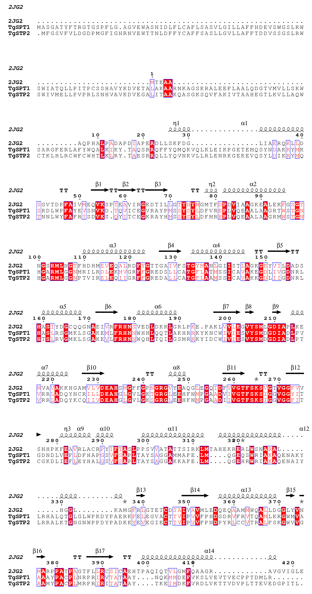
Figure 34: The ESPript 3.0 MSA detailing the secondary structural elements of SpSPT aligned with the novel Toxoplasma SPTs.
Figure 35 shows a homology model of TgSPT1, based on the crystal structure of SpSPT (Mina et al., 2017). The model is of a mainly α-helical homodimeric protein, featuring PLP bound at the conserved lysine residue, with one chain shown in red and the other in blue.

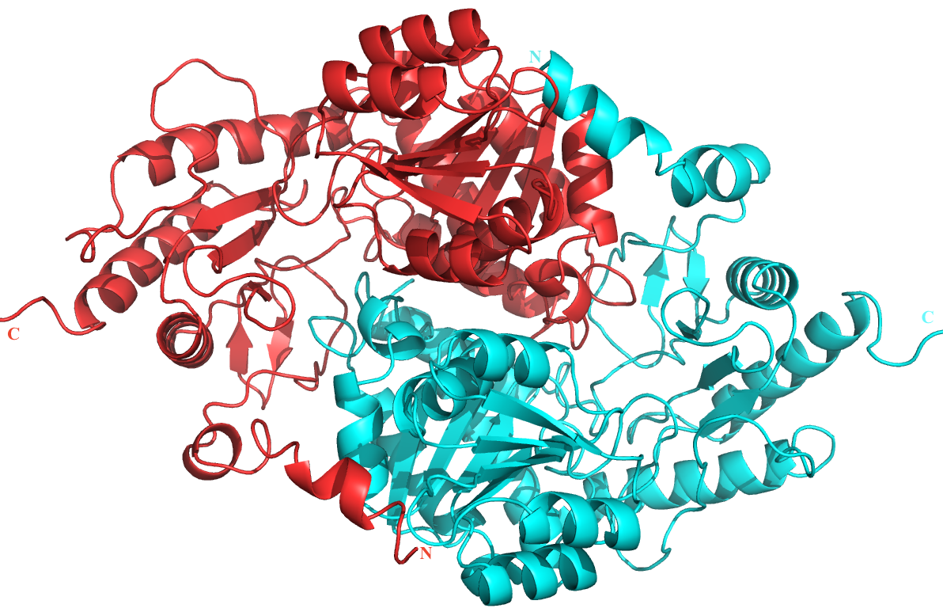
(A)

(B)
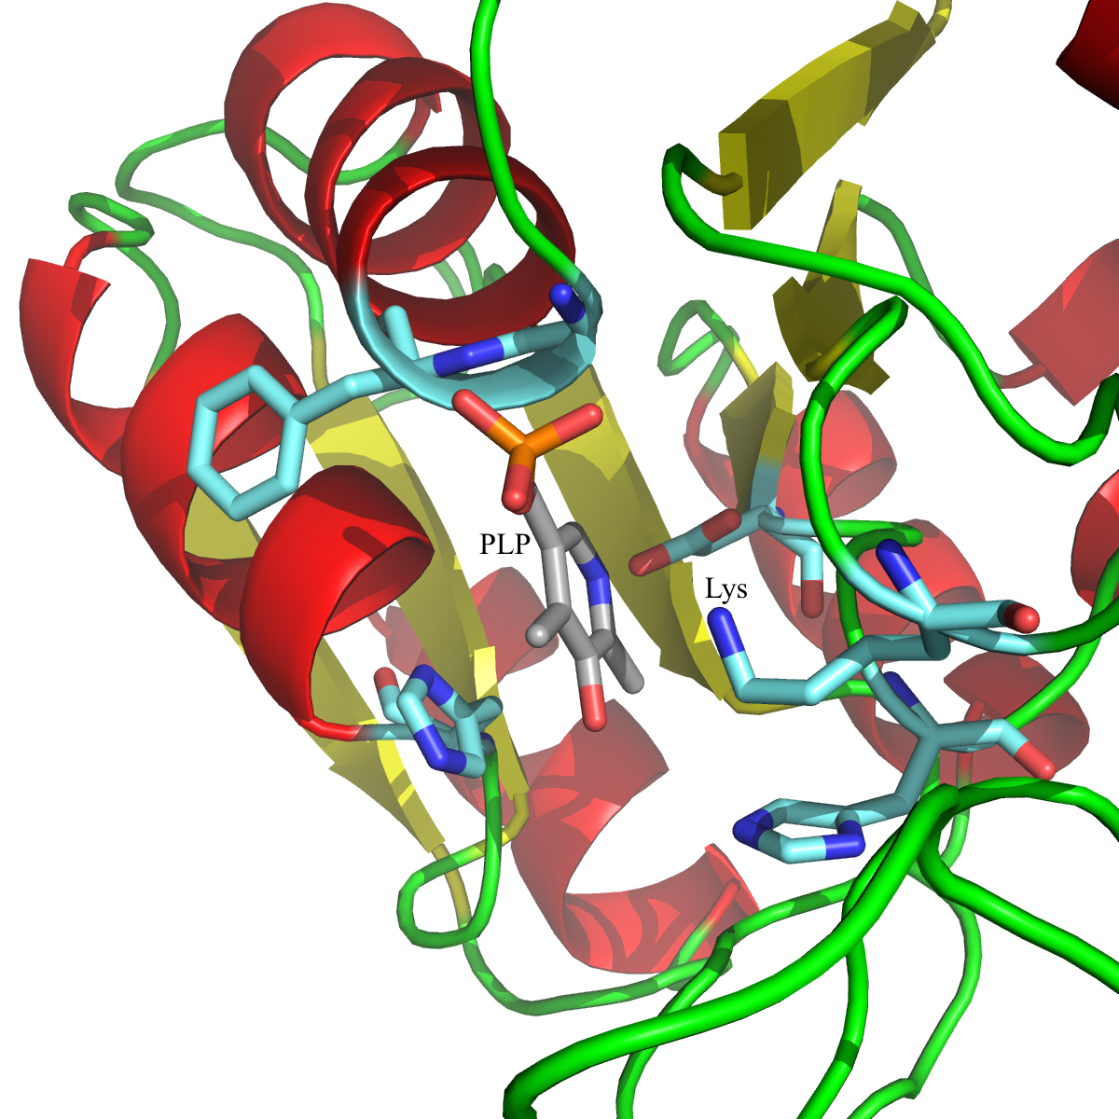
Figure 35: (A) A ribbon diagram representing the homology model of TgSTP1, based on the crystallised prokaryotic SpSPT. The structure details a homodimer with on monomeric subunit in red and the other in blue. The N- and C-termini of each monomer are labelled. (B) A close-up of the active site of one monomer, detailing PLP bound adjacent to the highly-conserved lysine residue.
Overall, TgSPT shows a closer evolutionary relationship to its bacterial counterpart than mammalian SPT, despite being of eukaryotic origin. The main difference between TgSPT and bacterial SPT is the N-terminal extension that houses a transmembrane domain, allowing localisation of TgSPT to the ER membrane (Mina et al., 2017). Detailed sequence analysis and bioinformatics studies conclude that TgSPT, and therefore possibly apicomplexan SPT in general, is radically different to all other eukaryotic SPT studied to date. This difference identifies apicomplexan SPTs as new potential drug targets, opening the door to the development of novel therapeutics for diseases such as toxoplasmosis and malaria.

2.3.2. Successful In-Fusion Cloning

The eight SPT constructs were successfully cloned into the pOPINS3C vector and transformed into RosettaTM II DE3 competent cells for expression. Appendix 13 lists all the glycerol stocks made throughout the In-Fusion cloning process. All eight pOPINS3C expression plasmids were validated through sequencing; FinchTV and sequence alignments aided in analysis of sequencing data. Subsequently, DNA were analysed by NanoDrop and AGE (Section 2.2.5.4.) to confirm concentration and purity. For AGE, both whole plasmid and plasmid restricted once at the conserved Kpn I site were analysed. Validated samples of the eight purified pOPINS3C vectors were stored at -20˚C to form a long-term stock of stable plasmid.

2.3.3. Small-Scale Expression Trials

Originally, RosettaTM II DE3 pLysS (Novagen, Merck) competent cells were used for the expression of the TgSPT1 constructs (Thye, 2014). This strain carries an additional gene for T7 lysozyme on the pACYC184-derived Cam^{R} plasmid pRARE2. T7 lysozyme is a natural inhibitor of T7 RNA polymerase, allowing control of the background activity of T7 RNA polymerase before induction. The purpose of T7 lysozyme is to simply repress the basal expression of the target gene (under the control of a T7 promoter) before the point of induction. Expression of all eight apicomplexan SPTs in this strain was extremely low or completely lacking so a change to RosettaTM II DE3 cells, without the additional T7 lysozyme, was made. Expression levels, illustrated by Figure 36, were still low in RosettaTM II DE3 cells and only TgSPT1 F6 and TgSPT2 were subsequently expressed at a larger scale.
Figure 36: SDS-PAGE analysis of cell lysate samples from small-scale expressions of CmSPT, EtSPT and PfSPT. A purple arrow indicates the approximate weight of recombinantly tagged apicomplexan SPT (~60 kDa). Lane 1: ladder; lane 2: empty pOPINS3C control; lane 3: CmSPT; lane 4: EtSPT; lane 5: PfSPT. The gel is representative of protein expressed in 30 mL of culture.

The gel shown in Figure 36 shows PfSPT as the protein that expressed best at small-scale; this apicomplexan SPT should be the next candidate for large-scale expression trials, after TgSPT.

2.3.4. Large-Scale Expression and Purification

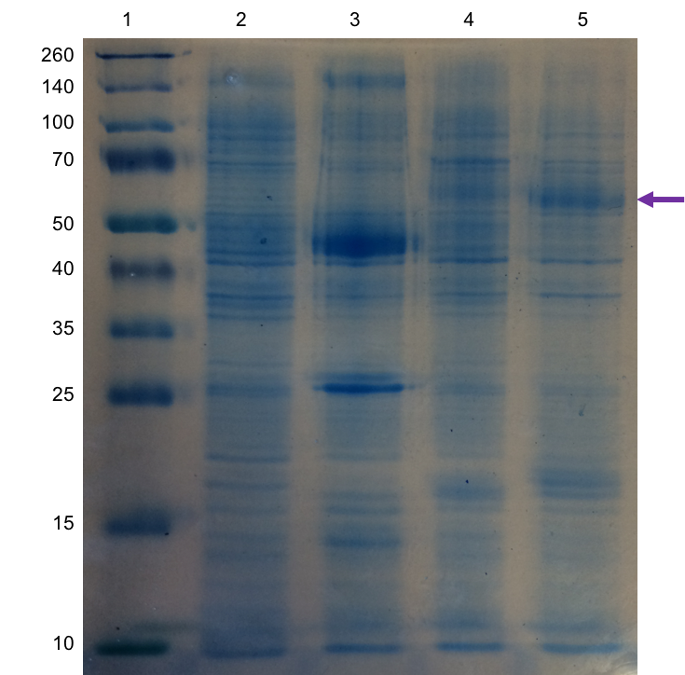
TgSPT1 F6 and TgSPT2 were taken to large-scale expression in RosettaTM II DE3 cells. Protein was initially purified from cell lysate using IMAC. TgSPT1 F6 eluted at approximately 225 mM imidazole, and TgSPT2 at 255 mM imidazole; such imidazole concentrations are within the expected range for the purification of recombinantly His₆-tagged proteins (Mooney et al., 2015; Noirclerc-Savoye et al., 2015). Figure 37 displays a gel representative of protein fractions pooled following IMAC. This gel revealed some contaminants, identified by MS as E. coli chaperones such as DnaK and GroEL. It is possible that these chaperones have multiple surface histidine residues, resulting in their weak binding to the Ni²⁺-NTA column.

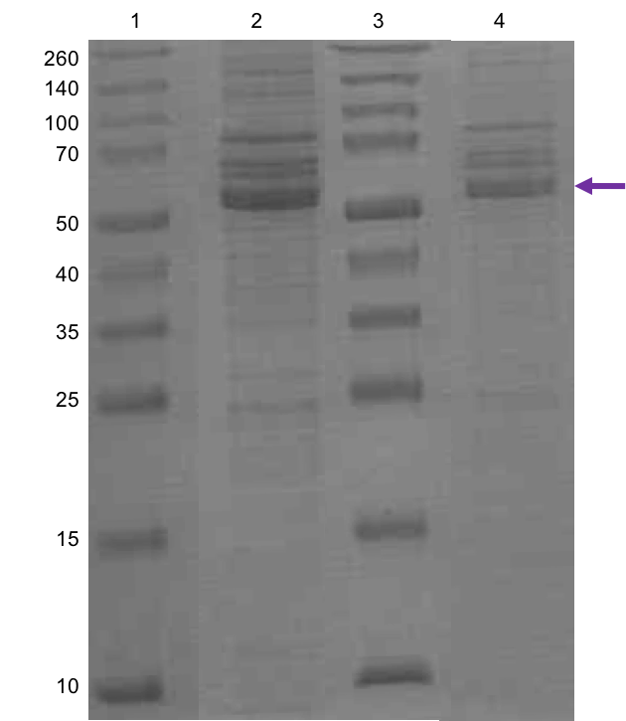
Figure 37: SDS-PAGE analysis of pooled fractions from IMAC purification. A purple arrow indicates the approximate weight of recombinantly tagged TgSPT (~60 kDa). Lane 1: ladder; lane 2: TgSPT1 F6; lane 3: ladder, lane 4: TgSPT2. The gel is representative of protein expressed in 2 L of culture.

The gel shown in Figure 37 indicates that the large-scale expression of TgSPT1 F6 and TgSPT2 was successful and can yield quantities of protein large enough to facilitate downstream biophysical and structural characterisation.

2.3.5. Mass Spectrometry Confirmation of Protein Molecular Weight

A purified tagged sample of TgSPT2, alongside samples of TgSPT1 E6, TgSPT1 F6 and TgSPT1 H6 purified by Thye (2014), were submitted for analysis by MALDI and ESI. Figure 38 displays the ESI spectra for the four samples and Table 19 summarises the ESI data.
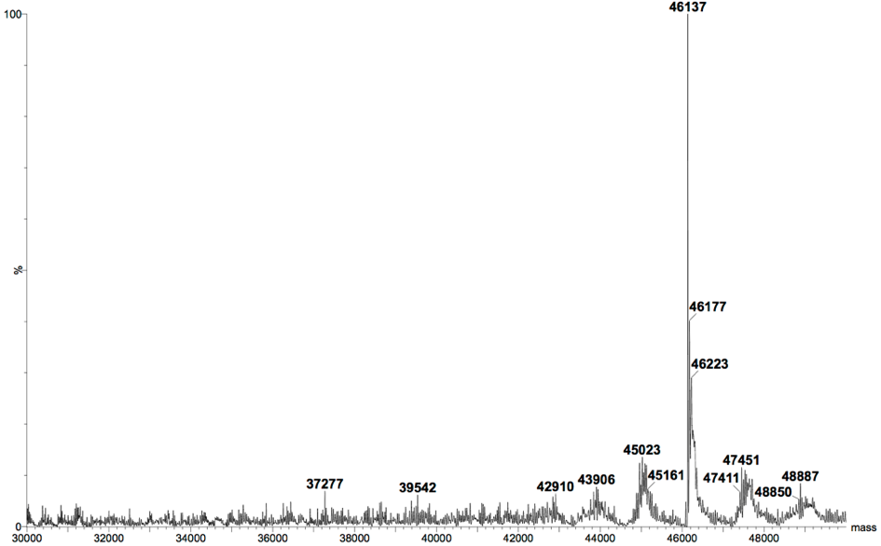
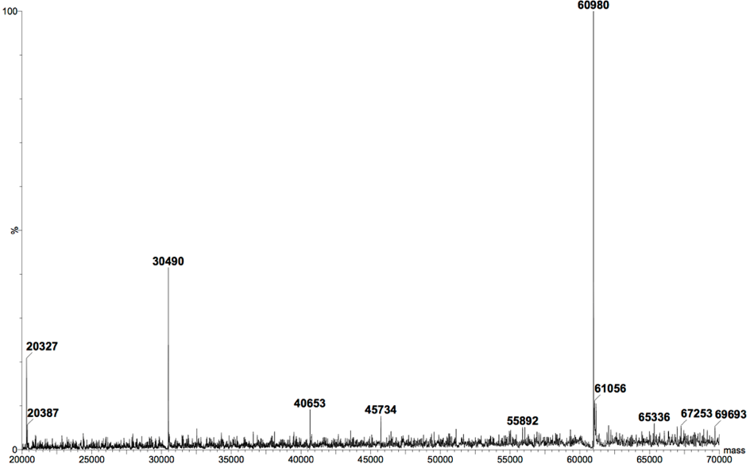
(A)
(B)

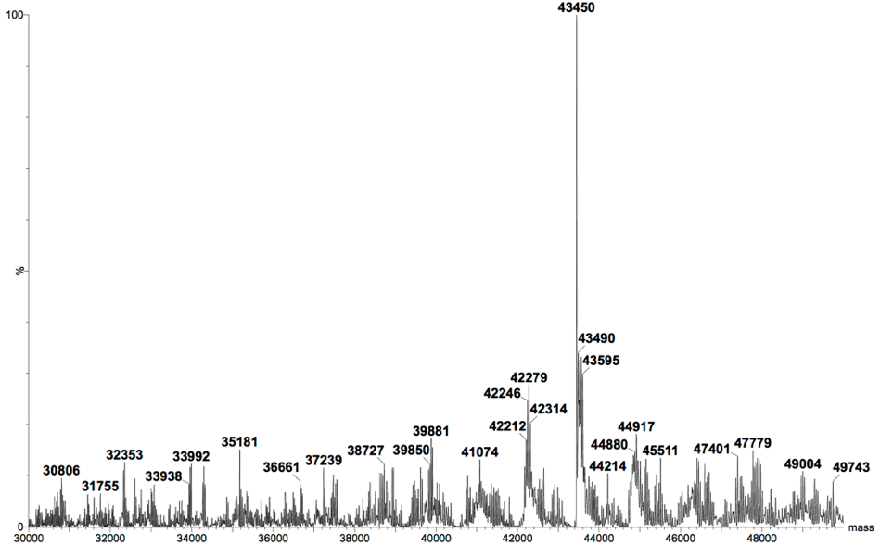
(C)

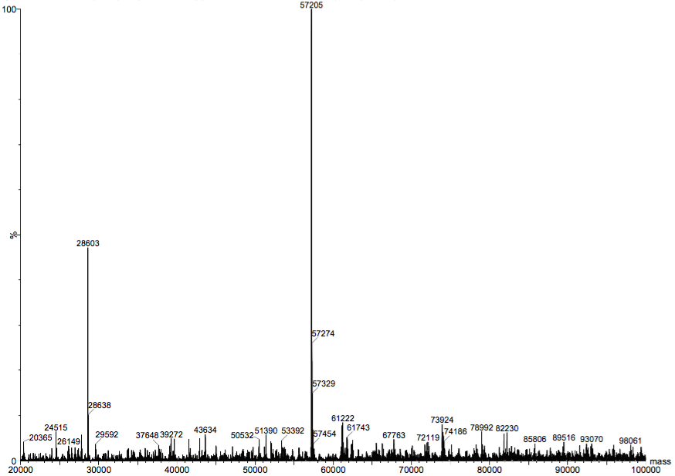
(D)
Table 19: Summary of the predicted MWs for both tagged and cleaved protein samples, compared to the ESI peaks observed.
Figure 38: The ESI spectra for (A) TgSPT1 E6, (B) TgSPT1 F6, (C) TgSPT1 H6 and (D) TgSPT2.
 | Predicted Tagged MW (kDa) | Predicted Cleaved MW (kDa) | ESI Peak  (kDa)
TgSPT1 E6 | 61.12 | 47.91 | 60.98
TgSPT1 F6 | 59.19 | 45.98 | 46.14
TgSPT1 H6 | 57.07 | 43.86 | 43.45
TgSPT2 | 59.94 | 46.73 | 57.21

The ESI data for the TgSPT1 samples concludes that the E6 construct is a His₆-SUMO-3C tagged sample (Figure 38 (A)), whereas the F6 and H6 constructs have been proteolytically cleaved (Figure 38 (B) and (C), respectively). The data for the TgSPT2 sample shows a peak approximately 2.73 kDa lighter than predicted for a tagged sample (Figure 38 (D)); it is possible that protein degradation is occurring at either the N- or C- terminus or both. In order to clarify the TgSPT2 result, a pure protein sample should be submitted for sequencing via trypsin digest and subsequent MS analysis of the resulting peptides. Additionally, the pOPINS3C vector containing the TgSPT2 expression construct should be subject to re-sequencing. Nucleic acid and amino acid sequences will show if the expression construct is incomplete or highlight any protein degradation.

2.3.6. Investigation of Protein Fold Using Circular Dichroism

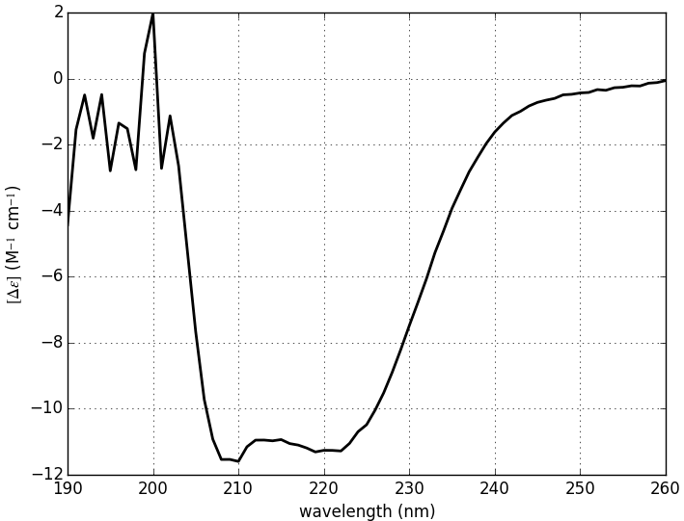
CD was performed on purified tagged TgSTP2 protein. The online CAPTIO server (Wiedemann et al., 2013) was used to interpret raw CD data. The CD spectrum for TgSPT2 (Figure 39) shows a small hump around 210-220 nm followed by a large curve between 220-250 nm; this pattern is typical of a mainly α–helical protein (Campbell, 2012; Kelly et al., 2005). Therefore, despite the presence of the His₆-SUMO-3C tag, TgSPT2 remains correctly folded in vitro.
Figure 39: The CD spectrum for tagged TgSPT2, generated by the CAPITO server.
CAPITO also performed a Chou-Fasman algorithm to estimate the protein fold as 43% α–helical, 38% β-sheet and 19% irregular. This result aligns with the homology model (Figure 35), which details a mainly α–helical structure. However, the CD spectrum lacks the signature curve for β-sheet, despite the estimate of 38% β-sheet; this may be due to the presence of the His₆-SUMO-3C tag. Conversely, analysis using the online Phyre² server (Kelley et al., 2015) estimates a fold of 47% α–helical, 13% β-sheet, 15% transmembrane helices and 10% disordered. The difference between the CAPITO and Phyre² fold predications could be explained by the limited accuracy of CD data and the CD being performed on tagged protein, whilst the Phyre² analysis was conducted using the native TgSPT2 sequence.

2.3.7. Validation of In vitro Enzyme Activity

The novel activity assay was positive for tagged TgSPT1 E6 and cleaved TgSTP1 F6 samples purified previously by Thye, 2014, and purified and tagged TgSPT2. The product of SPT catalytic activity, KDS, has a predicated MW of 299.28 g/mol. Pure KDS was purchased from Matreya and a 25 mM sample in methanol was used as a standard in the activity assay. Both LC-MS and accurate mass analysis were performed, confirming the mass of KDS as 300.29 g/mol (Figure 40).

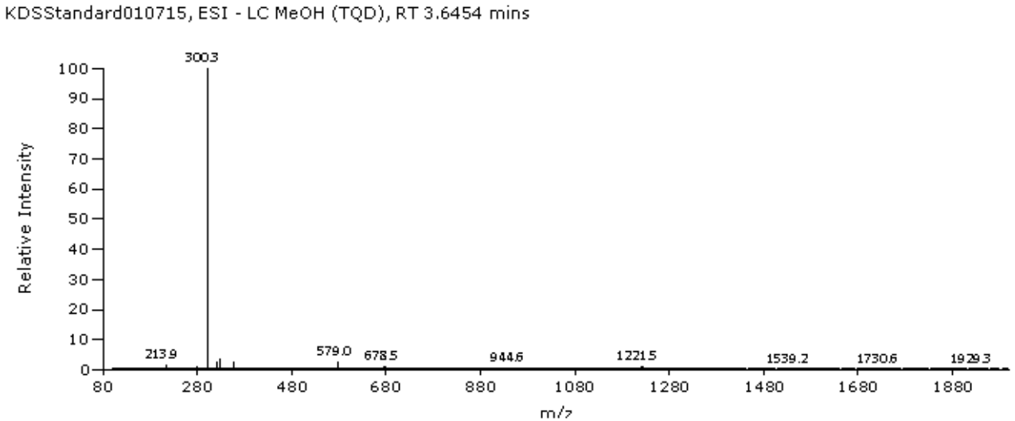
(A)

(B)
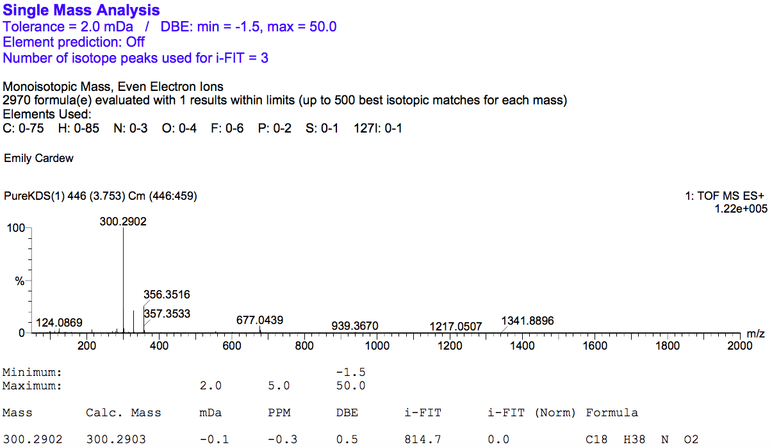
Figure 40: (A) The LC-MS spectrum for the pure 25 mM KDS sample in methanol. At a retention time of 3.6454 minutes there is a dominant peak at 300.3 m/z with 100% relative abundance, representing KDS. (B) The accurate mass spectrum of the same sample of KDS agrees with the LC-MS data as there is a peak at 100% relative abundance at 300.2902 m/z.
Figure 41 shows the LC-MS spectra for the positive in vitro activity assays with palmitoyl-CoA for the TgSPT1 E6, TgSPT F6 and TgSPT2 samples. All three spectra detail a dominant peak at similar retention times, at approximately 300 m/z with 100% relative intensity. Table 20 summarises the activity assay data. These spectra confirm that the SPT samples are catalytically active.
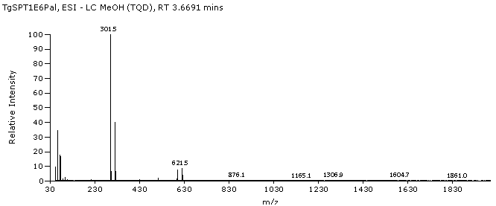
(A)

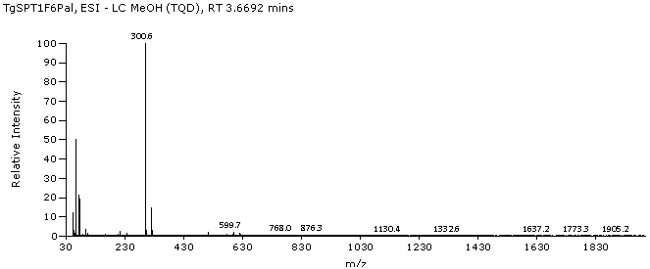
(B)
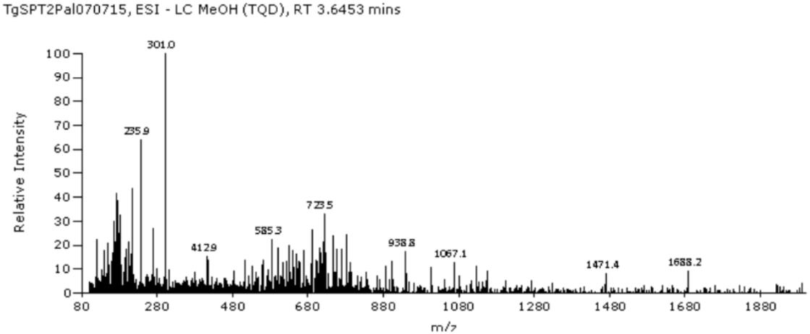
(C)
Figure 41: The LC-MS spectra for the palmitoyl-CoA activity assays for (A) TgSPT1 E6, (B) TgSPT1 F6 and (C) TgSTP2. All three spectra are at a similar retention time (3.6453-3.6692 minutes) and feature a dominant peak at 300.6-301.5 m/z with 100% relative intensity. These peaks are evidence of KDS.

Table 20: Summary allowing comparison of the LC-MS spectral data for the palmitoyl-CoA in vitro activity assays.
LC-MS Spectrum | Retention Time (minutes) | m/z Value | Relative Intensity (%)
25 mM KDS | 3.6454 | 300.3 | 100
TgSPT1 E6 | 3.6691 | 301.5 | 100
TgSPT F6 | 3.6692 | 300.6 | 100
TgSPT2 | 3.6453 | 301.0 | 100

These LC-MS experiments are within the experimental error of the standard and, hence, confidently evidence the production of KDS by the three tested TgSPT samples. Overall, despite the ESI data for the TgSPT2 sample (Figure 41 (C)) revealing a peak approximately 2.73 kDa lighter than estimated MW for tagged protein, the CD and in vitro activity assay results conclude that the protein samples does contain TgSPT2; despite possible degradation at the N- or C-terminus, or both, tagged TgSPT2 protein remains folded, soluble and catalytically active.

2.3.8. Analysis of Serine Palmitoyltransferase Thermal Stability

Please refer to Section 1.3.8. in Chapter I of this thesis for the TSA results for TgSPT1 (constructs F6 and H6) and a discussion of the results in terms of protein stability and protein crystallisation.

2.3.9. Protein Crystallisation Trials

Four 24-well plates were set up with purified and tagged TgSPT2, known to be folded and catalytically active, on 7th July 2016, containing the 96-condition PEGs Suite Screen. The trays were checked one week later, on 14th July 2016. No crystals were evident, along with no salt crystals or indication of protein insolubility. This indicates that a higher protein concentration should be used.
2.4. Conclusions

Eight SPTs from a variety of apicomplexan parasites have been successfully cloned into the pOPINS3C expression vector with a recombinant N-terminal His₆-SUMO-3C tag. All constructs were verified by sequencing and AGE. The cloned pOPINS3C products were subsequently transformed into RosettaTM II DE3 cells for expression.

The expression, purification and biophysical characterisation of TgSPT1 and TgSPT2 were established to the point of pure, folded and catalytically active samples. The expression and purification of other apicomplexan SPTs is yet to be optimised. However, the successful In-Fusion cloning experiments are an excellent starting point to trial alternative E. coli strains for expression in the future.

SDS-PAGE and MS experiments positively confirmed purified protein identities. The combination of CD and a novel in vitro activity assay demonstrated TgSPT2 to be a folded, catalytically active protein, independent of TgSPT1. Therefore, it can be hypothesised that TgSPT2 forms a homodimer is solution with an active site consisting of residues from the two subunits.

Aside from the necessary optimisation of the expression of other apicomplexan SPTs and development of a proteolytic cleavage assay to remove the recombinant tag, the data presented in this chapter represents the groundwork contributing towards validating SPT as a potential therapeutic drug target for the treatment and prevention of toxoplasmosis and other diseases in animals and humans.
2.5. Future Work for the Characterisation and Crystallisation of Apicomplexan Serine Palmitoyltransferase

Overall, there was limited success of small-scale SPT expression in RosettaTM II DE3 cells. Therefore, it is proposed that BL21 DE3 cells should be considered for protein expression. The SPT ORFs were codon-optimised for bacterial expression and cloned into pUC57 plasmids by GenScript. Due to the codon-optimisation step, the use of the RosettaTM II DE3 strain, that offers seven eukaryotic tRNAs for the expression of eukaryotic protein in bacterial systems, is obsolete. It is highly probable that the codon-optimised sequences will express in BL21 DE3 cells. Furthermore, it would be interesting to investigate induction of protein expression through IPTG as opposed to auto-induction media, as Chapter III illustrates the successful optimisation of the IPTG-induced expression of a bacterial protein that is a potential drug target.

The proteolytic removal of the recombinant tag also needs to be optimised, particularly with regards to future crystallisation experiments. HRV 3C protease activity can be enhanced by several additives in the cleavage buffer; a small screening of cleavage assay conditions could be performed to optimise the cleavage buffer and protein to protease ratio.

The in vitro activity assay could be expanded to assess SPT activity towards other acyl-CoA substrates, such as lauroyl-CoA and myristoyl-CoA; this would help establish the specificity of SPT catalytic activity. Furthermore, known inhibitor compounds, such as cycloserine (Lowther et al., 2010) and myriocin (Wadsworth et al., 2013), could be introduced into the in vitro activity assay.

Purified samples of apicomplexan SPT would be ideal candidates for assessment of thermal stability using the Durham Screens. The TSA protocol could subsequently be developed to thermally analyse the binding of both known and unknown inhibitor compounds and other chemical moieties to SPT, such as the anti-leishmanial drug miltefosine and the structurally similar anti-cancer drug perifosine.
Currently, there is no crystallographic data for apicomplexan SPT. The driving force of all future work should be to obtain a 3D X-ray structure for a parasitic SPT cloned in this chapter as structural information is of high importance, especially with regards to the drug development industry (Hol, 2015). A crystal structure will confirm the in vivo protein complex (predicted to be a membrane-bound heterodimer) and help elucidate binding sites for novel inhibitors. Initially, TSAs with the Durham Screens could aid in the optimisation of crystallisation trials. Also, opportunities for co-crystallisation with known and novel inhibitor compounds must be considered.

Overall, future research will contribute to the characterisation of SPT as a potential drug target in apicomplexan parasites that cause a range of prevalent human and veterinary diseases worldwide.
Chapter III: The RisA Response Regulator from a Bordetella pertussis Two-Component Regulatory System

This chapter summaries research into the response regulator protein RisA from the Gram-negative pathogenic bacterium Bordetella pertussis, the causative agent of whooping cough. As part of a two-component signal transduction system, RisA is involved in the regulation of bacterial virulence and is therefore of particular interest. The characterisation of proteins that control bacterial pathogenesis is highly important for the design and development of novel therapeutics to combat the rise of antibiotic resistance in the twenty-first century. This chapter presents the work to optimise the expression and purification of RisA for future biophysical and structural characterisation.

3.1. Introduction

3.1.1. Bacterial Two-Component Regulatory Systems

Two-component regulatory systems (TCSs) are, arguably, the most important players in prokaryotic signal transduction. Involved in cellular development, survival and virulence (Gooderham and Hancock, 2008), they are among the most abundant proteins in sequence databases. TCSs link environmental stimuli to specific adaptive responses using a phospho-relay system between two protein components, namely a sensory histidine kinase (HK) and a response regulator (RR) (Hoch, 2000; Nguyen et al., 2015).

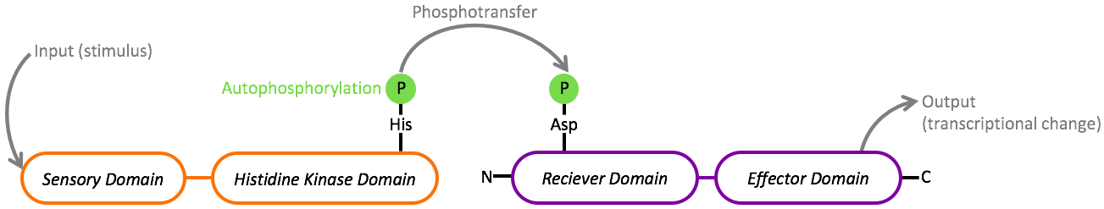
The well-characterised EnvZ-OmpR TCS, that regulates the expression of porin genes ompF and ompC in response to changes in osmolarity, is a typical example of this form of signal transduction in prokaryotes (Forst and Roberts, 1994). The initial signal is received by a membrane-bound sensory protein (EnvZ, for example) that is a HK with a sensory domain and a transmitter domain (Stock et al., 2000). Upon receiving a stimulus, the HK will undergo autophosphorylation at a histidine residue within the cytoplasmic transmitter domain; the signal is transmitted by phosphotransfer to an aspartate residue on the receiver domain of the cognate RR protein (OmpR, for example) (Figure 42). The activated effector domain of the RR protein generates a signal output. It is estimated that 70% of classified RR proteins contain a DNA-binding domain and, therefore, undergo their signal out function as a transcriptional regulator (Zschiedrich et al., 2016).
Figure 42: Illustration of the workings of a prokaryotic TCS, such as EnvZ-OmpR.

This chapter specifically investigates the TCSs of pathogenic bacteria, as their involvement in bacterial virulence makes TCS proteins likely drug targets.

3.1.2. Bordetella pertussis; the Causative Agent of Whooping Cough

3.1.2.1. Bordetella pertussis as a Gram-Negative Pathogen

B. pertussis, a Gram-negative pathogen, is the causative agent of whooping cough (pertussis), a highly contagious respiratory disease that is transmitted directly from human to human via aerosolised respiratory droplets. Upon infection, the bacteria adhere to ciliated epithelial cells in the respiratory tract and subsequently proliferate, producing an arsenal of adhesins, virulence factors and toxins that allow avoidance host immune detection and ensure their survival (Melvin et al., 2014).

3.1.2.2. Symptoms, Diagnosis and Treatment of Whooping Cough

Initially evoking systems of the common cold/flu, including coughing and sneezing, manifestation of the disease is characterised by three phases: catarrhal, paroxysmal and convalescent. The second phase involves experiencing sudden, reoccurring coughing fits. The coughing can be severe enough to induce fainting, vomiting, fatigue and even broken ribs. Upon presenting with such symptoms, a diagnostic swab is often taken to culture the bacteria and identify the species causing the illness.

Antibiotics, in particular, macrolide compounds, can be used to treat B. pertussis infections. Interestingly, a common therapeutic regime is the combinatorial use of trimethoprim and sulfamethoxazole; a key treatment for the treatment of toxoplasmosis (discussed in Section 2.1.4.2.).

3.1.2.3. Current Worldwide Outlook on Whopping Cough

It was estimated in 2015 that 16.3 million people worldwide were infected with B. pertussis, resulting is approximately 58,700 deaths in the same year. Most cases occur in developing countries. A vaccination programme is in place, but with only an estimated 86% world coverage, whooping cough remains a key cause of infant morbidity and mortality (World Health Organisation, 2015).

3.1.3. Two-Component Regulatory Systems and Virulence Gene Expression in Bordetella pertussis

3.1.3.1. Regulation of Virulence Genes in Bordetella pertussis

The expression of virulence genes in B. pertussis is controlled by the BvgA/S TCS (Uhl and Miller, 1994). When BvgA, the RR protein, is phosphorylated, an array of adhesins, toxins and other virulence factors are expressed and produced via the positive regulation of virulence-activated genes (vags). These gene products interfere with the host metabolic pathways immune responses. Alternatively, when BvgA is not phosphorylated then a different set of genes, collectively called virulence-repressed genes (vrgs), are expressed and the pathogen enters an avirulent phase.

RisA, a suspected RR protein, is involved in the expression of vrgs and has been shown to be required for maximal expression of some vrgs (Cróinín et al., 2005; Stenson et al., 2005). RisA is additionally involved in the regulation of chemotaxis and flagellar operons, iron-regulated genes and genes of unknown function (Coutte et al., 2016). The discovery of RisA, and its hypothesised cognate kinase RisK, adds a further layer of complexity to the regulation of virulence in B. pertussis.

While the BvgA/S phosphorelay system is thought to be central/integral to pathogenesis, it is now hypothesised that many other regulatory systems interlink to form a complex regulatory network.

3.1.3.2. Improving our Understanding of Control of Virulence in Bordetella spp.

The threat of returning to the pre-antibiotic era is currently hovering over the human race, as the rate of anti-bacterial resistance overtakes the speed at which scientists can discover, develop, test and market antibiotic drugs. In these circumstances, it is of high importance to use all resources available to fight the rise in anti-bacterial resistance. This chapter initiates the characterisation of RisA, a protein known to regulate the expression of virulence factors in B. pertussis, as a potential drug target. Ultimately, compounds that repress the activity of such transcriptional regulators could be used in combination with antibiotics for the therapeutic treatment of whooping cough.

3.2. Materials and Methods

3.2.1. Constructs, Plasmids, Escherichia coli Strains and Antibiotics Used for Expression

Three constructs feature in this chapter; wild-type B. pertussis RisA, a phospho-ablative D60N mutant and a phospho-mimetic D60E mutant (Table 21). All constructs were expressed in the pET-15b vector under the control of a T7 promoter. pET-15b features a recombinant N-terminal His₆ tag that facilitated IMAC (Section 3.2.4.3.) and an Amp^{R} gene. E. coli BL21 DE3 competent cells (Appendix 6) were used for protein over-expression. The BL21 DE3 stain carries a copy of T7 RNA polymerase under control of lacUV5 promoter, enabling the IPTG-inducible expression of the protein of interest (POI). 100 μg/mL Amp were used to select for transformants.

Table 21: The amino acid sequence lengths and MWs of native full-length and tagged BpRisA.
Full Length (aa) | Full Length MW (Da) | Tagged Length (aa) | Tagged MW (Da)
244 | 27,739 | 264 | 29,902

Samples of the BpRisA expression constructs cloned into pET-15b and transformed into competent cells were received from Dr. Loïc Coutte at INSERM, Institut Pasteur de Lille.

3.2.2. Preparation of Cells for Expression

On receipt of the samples, cells were streaked onto LB agar plates (Appendix 7) supplemented with 100 μg/mL Amp and incubated at 37˚C overnight to allow colony growth. The following day, one colony was used to inoculate 10 mL LB (Appendix 7) supplemented with 100 μg/mL Amp; cultures were grown overnight at 37˚C, 200 rpm. Plasmid DNA was purified by miniprep (Section 2.2.5.3.) and subsequently analysed by AGE (Section 2.2.4.5.) and concentration estimated using NanoDrop. A sample of purified, quantified plasmid was sent for sequencing at the DBS Genomics facility in the Department of Biosciences, Durham University. Appendix 14 details the primers used for sequencing. Once the correct sequence was verified, purified pET-15b plasmid containing the BpRisA ORF was transformed into BL21 DE3 competent cells using heat shock (Section 2.2.5.1.) and glycerol stocks were made (Section 2.2.5.2.).

3.2.3. Small-Scale Protein Expression and Batch Purification

Appendix 7 details the media used in the following expression experiments and Appendix 15 lists the buffer compositions for purifications.

3.2.3.1. Streaking Glycerol Stocks

Glycerol stocks of BL21 DES competent cells transformed with the pET-15b plasmid for expression were steaked out onto LB agar places supplemented with 100 g/mL Amp using sterile loops. Plates were incubated at 37˚C overnight to allow colony growth.

3.2.3.2. Starter Cultures and Expression Cultures

10 mL LB starter cultures, supplemented with 100 μg/mL Amp, were grown overnight at 37˚C and 200 rpm in sterile 50 mL Falcon tubes. The following day, 30 mL aliquots of LB supplemented with 100 μg/mL Amp, in sterile conical flasks, were inoculated with 1.2 mL starter culture (1:25 inoculation ratio). Cultures were grown at 37˚C and 150 rpm until an OD₆₀₀ of 0.7-0.8 was reached. Expression was then induced with 1 mM IPTG and the cultures were left to grow for a further 3 hours in the same conditions.

3.2.3.3. Bacterial Cell Lysis

Cells were harvested by centrifugation at 3,000 g, 4˚C, for 10 minutes and cell pellets were processed as described in Section 2.2.6.4., only using a different lysis buffer (Appendix 15). Samples of filtered soluble fractions were analysed by SDS-PAGE (Section 2.2.6.6.) and compared to a non-induced control culture.

3.2.3.4. Nickel Agarose Batch Purification

Small-scale batch purification was performed, as per Section 2.2.6.5., with the buffers detailed in Appendix 15. All supernatant samples (two wash steps and four elution steps) were retained for SDS-PAGE analysis (Section 2.2.6.6.), alongside a sample of the cell lysate.

3.2.4. Large-Scale Protein Expression and Column Protein Purification

The following expression and IMAC purification protocols originate from Dr. Loïc Coutte’s work and were adapted for use in this thesis. The subsequent ion exchange chromatography protocols were used to optimise the purification of BpRisA. The compositions of all buffers used for the following purification and experiments are detailed in Appendix 15. Large-scale expression and purification was only performed for native BpRisA.

3.2.4.1. Large-Scale Expression

As per Section 3.2.3.1., glycerol stocks were streaked onto LB agar plated supplemented with 100 μg/mL Amp using sterile loops. The plates were incubated at 37˚C overnight to allow colony growth.

LB was prepared (Appendix 7) and 50 mL aliquots were supplemented with 100 μg/mL Amp in 200 mL sterile conical flasks. Starter cultures were inoculated with one colony each and then left to shake at 37˚C, 200 rpm overnight. One starter culture was prepared for every expression culture.

1 L aliquots of LB (Appendix 7) supplemented with 100 μg/mL Amp, prepared in 2 L non-baffled Erlenmeyer flasks, were inoculated with 40 mL starter culture (1:25 inoculation ratio). Expression cultures were then grown at 37˚C, 150 rpm for approximately three hours until an OD₆₀₀ of 0.7-0.8 was reached. Expression was subsequently induced using 1 mM IPTG and the temperature was then reduced to 30˚C. The cultures were then left shaking at 150 rpm for three hours before cells were harvested by centrifugation at 4,000 g, 4˚C for 30 minutes. Supernatants were discarded and cell pellets transferred to sterile 50 mL Falcon tubes. All cell pellets were weighed before storage at -80˚C.

3.2.4.2. Bacterial Cell Lysis

Cell pellets were processed as in Section 2.2.7.4., with only a different lysis buffer being used (Appendix 15).

3.2.4.3. Immobilised Metal Affinity Chromatography

As per Section 2.2.7.5., a 1 mL HisTrap FF column was used on an ÄKTA FPLC system. The protocol was identical with only the buffer compositions (Appendix 15) differing.

3.2.4.4. Size Exclusion Chromatography

The same protocol as described in Section 2.2.7.7. was used but with a different buffer (detailed in Appendix 15).

3.2.4.5. Anion and Cation Exchange Chromatography

Mono Q 5/50 GL and Mono S 5/50 GL columns (GE Healthcare) were used for anion and cation exchange chromatography, respectively, with an ÄKTA FPLC system. The protocol for both columns is the same, apart from the buffers used (detailed in Appendix 15). In preparation, protein was dialysed overnight in dialysis buffer to remove high concentrations of salt. The column was first equilibrated with the appropriate wash buffer before 1 mL of concentrated sample was loaded. A 0-100% gradient of elution buffer was applied to the column, at 1 mL/minute, to elute protein in 1 mL fractions. Column flow-through and protein-containing fractions were collected for analysis by SDS-PAGE (Section 2.2.6.6.).

3.2.5. Optimisation of Harbinger LEX-48TM Bioreactor Protein Expression

A total of nine different expression conditions, trialling a variety of induction densities and induction times (shown in Table 22) were tested in order to optimise the bioreactor expression of BpRisA. 3 X 0.5 L cultures were grown for each of the nine conditions and resulting data was averaged across the three flasks of each condition. Optimisation of bioreactor expression was only performed for native BpRisA.

Table 22: The induction densities and times chosen to be tested for bioreactor expression optimisation at 37˚C.
 | Induction Density (OD₆₀₀) | Induction Time (hours)
1 | 0.7-0.8 | 2
2 | 0.7-0.8 | 3
3 | 0.7-0.8 | 5
4 | 1.3-1.4 | 2
5 | 1.3-1.4 | 3
6 | 1.3-1.4 | 5
7 | 1.9-2.0 | 2
8 | 1.9-2.0 | 3
9 | 1.9-2.0 | 5

Cells were harvested (as detailed in Section 2.3.4.1.) and the three cell pellets for each condition were pooled for bacterial cell lysis and IMAC purification. The IMAC chromatograms, along with SDS-PAGE analysis and NanoDrop, were used to ultimately decide the optimal protocol for bioreactor expression of BpRisA.

3.2.6. Mass Spectrometry

As per Section 2.2.8., purified protein was submitted to the Mass Spectrometry service within the Department of Chemistry, Durham University, to verify protein MW.

3.3. Results and Discussion

3.3.1. Bioinformatics Analysis of Bordetella pertussis RisA Amino Acid Sequence

An initial protein-protein BLAST® search (Altschul et al., 1990) of the full-length native BpRisA sequence revealed a response regulator, namely OmpR, from multiple species as a highly-related sequence. OmpR is a well-characterised DNA-binding protein from the prokaryotic EnvZ-OmpR TCS; OmpR works cooperatively with the EnvZ histidine kinase in vivo to form a phosphotransfer system that links stimuli to specific adaptive responses (Nguyen et al., 2015). More specifically, EnvZ-OmpR is evidenced to facilitate adaptation to both environmental stresses and to host body through production of virulence factors and biofilm formation (Tiganova et al., 2014). The PDB was subsequently searched for OmpR structures and an entry for the crystallised DNA-binding domain of OmpR from E. coli was found (PDB accession code 1OPC). The resolved 3D structure, at 1.95 Å, detailed three α-helices packed against two anti-parallel β-sheets, grouping EcOmpR in the superfamily of winged helix-turn-helix (wHTH) DNA-binding proteins (Martínez-Hackert and Stock, 1997). A pairwise sequence alignment of full-length BpRisA and EcOmpR, using Needle (McWilliam et al., 2013), revealed a sequence identity of 64.1% (Appendix 16) with sequence identity at 63.6% between the DNA-binding domains alone (Figure 43). The phosphorylation site Asp60 in BpRisA is highly conserved; the corresponding Asp55 residue in EcOmpR is within the same VLDLML motif, thus further evidencing the response regulator function of BpRisA in vivo.

EcOmpR 1 APSQEEAVIAFGKFKLNLGTREMFREDEPMPLTSGEFAVLKALVSHPREP 50

|||||...||||.:.|||.||.:.|..|.:|:|:|||:|||....||:.|

BpRisA 1 APSQENESIAFGPYVLNLSTRTLTRNGEQVPITTGEFSVLKVFARHPKIP 50

EcOmpR 51 LSRDKLMNLARGREYSAMERSIDVQISRLRRMVEEDPAHPRYIQTVWGLG 100

|||||||.|||||||.|.:||:||||||||:::|.:|:.|.:||||||||

BpRisA 51 LSRDKLMELARGREYEAFDRSLDVQISRLRKLIEPNPSKPVFIQTVWGLG 100

EcOmpR 101 YVFVPDGSKA 110

|||||||..

BpRisA 101 YVFVPDGGS- 109
Figure 43: The pairwise sequence alignment of the DNA-binding domains of EcOmpR and BpRisA. Identical residues are highlighted in green to emphasise the 63.6% sequence identity.

A more detailed sequence alignment of the two DNA-binding domains was subsequently generated using the online ESPript 3.0 server (Robert and Gouet, 2014) (Figure 44). The PDB file 1OPC was used along with the sequence corresponding to the DNA-binding domain of BpRisA, allowing alignment of novel BpRisA sequence to the secondary structural elements of crystallised EcOmpR.
Figure 44: The ESPript 3.0 alignment of the DNA-binding domains of EcOmpR sequence and secondary structure to novel BpRisA.

Given the relatively high sequence identity of 63.6%, it is very likely that the C-terminal domain of BpRisA contains a DNA-binding domain. Unfortunately, there are no crystal structures deposited in the PDB representing DNA-binding proteins from B. pertussis for further comparison and analysis.

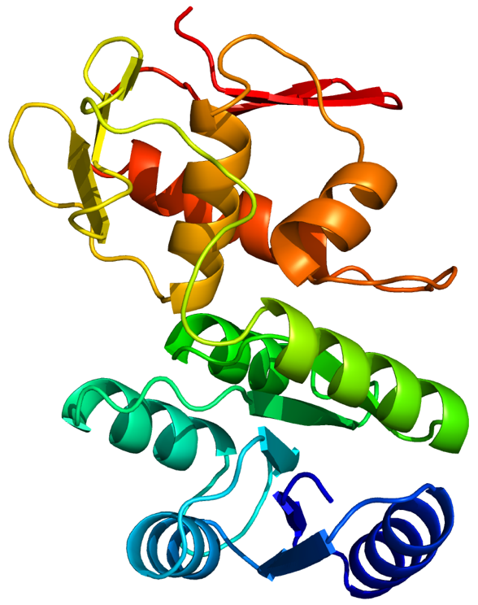
Interestingly, analysis of BpRisA amino acid sequence using the Phyre² online server (Kelley et al., 2015) produced a 3D model of the protein (Figure 45) based on the crystal structure of the PrrA response regulator protein from M. tuberculosis that was recombinantly expressed in E. coli (PDB accession code 1YS7) (Nowak et al., 2006). MtPrrA is a homodimeric protein that was crystallised in complex with magnesium (Mg²⁺). The BpRisA model depicts one BpRisA monomer.
Figure 45: The 3D model of BpRisA based on MtPrrA, generated by Phyre². The ribbon diagram is rainbow colour-coded from the N- to C-terminus.

A pairwise sequence alignment using Needle (McWilliam et al., 2013), shown in Figure 46, reveals 37.3% sequence identity between BpRisA and MtPrrA. However, this relatively low sequence identity means that no structural information about BpRisA can be confidently inferred from the resolved crystal structure of MtPrrA. The homology model is sufficiently accurate to gain insight into the overall fold of BpRisA; however, the atomic detail, that determines specificity and DNA recognition, is lacking. Therefore, the 3D model presented in Figure 45 is not an accurate prediction of the 3D structure of BpRisA. Ideally, an improved homology model would be obtained using the crystal structure of EcOmpR.

MtPrrA 1 MDTGVTSP--RVLVVDDDSDVLASLERGLRLSGFEVATAVDGAEALRSAT 48
|:|..|:| ::||||||..:...|.|.|...||.|..|.|..|..:...
BpRisA 1 MNTQNTTPTRKILVVDDDPRLRDLLRRYLSEQGFNVFVAEDAKEMGKLWQ 50

MtPrrA 49 ENRPDAIVLDINMPVLDGVSVVTALRAMDNDVPVCVLSARSSVDDRVAGL 98
....|.:|||:.:|..||:|:...||...::.|:.:|:|::...||:.||
BpRisA 51 REHFDLLVLDLMLPGEDGLSICRRLRGGHDNTPIIMLTAKAEEIDRIVGL 100

MtPrrA 99 EAGADDYLVKPFVLAELVARVKALLRRRGS-----TATSSSETITVGPLE 143
|.||||||.|||...||:||:.|:|||||: ..:..:|:|..||..
BpRisA 101 EMGADDYLSKPFNPRELLARINAILRRRGTEEHPGAPSQENESIAFGPYV 150

MtPrrA 144 VDIPGRRARVNGVDVDLTKREFDLLAVLAEHKTAVLSRAQLLELVWGYDF 193
:::..|....||..|.:|..||.:|.|.|.|....|||.:|:||..|.::
BpRisA 151 LNLSTRTLTRNGEQVPITTGEFSVLKVFARHPKIPLSRDKLMELARGREY 200

MtPrrA 194 AADTNVVDVFIGYLRRKLEAG-GGPRLLHTVRGVGFVLRMQ--- 233
.|....:||.|..||:.:|.. ..|..:.||.|:|:|....
BpRisA 201 EAFDRSLDVQISRLRKLIEPNPSKPVFIQTVWGLGYVFVPDGGS 244
Figure 46: The pairwise sequence alignment of full-length MtPrrA and BpRisA, suggesting 37.3% sequence identity. The conserved aspartic acid phosphorylation site is highlighted in bold and purple.

Two key features of a response regulator protein are a phosphorylation site and DNA-binding domain. Bioinformatics analysis of full-length BpRisA amino acid sequence reveals a highly conserved likely aspartic acid phosphorylation site (highlighted in Appendix 16 and Figure 46) and a DNA-binding domain with high sequence identity to helix-turn-helix DNA-binding proteins. Overall, bioinformatics analysis strongly suggests that BpRisA is a DNA-binding protein in vivo. However, further analysis and experimental data is needed to determine if BpRisA functions as a monomeric or multimeric protein and if metal-binding is required for DNA-binding activity.

3.3.2. Successful Small-Scale Expression of Native and Mutant RisA

Figure 47 shows the SDS-PAGE analysis of the soluble fractions (before any purification) from a small-scale expression of both native and mutant BpRisA, compared to a non-induced control. Bands of BpRisA are highlighted by a purple arrow at approximately ~30 kDa. This gel confirms the IPTG-inducible expression of BpRisA in the proposed expression system.
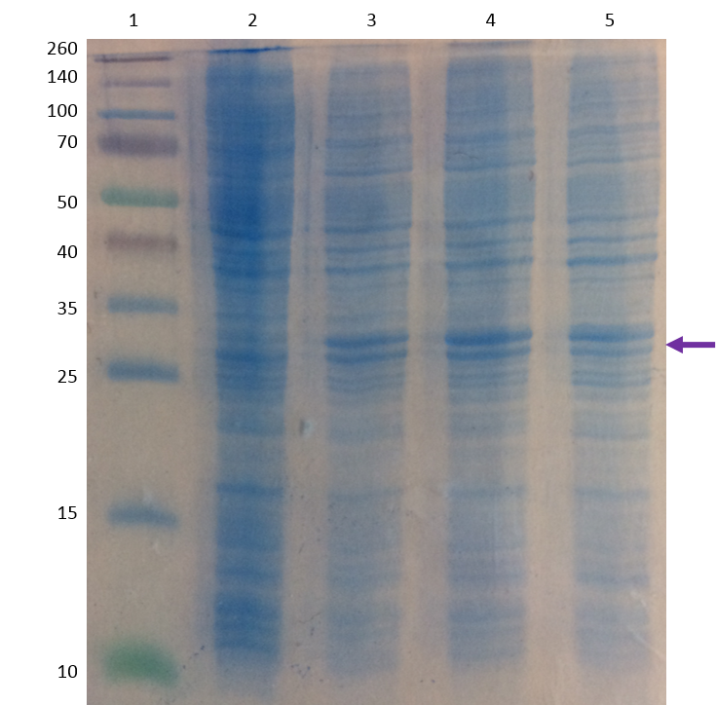
Figure 47: SDS-PAGE analysis of a small-scale expression (30 mL) of all three BpRisA constructs. A purple arrow indicates the approximate weight of recombinantly His₆-tagged BpRisA (~30 kDa). Lane 1: ladder; lane 2: non-induced control; lane 3: induced native RisA; lane 4: induced RisA D60E; lane 5: induced RisA D60N.

After validating the expression system on a small-scale, a batch purification was performed to investigate binding of expressed protein to Ni²⁺ agarose. Figure 48 displays SDS-PAGE analysis of the batch purification of native BpRisA. Lanes 5-8 show four elution steps using 500 mM imidazole; although faint, bands are visible at the correct MW for BpRisA.
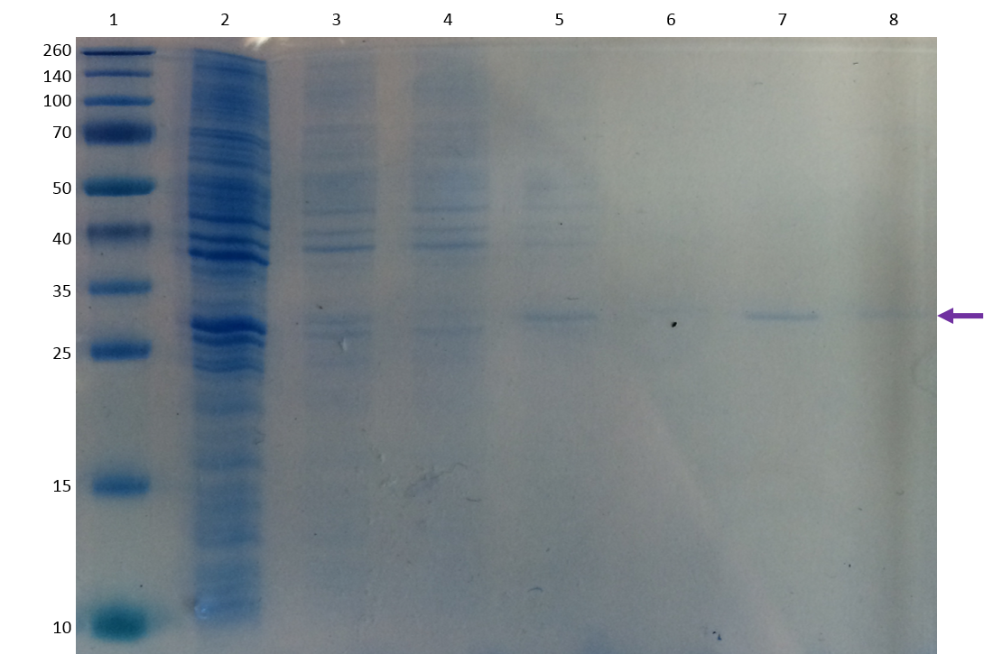
Figure 48: SDS-PAGE analysis of a small-scale (30 mL) Ni²⁺ agarose batch purification of native BpRisA. A purple arrow indicates the approximate weight of recombinantly His₆-tagged BpRisA (~30 kDa). Lane 1: ladder; lane 2: soluble fraction before purification; lane 3: wash 1; lane 4: wash 2; lane 5: elution 1; lane 6: elution 2; lane 7: elution 2; lane 8.

The faintness of the bands can be explained by this gel representing the protein expressed in only a small-scale 30 mL expression culture. However, it confirms that expressed protein is binding to Ni²⁺ agarose with a higher affinity than most other proteins present in the cell lysate.

3.3.3. Successful Large-Scale Expression and Purification of RisA

Figure 49 details the chromatogram and SDS-PAGE analysis of native BpRisA IMAC purification (expressed as per Section 3.2.4.1.). The chromatogram shows a large peak between an elution volume of 17-20 mL, representing BpRisA elution at approximately 400 mM imidazole (80% of the 500 mM imidazole gradient). This elution concentration of imidazole is relatively high compared to the expected range (150-250 mM) for the purification of recombinantly His₆-tagged proteins (Mooney et al., 2015). This means that RisA-His₆ binds to the Ni²⁺ agarose with a higher affinity than usually observed.

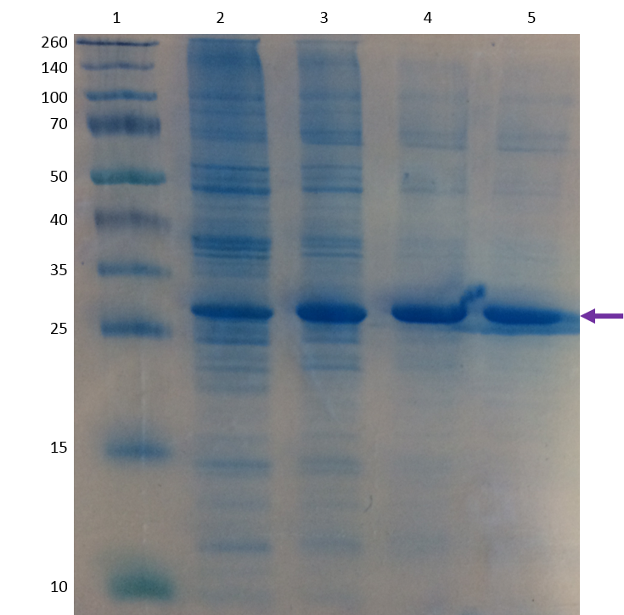
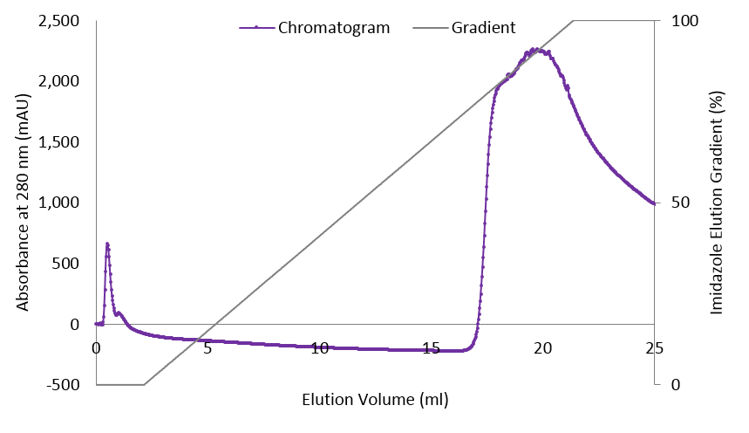
(A)

(B)
Figure 49: (A) Chromatogram for the IMAC purification of BpRisA cell lysate. The purple curve depicts the elution of BpRisA against an imidazole gradient show in in grey. (B) SDS-PAGE analysis of four fractions from IMAC purification. A purple arrow indicates the approximate weight of recombinantly His₆-tagged BpRisA (~30 kDa). Lane 1: ladder; lanes 2-5: fractions. This gel is representative of protein expressed in 2 L of culture.

SDS-PAGE analysis of four 1 mL fractions represented by the large peak revealed clear bands of BpRisA at ~30 kDa, highlighted by a purple arrow in Figure 49 (B). However, the protein sample is not 100% pure. With regards to the contaminating proteins visible in the gel, the imidazole concentration in the wash buffers could be increased to 100 mM. Theoretically, RisA-His₆ should bind to the Ni²⁺ agarose stronger than any other protein in the cell lysate. Therefore, increasing the imidazole concentration in the wash buffer would compete with weaker-binding contaminants and potentially remove them from the column without impacting the binding of RisA-His₆.

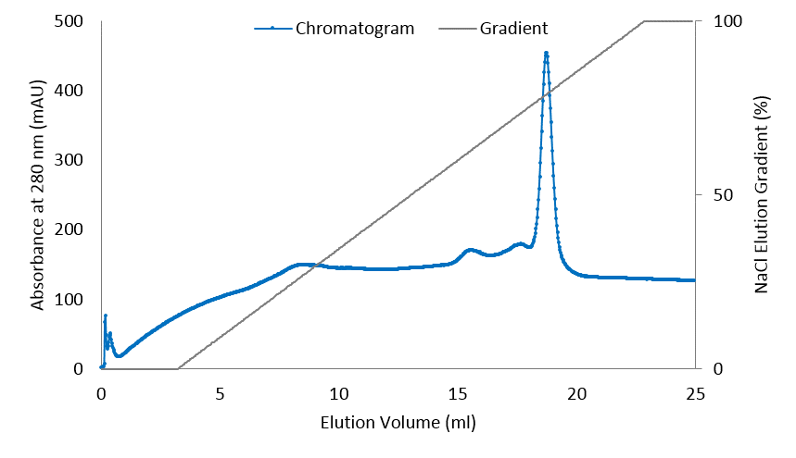
Despite successful IMAC purification, SDS-PAGE analysis (Figure 49 (B)) highlights the need for further purification. Small samples of IMAC-purified BpRisA were used to explore SEC and ion exchange chromatography as possible second purification steps. Anion exchange chromatography, using a Mono Q 5/50 GL column (GE Healthcare Life Sciences), and cation exchange chromatography, using a Mono S 5/50 GL column (GE Healthcare Life Sciences) were initially performed. Figure 50 and Figure 51 show the relevant chromatograms.
Figure 50: Chromatogram for the anion exchange (MonoQ) purification of BpRisA.
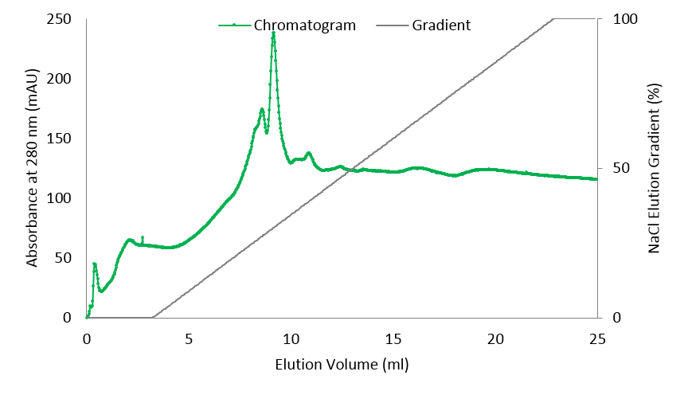
Figure 51: Chromatogram for the cation exchange (MonoS) purification of BpRisA.
As per the gel shown in Figure 52, SEC did not adequately purify the BpRisA sample. Furthermore, cation exchange chromatography did not separate BpRisA from contaminant proteins. Therefore, it was concluded that a two-step column purification of IMAC followed by anion exchange chromatography was the optimal system for purification of BpRisA recombinantly expressed in E. coli.
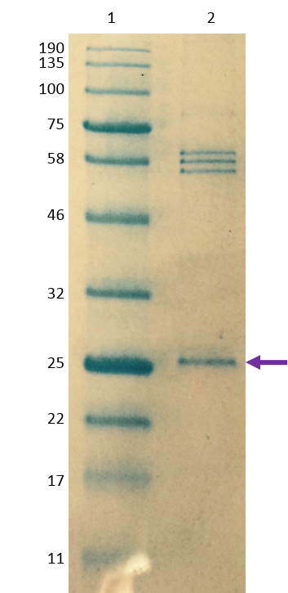
Figure 52: SDS-PAGE analysis of SEC purification of BpRisA. A purple arrow indicates the approximate weight of recombinantly His₆-tagged BpRisA (~30 kDa). Lane 1: ladder; lanes 2: fraction.

3.3.4. Optimisation of RisA Expression in a Harbinger LEX-48TM Bioreactor

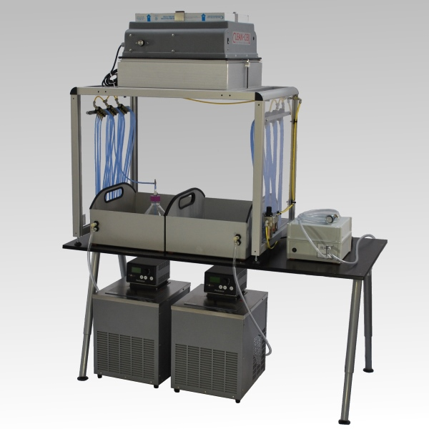
The Harbinger LEX-48TM Bioreactor, shown in Figure 53, has a capacity of 40 X 1 L cultures, using standard glass media bottles and filtered and compressed air for aeration and mixing of each individual culture.
Figure 53: The general set-up of the bench-top Harbinger LEX-48TM Bioreactor, taken from www.epiphyte3.com/LEX.
On initial set-up of the bioreactor, 2 X 1 L cultures were used to test the apparatus. Cell growth was monitored by OD₆₀₀. However, densities were unchanging over a period of 6 hours and cells appeared not to be growing. This initial test was repeated with a further 2 X 1 L cultures using a new glycerol stock of BL21 DE3 competent cells containing the gene for native BpRisA in pEt-15b vector. Again, very little change in cell density was observed over the first four hours. The 2 X 1 L cultures were then transferred to two separate 2 L non-baffled Erlenmeyer flasks and placed in a shaking incubator at 37˚C, 150 rpm. Cell density was continually monitored for a further two hours and the cells resumed normal growth and cell density increased. It was concluded that having 1 L of culture in a 1 L glass bottle meant the culture was not being fully aerated and mixed by the bioreactor and thus cell growth was limited. Subsequently, 2 X 0.5 L cultures in 1L glass bottles were set-up; OD₆₀₀ was monitored and normal cell growth was observed over 6 hours.

The first bioreactor expression of BpRisA reflected the large-scale protocol presented in Section 3.2.4.1.; 10 X 0.5 L cultures in 1 L glass bottles were inoculated with 20 mL of starter culture (1:25 inoculation ratio) and grown at 37˚C to an OD₆₀₀ of 0.7-0.8 over approximately seven hours. Cultures were then induced with 1 mM IPTG and, upon induction, the temperature was reduced to 30˚C. The cultures were subsequently left to express for 16 hours overnight. Cells were harvested by centrifugation at 4,000 g, 4˚C for 30 minutes. The supernatant was discarded and cell pellets were transferred to sterile 50 mL Falcon tubes. All cell pellets were weighed before storage at -80˚C. Following IMAC purification, SDS-PAGE analysis indicated limited protein expression, especially in comparison to the previous small- and large-scale expressions using conventional non-baffled Erlenmeyer flasks and shaking incubators. Therefore, it was decided that an optimisation for expression using the bioreactor was to be undertaken.

Having established the optimal volume for growth being 0.5 L per flask, a series of different induction densities and induction times were explored; Table 23 details the nine combinations of parameters that were tested. Three 0.5 L cultures were grown for each condition. For all nine expression conditions, the average densities at induction and finish were recorded, along with average cell pellet mass. Protein yields following bacterial cell lysis and IMAC purification were compared using the chromatograms, NanoDrop and SDS-PAGE analysis (Figure 54).

Table 23: The results of the bioreactor optimisation experiments at 37˚C. The first two columns detail the fixed parameters chosen for the optimisation. The following three columns detail average values of actual recorded densities and masses.
 | Induction Density (OD₆₀₀) | Induction Time (hours) | Density at Induction (OD₆₀₀) | Density at Finish (OD₆₀₀) | Cell Pellet Mass (g)
1 | 0.7-0.8 | 2 | 0.85 | 2.44 | 3.828
2 | 0.7-0.8 | 3 | 0.88 | 2.43 | 4.201
3 | 0.7-0.8 | 5 | 0.86 | 3.05 | 3.941
4 | 1.3-1.4 | 2 | 1.30 | 2.73 | 4.073
5 | 1.3-1.4 | 3 | 1.31 | 2.32 | 4.311
6 | 1.3-1.4 | 5 | 1.32 | 2.89 | 3.901
7 | 1.9-2.0 | 2 | 2.14 | 2.66 | 4.933
8 | 1.9-2.0 | 3 | 2.15 | 2.75 | 4.981
9 | 1.9-2.0 | 5 | 2.18 | 3.23 | 4.786
 | Fixed parameters. |  | Actual recorded values.
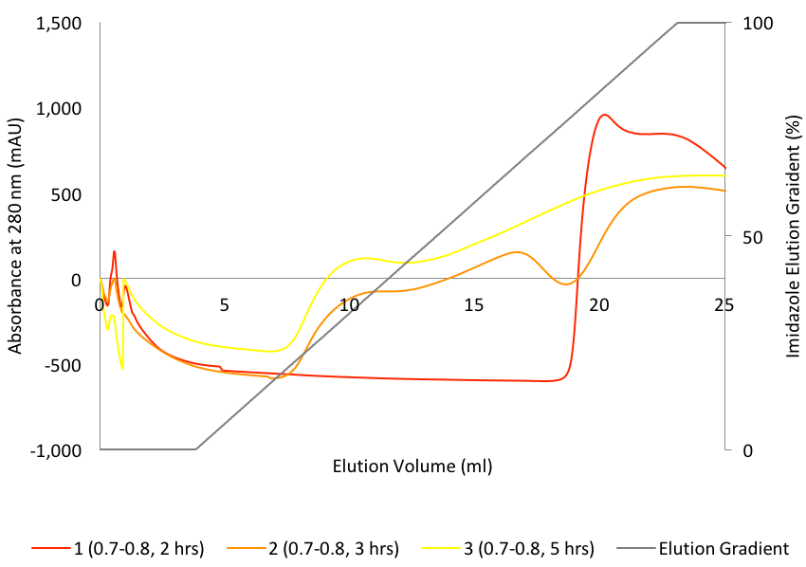
(A)

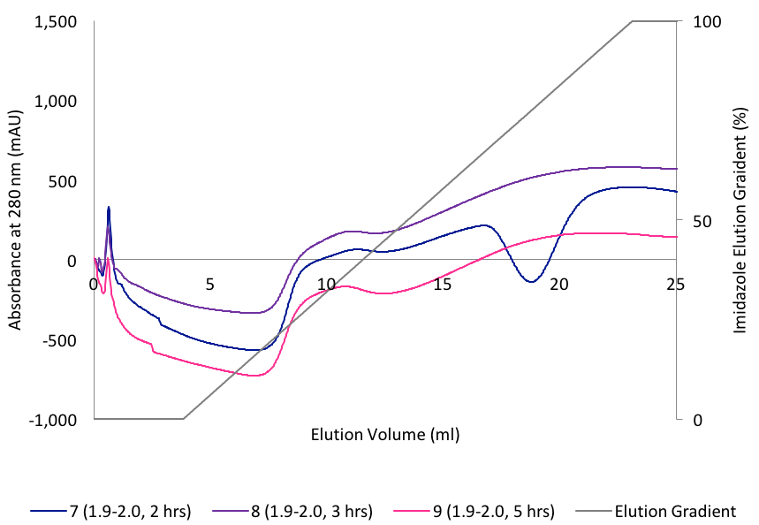
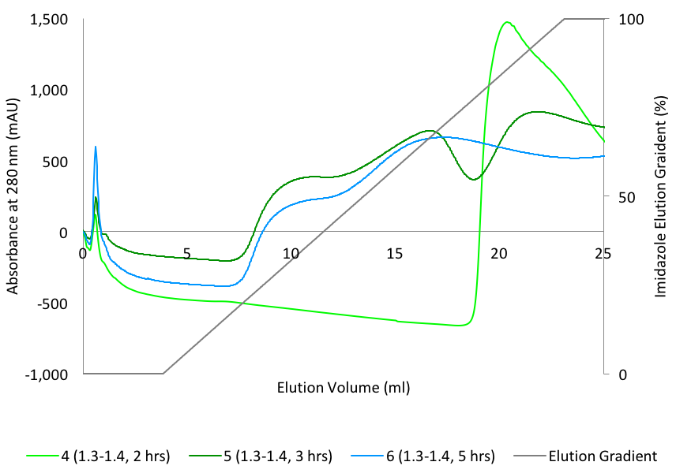
(B)
(C)

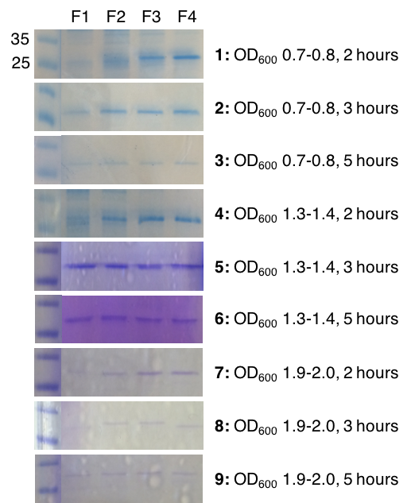
(D)
Figure 54: IMAC chromatograms for all nine expression conditions, (A) induction density 0.7-0.8, (B) induction density 1.3-1.4 and (C) induction density 1.9-2.0, with the imidazole elution gradient in grey. (D) SDS-PAGE analysis of fractions from all nine IMAC purifications. Each gel represents protein recovered from 1.5 L of expression culture. Lane 1: ladder; lanes 2-5: samples from four 1 mL fractions.

Looking at Table 23, there is no obvious correlation between the induction density and the cell pellet mass; a higher induction density and/or longer induction period does not necessarily produce a heavier cell pellet. This was an unexpected result and the lack of relationship between induction density/time and cell pellet mass may be due to the recurring issue of inconsistent aeration of the cultures.

Given the IMAC chromatograms and SDS-PAGE results (Figure 54), conditions 2, 4 and 5 appear to most suit the recombinant expression of BpRisA. Ultimately, condition 2 (induction density of 0.7-0.8, induction time of 2 hours) was pursued as the optimised protocol for BpRisA expression in the bioreactor. Subsequently, a large-scale expression was undertaken. Cells were harvested and cell pellets stored at -80˚C for future use.

Overall, the use of 0.5 L expression cultures with the bioreactor, as opposed to 1.0 L, unfavourably halves the capacity of the apparatus and therefore limits the high-throughput impact of this method, given that initially 12 L were simultaneously grown using the conventional method of 12 X 2 L non-baffled Erlenmeyer flasks and shaking incubators.

3.3.5. Mass Spectrometry Confirmation of Protein Molecular Weight

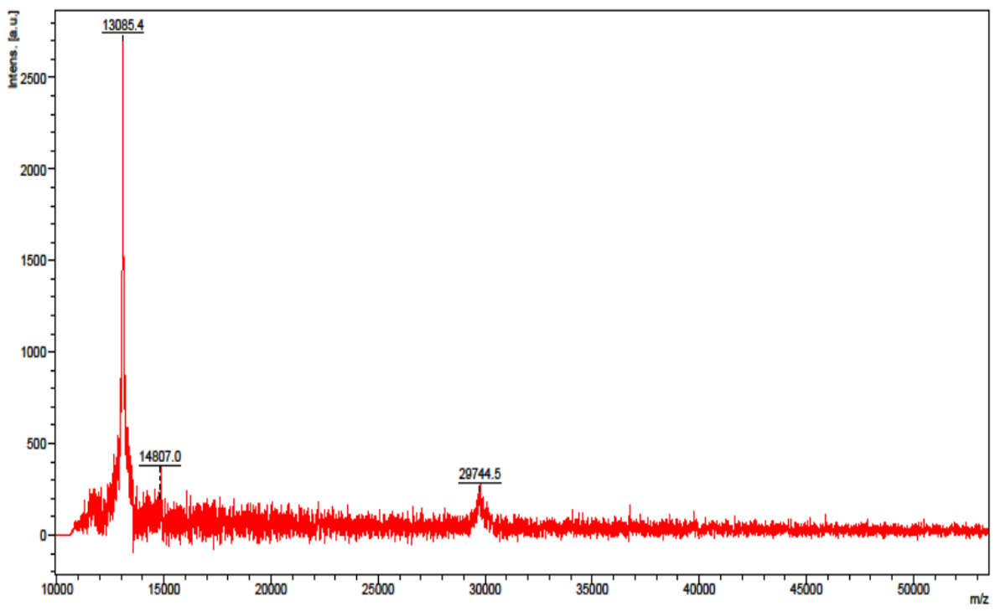
A sample of IMAC-purified recombinantly tagged BpRisA was submitted for analysis by MALDI and Figure 55 displays the relevant spectrum. The predicted MW for His₆ tagged BpRisA is approximately 29,902 Da and Figure 55 shows a peak at 29,744.5 Da. If the molecular weight of the N-terminal methionine (149.2 Da) is subtracted from the predicted MW of 29,902, then the peak at 29,744.5 Da correlates well with the expected mass of the POI, within the expected error margin.
Figure 55: The MALDI spectrum for an IMAC-purified sample of BpRisA showing a peak at 29,744.5 Da that corresponds to the predicted MW of the POI.
It is important to note that the peaks in the MALDI spectrum do not correspond to the concentration of protein in the sample. The relatively large peak at 13,085.5 Da is simply a contaminant protein; the SDS-PAGE analysis (Figure 49 (B)) of this sample clearly evidences that a majority of the protein in the sample is BpRisA, despite the MALDI peak at 29,744.5 Da being comparatively small. Overall, this data confirms the successful expression and purification of native BpRisA.
3.4. Conclusions

This chapter documents the successful optimisation of expression and purification of the response regulator protein RisA from B. pertussis; a key player in the control of expression of virulence genes in the Gram-negative pathogen responsible for whooping cough.

After successful small-scales expression and batch purification, expression was optimised in a Harbinger LEX-48TM Bioreactor. Purification was also optimised to a two-column protocol involving IMAC followed by anion exchange chromatography. SDS-PAGE analysis and MS experiments confirmed the protein expressed and purified to be BpRisA-His₆.

Despite optimisation of BpRisA expression in a bioreactor, the high-throughput of the methodology is questionable when compared to a 12 L expression in 12 X 2 L non-baffled Erlenmeyer flasks. Due to problems with inconsistent aeration (a technical fault highlighted by the set-up of the new Harbinger LEX-48TM apparatus) 0.5 L cultures were grown using the bioreactor, thus halving the maximum capacity for the apparatus to 20 L. For the work presented in this chapter, cylinders of compressed air were used to supply the bioreactor with a pressurised air flow for aeration and mixing of the cultures. Ideally, a continuous outlet of pressurised air from a tap would be used, therefore removing the limitation of the finite volume of pressurised air in one cylinder. It is not ideal to have to change the compressed air cylinder during an expression; the use of cylinders ultimately meant that the necessary air pressure was not continuously sustained throughout expression. It is possible that using a continuous outlet of pressurised air from a tap would facilitate substantial aeration and mixing of 1 L cultures. For a truly robust, high-throughput bioreactor expression of BpRisA, it would be necessary to switch from cylinders of compressed air to a continuous outlet of pressurised air from a tap. From the bioreactor optimisation experiments presented in this chapter, this proposed change of pressurised air source would allow future scientists to take advantage of the maximum capacity of the bioreactor (40 L). Due to the results presented in this chapter, the Harbinger LEX-48TM Bioreactor apparatus has been relocated to a different room that offers a constant and consistent airflow.
A possible minor change to the purification protocol would be to increase the imidazole concentration in the IMAC wash buffer (to 100 mM) to potentially improve the purity of the sample after the first purification step. Additionally, a continuous supply of pressurised air needs to be used with the bioreactor. Overall, minor amendments aside, the expression and purification of BpRisA was successful. Protein samples can continue to be produced in this way for future research to further characterise BpRisA as a potential drug target for the development of novel therapeutics for whooping cough.
3.5. Future Work for the Characterisation of RisA from Bordetella pertussis

The data presented in this chapter represents only the groundwork for the functional and structural characterisation of BpRisA. Having optimised expression and purification systems in place allows future work to focus solely on increasing understanding of the role of RisA in vivo.

Additional data needs to be collected to consolidate the biophysical characterisation of BpRisA, including a CD spectrum that illustrates protein fold and TSA analysis of thermal stability using the Durham Screens. Small angle X-ray scattering (SAXS) could be used to determine the molecular envelope of BpRisA and elucidate if BpRisA functions as a monomeric or multimeric protein in vivo.

It would be interesting to characterise the DNA-binding activity of BpRisA. The main challenge lies in identifying the DNA sequence(s) to which BpRisA specifically binds within the RisA regulon of genes. The expression of almost all vrgs in B. pertussis depends on RisA; RisA additionally regulates chemotaxis and flagellar operons, iron-regulated genes and some genes of unknown function (Coutte et al., 2016). It would be exciting to try to develop a TSA protocol, using the dye-free Prometheus NT.48 DSF apparatus. With no buffer restrictions when using the Prometheus NT.48 machine it would be possible to include oligonucleotides in the screening conditions. DNA fragments could be screened and their binding assessed based on changes in the thermal stability of BpRisA. One setback is that random DNA oligonucleotides couldn’t be screened; the sequence(s) to which BpRisA binds would have to first be discovered and the appropriate oligonucleotides synthesised. BpRisA is known to activate the vgr6 promoter (Cróinín et al., 2005); this could be a good starting point for the design of an oligonucleotide screening library. The kinetics of BpRisA-DNA binding interaction(s) could be further characterised using surface plasmon resonance (SPR) (Majka and Speck, 2007) and/or microscale thermophoresis (MST).

Importantly, having established a protocol for the large-scale expression and purification of BpRisA, pure protein samples can be attained and concentrated for protein crystallisation trials. A mixture of commercial crystallisation screens and screens designed based upon the TSA results with the Durham Screens could be used. 384-well plates could be set up using a liquid handling robot to facilitate high throughput crystallisation screening. Additionally, as a DNA-binding protein, it is highly likely BpRisA will be stabilised in vitro by DNA and therefore the inclusion of DNA fragments in crystallisation trials must be considered.

Overall, future work will only increase insight into the expression of virulence genes in the causative agent of whooping cough, B. pertussis. Further biophysical and structural characterisation of the potential drug target BpRisA could aid in the development of improved vaccines and novel therapeutics for the prevention and treatment of whooping cough. Such research underpins the driving force of research to eradicate today’s most prevalent vaccine-preventable respiratory disease in infants worldwide.

Thesis Conclusions

Overall, this thesis represents a successful exploration into the cloning, expression, purification and biophysical characterisation of protein samples prior to crystallisation and X-ray structure determination.

The Durham Screens have been evidenced as an extremely insightful tool for assessing protein stability. The data collected revealed links between thermally stabilising conditions and crystallisation conditions, highlighting the potential of using the screens to design bespoke protein crystallisation trials.

The knowledge of potential drug targets in pathogenic eukaryotic and prokaryotic organisms, harmful to both humans and animals, has generally been increased. Significantly, TgSPT2 has been validated as a membrane-bound, catalytically active homodimer, independent of TgSPT1 and distinct from the human cytosolic, heterodimeric complex.

Looking to the future, the Durham Screens will be used as a screening tool in a pre-crystallisation context to, hopefully, aid in the generation of ordered, diffracting crystals for many protein drug targets. The expression, purification and characterisation data for apicomplexan and SPT and B. pertussis RisA is merely the groundwork for future experiments to build upon.

References

- Alexandrov, A. I., Mileni, M., Chien, E. Y., Hanson, M. A. and Stevens, R. C. (2008) “Microscale Fluorescent Thermal Stability Assay for Membrane Proteins”, Structure, vol. 16, no. 3, March, pp. 351-359.
- Almirón, M. A. and Ugalde, R. A. (2010) “Iron Homeostasis in Brucella abortus: The Role of Bacterioferritin”, Journal of Microbiology, vol. 48, no. 5, October, pp. 668-673.
- Altschul, S. F., Gish, W., Miller, W., Myers, E. W. and Lipman, D. J. (1990) “Basic Local Alignment Search Tool”, Journal of Molecular Biology, vol. 215, no. 3, October, pp. 403-410.
- Arisue, N. and Hashimoto, T. (2015) “Phylogeny and Evolution of Apicoplasts and Apicomplexan Parasites”, Parasitology International, vol. 64, no. 3, June, pp. 254-259.
- Arrizabalaga, G., Ruiz, F., Moreno, S. and Boothroyd, J. C. (2004) “Ionophore-Resistant Mutant of Toxoplasma gondii Reveals Involvement of a Sodium/Hydrogen Exchanger in Calcium Regulation”, The Journal of Cell Biology, vol. 165, no. 95 June, pp. 653-662.
- Azzouz, N., Rauscher, B., Gerold, P., Cesbron-Delauw, M. F., Dubremetz, J. F. and Schwarz, R. T. (2002) “Evidence for De Novo Sphingolipids Biosynthesis in Toxoplasma gondii”, International Journal for Parasitology, vol. 32, no. 6, June, pp. 677-684.
- Bacci, C., Vismarra, A., Mangia, c., Bonardi, S., Bruini, I., Genchi, M., Kramer L. and Brindani, F. (2015) “Detection of Toxoplasma gondii in Free-Range, Organic Pigs in Italy using Serological and Molecular Methods”, International Journal of Food Microbiology, vol. 202, June, pp.54-56.
- Baldursson, S. and Karanis, P. (2011) “Waterborne Transmission of Protozoan Parasites: Review of Worldwide Outbreaks – An Update 2004-2010”, Water Research, vol. 45, no. 20, December, pp. 6603-6614.
- Beck, T., Krasauskas, A., Gruene, T. and Sheldrick, G. M. (2008) “A Magic Triangle for Experimental Phasing of Macromolecules”, Acta Crystallographica Section D, vol. 64, no. 11, November, pp. 1179-1182.
- Berglund, G. I., Carlsson, G. H., Smith, A. T., Szöke, H., Henriksen, A., and Hajdu, J. (2002) “The Catalytic Pathway of Horseradish Peroxidase at High Resolution”, Nature, vol. 417, no. 6887, May, pp. 463-468.
- Berman, H. M., Westbrook, J., Feng, Z., Gilliland, G., Bhat, T. N., Weissig, H., Shindyalov, I. N. and Bourne, P. E. (2000) “The Protein Data Bank”, Nucleic Acids Research, vol. 28, no. 1, January, pp. 235-242.
- Bernal, J. D. and Crowfoot, D. (1934) “X-Ray Photographs of Crystalline Pepsin”, Nature, vol. 133, no. 3369, May, pp. 794-795.
- Berrow, N. S., Alderton, D., Sainsbury, S., Nettleship, J., Assenberg, R., Rahman, N., Stuart, D. I. and Owens, R. J. (2007) “A Versatile Ligation-Independent Cloning Method Suitable for High-Throughput Expression Screening Applications”, Nucleic Acids Research, vol. 35, no. 6, February, e45.
- Bertucci, C., Pistolozzi, M. and De Simone, A. (2010) “Circular Dichroism in Drug Discovery and Development: An Abridged Review”, Analytical and Bioanalytical Chemistry, vol. 398, no. 1, September, pp. 155-166.
- Buede, R., Rinker-Schaffer, C., Pinto, W. J. Lester, R. L. and Dickson, R. C. (1991) “Cloning and Characterisation of LCB1, a Saccharomyces Gene Required for Biosynthesis of the Long-Chain Base Component of Sphingolipids”, Journal of Bacteriology, vol. 173, no. 14, July, pp. 4325-4332.
- Blackman, M. J. and Bannister, L. H. (2001) “Apical Organelles of Apicomplexa: Biology and Isolation by Subcellular Fractionation”, Molecular & Biochemical Parasitology, vol. 117, no. 1, September, pp. 11-25.
- Blake, C. C., Koenig, D. F., Mair, G. A., North, A. C., Phillips, D. C. and Sarma, V. R. (1965) “Structure of Hen Egg-White Lysozyme. A Three-Dimensional Fourier Synthesis at 2 Angstrom Resolution.”, Nature, vol. 206, no. 4986, May, pp. 757-761.
- Blundell, T. L., Cutfield, J. F., Cutfield, S. M., Dodson, E. J., Dodson, G, G., Hodgkin, D. C., Mercola, D. A. and Vijayan, M. (1971) “Atomic Positions in Rhombohedral 2-Zinc Insulin Crystals”, Nature, vol. 231, no. 5304, June, pp. 506-511.
- Blundell, T. L., Jhoti, H. and Abell, C. (2002) “High-Throughput Crystallography for Lead Discovery in Drug Design”, Nature Reviews Drug Discovery, vol. 1, no. 1, January, pp. 45-54.
- Bowie, W. R., King, A. S., Werker, D. H., Isaac-Renton, J. L., Bell, A., Eng, S. B. and Marion, S. A. (1997) “Outbreak of Toxoplasmosis Associated with Municipal Drinking Water”, The Lancet, vol. 350, no. 9072, July, pp. 173-177.
- Boivin, S., Kozak, S. and Meijers, R. (2013) “Optimisation of Protein Purification and Characterisation Using Thermofluor Screens”, Protein Expression and Purification, vol. 91, no. 2, October, pp. 192-206.
- Bougouffa, S., Radovanovic, A. Essack, M. and Bajic, V. B. (2014) “DEOP: A Database on Osmoprotectants and Associated Pathways”, Database, vol. 2014, no. 100, October.
- Bradford, M. M. (1976) “A Rapid and Sensitive Method for the Quantitation of Microgram Quantities of Protein Utilising the Principle of Protein-Dye Binding”, Analytical Biochemistry, vol. 72, no. 1-2, May, pp. 248-254.
- Brown, A., Amunts, A., Bai, X. C., Sugimoto, Y., Edwards, P. C., Murshudov, G., Scheres, S. H. and Ramakrishnan, V. (2014) “Structure of the Large Ribosomal Subunit from Human Mitochondria”, Science, vol. 346, no. 6210, November, pp. 718-722.
- Campbell, I. D. (2012) “Biophysical Techniques”, 1st edition, Oxford, Oxford University Press.
- Carlsson, G. H., Nicholls, P., Svistunenko, D., Berglund, G. I. and Hajdu, J. (2005) “Complexes of Horseradish Peroxidase with Formate, Acetate and Carbon Monoxide”, Biochemistry, vol. 44, no. 2, January, pp. 635-642.
- Chaudhry, S. A., Gad, N. and Koren, G. (2014) “Toxoplasmosis and Pregnancy”, Canadian Family Physician, vol. 60, no. 4, April, pp. 334-336.
- Chayen, N. E. (2004) “Turning Protein Crystallisation from an Art into a Science”, Current Opinion in Structural Biology, vol. 14, no. 5, October, pp. 577-583.
- Chayen, N. E. and Saridakis, E. (2008) “Protein Crystallisation: From Purified Protein to Diffraction-Quality Crystal”, Nature Methods, vol. 5, no. 2, February, pp. 147-153.
- Chen, X., Tordova, M., Gilliland, G. L., Wang, L., Li, Y., Yan, H. and Ji, X. (1998) “Crystal Structure of Apo-Cellular Retinoic Acid-Binding Protein Type II (R111M) Suggests a Mechanism of Ligand Entry”, Journal of Molecular Biology, vol. 278, no. 3, May, pp. 641-653.
- Coppens, I. (2013) “Targeting Lipid Biosynthesis and Salvage in Apicomplexan Parasites for Improved Chemotherapies”, Nature Reviews Microbiology, vol. 11, no. 12, December, pp. 823-835.
- Couper, K. N., Nielsen, H. V., Petersen, E., Roberts, F., Roberts, C. W. and Alexander, J. (2003) “DNA Vaccination with the Immunodominant Tachyzoite Surface Antigen (SAG-1) Protects Against Adult Acquired Toxoplasma gondii Infection but Does Not Prevent Maternofoetal Transmission”, Vaccine, vol. 21, no. 21-22, June, pp. 2813-2820.
- Coutte, L., Huot, L., Antoine, R., Slupek, S., Merkel, T. J., Chen, Q., Stibitz, S., Hot, D. and Locht, C. (2016) “The Multifaceted RisA Regulon of Bordetella pertussis”, Scientific Reports, vol. 6, no. 32774, September.
- Cróinín, T. O., Grippe, V. K. and Merkel, T. J. (2005) “Activation of the vrg6 Promoter of Bordetella pertussis by RisA”, Journal of Bacteriology, vol. 187, no. 5, March, pp. 1648-1658.
- Datta, S., Biswal, B. K. and Vijayan, M. (2001) “The Effect of Stabilising Additives on the Structure and Hydration of Proteins: A Study Involving Tetragonal Lysozyme”, Acta Crystallographica Section D, vol. 57, no. 11, November, pp. 1614-1620.
- Davies, J. F., Hostomska, Z., Hostomsky, Z., Jordan, S. R. and Matthews, D. A. (1991) “Crystal Structure of the Ribonuclease H Domain of HIV-1 Reverse Transcriptase”, Science, vol. 252, no. 5002, April, pp. 88-95.
- De la Mora, E., Carmichael, I. and Garman, E. F. (2011) “Effective Scavenging at Cryotemperatures: Further Increasing the Dose Tolerance of Protein Crystals”, Journal of Synchrotron Radiation, vol. 18, no. 3, May, pp. 346-357.
- Denny, P. W., Goulding, D., Ferguson, M. A. and Smith, D. F. (2004) “Sphingolipid-Free Leishmania are Defective in Membrane Trafficking, Differentiation and Infectivity”, Molecular Microbiology, vol. 52, no. 2, April, pp. 313-327.
- Dubey, J. P. (2008) “The History of Toxoplasma gondii – The First 100 Years”, Journal of Eukaryotic Microbiology, vol. 55, no. 6, November-December, pp. 467-475.
- Dubey, J. P. (2009) “History of the Discovery of the Life Cycle of Toxoplasma gondii”, International Journal for Parasitology, vol. 39, no. 8, July, pp. 877-882.
- Dubey, J. P., Hill, D. E., Rozeboom, D. W., Rajendran, C., Choudhary, S., Ferreira, L. R., Kwok, O. C. H. and Su, C. (2012a) “High Prevalence and Genotypes of Toxoplasma gondii Isolated from Organic Pigs in Northern USA”, Veterinary Parasitology, vol. 188, no. 1-2, August, pp. 14-18.
- Dubey, J. P., Lago, E. G., Gennari, S., Su, C. and Jones, J. L. (2012b) “Toxoplasmosis in Humans and Animals in Brazil: High Prevalence, High Burden of Disease, and Epidemiology”, Parasitology, vol. 139, no. 11, September, pp. 1375-1424.
- Dubey, J. P., Lindsay, D. S. and Speer, C. A. (1998) “Structures of Toxoplasma gondii Tachyzoites, Bradyzoites, and Sporozoites and Biology and Development of Tissue Cysts”, Clinical Microbiology Reviews, vol. 11, no. 2, April, pp. 267-299.
- Dulgońska, H. (2014) “Toxoplasma gondii and the Host Cells”, Annals of Parasitology, vol. 60, no. 2, pp. 83-88.
- Ericsson, U. B., Hallberg, B. M., Detitta, G. T., Dekker, N. and Nordlund, P. (2006) “Thermofluor-Based High-Throughput Stability Optimisation of Protein for Structural Studies”, Analytical Biochemistry, vol. 257, no. 2, October, pp. 289-298.
- Fabiani, S., Pinto, B. and Bruschi, F. (2013) “Toxoplasmosis and Neuropsychiatric Diseases: Can Serological Studies Establish a Clear Relationship?”, Neurological Sciences, vol. 34, no. 4, April, pp. 417-425.
- Flegr, J., Prandota, J., Sovičková. and Israili, Z. H. (2014) “Toxoplasmosis – A Global Threat. Correlation of Latent Toxoplasmosis with Specific Disease Burden in a Set of 88 Countries”, PLoS ONE, vol. 9, no. 3, March, e90203.
- Foroutan-Rad, M., Majidiani, H., Dalvand, S., Daryani, A., Kooti, W., Saki, J., Hedayati-Rad, F. and Ahmadpour, E. (2016) “Toxoplasmosis in Blood Donors: A Systematic Review and Meta-Analysis”, Transfusion Medicine Reviews, vol. 30, no, 3, July, pp. 116-122.
- Forst, S. A. and Roberts, D. L. (1994) “Signal Transduction by the EnvZ-OmpR Phosphotransfer System in Bacteria”, Research in Microbiology, vol. 145, no. 5-6, June-August, pp. 363-373.
- Frénois, F., Baulard A. R. and Villeret, V. (2006) “Insights into Mechanisms of Induction and Ligands Recognition in the Transcriptional Repressor EthR from Mycobacterium tuberculosis”, Tuberculosis, vol. 86, no. 2, March, pp. 110-114.
- Frénois, F., Engohang-Ndong, J., Locht, C., Baulard, A. R. and Villeret, V. (2004) “Structure of EthR in a Ligand Bound Conformation Reveal Therapeutic Perspectives Against Tuberculosis”, Molecular Cell, vol. 16, no. 2, October, pp. 301-307.
- Funke, O. (1851) “Über das Milzvenenblut”, Z Rat Medicin, vol. 1, pp. 172-218.
- Gable, K., Slife, H., Bacikova, D., Monaghan, E. and Dunn, T. M. (2000) “Tsc3p is an 80 Amino Acid Protein Associated with Serine Palmitoyltransferase and Required for Optimal Enzyme Activity”, The Journal of Biological Chemistry, vol. 275, no. 11, March, pp. 7597-7603.
- Garman, E. F. and Owen, R. L. (2006) “Cryocooling and Radiation Damage in Macromolecular Crystallography”, Acta Crystallographica Section D, vol. 62, no. 1, January, pp. 32-47.
- Giegé, R. (2013) “A Historical Perspective on Protein Crystallisation from 1840 to the Present Day”, The FEBS Journal, vol. 280, no. 24, December, pp. 6456-6497.
- Goldston, A. M., Powell, R. R. and Temesvari, L. A. (2012) “Sink or Swim: Lipid Rafts in Parasite Pathogenesis”, Trends in Parasitology, vole. 28, no. 10, October, pp. 417-426.
- Green, A. A. (1931) “Studies in the Physical Chemistry of the Proteins (VIII): The Solubility of Hemoglobin in Concentrated Salt, A Study of the Salting Out of Proteins.”, The Journal of Biological Chemistry, vol. 93, pp. 495-516.
- Green, A. A. (1932) “Studies in the Physical Chemistry of the Proteins (X): The Solubility of Hemoglobin in Solutions of Chlorides and Sulfates of Varying Cocnentration”, The Journal of Biological Chemistry, vol. 95, pp. 47-66.
- Grøftehauge, M. K., Hajizadeh, N. R., Swann, M. J. and Pohl, E. (2015) “Protein-Ligand Interactions Investigated by Thermal Shift Assays (TSA) and Dual Polarisation Interferometry (DPI)”, Acta Crystallographica Section D, vol. 71, no. 1, January, pp. 36-44.
- Guerina, N. G., Hsu, H. W., Meissner, H. C., Maguire, J. H., Lynfield, R., Stechenberg, B., Abroms, I., Pasternack, M. S., Hoff, R. Eaton, R. B., Grady, G. F. and the New England Regional Toxoplasma Working Group (1994) “Neonatal Serologic Screening and Early Treatment for Congenital Toxoplasma gondii Infection”, The New England Journal of Medicine, vol. 330, no. 26, June, pp. 1858-1863.
- Hajizadeh, N. R. (2014) “Biophysical Characterisation of Protein-Ligand Interactions”, M.Sci. Honours Biology and Physics thesis, Durham University.
- Han, G., Gupta, S. D., Gable, K., Somashekarappa, N., Moitra, P., Eichler, F., Brown, R. H., Harmon, J. M. and Dunn, T. M. (2009) “Identification of Small Subunits of Mammalian Serine Palmitoyltransferase that Confer Distinct Acyl-CoA Substrate Specificities”, Proceedings of the National Academy of Sciences (PNAS) USA, vol. 106, no. 20, May, pp. 8186-8191.
- Hanada, K. (2005) “Sphingolipids in Infectious Diseases”, Japanese Journal of Infectious Diseases, vol. 58, no. 3, June, pp. 131-148.
- Hannun, Y. A., Luberto, C. and Argraves, K. M. (2001) “Enzymes of Sphingolipid Metabolism: From Modular to Integrative Signalling”, Biochemistry, vol. 40, no. 16, April, pp. 4893-4903.
- Harata, K. (1994) “X-Ray Structure of a Monoclinic form of Hen Egg-White Lysozyme Crystallised at 313 K. Comparison of Two Independent Molecules.”, Acta Crystallographica Section D, vol. 50, no. 3, May, pp. 250-257.
- Harmon, J. M., Bacikova, D., Gable, K., Gupta, S. D., Han, G., Sengupta, N., Somashekarappa, N. and Dunn, T. M. (2013) “Topological and Functional Characterisation of the ssSPTs, Small Activating Subunits of Serine Palmitoyltransferase”, The Journal of Biological Chemistry, vol. 288, no. 14, April, pp. 10144-10153.
- Haroon, F., Händel, U., Angenstein, F., Goldschmidt, J., Kreutzmann, P., Lison, H., Fischer, K. D., Scheich, H., Wetzel, W. Schlüter, D. and Budinger, E. (2012) “Toxoplasma gondii Actively Inhibits Neuronal Function in Chronically Infected Mice”, PLoS ONE, vol. 7, no. 9, April, e35516.
- Hawe, A., Sutter, M. and Jiskoot, W. (2008) “Extrinsic Fluorescent Dyes as Tools for Protein Characterisation”, Pharmaceutical Research, vol. 25, no. 7, July, pp. 1487-1499.
- Henriksen, A., Schuller, D. J., Meno, K., Welinder, K. G., Smith, A. T. and Gajhede, M. (1998) “Structural Interactions Between Horseradish Peroxidase C and the Substrate Benzhydroxamic Acid Determined by X-Ray Crystallography”, Biochemistry, vol. 37, no. 22, June, pp. 8054-8060.
- Heung, L. J., Luberto, C. and Poeta, M. D. (2006) “Role of Sphingolipids in Microbial Pathogenesis”, Infection and Immunity, vol. 74, no. 1, January, pp. 28-39.
- Hill, D. and Dubey, J. P. (2002) “Toxoplasma gondii: Transmission, Diagnosis and Prevention”, Clinical Microbiology and Infection, vol. 8, no. 10, October, pp. 634-640.
- Hoch, J. A. (2000) “Two-Component and Phosphorelay Signal Transduction”, Current Opinion in Microbiology, vol. 3, no. 2, April, pp. 165-170.
- Hofmeister, F. (1890) “Über die Darstellung von Krystallisirten Eieralbumin und die Krystalallisierbarkeit von Colloider Stoffe”, Hoppe-Seylers Z Physiol Chem, vol. 14, pp. 165.
- Hol, W. G. (2015) “Three-Dimensional Structures in the Design of Therapeutics Targeting Parasitic Protozoa: Reflections on the Past, Present and Future”, Acta Crystallographica Section F, vol. 71, no. 5, May, pp. 485-499.
- Hornemann, T., Penno, A., Rütti, M. F., Ernst, D., Kivrak-Pfiffner, F., Rohrer, L. and Eckardstein, A. (2009) “The SPTLC3 Subunit of Serine Palmitoyltransferase Generates Short Chain Sphingoid Bases”, The Journal of Biological Chemistry, vol. 284, no. 39, September, pp. 26322-26330.
- Hornemann, T., Richard, S., Rütti, M. F., Wei, Y. and Eckardstein, A. (2006) “Cloning and Initial Characterisation of a New Subunit for Mammalian Serine Palmitoyltransferase”, The Journal of Biological Chemistry, vol. 281, no. 49, December, pp. 37275-37281.
- Hünefeld, F. L. (1840) “Der Chemismus in der Thierischen Organisation”, 1st Edition, Brockhaus, Leipzig.
- Ikushiro, H., Islam, M. M., Okamoto, A., Hoseki, J., Murakawa, T., Fujii, S., Miyahara, I. and Hayashi, H. (2009) “Structural Insights into the Enzymatic Mechanism of Serine Palmitoyltransferase from Sphingobacterium multivorum”, The Journal of Biochemistry, vol. 146, no. 4, October, pp. 549-562.
- Jones, J. L. and Dubey, J. P. (2010) “Waterborne Toxoplasmosis – Recent Developments”, Experimental Parasitology, vol. 124, no. 1, January, pp. 10-25.
- Jones, J. L. and Dubey, J. P. (2012) “Foodborne Toxoplasmosis”, Clinical Infectious Diseases, vol. 55, no. 6, September, pp. 845-851.
- Karanis, P., Aldeyarbi, H. M., Mirhashemi, M. E. and Khalil, K. M. (2013) “The Impact of the Waterborne Transmission of Toxoplasma gondii and Analysis Efforts for Water Detection: An Overview and Update”, Environmental Science and Pollution Research, vol. 20, no. 1, January, pp. 86-99.
- Kaye, A (2011) “Toxoplasmosis: Diagnosis, Treatment and Prevention in Congenitally Exposed Infants”, Journal of Pediatric Health Care, vol. 25, no. 6, November-December, pp. 355-364.
- Kelley, L. A., Mezulis, S., Yates, C. M., Wass, M. N. and Sternberg, M. J. (2015) “The Phyre2 Web Portal for Protein Modelling, Prediction and Analysis”, Nature Protocols, vol. 10, no. 6, June, pp. 845-858.
- Kelly, S. M., Jess, T. J. and Price, N. C. (2005) “How to Study Protein by Circular Dichroism”, Biochimica et Biophysica Acta, vol. 1751, no. 2, August, pp. 119-139.
- Kendrew, J. C., Bodo, G., Dintzis, H. M., Parrish, R. G., Wyckoff, H. and Phillips, D. C. (1958) “A Three-Dimensional Model of the Myoglobin Molecule Obtained by X-Ray Analysis”, Nature, vol. 181, no. 4610, March, pp. 662-666.
- Kim, J. Y., Ahn, H. J., Ryu, K. J. and Nam, H. W. (2008) “Interaction Between Parasitophorous Vacuolar Membrane-Associated GRA3 and Calcium Modulating Ligand of Host Cell Endoplasmic Reticulum in the Parasitism of Toxoplasma gondii”, The Korean Journal of Parasitology, vol. 46, no. 4, December, pp. 209-216.
- Kobilka, B. K. (2011) “Structural Insights into Adrenergic Receptor Function and Pharmacology”, Trends in Pharmacological Sciences, vol. 32, no. 4, April, pp. 213-218.
- Lewis, J. M., Clifford, S. and Nsutebu, E. (2015) “Toxoplasmosis in Immunosuppressed Patients”, Rheumatology (Oxford Journals), vol. 54, no. 11, November, pp. 1939-1940.
- Li, E. (1999) “Structure and Function of Cytoplasmic Retinoid Binding Proteins”, Molecular and Cellular Biochemistry, vol. 192, no. 1-2, February, pp. 105-108.
- Lo, M. C., Aulabaugh, A., Jin, G., Cowling, R., Bard, J., Malamas, M. and Ellestad, G. (2004) “Evaluation of Fluorescence-Based Thermal Shift Assays for Hit Identification in Drug Discovery”, Analytical Biochemistry, vol. 332, no. 1, September, pp. 153-159.
- Lowther, J., Naismith, J. H., Dunn, T. M. and Campopiano, D. J. (2012) “Structural, Mechanistic and Regulatory Studies of Serine Palmitoyltransferase”, Biochemical Society Transactions, vol. 40, no. 3, June, pp. 547-554.
- Lowther, J., Yard, B. A., Johnson, K. A., Carter, L. G., Bhat, V. T., Raman, M. C. C., Clarke, D. J., Ramakers, B., McMahon, S. A., Naismith, J., H. and Campopiano, D. J. (2010) “Inhibition of the PLP-Dependent Enzyme Serine Palmitoyltransferase by Cycloserine: Evidence for a Novel Decarboxylative Mechanism of Inactivation”, Molecular BioSystems, vol. 6, no. 9, September, pp. 1682-1693.
- Majka, J. and Speck, C. (2007) “Analysis of Protein-DNA Interactions Using Surface Plasmon Resonance”, Advances in Biochemical Engineering / Biotechnology, vol. 104, pp. 13-36.
- Martínez-Hackert, E. and Stock, A. M., (1997) “The DNA-Binding Domain of OmpR: Crystal Structure of a Winged Helix Transcription Factor”, Structure, vol. 5, no. 1, January, pp. 109-12
- McPherson, A. and Cudney, B. (2014) “Optimisation of Crystallisation Conditions for Biological Macromolecules”, Acta Crystallographica Section F, vol. 70, no. 11, November, pp. 1445-1467.
- McWilliam, H., Li, W., Uludag, M., Squizzato, S., Park, Y. M., Buso, N., Cowley, A. P. and Lopez, R. (2013) “Analysis Tool Web Services from the EMBL-EBI”, Nucleic Acids Research, vol. 41, Web Server Issue, July, pp. W597-W600.
- Melvin, J. A., Scheller, E. V., Miller, J. F. and Cotter, P. A. (2014) “Bordetella pertussis Pathogenesis: Current and Future Challenges”, Nature Reviews Microbiology, vol. 12, no. 4, April, pp. 274-288.
- Mina, J. G. M. and Denny, P. W. (2017) “Everybody Needs Sphingolipids, Right! Mining for New Drug Targets in Protozoan Sphingolipid Biosynthesis”, Parasitology, published online 22nd June 2017.
- Mina, J. G., Thye, J. K., Alqaisi, A. Q. I., Bird, L. E., Dods, R. H., Grøftehauge, M. K., Mosely, J. A., Pratt, S., Shams-Eldin, H., Schwarz, R. T., Pohl, E. and Denny, P. W. (2017) “Functional and Phylogenetic Evidence of a Bacterial Origin for the First Enzyme in Sphingolipid Biosynthesis in a Phylum of Eukaryotic Protozoan Parasites”, The Journal of Biological Chemistry, vol. 292, no. 29, July, pp. 12208-12219.
- Mooney, J. T., Fredericks, D. P., Christensen, T., Schiødt, C. B. and Hearn, M. T. W. (2015) “N-Terminal Processing of Affinity-Tagged Recombinant Proteins Purified by IMAC Procedures”, Journal of Molecular Recognition, vol. 28, no. 7, July, pp. 401-412.
- Muirhead, H. and Perutz, M. F. (1963) “Structure of Haemoglobin: A Three-Dimensional Fourier Synthesis of Reduce Human Haemoglobin at 5.5 Å Resolution”, Nature, vol. 199, August, pp. 633-638.
- Nagiec, M. M., Baltisberger, J. A., Wells, G. B., Lester, R. L. and Dickson, R. C. (1994) “The LCB2 Gene of Saccharomyces and the Related LCB1 Gene Encode Subunits of Serine Palmitoyltransferase, the Initial Enzyme in Sphingolipid Synthesis”, Proceedings of the National Academy of Sciences (PNAS) USA, vol. 91, no. 17, August, pp. 7899-7902.
- Nagiec, M. M., Lester, R. L. and Dickson, R. C. (1996) “Sphingolipid Synthesis: Identification and Characterisation of Mammalian cDNAs Encoding the LCB2 Subunit of Serine Palmitoyltransferase”, Gene, vol. 177, no. 1-2, October, pp. 237-241.
- Neuefeind, T., Huber, R., Dasenbrock, H., Prade, L. and Bieseler, B. (1997) “Crystal Structure of Herbicide-Detoxifying Maize Glutathione S-Trasferase-1 in Complex with Lactoylglutathione: Evidence for an Induced-Fit Mechanism”, Journal of Molecular Biology, vol. 274, no. 4, December, pp. 446-453.
- Newcomer, M. E., Jamison, R. S. and Ong, D. E. (1998) “Structure and Function of Retinoid-Binding Proteins”, Subcellular Biochemistry, vol. 30, pp. 53-80.
- Newman, J. (2004) “Novel Buffer Systems for Macromolecular Crystallisation”, Acta Crystallographica Section D, vol. 60, no. 3, March, pp. 610-612.
- Ngoungou, E. B., Bhalla, D., Nzoghe, A., Dardé, M. L. and Preux, P. M. (2015) “Toxoplasmosis and Epilepsy – Systematic Review and Meta-Analysis”, PLoS Neglected Tropical Diseases, vol. 9, no. 2, February, e0003525.
- Nguyen, M. P., Yoon, J. M., Cho, M. H. and Lee, S. W. (2015) “Prokaryotic 2-Component Systems and the OmpR/PhoB Superfamily”, Canadian Journal of Microbiology, vol. 61, no. 11, November, pp. 799-810.
- Nicolle, C. and Manceaux, L. (1908) “Sur une Infection à Corps de Leishman (ou Organismes Voisins) du Gondi”, Comptes Rendus de l’Académie des Sciences, vol. 147, July-December, pp. 763-766.
- Nowak, E., Panjikar, S., Konarev, P., Svergun, D. I. and Tucker, P. A. (2006) “The Structural Basis of Signal Transduction for the Response Regulator PrrA from Mycobacterium tuberculosis”, Journal of Molecular Biology, vol. 281, no. 14, April, pp. 9659-9666.
- Opsteegh, M., Kortbeek, T. M., Havelaar, A. H. and van der Giessen, J. W. B. (2015) “Intervention Strategies to Reduce Human Toxoplasma gondii Disease Burden”, Clinical Infectious Diseases, vol. 60, no. 1, January, pp. 101-107.
- Pantoliano, M. W., Petrella, E. C., Kwasnoski, J. D., Lobanov, V. S., Myslik, J., Graf, E., Carver, T., Asel, E., Springer, B. A., Lane, P. and Salemme, F. R. (2001) “High-Density Miniaturised Thermal Shift Assays as a General Strategy for Drug Discovery”, Journal of Bimolecular Screening, vol. 6, no. 6, December, pp. 429-440.
- Pohl, E., Haller, J. C., Mijovilovich, A., Meyer-Klaucke, W., Garman, E. and Vasil, M. L. (2003) “Architecture of a Protein Central to Iron Homeostasis: Crystal Structure and Spectroscopic Analysis of the Ferric Uptake Regulator”, Molecular Microbiology, vol. 47, no. 2, February, pp. 903-915.
- Pohl, E., Holmes, R. K. and Hol, W. G. (1998) “Motion of the DNA-Binding Domain with Respect to the Core of the Diphtheria Toxin Repressor (DtxR) Revealed in the Crystal Structures of Apo- and Holo-DtxR”, The Journal of Biological Chemistry, vol. 273, no. 35, August, pp. 22420-22427.
- Poklar, N., Lah, J., Salobir, M., Macek, P. and Vesnaver, G. (1997) “pH- and Temperature-Induced Molten Globule-Like Denatured States of Equinatoxin II: A Study by UV-Melting, DSC, Far- and Near-UV CD Spectroscopy and ANS Fluorescence”, Biochemistry, vol. 36, no. 47, November, pp. 14345-14352.
- Rajapakse, S., Shivanthan, M. C., Samaranayake, N., Rodrigo, C. and Fernando, S. D. (2013) “Antibiotics for Human Toxoplasmosis: A Systematic Review of Randomised Trials”, Pathogens and Global Health, vol. 107, no. 4, June, pp. 162-169.
- Ramakrishnan, V. (2011) “The Eukaryotic Ribosome”, Science, vol. 331, no. 6018, February, pp. 681-682.
- Raman, M. C., Johnson, K. A., Clarke, D. J., Naismith, J. H. and Campopiano, D. J. (2010) “The Serine Palmitoyltransferase from Sphingomonas wittichii RW1: An Interesting Link to an Unusual Acyl Carrier Protein”, vol. 93, no. 9, pp. 811-822.
- Rasmussen, S. G., Choi, H. J., Rosenbaum, D. M., Kobilka, T. S., Thian, F. S., Edwards, P. C., Burghammer, M., Ratnala, V. R., Sanishvili, R., Fischetti, R. F., Schertler, G. F., Weis, W. I. and Kobilka, B. K. (2007) “Crystal Structure of the Human Beta 2 Adrenergic G-Protein-Coupled Receptor”, Nature, vol. 250, no. 7168, November, pp. 383-387.
- Reade, J. P. and Cobb, A. H. (2002) “New, Quick Tests for Herbicide Resistance in Black-Grass (Alopecurus myosuroides) Based on Increased Glutathione S-Transferase Activity and Abundance”, Pest Management Science, vol. 58, no. 1, January, pp. 26-32.
- Reinhard, L., Mayerhofer, H., Geerlof, A., Mueller-Dieckmann, J. and Weiss, M. S. (2013) “Optimisation of Protein Buffer Cocktails Using Thermofluor”, Acta Crystallographica Section F, vol. 69, no. 2, February, pp. 209-214.
- Riethmüller, J., Riehle, A., Grassmé, H. and Gulbins, E. (2006) “Membrane Rafts in Host–Pathogen Interactions”, Biochimica et Biophysica Acta, vol. 1758, no. 12, December, pp. 2139-2147.
- Robert, X. and Gouet, P. (2014) “Deciphering Key Features in Protein Structures with the New ENDscript Server”, Nucleic Acids Research, vol. 42, no. 1, July, pp. 320-324.
- Roberts, M. F. (2005) “Organic Compatible Solutes of Halotolerant and Halophilic Microorganisms”, Saline Systems, vol. 1, no. 5, August.
- Rupesh, K. R., Smith, A. and Boehmer, P. E. (2014) “Ligand Induced Stabilisation of the Melting Temperature of the HSV-1 Single-Strand DNA Binding Protein Using the Thermal Shift Assay”, Biochemical and Biophysical Research Communications, vol. 454, no. 4, November, pp. 604-608.
- Rupp, B. (2009) “Biomolecular Crystallography: Principles, Practice and Application to Structural Biology”, 1st Edition, Garland Science.
- Sarafianos, S. G., Marchand, B., Das, K., Himmel, D., Parniak, M. A., Hughes, S. H. and Arnold, E. (2009) “Structure and Function of HIV-1 Reverse Transcriptase: Molecular Mechanisms of Polymerisation and Inhibition”, Journal of Molecular Biology, vol. 385, no. 3, January, pp. 693-713.
- Sato, S. (2011) “The Apicomplexan Plastid and its Evolution”, Cell and Molecular Life Sciences, vol. 68, no. 8, April, pp. 1285-1296.
- Sekula, B., Zielinski, K. and Bujacz, A. (2013) “Crystallographic Studies of the Complexes of Bovine and Equine Serum Albumin with 3,5-Diiodosalicyclic Acid”, International Journal of Biological Macromolecules, vol. 60, September, pp. 316-324.
- Semisotnov, G. V., Rodionova, N. A., Razgulyaev, O. I., Uversky, V. N., Gripas’, A. F. and Gilmanshin, R. I. (1991) “Study of the “Molten Globule” Intermediate State in Protein Folding by a Hydrophobic Florescent Probe”, Biopolymers, vol. 31, no. 1, January, pp. 119-128.
- Senisterra, G. A., Hong, B. S., Park, H. W., and Vedadi, M. (2008) “Application of High-Throughput Isothermal Denaturation to Assess Protein Stability and Screen for Ligands”, Journal of Biomolecular Screening, vol. 15, no. 5, June, pp. 337-342.
- Shoichet, B. K. and Kobilka, B. K. (2012) “Structure-Based Drug Screening for G-Protein-Coupled Receptors”, Trends in Pharmacological Sciences, vol. 33, no. 5, May, pp. 268-272.
- Sievers, F., Wilm, A., Dineen, d., Gibson, T. J., Karplus, K., Li, W., Lopez, R., McWilliam, H., Remmert, M., Söding, J., Thompson, J. D. and Higgins, D. G. (2011) “Fast, Scalable Generation of High-Quality Protein Multiple Sequence Alignments Using Clustal Omega”, Molecular Systems Biology, vol. 7, no. 1, October, pp. 539-544.
- Sonda, S. and Hehl, A. B. (2006) “Lipid Biology of Apicomplexa: Perspective for New Drug Targets, Particularly for Toxoplasma gondii”, Trends in Parasitology, vol. 22, no. 1, January, pp. 41-47.
- Steinberg, T. H., Jones, L. J., Haugland, R. P. and Singer, V. L. (1996a) “SYPRO Orange and SYPRO Red Protein Gel Stains: One-Step Fluorescent Staining of Denaturing Gels for Detection of Nanogram Levels of Protein”, Analytical Biochemistry, vol. 239, no. 2, August, pp. 223-237.
- Steinberg, T. H., Haugland, R. P. and Singer, V. L. (1996b) “Applications of SYPRO Orange and SYPRO Red Protein Gel Stains”, Analytical Biochemistry, vol. 239, no. 2, August, pp. 238-245.
- Stenson, T. H., Allen, A. G., al-Meer, J. A., Maskell, D. and Peppler, M. S. (2005) “Bordetella pertussis risA, but Not risS, is Required for Maximal Expression of Bvg-Repressed Genes”, Infection and Immunology, vol. 73, no. 9, September, pp. 5995-6004.
- Stewart, L., Redinbo, M. R., Qiu, X., Hol, W. G. and Champoux, J. J. (1998) “A Model for the Mechanism of Human Topoisomerase I”, Science, vol. 279, no. 5356, March, pp. 1534-1541.
- Striepen, B. (2011) “The Apicoplast: A Red Alga in Human Parasites”, Essays in Biochemistry, vol. 51, October, pp. 111-125.
- Stock, A. M., Robinson, V. L. and Goudreau, P. N. (2000) “Two-Component Signal Transduction”, Annual Review of Biochemistry, vol. 69, pp. 183-215.
- Sukumar, N., Biswal, B. K. and Vijayan, M. (1999) “Structures of Orthorhombic Lysozyme Grown at Basic pH and its Low-Humidity Variant”, Acta Crystallographica Section D, vol. 55, no. 4, April, pp. 934-937.
- Sussman, J. L., Holbrook, S. R., Warrant, R. W., Church, G. M. and Kim, S. H. (1978) “Crystal Structure of Yeast Phenylalanine Transfer RNA: I. Crystallographic Refinement”, Journal of Molecular Biology, vol. 123, no. 4, August, pp. 607-630.
- Tatum, N. J. (2015) “Discovery by Virtual Screening of Ethionamide Boosters for Tuberculosis Treatment”, Ph.D. thesis, Durham University.
- Temel, D. B., Landsman, P. and Brader, M. L. (2016) “Orthogonal Methods for Characterising the Unfolding of Therapeutic Monoclonal Antibodies: Differential Scanning Calorimetry, Isothermal Chemical Denaturation, and Intrinsic Fluorescence with Concomitant Static Light Scattering”, Methods in Enzymology, vol. 567, pp. 359-389.
- Tenter, A. M., Heckeroth, A. R. and Weiss, L. M. (2000) “Toxoplasma gondii: From Animals to Humans”, International Journal for Parasitology, vol. 30, no. 12-13, November, pp. 1217-1258.
- Thye, J. K. (2014) “The Diverse Roles of the Pseudomonas aeruginosa Phospholipase PlcH and Toxoplasma gondii Serine Palmitoyltransferase in Sphingolipid Biochemistry”, Ph.D. thesis, Durham University.
- Tidhar, R. and Futerman, A. H. (2013) “The Complexity of Sphingolipid Biosynthesis in the Endoplasmic Reticulum”, Biochimica et Biophysica Acta, vol. 1833, no. 11, November, pp. 2511-2518.
- Tiganova, I. G., Il’iana, T. S. and Romanova, Y. M. (2014) “Double-Component Bacterial Regulation Systems as a Target for Searching New Antimicrobial Agents”,
Molecular Genetics, Microbiology and Virology, vol. 3, January, pp. 3-12.
- Uhl, M. A. and Miller, J. F. (1994) “Autophosphorylation and Phosphotransfer in the Bordetella pertussis BvgAS Signal Transduction Cascade”, PNAS, vol. 91, no. 3, February, pp. 1163-1167.
- Vaezeslami, S., Mathes, E., Vasileiou, C., Borhan, B. and Geiger, J. H. (2006) “The Structure of Apo-Wild-Type Cellular Retinoic Acid Binding Protein II at 1.4 Å and its Relationship to Ligand Binding and Nuclear Translocation”, Journal of Molecular Biology, vol. 363, no. 3, October, pp. 687-701.
- van der Giessen, J., Fonville, M., Bouwknegt, M. Langelaar, M. and Vollema, A. (2007) “Seroprevalence of Trichinella spiralis and Toxoplasma gondii in Pigs from Different Housing Systems in the Netherlands”, Veterinary Parasitology, vol. 148, no. 3-4, September, pp.371-374.
- van Dooren, G. G. and Striepen, B. (2013) “The Algal Past and Parasite Present of the Apicoplast”, Annual Review of Microbiology, vol. 67, September, pp. 271-289.
- Vaney, M. C., Maignan, S., Riès-Kautt, M. and Ducriux, A. (1996) “High-Resolution Structure (1.33 Å) of a HELW Lysozyme Tetragonal Crystal Grown in the APCF Apparatus. Data and Structural Comparison with a Crystal Grown Under Microgravity from SpaceHab-01 Mission”, Acta Crystallographica Section D, vol. 52, no. 3, May, pp. 505-517.
- Vedadi, M., Niesen, F. H., Allali-Hassani, A., Fedorov, O. Y., Finerty, P. J., Wasney, G. A., Yeung, R., Arrowsmith, C., Ball, L. J., Berglund, H., Hui, R., Marsden, B. D., Nordlund, P., Sundstrom, M., Weigelt, J. and Edwards, A. M. (2006) “Chemical Screening Methods to Identify Ligands that Promote Protein Stability, Protein Crystallisation and Structure Determination”, PNAS, vol. 103, n0. 43, October, pp. 15835-15840.
- Vollrath, F., Hawkins, N., Porter, D., Holland, C. and Boulet-Audet, M. (2014) “Differential Scanning Fluorimetry Provides High Throughput Data on Silk Protein Transitions”, Nature Scientific Reports, vol. 4, no. 5625, July.
- Wadsworth, J. M., Clarke, D. J., McMahon, S. A., Lowther, J. P., Beattie, A. E., Langridge-Smith, P. R. R., Broughton, H. B., Dunn, T. M., Naismith, J. H. and Campopiano, D. J. (2013) “The Chemical Basis of Serine Palmitoyltransferase Inhibition by Myriocin”, Journal of the American Chemical Society, vol. 135, no. 38, September, pp. 14276-14285.
- Walsh, M. A., Schneider, T. R., Sieker, L. C., Dauter, Z., Lamzin, V. S. and Wilson, K. S. (1998) “Refinement of Triclinic Hen Egg-White Lysozyme at Atomic Resolution”, Acta Crystallographica Section D, vol. 54, no. 4, July, pp. 522-546.
- Weiss, B. and Stoffel, W. (1997) “Human and Murine Serine-Palmitoyl-CoA Transferase: Cloning, Expression and Characterisation of the Key Enzyme in Sphingolipid Synthesis”, European Journal of Biochemistry, vol. 249, no. 1, October, pp. 239-247.
- Wiedemann, C., Bellstedt, P. and Görlach, M. (2013) “CAPITO – A Web Server-Based Analysis and Plotting Tool for Circular Dichroism Data”, Bioinformatics, vol. 29, no. 14, pp. 1750-1757.
- World Health Organisation (2015) “Pertussis Vaccines: WHO Position Paper”, Weekly Epidemiological Record, vol. 90, no. 35, August, pp. 433-458.
- Yancey, P. H. (2005) “Organic Osmolytes as Compatible, Metabolic and Counteracting Cryoprotectants in High Osmolarity and Other Stresses”, Journal of Experimental Biology, vol. 208, no. 15, August, pp. 2819-2830.
- Yard, B. A., Carter, L. G., Johnson, K. A., Overton, I. M., Dorward, M., Liu, H., McMahon, S. A., Oke, M., Puech, D., Barton, G. J., Naismith, J. H. and Campopiano, D. J. (2007) “The Structure of Serine Palmitoyltransferase; Gateway to Sphingolipid Biosynthesis”, Journal of Molecular Biology, vol. 370, no. 5, July, pp. 870-886.
- Yeh, J. I., Du, S., Tortajada, A., Paulo, J. and Zhang, S. (2005) “Peptergents: Peptide Detergents that Improve Stability and Functionality of a Membrane Protein, Glycerol-3-Phosphate Dehydrogenase”, Biochemistry, vol. 44, no. 51, December, pp. 16912-16919.
- Zhang, K., Bangs, J. D. and Beverley, S. M. (2010) “Sphingolipids in Parasitic Protozoa”, Advances in Experimental Medicine and Biology, vol. 688, October, pp. 238-248.
- Zschiedrich, C. P., Keidel, V. and Szurmant, H. (2016) “Molecular Mechanisms of Two-Component Signal Transduction”, Journal of Molecular Biology, vol. 428, no. 19, September, pp. 3752-3775.

Appendices

Appendix 1: The stock solutions made for the Durham screens. All stock solutions were made with water, except where otherwise stated. All solutions were filter-sterilised through 0.22 µm filters and stored at 4˚C.

Durham Salt Screen
- Guanidine Hydrochloride 6 M stock solution, diluted to 2 M, 1.6 M, 1.2 M, 0.8 M, 0.4 M and 10 mM
- Sodium Citrate 1 M stock solution, diluted to 0.4 M
- Sodium Malonate 3 M stock solution, diluted to 2 M, 1.6 M, 1.2 M, 0.8 M and 0.4 M
- Ammonium Sulfate 3 M stock solution, diluted to 2 M, 1.6 M, 1.2 M, 0.8 M and 0.4 M
- Sodium Chloride 3 M stock solution, diluted to 2 M, 1.6 M, 1.2 M, 0.8 M and 0.4 M
- Ammonium Chloride 3 M stock solution, diluted to 2 M, 1.6 M, 1.2 M, 0.8 M and 0.4 M
- Magnesium Sulfate 2 M stock solution, diluted to 1.6 M, 1.2 M, 0.8 M and 0.4 M
- Sodium Sulfate 2 M stock solution, diluted to 1.6 M, 1.2 M, 0.8 M and 0.4 M
- Potassium Chloride 1 M stock solution, diluted to 0.4 M
- Lithium Chloride 1 M stock solution, diluted to 0.4 M
- Rubidium Chloride 1 M stock solution, diluted to 0.4 M
- Caesium Chloride 1 M stock solution, diluted to 0.4 M
- Sodium Fluoride 0.8 M stock solution, diluted to 0.2 M
- Sodium Bromide 3 M stock solution, diluted to 0.8 M and 0.2 M
- Sodium Iodide 0.8 M stock solution, diluted to 0.2 M
- Magnesium Chloride 0.8 M stock solution, diluted to 10 mM
- Calcium Chloride 10 mM stock solution, diluted to 10 mM
- Strontium Chloride 100 mM stock solution, diluted to 10 mM
- Zinc Chloride 0.1 M stock solution, diluted to 2 mM and 0.2 mM
- Nickel Chloride 100 mM stock solution, diluted to 2 mM and 0.2 mM
- Manganese Chloride 10 mM stock solution, diluted to 1 mM
- Cobalt Chloride 2 mM stock solution, diluted to 0.2 mM
- Copper Sulfate 2 mM stock solution, diluted to 0.2 mM
- Cadmium Sulfate 2 mM stock solution
- EDTA (ethylenediaminetetraacetic acid) pH 7.5 100 mM stock solution, diluted to 10 mM
- EGTA (ethylene glycol tetraacetic acid) pH 7.5 100 mM stock solution, diluted to 10 mM
- Magic Triangle (5-amino-2,4,6-triiodoisophthalic acid) pH 7.0 100 mM stock solution, dissolved in water, pH’d with 0.1 M LiOH to form lithium salt, diluted to 4 mM
- Lanthanum Nitrate 40 mM stock solution, diluted to 4 mM
- Praseodymium Chloride 40 mM stock solution, diluted to 4 mM
- Neodymium Chloride 40 mM stock solution, diluted to 4 mM
- Samarium Chloride 40 mM stock solution, diluted to 4 mM
- Europium Chloride 40 mM stock solution, diluted to 4 mM
- Gadolinium Chloride 40 mM stock solution, diluted to 4 mM
- Dysprosium Chloride 40 mM stock solution, diluted to 4 mM
- Holmium Chloride 40 mM stock solution, diluted to 4 mM
- Ytterbium Chloride 20 mM stock solution, diluted to 4 mM
- Lutetium Chloride 40 mM stock solution, diluted to 4 mM
- Sodium Phosphate Dibasic (Na₂HPO₄) 10 mM stock solution
- Sodium Orthovanadate 10 mM stock solution
- Sodium Tungstate 10 mM stock solution
- Sodium Molybdate 10 mM stock solution
- DTT (dithiothreitol) 10 mM stock solution
- TCEP (tris(2-carboxyethyl)phosphine) 10 mM stock solution
- Β-Mercaptoethanol 10 mM stock solution

Durham pH Screen
All of the following stock solutions were diluted down to 200 mM and pH’d accordingly.
- Citric Acid 1 M stock solution
- Acetic Acid 500 mM stock solution
- Succinic Acid 500 mM stock solution
- Malic Acid 1 M stock solution
- Tartaric Acid 500 mM stock solution
- Propionic Acid 500 mM stock solution
- Malonic Acid 1 M stock solution
- MES 1 M stock solution
- Maleic Acid 1 M stock solution
- Sodium Cacodylate 500 mM stock solution
- ADA 250 mM stock solution dissolved in 1 M NaOH
- Bis Tris 1 M stock solution
- ACES 250 mM stock solution dissolved in 0.1 M NaOH
- Sodium Phosphate Dibasic (Na₂HPO₄) 1 M stock solution
- PIPES 500 mM stock solution
- Imidazole 1 M stock solution
- MOPS 1 M stock solution
- Bis Tris Propane 1 M stock solution
- HEPES 1 M stock solution
- Tricine 500 mM stock solution
- EPPS 500 mM stock solution
- Tris 500 mM stock solution
- Bicine 1 M stock solution
- TAPS 500 mM stock solution
- Boric Acid 500 mM stock solution
- CHES 400 mM stock solution
- Glycine 1 M stock solution
- CAPS 500 mM stock solution

Durham Osmolyte Screen
- Glycerol 60% (v/v) stock solution, diluted to 40% (v/v) and 20% (v/v)
- Xylitol 320 mM stock solution, diluted to 40 mM
- D-Sorbitol 2 M stock solution, diluted to 400 mM
- D-Maltose 500 mM stock solution, diluted to 50 mM
- D-Sucrose 1 M stock solution, diluted to 100 mM
- D-Galactose 500 mM stock solution, diluted to 50 mM
- D-Glucose 1 M stock solution, diluted to 100 mM
- D-Trehalose 130 mM stock solution, diluted to 20 mM
- L-Arabinose 2 M stock solution, diluted to 400 mM
- Myo-Inositol 270 mM stock solution, diluted to 30 mM
- Maltitol 140 mM stock solution, diluted to 20 mM
- D-Mannitol 500 mM stock solution
- NDSB-195 400 mM stock solution
- NDSB-201 400 mM stock solution
- NDSB-211 400 mM stock solution
- NDSB-221 400 mM stock solution
- NDSB-256 400 mM stock solution
- Pyridine 100 mM stock solution
- Pyrimidine 2.4972 M stock solution (using exactly 1 g), diluted to 100 mM
- Adenine Sulfate 10 mM stock solution, diluted to 4 mM
- Dipicolinic Acid 20 mM stock solution, diluted to 4 mM
- Spermidine 100 mM stock solution, diluted to 2 mM
- Spermine HCl 20 mM stock solution, diluted to 2 mM
- Methyl Butyrate methanol 500 mM stock solution dissolved in 100% (v/v) methanol (MeOH), diluted to 40 mM
- Sodium Butyrate 500 mM stock solution diluted to 40 mM
- Ectoine 400 mM stock solution, diluted to 200 mM and 20 mM
- Hydroxyectoine 400 mM stock solution, diluted to 200 mM and 20 mM
- TMAO 1.5 M stock solution, diluted to 200 mM
- Sarcosine 200 mM stock solution, diluted to 20 mM
- DL-Carnitine Hydrochloride 500 mM stock solution, diluted to 200 mM and 20 mM
- Hypotaurine 500 mM stock solution, diluted to 200 mM and 20 mM
- Taurine 500 mM stock solution, diluted to 200 mM and 20 mM
- Acetylcholine Chloride 200 mM stock solution, diluted to 20 mM
- Choline Chloride 500 mM stock solution, diluted to 200 mM and 20 mM
- Glyphosate 50 mM stock solution, diluted to 6 mM
- Ala-Ala 200 mM stock solution, diluted to 20 mM
- Ala-Gly 200 mM stock solution dissolved in 1 M acetic acid, diluted to 20 mM
- Ala-Leu 200 mM stock solution, diluted to 20 mM
- Gly-Gly 200 mM stock solution, diluted to 20 mM
- L-Glutamic Acid Potassium Salt Monohydrate 240 mM stock solution, diluted to 30 mM
- L-Glutamine 400 mM stock solution dissolved in 1 M HCl, diluted to 100 mM
- L-Proline 400 mM stock solution, diluted to 100 mM
- 5-Oxoproline 400 mM stock solution, diluted to 100 mM
- L-Arginine 250 mM stock solution, diluted to 50 mM
- L-Lysine HCl 400 mM stock solution, diluted to 100 mM
- L-Citrulline 280 mM stock solution, diluted to 60 mM
- Glycine 400 mM stock solution, diluted to 100 mM
- Trimethyl Glycine 400 mM stock solution, diluted to 100 mM
- L-Alanine 400 mM stock solution, diluted to 100 mM
- β-alanine 400 mM stock solution, diluted to 100 mM
- L-Histidine 120 mM stock solution, diluted to 30 mM

Appendix 2: The filters present in the Applied Biosystems 7500 FAST system that was used to run the TSAs.
Filter | Excitation (nm) | Emission (nm)
A | 455-485 | 505-535
B | 510-530 | 545-563
C | 540-550 | 567-596
D | 560-590 | 607-639
E | 630-650 | 667-697

Appendix 3: The .sol files for the Durham Salt, pH and Osmolyte Screens are printed below. The .sol files can be inputted into NAMI to assist with TSA data analysis.

Salt Screen .sol File
# Screen name salt_1
# pH and pKa/deg must be given in units celsius degrees
# Well number, pH_at_25C, delta-pKa/T, Additives(name), Additive(mM), Optional Salt(name), Concentration of Salt(mM), Cation Charge, Anion Charge
1,,,Water,,,,,
2,,,Water,,,,,
3,,,Urea,4000,,,,
4,,,Guanidine hydrochloride,3000,,,1,-1
5,,,Guanidine hydrochloride,1000,,,1,-1
6,,,Guanidine hydrochloride,800,,,1,-1
7,,,Guanidine hydrochloride,600,,,1,-1
8,,,Guanidine hydrochloride,400,,,1,-1
9,,,Guanidine hydrochloride,200,,,1,-1
10,,,Guanidine hydrochloride,5,,,1,-1
11,,,Trisodium citrate,500,,,1,-3
12,,,Trisodium citrate,200,,,1,-3
13,,,Disodium malonate,1500,,,1,-2
14,,,Disodium malonate,1000,,,1,-2
15,,,Disodium malonate,800,,,1,-2
16,,,Disodium malonate,600,,,1,-2
17,,,Disodium malonate,400,,,1,-2
18,,,Disodium malonate,200,,,1,-2
19,,,Ammonium sulphate,1500,,,1,-2
20,,,Ammonium sulphate,1000,,,1,-2
21,,,Ammonium sulphate,800,,,1,-2
22,,,Ammonium sulphate,600,,,1,-2
23,,,Ammonium sulphate,400,,,1,-2
24,,,Ammonium sulphate,200,,,1,-2
25,,,Sodium chloride,1500,,,1,-1
26,,,Sodium chloride,1000,,,1,-1
27,,,Sodium chloride,800,,,1,-1
28,,,Sodium chloride,600,,,1,-1
29,,,Sodium chloride,400,,,1,-1
30,,,Sodium chloride,200,,,1,-1
31,,,Ammonium chloride,1500,,,1,-1
32,,,Ammonium chloride,1000,,,1,-1
33,,,Ammonium chloride,800,,,1,-1
34,,,Ammonium chloride,600,,,1,-1
35,,,Ammonium chloride,400,,,1,-1
36,,,Ammonium chloride,200,,,1,-1
37,,,Magnesium sulphate,1000,,,2,-2
38,,,Magnesium sulphate,800,,,2,-2
39,,,Magnesium sulphate,600,,,2,-2
40,,,Magnesium sulphate,400,,,2,-2
41,,,Magnesium sulphate,200,,,2,-2
42,,,Sodium sulphate,1000,,,1,-2
43,,,Sodium sulphate,800,,,1,-2
44,,,Sodium sulphate,600,,,1,-2
45,,,Sodium sulphate,400,,,1,-2
46,,,Sodium sulphate,200,,,1,-2
47,,,Potassium chloride,500,,,1,-1
48,,,Potassium chloride,200,,,1,-1
49,,,Lithium chloride,500,,,1,-1
50,,,Lithium chloride,200,,,1,-1
51,,,Rubidium chloride,500,,,1,-1
52,,,Rubidium chloride,200,,,1,-1
53,,,Caesium chloride,500,,,1,-1
54,,,Caesium chloride,200,,,1,-1
55,,,Sodium fluoride,400,,,1,-1
56,,,Sodium fluoride,100,,,1,-1
57,,,Sodium bromide,1500,,,1,-1
58,,,Sodium bromide,400,,,1,-1
59,,,Sodium bromide,100,,,1,-1
60,,,Sodium iodide,400,,,1,-1
61,,,Sodium iodide,100,,,1,-1
62,,,Magnesium chloride,400,,,2,-1
63,,,Magnesium chloride,5,,,2,-1
64,,,Calcium chloride,5,,,2,-1
65,,,Strontium chloride,5,,,2,-1
66,,,Zinc chloride,1,,,2,-1
67,,,Zinc chloride,0.1,,,2,-1
68,,,Nickel chloride,1,,,2,-1
69,,,Nickel chloride,0.1,,,2,-1
70,,,Manganese chloride,5,,,2,-1
71,,,Manganese chloride,0.5,,,2,-1
72,,,Cobalt chloride,1,,,2,-1
73,,,Cobalt chloride,0.1,,,2,-1
74,,,Copper(II) sulphate,1,,,2,-2
75,,,Copper(II) sulphate,0.1,,,2,-2
76,,,Cadmium sulphate,1,,,2,-2
77,7.5,,EDTA,5,,,,
78,7.5,,EGTA,5,,,,
79,,,Magic triangle,,,,1,-2
80,,,Lanthanum(III) nitrate,2,,,3,-1
81,,,Praseodymium(III) chloride,2,,,3,-1
82,,,Neodymium(III) chloride,2,,,3,-1
83,,,Samarium(III) chloride,2,,,3,-1
84,,,Europium(III) chloride,2,,,3,-1
85,,,Gadolinium(III) chloride,2,,,3,-1
86,,,Dysprosium(III) chloride,2,,,3,-1
87,,,Holmium(III) chloride,2,,,3,-1
88,,,Ytterbium(III) chloride,2,,,3,-1
89,,,Lutetium(III) chloride,2,,,3,-1
90,,,Disodium phosphate,5,,,1,-3
91,,,Sodium orthovanadate,5,,,1,-3
92,,,Sodium tungstate,5,,,1,-2
93,,,Sodium molybdate,5,,,1,-2
94,,,DTT,5,,,,
95,7.0,,TCEP,5,,,,
96,,,2-Mercaptoethanol,5,,,,

pH Screen .sol File
# Screen name pH_1
# pH and pKa/deg must be given in units celsius degrees
# Well number, pH_at_25C, delta-pKa/T, Additives(name), Additive(mM), Optional Salt(name), Concentration of Salt(mM), Cation Charge, Anion Charge
1,,,water,,,,,
2,,,water,,,,,
3,,,Urea,4000,,,,
4,4.1,-0.0024,Citric acid,100,,,,
5,4.6,-0.0024,Citric acid,100,,,,
6,5.1,-0.0024,Citric acid,100,,,,
7,4.2,0.0002,Acetic acid,100,,,,
8,4.7,0.0002,Acetic acid,100,,,,
9,5.2,0.0002,Acetic acid,100,,,,
10,4.4,-0.0018,Succinic acid,100,,,,
11,4.9,-0.0018,Succinic acid,100,,,,
12,5.4,-0.0018,Succinic acid,100,,,,
13,4.3,-0.0006,Malic acid,100,,,,
14,4.8,-0.0006,Macromolecularlic acid,100,,,,
15,5.3,-0.0006,Malic acid,100,,,,
16,4.3,-0.0005,Tartaric acrylamideid,100,,,,
17,4.8,-0.0005,Tartaric acid,100,,,,
18,5.3,-0.0005,Tartaric acid,100,,,,
19,4.3,-0.0312,Propionic acid,100,,,,
20,4.8,-0.0312,Propionic acid,100,,,,
21,5.3,-0.0312,Propionic acid,100,,,,
22,5.2,-0.0006,Malonic acid,100,,,,
23,5.7,-0.0006,Malonic acid,100,,,,
24,6.2,-0.0006,Malonic acid,100,,,,
25,5.5,-0.0024,Citric acid,100,,,,
26,6.0,-0.0024,Citric acid,100,,,,
27,6.5,-0.0024,Citric acid,100,,,,
28,5.6,-0.0018,Succinic acid,100,,,,
29,6.1,-0.0018,Succinic acid,100,,,,
30,6.6,-0.0018,Succinic acid,100,,,,
31,5.6,-0.0087,MES,100,,,,
32,6.1,-0.0087,MES,100,,,,
33,6.6,-0.0087,MES,100,,,,
34,5.7,-0.0006,Maleic acid,100,,,,
35,6.2,-0.0006,Maleic acid,100,,,,
36,6.7,-0.0006,Maleic acid,100,,,,
37,5.7,0.0018,Sodium cacodylate,100,,,,
38,6.2,0.0018,Sodium cacodylate,100,,,,
39,6.7,0.0018,Sodium cacodylate,100,,,,
40,6.1,-0.0072,ADA,100,,,,
41,6.6,-0.0072,ADA,100,,,,
42,7.1,-0.0072,ADA,100,,,,
43,6.1,-0.017,bisTRIS,100,,,,
44,6.6,-0.017,bisTRIS,100,,,,
45,7.1,-0.017,bisTRIS,100,,,,
46,6.3,-0.018,ACES,100,,,,
47,6.8,-0.018,ACES,100,,,,
48,7.3,-0.018,ACES,100,,,,
49,6.3,-0.0022,Sodium phosphate,100,,,,
50,6.8,-0.0022,Sodium phosphate,100,,,,
51,7.3,-0.0022,Sodium phosphate,100,,,,
52,6.3,-0.0072,PIPES,100,,,,
53,6.8,-0.0072,PIPES,100,,,,
54,7.3,-0.0072,PIPES,100,,,,
55,6.6,-0.021,Imidazole,100,,,,
56,7.1,-0.021,Imidazole,100,,,,
57,7.6,-0.021,Imidazole,100,,,,
58,6.6,-0.012,MOPS,100,,,,
59,7.1,-0.012,MOPS,100,,,,
60,7.6,-0.012,MOPS,100,,,,
61,6.6,-0.03,bisTRIS propane,100,,,,
62,7.1,-0.03,bisTRIS propane,100,,,,
63,7.6,-0.03,bisTRIS propane,100,,,,
64,7.0,-0.012,HEPES,100,,,,
65,7.5,-0.012,HEPES,100,,,,
66,8.0,-0.012,HEPES,100,,,,
67,7.5,-0.018,Tricine,100,,,,
68,8.0,-0.018,Tricine,100,,,,
69,8.5,-0.018,Tricine,100,,,,
70,7.5,-0.013,EPPS,100,,,,
71,8.0,-0.013,EPPS,100,,,,
72,8.5,-0.013,EPPS,100,,,,
73,7.7,-0.028,TRIS,100,,,,
74,8.2,-0.028,TRIS,100,,,,
75,8.7,-0.028,TRIS,100,,,,
76,7.7,-0.016,Bicine,100,,,,
77,8.2,-0.016,Bicine,100,,,,
78,8.7,-0.016,Bicine,100,,,,
79,7.9,-0.024,TAPS,100,,,,
80,8.4,-0.024,TAPS,100,,,,
81,8.9,-0.024,TAPS,100,,,,
82,8.5,-0.03,bisTRIS propane,100,,,,
83,9.0,-0.03,bisTRIS propane,100,,,,
84,9.5,-0.03,bisTRIS propane,100,,,,
85,8.6,-0.008,Boric acid,100,,,,
86,9.1,-0.008,Boric acid,100,,,,
87,9.6,-0.008,Boric acid,100,,,,
88,8.8,-0.023,CHES,100,,,,
89,9.3,-0.023,CHES,100,,,,
90,9.8,-0.023,CHES,100,,,,
91,9.2,-0.026,Glycine,100,,,,
92,9.7,-0.026,Glycine,100,,,,
93,10.2,-0.026,Glycine,100,,,,
94,9.9,-0.028,CAPS,100,,,,
95,10.4,-0.028,CAPS,100,,,,
96,10.9,-0.028,CAPS,100,,,,

Osmolyte Screen .sol File
# Screen name osmolyte_1
# pH and pKa/deg must be given in units celsius degrees
# Well number, pH_at_25C, delta-pKa/T, Additives(name), Additive(mM), Optional Salt(name), Concentration of Salt(mM), Cation Charge, Anion Charge
1,,,water,,,,,
2,,,water,,,,,
3,,,Urea,4000,,,,
4,,,30% Glycerol,,,,,
5,,,20% Glycerol,,,,,
6,,,10% Glycerol,,,,,
7,,,Xylitol,160,,,,
8,,,Xylitol,20,,,,
9,,,D-sorbitol,1000,,,,
10,,,D-sorbitol,200,,,,
11,,,D-maltose,250,,,,
12,,,D-maltose,25,,,,
13,,,D-sucrose,500,,,,
14,,,D-sucrose,500,,,,
15,,,D-galactose,250,,,,
16,,,D-galactose,25,,,,
17,,,D-glucose,500,,,,
18,,,D-glucose,50,,,,
19,,,D-trehalose,65,,,,
20,,,D-trehalose,10,,,,
21,,,L-arabinose,1000,,,,
22,,,L-arabinose,200,,,,
23,,,Myo-inositol,135,,,,
24,,,Myo-inositol,15,,,,
25,,,Maltitol,70,,,,
26,,,Maltitol,10,,,,
27,,,D-mannitol,250,,,,
28,,,D-mannitol,25,,,,
29,,,NDSB-195,200,,,,
30,,,NDSB-201,200,,,,
31,,,NDSB-211,200,,,,
32,,,NDSB-221,200,,,,
33,,,NDSB-256,200,,,,
34,,,Pyridine,50,,,,
35,,,Pyrimidine,50,,,,
36,,,Adenine,2,,,,
37,,,Dipicolinic acid,10,,,,
38,,,Dipicolinic acid,2,,,,
39,,,Spermidine,1,,,,
40,,,Spermine-HCl,1,,,,
41,,,Methyl butyrate,250,,,,
42,,,Methyl butyrate,20,,,,
43,,,Sodium butyrate,250,,,,
44,,,Sodium butyrate,20,,,,
45,,,Ectoine,100,,,,
46,,,Ectoine,10,,,,
47,,,Hydroxyectoine,100,,,,
48,,,Hydroxyectoine,10,,,1,1
49,,,TMAO,750,,,,
50,,,TMAO,100,,,,
51,,,Sarcosine,100,,,,
52,,,Sarcosine,10,,,,
53,,,Carnitine,100,,,,
54,,,Carnitine,10,,,,
55,,,Hypotaurine,100,,,,
56,,,Hypotaurine,10,,,,
57,,,Taurine,100,,,,
58,,,Taurine,10,,,,
59,,,Acetylcholine,100,,,,
60,,,Acetylcholine,10,,,,
61,,,Choline,100,,,,
62,,,Choline,10,,,,
63,,,Glyphosate,25,,,,
64,,,Glyphosate,3,,,,
65,,,Ala-Ala,100,,,,
66,,,Ala-Ala,10,,,,
67,,,Ala-Gly,100,,,,
68,,,Ala-Gly,10,,,,
69,,,Ala-Leu,100,,,,
70,,,Ala-Leu,10,,,,
71,,,Gly-Gly,100,,,,
72,,,Gly-Gly,10,,,,
73,,,L-glutamic acid,120,,,,
74,,,L-glutamic acid,15,,,,
75,,,L-glutamine,200,,,,
76,,,L-glutamine,50,,,,
77,,,L-proline,200,,,,
78,,,L-proline,50,,,,
79,,,5-oxoproline,200,,,,
80,,,5-oxoproline,50,,,,
81,,,L-arginine,125,,,,
82,,,L-arginine,25,,,,
83,,,L-lysine-HCl,200,,,,-
84,,,L-lysine-HCl,50,,,,
85,,,L-citrulline,140,,,,
86,,,L-citrulline,30,,,,
87,,,Glycine,200,,,,
88,,,Glycine,50,,,,
89,,,Trimethyl glycine,200,,,,
90,,,Trimethyl glycine,50,,,,
91,,,L-alanine,200,,,,
92,,,L-alanine,50,,,,
93,,,β-alanine,200,,,,
94,,,β-alanine,50,,,,
95,,,L-histidine,60,,,,
96,,,L-histidine,15,,,,

Appendix 4: Summary of all the data sets collected for the Durham Screens.
Durham Screens | Osmolyte | ✓ | ✗ | ✗ | ✗ | ✓ | ✓ | ✓ | ✓ | ✓
Durham Screens | pH | ✓ | ✓ | ✓ | ✓ | ✓ | ✓ | ✓ | ✓ | ✓
Durham Screens | Salt | ✓ | ✓ | ✓ | ✓ | ✓ | ✓ | ✓ | ✓ | ✓
Protein Source |  | purchased from Alfa Aesar | Andrew Heyworth | Christopher Moon | Mohammed Alhaddad | Rebecca Eno | purchased from Alfa Aesar | purchased from Alfa Aesar | Julie Thye | Julie Thye
Protein Origin |  | Bos taurus | Homo sapiens | Brucella suis | Mycobacterium tuberculosis | Alopecurus myosuroides | Gallus gallus | Armoracia rusticana | Toxoplasma gondii | Toxoplasma gondii
Protein |  | Bovine Serum Albumin | Cellular Retinoic Acid Binding Protein II | Erythrin Domain of Membrane-Bound Ferritin A | EthR | Glutathione S-Transferase 1 | Hen Egg White Lysozyme | Peroxidase | Serine Palmitoyltransferase 1 F6 | Serine Palmitoyltransferase 1 H6

Appendix 5: The amino acid sequence identities for all eight full-length apicomplexan SPTs and SpSPT.
 |  | Sequence Identity (%)
 |  | CmSPT | EtSPT | PfSPT | PvSPT | SpSPT | TgSPT1 | TgSPT2 | TtSPT1 | TtSPT2
Sequence Identity (%) | CmSPT | – | 45.0 | 45.2 | 43.2 | 27.8 | 49.4 | 46.1 | 23.4 | 24.0
Sequence Identity (%) | EtSPT | 45.0 | – | 46.2 | 44.5 | 26.3 | 56.5 | 54.5 | 22.5 | 20.9
Sequence Identity (%) | PfSPT | 45.2 | 46.2 | – | 76.4 | 25.1 | 49.5 | 48.0 | 24.0 | 20.9
Sequence Identity (%) | PvSPT | 43.2 | 44.5 | 76.4 | – | 24.6 | 48.0 | 47.7 | 22.7 | 21.6
Sequence Identity (%) | SpSPT | 27.8 | 26.3 | 25.1 | 24.6 | – | 25.8 | 27.3 | 31.7 | 22.2
Sequence Identity (%) | TgSPT1 | 49.4 | 56.5 | 49.5 | 48.0 | 25.8 | – | 66.0 | 21.9 | 22.1
Sequence Identity (%) | TgSPT2 | 46.1 | 54.5 | 48.0 | 47.7 | 27.3 | 66.0 | – | 22.5 | 22.1
Sequence Identity (%) | TtSPT1 | 23.4 | 22.5 | 24.0 | 22.7 | 31.7 | 21.9 | 22.5 | – | 23.9
Sequence Identity (%) | TtSPT2 | 24.0 | 20.9 | 20.9 | 21.6 | 22.2 | 22.1 | 22.1 | 23.9 | –

Appendix 6: The genotypes of all the E. coli bacterial strains that feature in this thesis.
Competent Cell Type | Genotype
Library Efficiency DH5αTM  (Invitrogen, Thermo Fisher Scientific) | F⁻ Φ80lacZ∆M15 ∆(lacZYA-argF) U169 recA1 endA1 hsdR17  (rk⁻, mk⁺) phoA supE44 λ⁻ thi⁻1 gyrA96 relA1
Stellar  (Clontech) | F⁻ endA1 supE44 thi⁻1 recA1 relA1 gyrA96 phoA Φ80dlacZ∆M15 ∆(lacZYA-argF) U169 ∆(mrr-hsdRMS-mcrBC) ∆mcrA λ⁻
RosettaTM II DE3  (Novagen, Merck) | F⁻ ompT hsdS_{B}(r_{B}⁻m_{B}⁻) gal dcm (DE3) pRARE2³ (Cam^{R})
RosettaTM II DE3 pLysS  (Novagen, Merck) | F⁻ ompT hsdS_{B}(r_{B}⁻m_{B}⁻) gal dcm (DE3) pLysSpRARE2³ (Cam^{R})
BL21 DE3  (Novagen, Merck) | F⁻ ompT hsdS_{B}(r_{B}⁻m_{B}⁻) gal dcm (DE3)

Appendix 7: Composition of all types of media used throughout this thesis.
Media | Composition
Luria Broth  (LB) | 2.5 g per 100 mL MilliQ H₂O, sterilised by autoclaving before addition of required antibiotics
Luria Broth  (LB) Agar | 2.5 g LB media and 1.5 g agar per 100 mL MilliQ H₂O, sterilised by autoclaving before addition of required antibiotics
Power Broth  (PB) | 5.2 g per 100 mL with 0.4% (v/v) glycerol, sterilised by autoclaving before supplementation with 0.5% (w/v) glucose, 100 μg/mL Amp and 34 μg/mL Cam
Terrific Broth  (TB) | 6.0 g per 100 mL MilliQ H₂O with 1% (v/v) glycerol, sterilised by autoclaving before supplementation with 100 μg/mL Amp and 34 μg/mL Cam
Appendix 8: The primers used for the conventional PCR of the eight SPT constructs, prior to In-Fusion cloning. All primers are written in the 5’→3’ direction. The sequence in bold represents the primer extensions (Table 15) required for successful In-Fusion cloning, followed by the primer sequence specific to the construct.
Reverse Primer | ATGGTCTAGAAAGCTTTACATCGAATCGGTCAGTTCTGAGCC | ATGGTCTAGAAAGCTTTACAGCGGGCCCGGCAGTTTGCG | ATGGTCTAGAAAGCTTTAGATAATCAGCTGCGTGTCCAG | ATGGTCTAGAAAGCTTTACAGCAGGCCATTATCAAACGG | ATGGTCTAGAAAGCTTTAAGCGGTAATGATCAGTTTTTC | ATGGTCTAGAAAGCTTTACAGTTTGCTATCGGTTTTGTG | ATGGTCTAGAAAGCTTTAACGCAGCATGTCGGTC | ATGGTCTAGAAAGCTTTACAGCGTAATCGGGCCATCTTC
Forward Primer | AAGTTCTGTTTCAGGGCCCGAAAGGCGAAACCGAAAAAGAATCG | AAGTTCTGTTTCAGGGCCCGCCGGGCGAATCGGAAGTGGTG | AAGTTCTGTTTCAGGGCCCGAAAGAAGAAAATGAAATGCAGTCG | AAGTTCTGTTTCAGGGCCCGAAAGACGAAAGCGAAATGAAATCC | AAGTTCTGTTTCAGGGCCCGATGAAAGGTCTGAATAAATTC | AAGTTCTGTTTCAGGGCCCGATGAAATCCTTCCCGACCACC | AAGTTCTGTTTCAGGGCCCGCCGGGCGAGACCG | AAGTTCTGTTTCAGGGCCCGAAAGGTGAAAAAGAAGTTCAATC
Construct | Cm SPT | Et SPT | PfSPT | PvSPT | Tt SPT1 | TtSPT2 | TgSPT1 | TgSPT2

Appendix 9: The primers used for sequencing the SPT In-Fusion cloning constructs for expression. All primers are written in the 5’→3’ direction.
Primer |  | Sequence
Forward | T7 Promoter | TAATACGACTCACTATAGGG | (20 bp)
Reverse | Baculovirus | ACTTCAAGGAGAATTTCC | (18 bp)

Appendix 10: The compositions of all of the buffers used for SPT protein purification work, both small- and large-scale. All buffers were filtered and degassed before use.
Buffer | SPT Composition
Lysis Buffer | 50 mM Tris pH 7.5, 500 mM NaCl, 20 mM imidazole, 0.2% (v/v)  Tween R 20
Resuspension Buffer  (Ni²⁺-NTA Batch) | 50 mM Tris pH 7.6, 500 mM NaCl, 5% (v/v) glycerol, 25 μM PLP
Wash Buffer 1  (Ni²⁺-NTA Batch) | 50 mM Tris pH 7.6, 500 mM NaCl, 50 mM imidazole, 5% (v/v) glycerol, 25 μM PLP
Wash Buffer 2  (Ni²⁺-NTA Batch) | 50 mM Tris pH 7.6, 500 mM NaCl, 100 mM imidazole, 5% (v/v) glycerol, 25 μM PLP
Elution Buffer  (Ni²⁺-NTA Batch) | 50 mM Tris pH 7.6, 500 mM NaCl, 500 mM imidazole, 5% (v/v) glycerol, 25 μM PLP
Wash Buffer  (IMAC) | 50 mM Tris pH 7.6, 500 mM NaCl, 20 mM imidazole, 5% (v/v) glycerol, 25 μM PLP
Elution Buffer  (IMAC) | 50 mM Tris pH 7.6, 500 mM NaCl, 1 M imidazole, 5% (v/v) glycerol,  25 μM PLP
Dialysis Buffer | 10 mM Tris pH 7.6, 150 mM NaCl, 5% (v/v) glycerol, 25 μM PLP
SEC Buffer | 20 mM Tris pH 7.5, 200 mM NaCl, 5% (v/v) glycerol, 25 μM PLP
CD Buffer | 10 mM NaH₂PO₄ pH 7.5
In vitro Activity Assay Buffer | 50 mM HEPES pH 7.6, 150 mM KCl, 0.2 mM EDTA, 5% (v/v) glycerol, 25 μM PLP

Appendix 11: The PEGs Suite Screen of 96 protein crystallisation conditions.
Solution | Well | Condition
1 | A1 | 40% (v/v) PEG 200, 0.1 M sodium acetate, pH 4.6
2 | A2 | 30% (v/v) PEG 300, 0.1 M sodium acetate, pH 4.6
3 | A3 | 30% (v/v) PEG 400, 0.1 M sodium acetate, pH 4.6
4 | A4 | 25% (v/v) PEG 550 MME, 0.1 M sodium acetate, pH 4.6
5 | A5 | 25% (w/v) PEG 1000, 0.1 M sodium acetate, pH 4.6
6 | A6 | 25% (w/v) PEG 2000 MME, 0.1 M sodium acetate, pH 4.6
7 | B1 | 40% (v/v) PEG 200, 0.1 M MES, pH 6.5
8 | B2 | 30% (v/v) PEG 300, 0.1 M MES, pH 6.5
9 | B3 | 30% (v/v) PEG 400, 0.1 M MES, pH 6.5
10 | B4 | 25% (v/v) PEG 550 MME, 0.1 M MES, pH 6.5
11 | B5 | 25% (w/v) PEG 1000, 0.1 M MES, pH 6.5
12 | B6 | 25% (w/v) PEG 2000 MME, 0.1 M MES, pH 6.5
13 | C1 | 40% (v/v) PEG 200, 0.1 M HEPES, pH 7.5
14 | C2 | 30% (v/v) PEG 300, 0.1 M HEPES, pH 7.5
15 | C3 | 30% (v/v) PEG 400, 0.1 M HEPES, pH 7.5
16 | C4 | 25% (v/v) PEG 550 MME, 0.1 M HEPES, pH 7.5
17 | C5 | 25% (w/v) PEG 1000, 0.1 M HEPES, pH 7.5
18 | C6 | 25% (w/v) PEG 2000 MME, 0.1 M HEPES, pH 7.5
19 | D1 | 40% (v/v) PEG 200, 0.1 M Tris-HCl, pH 8.5
20 | D2 | 30% (v/v) PEG 300, 0.1 M Tris-HCl, pH 8.5
21 | D3 | 30% (v/v) PEG 400, 0.1 M Tris-HCl, pH 8.5
22 | D4 | 25% (v/v) PEG 550 MME, 0.1 M Tris-HCl, pH 8.5
23 | D5 | 25% (w/v) PEG 1000, 0.1 M Tris-HCl, pH 8.5
24 | D6 | 25% (w/v) PEG 2000 MME, 0.1 M Tris-HCl, pH 8.5
25 | A1 | 25% (w/v) PEG 3000, 0.1 M sodium acetate, pH 4.6
26 | A2 | 25% (w/v) PEG 4000, 0.1 M sodium acetate, pH 4.6
27 | A3 | 25% (w/v) PEG 6000, 0.1 M sodium acetate, pH 4.6
28 | A4 | 25% (w/v) PEG 8000, 0.1 M sodium acetate, pH 4.6
29 | A5 | 20% (w/v) PEG 10000, 0.1 M sodium acetate, pH 4.6
30 | A6 | 15% (w/v) PEG 20000, 0.1 M sodium acetate, pH 4.6
31 | B1 | 25% (w/v) PEG 3000, 0.1 M MES, pH 6.5
32 | B2 | 25% (w/v) PEG 4000, 0.1 M MES, pH 6.5
33 | B3 | 25% (w/v) PEG 6000, 0.1 M MES, pH 6.5.6
34 | B4 | 25% (w/v) PEG 8000, 0.1 M MES, pH 6.5
35 | B5 | 20% (w/v) PEG 10000, 0.1 M MES, pH 6.5
36 | B6 | 15% (w/v) PEG 20000, 0.1 M MES, pH 6.5
37 | C1 | 25% (w/v) PEG 3000, 0.1 M HEPES, pH 7.5
38 | C2 | 25% (w/v) PEG 4000, 0.1 M HEPES, pH 7.5
39 | C3 | 25% (w/v) PEG 6000, 0.1 M HEPES, pH 7.5
40 | C4 | 25% (w/v) PEG 8000, 0.1 M HEPES, pH 7.5
41 | C5 | 20% (w/v) PEG 10000, 0.1 M HEPES, pH 7.5
42 | C6 | 15% (w/v) PEG 20000, 0.1 M HEPES, pH 7.5
43 | D1 | 25% (w/v) PEG 3000, 0.1 M Tris-HCl, pH 8.5
44 | D2 | 25% (w/v) PEG 4000, 0.1 M Tris-HCl, pH 8.5
45 | D3 | 25% (w/v) PEG 6000, 0.1 M Tris-HCl, pH 8.5
46 | D4 | 25% (w/v) PEG 8000, 0.1 M Tris-HCl, pH 8.5
47 | D5 | 20% (w/v) PEG 10000, 0.1 M Tris-HCl, pH 8.5
48 | D6 | 15% (w/v) PEG 20000, 0.1 M Tris-HCl, pH 8.5
49 | A1 | 20% (w/v) PEG 3350, 0.2 M sodium fluoride
50 | A2 | 20% (w/v) PEG 33500, 0.2 M potassium fluoride
51 | A3 | 20% (w/v) PEG 3350, 0.2 M ammonium fluoride
52 | A4 | 20% (w/v) PEG 3350, 0.2 M lithium chloride
53 | A5 | 20% (w/v) PEG 3350, 0.2 M magnesium chloride
54 | A6 | 20% (w/v) PEG 3350, 0.2 M sodium chloride
55 | B1 | 20% (w/v) PEG 3350, 0.2 M calcium chloride
56 | B2 | 20% (w/v) PEG 3350, 0.2 M potassium chloride
57 | B3 | 20% (w/v) PEG 3350, 0.2 M ammonium chloride
58 | B4 | 20% (w/v) PEG 3350, 0.2 M sodium iodide
59 | B5 | 20% (w/v) PEG 3350, 0.2 M potassium iodide
60 | B6 | 20% (w/v) PEG 3350, 0.2 M ammonium iodide
61 | C1 | 20% (w/v) PEG 3350, 0.2 M sodium thiocyanate
62 | C2 | 20% (w/v) PEG 3350, 0.2 M potassium thiocyanate
63 | C3 | 20% (w/v) PEG 3350, 0.2 M lithium nitrate
64 | C4 | 20% (w/v) PEG 3350, 0.2 M magnesium nitrate
65 | C5 | 20% (w/v) PEG 3350, 0.2 M sodium nitrate
66 | C6 | 20% (w/v) PEG 3350, 0.2 M potassium nitrate
67 | D1 | 20% (w/v) PEG 3350, 0.2 M ammonium nitrate
68 | D2 | 20% (w/v) PEG 3350, 0.2 M magnesium formate
69 | D3 | 20% (w/v) PEG 3350, 0.2 M sodium formate
70 | D4 | 20% (w/v) PEG 3350, 0.2 M potassium formate
71 | D5 | 20% (w/v) PEG 3350, 0.2 M ammonium formate
72 | D6 | 20% (w/v) PEG 3350, 0.2 M lithium acetate
73 | A1 | 20% (w/v) PEG 3350, 0.2M magnesium acetate
74 | A2 | 20% (w/v) PEG 3350, 0.2 M zinc acetate
75 | A3 | 20% (w/v) PEG 3350, 0.2 M sodium acetate
76 | A4 | 20% (w/v) PEG 3350, 0.2 M calcium acetate
77 | A5 | 20% (w/v) PEG 3350, 0.2 M potassium acetate
78 | A6 | 20% (w/v) PEG 3350, 0.2 M ammonium acetate
79 | B1 | 20% (w/v) PEG 3350, 0.2 M lithium sulfate
80 | B2 | 20% (w/v) PEG 3350, 0.2 M magnesium sulfate
81 | B3 | 20% (w/v) PEG 3350, 0.2 M sodium sulfate
82 | B4 | 20% (w/v) PEG 3350, 0.2 M potassium sulfate
83 | B5 | 20% (w/v) PEG 3350, 0.2 M ammonium sulfate
84 | B6 | 20% (w/v) PEG 3350, 0.2 M di-sodium tartrate
85 | C1 | 20% (w/v) PEG 3350, 0.2 M potassium sodium tartrate
86 | C2 | 20% (w/v) PEG 3350, 0.2 M di-ammonium tartrate
87 | C3 | 20% (w/v) PEG 3350, 0.2 M sodium phosphate
88 | C4 | 20% (w/v) PEG 3350, 0.2 M di-sodium phosphate
89 | C5 | 20% (w/v) PEG 3350, 0.2 M potassium phosphate
90 | C6 | 20% (w/v) PEG 3350, 0.2 M di-potassium phosphate
91 | D1 | 20% (w/v) PEG 3350, 0.2 M ammonium phosphate
92 | D2 | 20% (w/v) PEG 3350, 0.2 M di-ammonium phosphate
93 | D3 | 20% (w/v) PEG 3350, 0.2 M tri-lithium citrate
94 | D4 | 20% (w/v) PEG 3350, 0.2 M tri-sodium citrate
95 | D5 | 20% (w/v) PEG 3350, 0.2 M tri-potassium citrate
96 | D6 | 20% (w/v) PEG 3350, 0.2 M di-ammonium citrate

Appendix 12: The multiple sequence alignment of all eight full-length apicomplexan SPT amino acid sequences, along with crystallised SpSPT for reference, generated using Clustal Omega. The sequence alignment illustrates the truncations generated for expression; all sequence in bold represents residues of the truncated sequences of the apicomplexan SPTs. Any residues preceding the bold amino acids can be assumed to form the transmembrane domain. It is evident that SpSPT does not possess such transmembrane helices. The catalytically active Lys265 of SpSPT is highlighted in green; this residue is clearly highly conserved throughout all SPTs, as shown by the sequence alignment.
SpSPT ------------------------------------------------------------
CmSPT MDFA---------SGFFGDIAHGL-------RVLNLVDTLLVIVVGVGIYLAVNGES---
EtSPT MFFGGSWVPRGEEFG----GAAQWLGYESLFASVDVLHCALLGIVLLGFLLASFTEDASS
PfSPT -------------MHLKGLMDYNYFLGLEVLQNFDIVNYLIAGIVLLALILAVFNEDASA
PvSPT -------------MRLNKLVDFNYSVGLDVLKNFDIVNYLIVVIVLLAVVLAIFNEDAST
TgSPT1 MASGATYFTRGTGSPFL-GAGVEW------ASNIDLFLCAFLSASVLGILLAFFNDEVSW
TgSPT2 -MFGSVFVLDSDPMGFIGNRNVEW------TTNLDFFYCAFFSASLLGVLLAFFTDDVSS
TtSPT1 ---------------MKG---------L------NK---FIQANKQCPFLYNHFKIDVSR
TtSPT2 ------------------------------------------------------------

SpSPT ------------------------------------------------------------
CmSPT -----AKAL--YGLLPGTKCDSGSSG-----------------------------KT---
EtSPT DSLRVSWIA--TQLLPGPRAPPALGA-----------------------------GLSDV
PfSPT GSPRLSWVL--GEFLPIQHSIFALNS--------------------------------NV
PvSPT GSPRLSWIL--GEFLPIQQSIFSLNA--------------------------------NA
TgSPT1 GSLRWSWIA--TQLLPITPCSSHA-------------------------------VYKDV
TgSPT2 GSLRWSWIV--MELLPVPRLSNHV-------------------------------AVKDV
TtSPT1 NQIASDFLKKFVNLCPHLKNANKMNEREASGQTVSACASTNTTTHVAAAASFFSKCPINH
TtSPT2 ------------------------------------------------------------

SpSPT ------------------------------------------------------------
CmSPT -------S-KSA---FGWLSSIIKQIRDAYVEGTLVSLLSRWTESCVKIVRLAITCYLLE
EtSPT QQMLKKLAEQKA---AQRLRGLLQPLAEALEEGRLLEVAAEALRRLRDSAGFYARVLYVR
PfSPT EKKLFRKRSSKIYTFITCLYNLFVELRNSITEGNFIMLVKGWFLKVLNKIILYKNLLLLK
PvSPT EKKLFKKKNGKVYTFITFVCNLFIKLKCSILEGTFLHLLKGFYKNGISKLVLYKNLAILK
TgSPT1 ETALAKAARNKA---G--SKRALEEFLAALQDGTVMVLLSKWSARGFERLAFYWQALKIK
TgSPT2 EGALITAAKQAS---G--KSQVFAKIVTAAHEGTLKVLLAQWCTKLHLRCWFCWHTLKLR
TtSPT1 SKLLGKKEKCTGCPHNACLHSNEAPLLNEITEKTLQESSQ--------KCPFV-GLLNID
TtSPT2 ----------------------------------------------------------MK

SpSPT -MTEAAAQ---------------------PHALPADAPDIAPERDLLSKFDGLIAERQK-
CmSPT ---------------AISQSRRHYFYLLEKKFLKL---EIRKGETEKESYV----DIKKH
EtSPT ---------------RFAEGTRHLFYMAQKIKLGI---EVRPGESEVVTYV----EAKRA
PfSPT ---------------YRSQSKRHLFYMLVKKKYNL---PIQKEENEMQSYL----DAKRE
PvSPT ---------------YKSESKRHFYYLVLKEKYKL---PIEKDESEMKSYL----DAKRE
TgSPT1 ---------------YTAQSRRQFFYQMQKVQLKL---EIKPGETEMQSYN----DAKRY
TgSPT2 ---------------YTAESRRQLLYQVNKVLLRL---ENRKGEKEVQSYL----DIKRY
TtSPT1 NSTETAASKLLKNQEEYEQSVKKNFIM-KNKSIQLDNQ--ETSEKELNEYDQQFANAIKG
TtSPT2 SFPTTATH------PTGLRSRKVDLEQLTSSDYNK---HHHPRGKDMFGRIKPFCEWLKT
: :

SpSPT LLDSGVTDPFAIVME------QVKSPTEAVIRG------KDTILLGTYNYMGMTFDPDVI
CmSPT LQRKGVWPYMQEV-------SQPRSDKVLCEGY-------EATPMSSYSYLDLVYDERVQ
EtSPT LKEDNRWPFMVEI-------SNVKADRVLCAGN------KHAYPMSSYSYLDFIREPQVQ
PfSPT LIRLNRWSFMWRV-------SNVKNEFLLCEKR-------KARPISSYSYLDFIREPLVQ
PvSPT LIRMNKWAFMWKV-------SGVKNEYITCENA-------KVRPISSYSYLDFIREPLVQ
TgSPT1 MKSRDLWPFAYEV-------SNVKDTQVICEGV-------RAYPMSSYSYLDFVREPLVQ
TgSPT2 MQTNNLWYFAFRI-------SDVKSQYITCEGK-------RAYHMSSYSYLDFMREPLVQ
TtSPT1 LKTEGRYRVFNHIKKIAGRFPKALYTDSATNET------KEITVWCSNDYLGMGQHPTVR
TtSPT2 LKDTNLFLYSRRTLS---------PPGPECYGMDEFGESFYGLNFASADYLGLSQSESSK
: : .*: :

SpSPT AAGKEALEKFGSGTNGSRMLNGTFHDHMEVEQALRDFYGTTGAIVFSTGYMANLGIISTL
CmSPT KKAIEAAQQYSTGSHGPRMLGGNTPLLRELEKAVGEFFGREDSLIVATGYMACMGAVCAI
EtSPT EAAIAAAREWSTGSHGARMLGGNSTILRQLERRVAEYYGRDDALLCATGFLATMSAVAAV
PfSPT NNAIQAAMEWSTGNHGPRMLGGNSQILRDLEKVVGNFFGRNDSILAVCGFLACMSGIVAV
PvSPT NYAIKAATEWSTGNHGPRLLGGNNEILRELEKKVGQFFGRNDSILAVCGFLACMSGIAAV
TgSPT1 EAALAAGRTWSTGNHGARMLGGNMRILRDLEKMVGRFFGREDSLLCATGFLATMSSICAV
TgSPT2 EAALAAGRMWSTGNHGARMLGGNPTVIRELEQIIGRFFGREDALLCATGFLAAMSSICAV
TtSPT1 QAMIDAVKETGVGAGGTRNIGGSSIYHTQLESELADLHFKEKAIVMSSGFVANQGAINAL
TtSPT2 QAAIEAAQEYGVNSCGSPLAFGGHKYYYQLVEELKEFWGVNNIMLLSAGWLAGFGAIKGL
* . * * :: : :: *::* . : :

SpSPT AGKGE--YVILDADSHASIYDGCQQGNAEIVRFRHNSVEDLDKRLGRLP-KEPAK--LVV
CmSPT YKKGD--VFFGDDRLHASIRAGFKVSGAKVYFFKHNNMAHLEQLVKQYRRKYRDA--WIF
EtSPT AKKGD--LVIADSRAHASLRTGMSVCGARCLFFKHNNYGHLLRLLQRERHKYRGC--WLV
PfSPT ATHED--IILYDSRTHACVKMGIQICGAKAYSFKHNDYNHLEVLLIKYRYKYRNC--WVC
PvSPT ATPSD--LILYDSRTHACVKIGIQISGAKAYTFKHNDYNHLEILLQKYRSKYRTC--WVC
TgSPT1 AKEGD--LIVGDNRLHASLRSGMKLSGAKEMLFRHNNWHHLQQTLAKHRRKYKNC--WIV
TgSPT2 AKKGD--LIIGDNRLHTSLRVGMKLSGAKEVLFRHNNWQHLTQILGSMRRKYIDC--WIV
TtSPT1 TKVLKDVIYLSDEKNHASIIEGIRNSKADKVVWKHNDMEDLENKLKQLP-LERNK--III
TtSPT2 VKAND--HVVMDALDHNCLLEGAKAATKNIYKVKHLCNESMEAKIKELREKYPDEGIFVV
. . * * .: * :* : : :

SpSPT LEGVYSMLGDIAPLKEMVAVAKKHGAMVLVDEAHSMGFFGPNGRGVYEAQGLEGQIDFVV
CmSPT IESVYSMDGDIAPLPDVRSIADKYDMKICIDEAHGMGVLGKMGRGLEEHFNMPGAADVIV
EtSPT IESVYSMEGDIAELPVLRTLANSHNCRILCDEAHGLGVLGRTGRGLEEHFDMPGACEVLC
PfSPT IESVYSMDGDIPHLPTFKKLCIQHKAKLYVDEAHGLGVLGKTGRGIEEHFNMPGTADIIV
PvSPT LESVYSMDGDIPHLPSFKKLCVKYNAKLFVDEAHGLGVLGKTGRGLEEHFNMPGSVDLIV
TgSPT1 IESVYSMDGDIADLPVVRRLADQYNCRILLDEAHGLGVLGKTGRGLEEHFNMPGAADVIV
TgSPT2 IESVYSMDGDIADLPTVRRLADQYKCQIIVDEAHGLGVLGKSGRGLEEHFNMPGAADIIV
TtSPT1 FESVYSMSGTISPIGEVCKLAKKYNALTFIDEVHAIGLYGKRGGGVAEMMGLMDQIDIFS
TtSPT2 TEGLFSMDADTANLVELQKITKKYDAFLMIDSAHDFGCMGPTGKGTWEAQGLTDLSNVLL
*.::** . : . : .: *..* :* * * * * : :..

SpSPT -GTFSKSVGTVGGFVVSNH-PKFEAVRLACRPYIFTASLPPSVVATATTSIRKLMTAH--
CmSPT -GTFSKSAAGVGGYITSNK-LFVDFLDFHTPGNTFSAALPAYCAGGVLESLRIISSEP--
EtSPT -GTFSKSIAGVGGFITCKR-PLIDFLDFHAPGSVFSASLTAYSAGGALKAFELMTGEQQ-
PfSPT -GTFSKSIGGVGGYIVASD-EVIEFLDFHCIGNVFSAPLPAYCAGGALKAFELIDTQP--
PvSPT -GTFSKSIGSVGGYIVASD-EVIEFMDIHCIGNVFSAPLPSYCAGAALKAFELIDSQP--
TgSPT1 -GTFSKSIGGVGGYITGDN-DLVEFLDFHAPGSVFSAPLTAYSAGGAMMAFELMQGEQS-
TgSPT2 -GTFSKSIGGVGGFITCGK-DLIEFLEYHALGSVFSAPLTAYSAGGAKKAFELMQGEHR-
TtSPT1 -GTLGKAYGCVGGYIAGNS-LLIDCIRSFAQNFIFTTSIPPCIAQAAKTSIAYVKEHN--
TtSPT2 MAGGSKCLSTNLGFIGCNNPDVIEYLKVHCTAYMFTNAVNPIQCNTALAQLRILKSEYGN
. .*. . *:: .: : *: : . : :

SpSPT EKRERLWSNARALHGGLKA------------MGFRLGTETCDSAIVAVMLEDQEQAAMMW
CmSPT ERVEKCRRNSLYLRNLIKSGGGYWPADYPEDKKYTVEGDDCTSVIAVVFKDDILRVIDVA
EtSPT WRIGRAQENAKYLRALIESGDGCWPADYPQELKYEVEGLACTTVIPVVFPNSPQRMFRIT
PfSPT WRIQKLKFNTKYLRNGLKTGMGHWPKDYPESYKYIIEGDDATSVIPVIFPNDPDRLFKIC
PvSPT WRIEKLKFNTKYLRNGLRTGMGLWPKDYPESNKYIIEGDDETSVIPVVFPNDPDRLLKIC
TgSPT1 WRIAKAQENAKYLRHALQTGLGLWPKDYPAERKFELEGVACTTVIPVVFPHDGDRVFRVT
TgSPT2 WRIAKAQENAIYLRRALKTGNGNWPPDYPADKKYEVEGIECTTVIPVVFPNDPYRLCCVT
TtSPT1 ELRERLHFIARLIKKRCND------------KNI--PILPNESHIIPVFIGDAKKAKMAS
TtSPT2 QIRNKCIENYNYTKKKLND------------LGYKIIGNPCPIM--IVYIGNEIICRLVS
: : . : .

SpSPT QALL-DGGLYVNMARPPATPAGTFLLRCSICAEHTPAQIQTVL----GMFQAAGRAVGVI
CmSPT HEML-KRGWLLSCVAFPACPLRFPRFRVTARAGYTQQLMDNFVKDLVECS------VACP
EtSPT TCLL-DKGFYCAAAAFPACPLLRPRIRVTATAAYTKQLMHAFVRALVETT------VQML
PfSPT NLLL-KMNWMISAVVYPACPLKYPRFRVTATSAYTIEYMNEFISDIVRAT------VRVK
PvSPT NVLF-QKKWMISAVTYPACPLKLPRFRVTATSAYSVEYMNDFIRDLVSAT------VSVE
TgSPT1 QAML-KRGWMVAAAAYPACPLNRPRIRVTATAAYNQKMMDEFVKSLVEVT------VECP
TgSPT2 RALF-SKGWVVGAAMYPACPLMRPRIRITATAAYTKEIMDKFVRDLVKTT------VDVP
TtSPT1 DLLMQKYDIYVQPINYPTVPKGQELLRISPTPNHNEDMVEKLVLALEGVFEELQL-RENF
TtSPT2 RLMM-DNGVHVNGIEYPVVAENEARLRLNLQPQHSFENMDIFVDTFDKVYKQSVQIFEEA
:: . *. :* . :. :. .:

SpSPT GLE------------------------------
CmSPT GSELTDSM-------------------------
EtSPT PDDHHHAKRKLPGPL------------------
PfSPT PSPLDTQLII-----------------------
PvSPT PSPFDNGLL------------------------
TgSPT1 PTDMLR---------------------------
TgSPT2 LTTEVED-----GPITL----------------
TtSPT1 GQELSH---NFTEPLSLAEK----LIITA----
TtSPT2 LQDFQNKM----EQKQLEEEKKEQLQHKTDSKL

Appendix 13: A list of all the SPT glycerol stocks made during the In-Fusion cloning experiments.
Construct | pUC57 Plasmid in DH5αTM/Stellar  Competent Cells | pOPINS3C Plasmid in DH5αTM/Stellar Competent Cells | pOPINS3C Plasmid in RosettaTM II DE3 Competent Cells
CmSPT
EtSPT
PfSPT
PvSPT
TgSPT1
TgSPT2
TtSPT1
TtSPT2
Empty pOPINS3C | –

Appendix 14: The primers used for sequencing the RisA constructs for expression. All primers are written in the 5’→3’ direction.
Primer |  | Sequence
Forward | T7 Promoter | TAATACGACTCACTATAGGG | (20 bp)
Reverse | Baculovirus | ACTTCAAGGAGAATTTCC | (18 bp)

Appendix 15: The compositions of all of the buffers used for RisA protein purification work, both small- and large-scale. All buffers were filtered and degassed before use.
Buffer | SPT Composition
Lysis Buffer | 10 mM Tris pH 6.5, 50 mM NaCl, 0.2% (v/v) Tween R 20
Resuspension Buffer  (Ni²⁺-NTA Batch) | 10 mM Tris pH 6.5, 50 mM NaCl, 5% (v/v) glycerol
Wash Buffer 1  (Ni²⁺-NTA Batch) | 10 mM Tris pH 6.5, 50 mM NaCl, 50 mM imidazole, 5% (v/v) glycerol
Wash Buffer 2  (Ni²⁺-NTA Batch) | 10 mM Tris pH 6.5, 50 mM NaCl, 100 mM imidazole, 5% (v/v) glycerol
Elution Buffer  (Ni²⁺-NTA Batch) | 10 mM Tris pH 6.5, 50 mM NaCl, 500 mM imidazole, 5% (v/v) glycerol
Wash Buffer  (IMAC) | 10 mM Tris pH 6.5, 50 mM NaCl, 20 mM imidazole, 5% (v/v) glycerol
Elution Buffer  (IMAC) | 10 mM Tris pH 6.5, 50 mM NaCl, 500 mM imidazole, 5% (v/v) glycerol
Dialysis Buffer | 10 mM Tris pH 6.5, 20 mM NaCl, 5% (v/v) glycerol
SEC Buffer | 10 mM Tris pH 6.5, 20 mM NaCl, 5% (v/v) glycerol
Wash Buffer  (MonoQ) | 10 mM Tris pH 7.5, 5% (v/v) glycerol
Elution Buffer  (MonoQ) | 10 mM Tris pH 7.5, 1 M NaCl, 5% (v/v) glycerol
Wash Buffer  (MonoS) | 10 mM MES pH 6.5, 5% (v/v) glycerol
Elution Buffer  (MonoS) | 10 mM MES pH 6.5, 1 M NaCl, 5% (v/v) glycerol

Appendix 16: The pairwise sequence alignment of full-length EcOmpR and BpRisA. Identical residues are highlighted in green to emphasise the 64.1% sequence identity. Note also the key aspartic aid residue, heighted in purple, in a highly conserved VLDLML motif.
EcOmpR 1 -----MQENYKILVVDDDMRLRALLERYLTEQGFQVRSVANAEQMDRLLT 45
.....||||||||.|||.||.|||:||||.|....:|::|.:|..
BpRisA 1 MNTQNTTPTRKILVVDDDPRLRDLLRRYLSEQGFNVFVAEDAKEMGKLWQ 50

EcOmpR 46 RESFHLMVLDLMLPGEDGLSICRRLRSQSNPMPIIMVTAKGEEVDRIVGL 95
||.|.|:|||||||||||||||||||...:..||||:|||.||:||||||
BpRisA 51 REHFDLLVLDLMLPGEDGLSICRRLRGGHDNTPIIMLTAKAEEIDRIVGL 100

EcOmpR 96 EIGADDYIPKPFNPRELLARIRAVLRRQ-ANELPGAPSQEEAVIAFGKFK 144
|:|||||:.||||||||||||.|:|||: ..|.|||||||...||||.:.
BpRisA 101 EMGADDYLSKPFNPRELLARINAILRRRGTEEHPGAPSQENESIAFGPYV 150

EcOmpR 145 LNLGTREMFREDEPMPLTSGEFAVLKALVSHPREPLSRDKLMNLARGREY 194
|||.||.:.|..|.:|:|:|||:|||....||:.||||||||.|||||||
BpRisA 151 LNLSTRTLTRNGEQVPITTGEFSVLKVFARHPKIPLSRDKLMELARGREY 200

EcOmpR 195 SAMERSIDVQISRLRRMVEEDPAHPRYIQTVWGLGYVFVPDGSKA 239
.|.:||:||||||||:::|.:|:.|.:|||||||||||||||..
BpRisA 201 EAFDRSLDVQISRLRKLIEPNPSKPVFIQTVWGLGYVFVPDGGS- 244

